**Title -** *125 characters*

T1, T1 and T2* mapping of menisci using UTE imaging in patients with acute anterior cruciate ligament rupture six months after surgical reconstruction

**Authors**

Martin Krämer1,2, Helena Schulz2, Aayush Nepal2, Nico Faber3, Stephan Oehme4, Tobias Jung4, Georg N. Duda3, Felix Güttler1, Jürgen R. Reichenbach2, Nicholas M. Brisson3

1 Institute of Diagnostic and Interventional Radiology, Jena University Hospital – Friedrich Schiller University Jena

2 Medical Physics Group, Institute of Diagnostic and Interventional Radiology, Jena University Hospital – Friedrich Schiller University Jena

3 Julius Wolff Institute, Berlin Institute of Health at Charité – Universitätsmedizin Berlin, Berlin, Germany

4 Center for Musculoskeletal Surgery, Charité – Universitätsmedizin Berlin, Germany

**Synopsis –** *100 words*

**Motivation**: Anterior cruciate ligament (ACL) and meniscal tears are significant risk factors for the development of post-traumatic osteoarthritis. Quantitative MRI tissue relaxation parameters offer insight into joint tissue integrity.

**Goal(s):** To compare meniscal relaxation parameters using multi-parametric ultra-short echo-time (UTE) imaging between patients with ACL reconstruction (ACLR) six months after surgery and healthy controls (CON).

**Approach:** Twenty-one ACLR patients and 17 CON participants underwent 3T MRI using 3D UTE sequences for T1, T1ρ and T2* mapping in four meniscal regions.

**Results:** ACLR had higher T2* values across all four meniscal regions, higher T1 values in two regions and higher T1ρ values in one region compared to CON.

**Impact -** *40 words***:** UTE-based quantitative MRI enables objective quantification of meniscal integrity – by comparing knees at high risk of developing OA versus healthy knees. Our approach may be used to detect patients with early meniscal degenerative changes, precursing post-traumatic knee osteoarthritis.

**Abstract -** *750 words - references not included, discussion and conclusion can be merged*

**Introduction**

Anterior cruciate ligament (ACL) and meniscal tears are significant risk factors for the development of post-traumatic knee osteoarthritis (PTOA). Despite surgical ACL reconstruction, roughly 50% of individuals develop PTOA within 15 years after injury 1. Strikingly, knees with ACL rupture and concomitant meniscal tears have even greater risk of OA onset compared to those without meniscal involvement 2.

Quantitative MRI-based tissue relaxation parameters can offer insight into joint tissue integrity. Specifically, it has been shown that even after surgical ACL reconstruction (ACLR), meniscus T1 and T2 values are elevated 3,4, with higher values typically interpreted as indicating early signs of degeneration 3,4. However, there is still a scarcity of research that has applied quantitative MRI to ACLR patients. One potential reason for this is a technical challenge inherent to the typically used turbo spin-echo (TSE)-based sequences, which suffer from reduced signal when applied to tissues with short T2 relaxation times such as menisci. In this work, we overcome this challenge by applying an ultra-short echo-time (UTE) based approach to measure T1, T1 and T2* in ACL-reconstructed patients six months after surgery, comparing their results to that of healthy controls.

**Methods**

MRI was acquired six months after surgery for 21 patients with single-bundle surgical ACL reconstruction due to a unilateral ACL rupture in the past six months (12 male, 9 female, age: 34 +/- 8 years, BMI: 24.3 +/- 2.8), and 17 healthy controls (CON) without prior knee injuries or known pathologies (10 male, 7 female, age: 33 +/- 7 years, BMI: 23 +/- 3.4 ) using a 3 T clinical MRI scanner (Magnetom Vida, Siemens Healthineers) with an 18-channel vendor supplied knee coil.

For quantitative MRI, 3D center-out UTE imaging was performed with a 550 Hz/pixel bandwidth and the following parameters: T2* 5: 0.6 x 0.6 x 1.5 mm³ voxel size, 12° flip angle, 22.0 ms TR and 8 monopolar echoes acquired between 0.07 ms and 17.0 ms as close as possible to the respective in-phase echo times; T1 5: 0.6 x 0.6 x 1.5 mm³ voxel size, 4.2 ms TR, 0.1 ms TE and flip angles of 4°, 7°, 12°, 18° and 24°; T1 6: 0.6 x 0.6 x 3.0 mm³ voxel size, 1.9 ms TR, 0.1 ms TE, 9° flip angle, 60 acquired readouts per spin-lock preparation, 900 ms relaxation delay between before the next spin-lock preparation, and TSL preparation times of 0 ms, 24.2 ms, 48.4 ms, 72.6 ms and 96.8 ms.

After image reconstruction, voxel-wise fitting was performed to obtain T2* (mono-exponential fit 5), T1 (FLASH equation with varied flip angle 5) and T1 (modified FLASH model 6). The menisci were manually segmented into four regions: the posterior and anterior horns of the medial meniscus (PHMED; AHMED), and the posterior and anterior horns of the lateral meniscus (PHLAT; AHLAT) using the last echo of the T2* mapping data as anatomical reference. If necessary, segmentations were manually adjusted to compensate for motion between scans. After averaging the quantitative MRI parameters for each meniscal region, interquartile range-based upper outlier detection with a fence constant of 1.0 was applied, and identified outliers were removed. The mean values for ACLR and CON were statistically compared using two-tailed unpaired t-tests if data were parametric and Mann-Whitney U test if nonparametric.

**Results**

ACLR had higher T2* values in all four meniscal regions: PHLAT (p=0.001), AHLAT (p=0.013), PHMED (p=0.021) and AHMED (p=0.042) compared to CON (Figure 1). Furthermore, ACLR patients had higher T1 values in AHMED (p=0.005) and PHLAT (p=0.030) (Figure 2) and higher T1 in AHMED (p=0.049) compared to CON (Figure 3).

**Discussion and Conclusion**

Meniscal tissue properties were different between ACLR patients 6 months after surgery and healthy asymptomatic controls. Higher T2* values in ACLR patients were not only observed in the posterior meniscus (PHLAT and PHMED) as reported before for T2 3,4, but also in the anterior meniscus (AHLAT and AHMED). Between-group differences in T1ρ were only observed in AHMED, contrasting prior reports of lower T1ρ values in AHMED and higher T1ρ values in PHLAT and PHMED 4. Higher T1 values were found in PHLAT and AHMED for the ACLR patients. One reason for these differences across study findings could be the UTE based acquisition. Due to its very short echo-times, a UTE based acquisition captures signals from all tissue compartments, which might not be the case for the typically used TSE-based acquisition.

In conclusion, our UTE-based approach demonstrates sensitivity to meniscal tissue alterations six months after ACLR, with T2* emerging as the most consistent discriminant parameter. Our results suggest widespread differences in tissue microstructure, possibly indicating early degenerative changes that precedes macroscopic damage.

**References**

1. Wen C, Lohmander LS. Does post-injury ACL reconstruction prevent future OA? *Nat Rev Rheumatol*. 2014;10(10):577-578. doi:10.1038/nrrheum.2014.120

2. Øiestad BE, Engebretsen L, Storheim K, Risberg MA. Knee osteoarthritis after anterior cruciate ligament injury: a systematic review. *Am J Sports Med*. 2009;37(7):1434-1443. doi:10.1177/0363546509338827

3. Knox J, Pedoia V, Tanaka M, et al. Longitudinal changes in MR T1ρ/T2 signal of meniscus and its association with cartilage T1p/T2 in ACL-injured patients. *Osteoarthritis Cartilage*. 2018;26(5):689-696. doi:10.1016/j.joca.2018.02.001

4. Wang A, Pedoia V, Su F, et al. MR T1ρ and T2 of meniscus after acute anterior cruciate ligament injuries. *Osteoarthritis Cartilage*. 2016;24(4):631-639. doi:10.1016/j.joca.2015.11.012

5. Krämer M, Maggioni MB, Brisson NM, et al. T1 and T2* mapping of the human quadriceps and patellar tendons using ultra-short echo-time (UTE) imaging and bivariate relaxation parameter-based volumetric visualization. *Magn Reson Imaging*. 2019;63:29-36. doi:10.1016/j.mri.2019.07.015

6. Ma YJ, Carl M, Shao H, Tadros AS, Chang EY, Du J. Three-dimensional ultrashort echo time cones T1ρ (3D UTE-cones-T1ρ ) imaging. *NMR Biomed*. 2017;30(6). doi:10.1002/nbm.3709

**Preview Figure -** *one figure, no caption, legible at the width of a mobile smartphone*

Ein Bild, das Text, Diagramm, Screenshot, Zahl enthält.

**Figures -** *up to 5 only for abstract, 500 characters per caption*

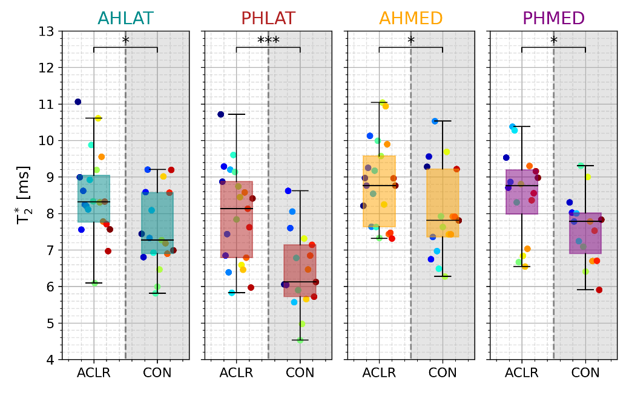

**Figure 1.** T2* in ACLR versus CON in the four meniscal regions. Colored dots within each group represent the same subject across meniscal regions. Overlays *, ** and *** indicate p<0.05, p<0.01, and p<0.001, respectively.

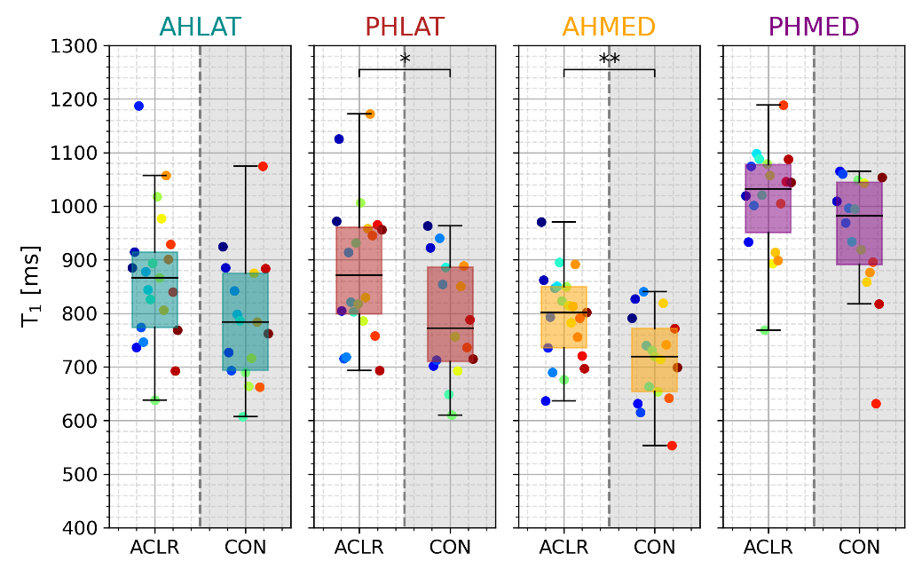

**Figure 2.** T1 in ACLR versus CON in the four meniscal regions. Colored dots within each group represent the same subject across meniscal regions. Overlays *, ** and *** indicate p<0.05, p<0.01, and p<0.001, respectively.

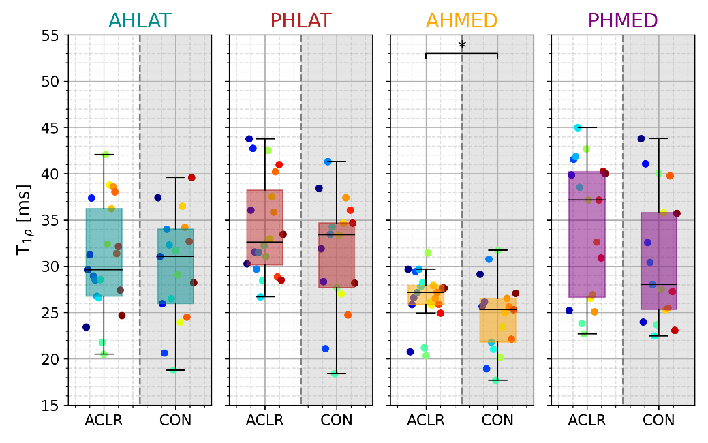

**Figure 3.** T1 in ACLR versus CON in the four meniscal regions. Colored dots within each group represent the same subject across meniscal regions. Overlays *, ** and *** indicate p<0.05, p<0.01, and p<0.001, respectively.