**Title -** *125 characters*

Semi-Automated Bone Tracking for Dynamic MRI Analysis of Knee Joint Kinematics

**Authors**

Aayush Nepal1, Nicholas M. Brisson2,3, Georg N. Duda2,3, Felix Güttler4, Jürgen R. Reichenbach1 and Martin Krämer1,4

1 Medical Physics Group, Institute of Diagnostic and Interventional Radiology, Jena University Hospital, Friedrich Schiller University Jena, Germany

2 Julius Wolff Institute, Berlin Institute of Health at Charité – Universitätsmedizin Berlin, Germany

3 Berlin Movement Diagnostics (BeMoveD), Center for Musculoskeletal Surgery, Charité – Universi-tätsmedizin Berlin, Germany

4 Institute of Diagnostic and Interventional Radiology, Jena University Hospital – Friedrich Schiller University Jena

**Synopsis -** *100 words - combined 4 sections*

**Motivation:** The ability to analyze tibiofemoral kinematics during dynamic motion is important for clinical assessment and research.

**Goal(s):** To develop and validate a semi-automated pipeline to track tibiofemoral motion and extract kinematic parameters from sagittal-plane CINE MRI.

**Approach:** Combination of edge detection with connected component labeling and frame-to-frame transformation optimization to track bone boundaries during knee flexion-extension cycles. Validation in five healthy volunteers and comparison with manual segmentation.

**Results:** Measured kinematics (flexion-extension angle: 24.10° ± 7.15°, AP translation: -18.78 ± 3.16 mm, SI translation: 0.82 ± 1.33 mm) aligned with expected physiological ranges and showed higher accuracy than manual segmentation.

**Impact -** *40 words***:** This work demonstrates that direct analysis of dynamic MRI frames can achieve accurate motion tracking of the tibia and femur without requiring high-resolution reference scans. This approach performs better than manual segmentation and streamlines the study of in vivo knee kinematics

**Abstract -** *750 words - references not included, discussion and conclusion can be merged*

**Introduction**

Accurate assessment of tibiofemoral kinematics is crucial for evaluating joint functionality and improving prosthetic design 1. While dynamic MRI is able to visualizes knee motion 2, only few methods exist for the quantification of kinematic parameters from such dynamic MRI scans, typically using manual segmentation or complex registration methods that rely on high-resolution static reference scans 3–5. Here, we present a semi-automated pipeline to track tibiofemoral motion and to extract kinematic parameters directly from sagittal-plane CINE MRI images. Our method combines Canny edge detection and connected-component labeling to track tibiofemoral kinematics across frames and allows the quantification of the anterior-posterior translation, superior-inferior translation, and the angle between tibia and femur. Results are compared against manual segmentation. The developed approach offers an efficient tool for analyzing tibiofemoral motion patterns from dynamic MRI data, with potential application in both research and clinical settings.

**Methods**

Five healthy volunteers (28–39 years) underwent dynamic MRI scans using a clinical 3T scanner (Magnetom Prisma, Siemens Healthineers) during repetitive, open-chain knee flexion-extension cycles to the beat of a metronome (6 cycles/min) using an MRI-compatible motion device 6. A 2D radial golden-angle FLASH sequence (TE/TR = 2.51/5.8 ms, flip angle 8°, 176 × 176 matrix) was used for imaging, with each scan lasting 160 s and acquiring 100 k-space repetitions. CINE images were reconstructed at 2° flexion angle intervals throughout the motion cycle 7 and used as sole input for the segmentation and tracking (Figure 1).

The semi-automated segmentation and tracking involved: (1) Canny edge detection to identify bone edges; (2) through frame connected-component labeling to pick out edges of the interior cortical bone boundaries; (3) establishment of discretized key reference points on the binary edge outputs of the first frame, facilitating frame-to-frame transformations using greedy nearest neighbor sorting and cubic spline interpolation; (4) optimizing transformation parameters via nonlinear least squares to minimize alignment error between frames, automating tracking across the motion cycle (Figure 2).

Using these segments, the anterior-posterior translation, superior-inferior translation and the angle between long axis of the tibia relative to the femur were extracted throughout the motion cycle for all subjects. The tibia and femur were also segmented manually for all subjects and frames, and kinematic parameters were extracted from the manual segmentations for comparison. To account for variability in the range of motion between subjects, the motion cycle was normalized to the percentage of flexion.

**Results**

The developed tracking algorithm was able to track the bone edges across all frames for all subjects with an average alignment error of the bone edges of 0.40 ± 0.02 mm. The results are illustrated for one subject in Figure 3, showing the semi-automatic segmentation results of the tibia and femur across the knee flexion-extension cycle.

Extraction of bone kinematics showed comparable results for manual and semi-automatic segmentation (Figure 4). The angle between the long axes of tibia and femur changed by 24.99 ± 8.20° for manual segmentation and 24.10 ± 7.15° for semi-automatic segmentation. The anterior-posterior translation showed a change of -18.95 ± 4.03 mm (manual) and -18.78 ± 3.16 mm (semi-automatic), and the superior-inferior translation showed minimal change, with values of 0.53 ± 1.76 mm (manual) and 0.82 ± 1.33 mm (semi-automatic). For the extension phase, both methods showed similar changes in kinematic parameters. In both extension and flexion phases the developed semi-automatic tracking showed lower standard deviations across the subjects.

**Discussion and Conclusion**

The semi-automated pipeline demonstrates high reliability in tracking tibiofemoral motion. The consistently lower standard deviations achieved by the semi-automated method indicates higher measurement accuracy compared to a fully manual segmentation. The symmetry of the observed kinematics between extension and flexion phase suggests reliable performance regardless of movement direction. The quantified kinematic parameters align well with previous reports and fall within expected physio-logical ranges 3,4. One limitation of the algorithm is that it operates under the assumption of rigid transformation within the analyzed 2D sagittal plane. Although there was no significant through-slice motion of the bones observed in our experiments, improper slice positioning or abnormal knee kinematics have the potential to increase tracking errors for later frames. Future work should focus on extending the methodology to track out-of-plane movements or an extension to 3D for more comprehensive joint motion analysis. Although currently limited to 2D sagittal plane analysis, the developed semi-automated has the advantage that it’s easy to implement and that it can be efficiently applied, making it suitable to quantify tibiofemoral kinematics also in larger clinical studies or even for clinical applications.

**References**

1. Postolka B, Taylor WR, Dätwyler K, Heller MO, List R, Schütz P. Interpretation of natural tibio-femoral kinematics critically depends upon the kinematic analysis approach: A survey and comparison of methodologies. *J Biomech*. 2022;144:111306. doi:10.1016/j.jbiomech.2022.111306

2. D’Entremont AG, Nordmeyer-Massner JA, Bos C, Wilson DR, Pruessmann KP. Do dynamic-based MR knee kinematics methods produce the same results as static methods? *Magn Reson Med*. 2013;69(6):1634-1644. doi:10.1002/mrm.24425

3. Kaiser J, Bradford R, Johnson K, Wieben O, Thelen DG. Measurement of tibiofemoral kinematics using highly accelerated 3D radial sampling. *Magn Reson Med*. 2013;69(5):1310-1316. doi:10.1002/mrm.24362

4. Seisler AR, Sheehan FT. Normative three-dimensional patellofemoral and tibiofemoral kinematics: a dynamic, in vivo study. *IEEE Trans Biomed Eng*. 2007;54(7):1333-1341. doi:10.1109/TBME.2007.890735

5. Behnam AJ, Herzka DA, Sheehan FT. Assessing the accuracy and precision of musculoskeletal motion tracking using cine-PC MRI on a 3.0T platform. *J Biomech*. 2011;44(1):193-197. doi:10.1016/j.jbiomech.2010.08.029

6. Brisson NM, Krämer M, Krahl LAN, Schill A, Duda GN, Reichenbach JR. A novel multipurpose device for guided knee motion and loading during dynamic magnetic resonance imaging. *Z Für Med Phys*. Published online February 2022:S093938892100115X. doi:10.1016/j.zemedi.2021.12.002

7. Aleksiev M, Krämer M, Brisson NM, Maggioni MB, Duda GN, Reichenbach JR. High-resolution CINE imaging of active guided knee motion using continuously acquired golden-angle radial MRI and rotary sensor information. *Magn Reson Imaging*. 2022;92:161-168. doi:10.1016/j.mri.2022.06.015

**Preview Figure -** *one figure, no caption, legible at the width of a mobile smartphone*

**Ein Bild, das Screenshot, Design enthält.
**

**Figures -** *up to 5 only for abstract*

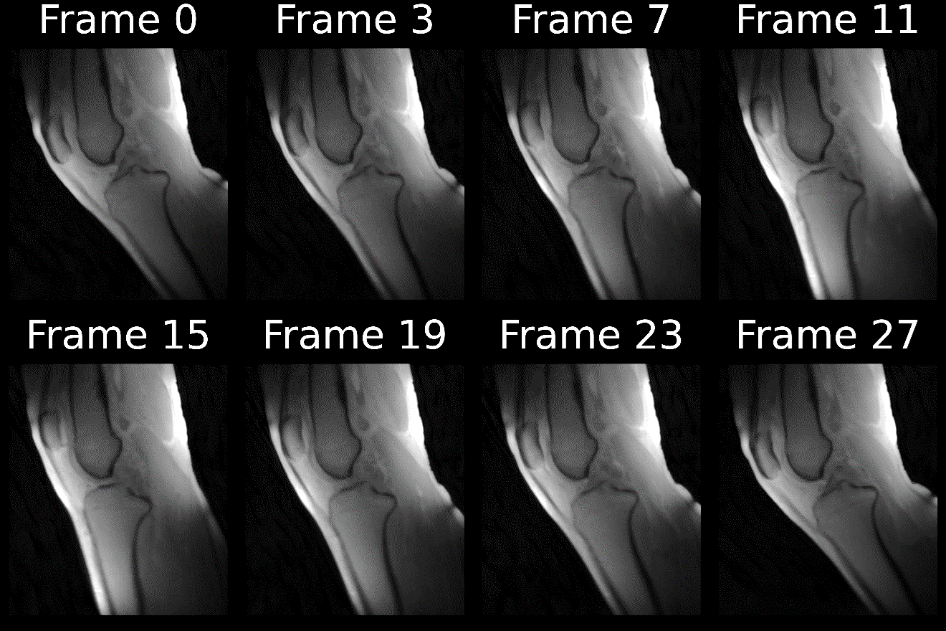

**Figure 1:** Dynamic MRI frames of knee motion during a full flexion-extension-flexion cycle. Each frame represents a 2-degree increment in knee angle. Frame 0 shows maximum flexion, with subsequent frames progressing through extension and returning to flexion in the final frame.

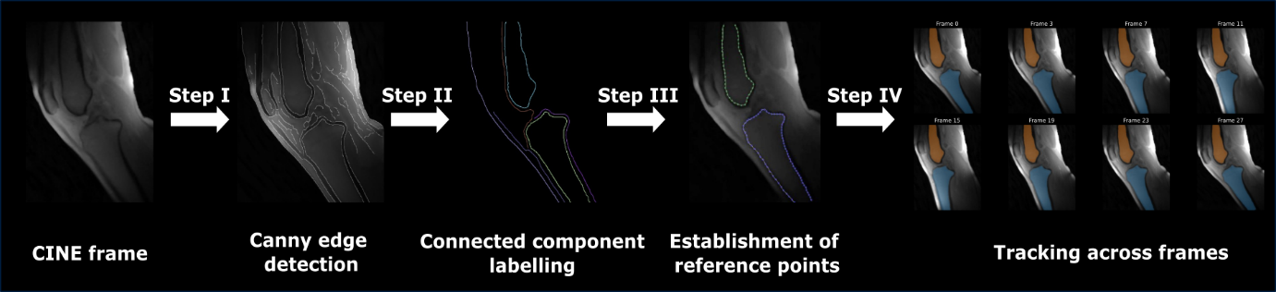

**Figure 2:** Schematic overview of the semi-automated pipeline for bone shape tracking. The process includes: (I) Canny edge detection for detection of bone boundaries; (II) Connected-component labeling to isolate edges; (III) Extraction of reference points along edges; and (IV) Computation of transformation parameters for frame-to-frame tracking. The final panel shows segmented tibia and femur overlaid on the MRI image after applying the transformations obtained from semi-automated tracking to manual segmentation performed in the first frame.

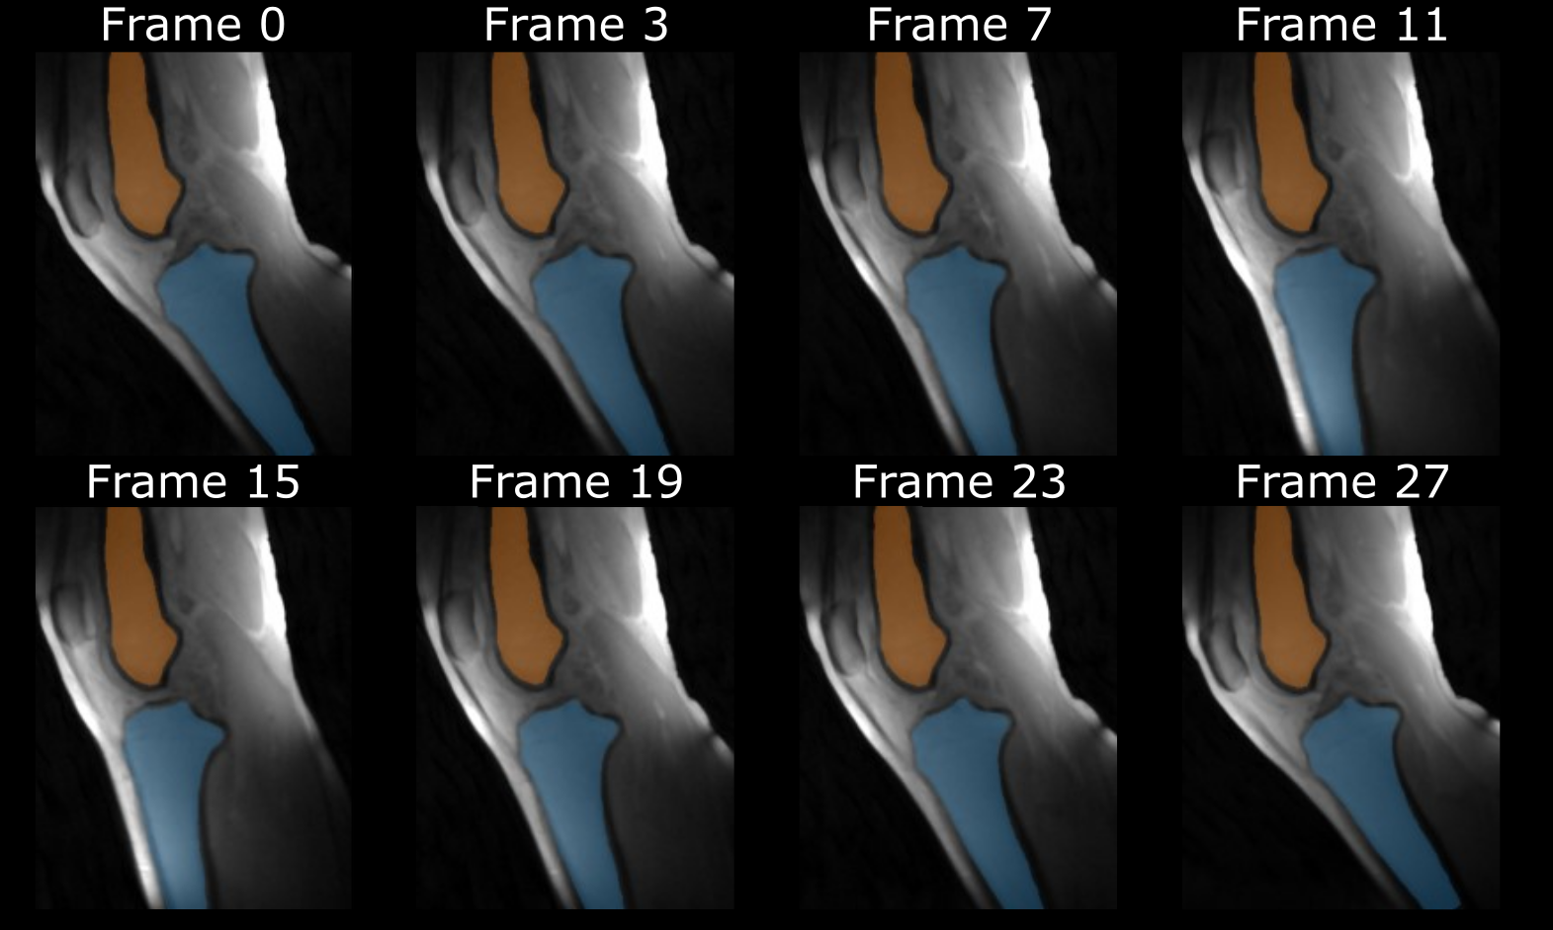

**Figure 3:** Example of semi-automatically tracked segmentation of the tibia (blue) and femur (orange) at different points during the knee motion cycle overlaid on the base CINE frames.

Ein Bild, das Text, Diagramm, Reihe, Zahl enthält.

**Figure 4:** Comparison of kinematic parameters during knee flexion-extension cycles using semi-automatic and manual segmentation. Panels show flexion-extension angle (left), anterior-posterior translation (center), and superior-inferior translation (right). Top row represents extension phase (flexed to extended), bottom row shows flexion phase (extended to flexed). Shaded areas indicate variability across subjects: orange for manual and blue for semi-automatic segmentation.