**Title -** *125 characters*

Semi-Automated Bone Tracking for Dynamic MRI Analysis of Knee Joint Kinematics

**Authors**

Aayush Nepal1, Nicholas M. Brisson2, Georg N. Duda2, Felix Güttler3,   
Jürgen R. Reichenbach1 and Martin Krämer1,3

1 Medical Physics Group, Institute of Diagnostic and Interventional Radiology, Jena University Hospital, Friedrich Schiller University Jena, Germany

2 Julius Wolff Institute, Berlin Institute of Health at Charité – Universitätsmedizin Berlin, Germany

3 Institute of Diagnostic and Interventional Radiology, Jena University Hospital – Friedrich Schiller University Jena

**Synopsis -** *100 words - combined 4 sections*

**Motivation:** The ability to analyze tibiofemoral kinematics during dynamic imaging is important for research and clinical assessment.

**Goal(s):** To develop and validate a semi-automated pipeline to track tibiofemoral motion and extract kinematic parameters from sagittal plane CINE MRI.

**Approach:** Acombination of edge detection with connected-component labeling and frame-to-frame transformation optimization was used to track bone boundaries during knee flexion-extension cycles during dynamic MRI. The method was validated in five healthy volunteers and compared with manual segmentation.

**Results:** Measured kinematics (flexion-extension range of motion: 24.1° ± 7.2°, anterior-posterior displacement: -18.8 ± 3.2 mm, superior-inferior displacement: 0.8 ± 1.3 mm) matched expected physiological ranges and showed higher accuracy than manual segmentation.

**Impact -** *40 words***:** Direct analysis of dynamic MRI frames can achieve accurate motion tracking of the tibia and femur without requiring high-resolution reference scans. This approach outperforms manual segmentation and streamlines the study of in vivo knee kinematics from imaging data.

**Abstract -** *750 words - references not included, discussion and conclusion can be merged*

**Introduction**

Accurate assessment of tibiofemoral kinematics is crucial for evaluating joint function and improving prosthetic design 1. While dynamic MRI is able to visualize knee motion 2, only a few methods exist for the quantifying kinematic parameters from these data, typically using manual segmentation or complex registration methods that rely on high-resolution static reference scans 3–5. Here, we present a semi-automated pipeline to track tibiofemoral motion and to extract kinematic parameters directly from sagittal plane CINE MRI images. Our method combines Canny edge detection6 and connected-component labeling7 to track tibiofemoral kinematics across frames, enabling quantification of the flexion-extension range of motion, anterior-posterior displacement and superior-inferior displacement. We also compare the results between the semi-automated and manual segmentations. Our developed approach represents an efficient tool for analyzing tibiofemoral motion from dynamic MRI data, with potential application in both research and clinical settings.

**Methods**

Five healthy volunteers (28–39 years old) underwent dynamic MRI scans using a clinical 3T scanner (Magnetom Prisma, Siemens Healthineers) as they performed repetitive, open-chain knee flexion-extension cycles to the beat of a metronome (6 cycles/minute) using an MRI-compatible motion and loading device 8. A 2D radial golden-angle FLASH sequence (TE/TR = 2.51/5.8 ms, flip angle 8°, 176 × 176 matrix) was used for imaging, with each scan lasting 160 s and acquiring 100 k-space repetitions. CINE images were reconstructed at 2° flexion angle intervals throughout the motion cycle 9 and used as sole input for the segmentation and tracking (Figure 1).

The semi-automated segmentation and tracking involved: (1) Canny edge detection to identify bone edges in all frames; (2) through frame connected-component labeling to pick out edges of the interior cortical bone boundaries; (3) establishing discrete key reference points on the binary edge outputs of the first frame, facilitating frame-to-frame transformations using greedy nearest neighbor sorting and cubic spline interpolation; and (4) optimizing transformation parameters via nonlinear least squares to minimize alignment error between frames, automating tracking across the motion cycle (Figure 2).

Finally, frame-to-frame transformation parameters obtained from edge tracking were applied to transform manual bone segmentations drawn in the first frame to all other frames. Using these transformed segmentations flexion-extension range of motion, anterior-posterior displacement and superior-inferior displacement were extracted throughout the motion cycle for all subjects. The tibia and femur were also segmented manually for all subjects and frames, and kinematic parameters were extracted from the manual segmentations for comparison. To account for variability in the range of motion between subjects, the motion cycle was normalized to the percentage of the maximal achieved flexion.

**Results**

The semi-automated bone tracking algorithm was able to track the bone edges across all frames for all subjects with an average alignment error 0.40 ± 0.02 mm for the bone edges. The semi-automatic segmentation results of the tibia and femur across the knee flexion-extension cycle are illustrated for one representative subject in Figure 3.

The flexion-extension range of motion was 25.0 ± 8.2° for manual segmentation and 24.1 ± 7.2° for semi-automatic segmentation. The anterior-posterior displacement was -18.9 ± 4.0 mm (manual) and -18.8 ± 3.2 mm (semi-automated), and the superior-inferior displacement showed only minimal change, with values of 0.5 ± 1.8 mm (manual) and 0.8 ± 1.3 mm (semi-automated). For the knee extension phase of the motion cycle, both segmentation methods showed similar changes in kinematic parameters. For both the knee extension and flexion phases, the semi-automated tracking showed lower standard deviations across the subjects (Figure 4).

**Discussion and Conclusion**

The semi-automated pipeline demonstrates high reliability in tracking tibiofemoral motion. The consistently lower standard deviations achieved by the semi-automated method indicates higher measurement accuracy compared to a fully manual segmentation. The symmetry of the observed kinematics between extension and flexion phase suggests reliable performance regardless of movement direction. The quantified kinematic parameters align well with previous reports and fall within expected physio-logical ranges 3,4. One limitation of the algorithm is that it operates under the assumption of rigid transformation within the analyzed 2D sagittal plane. Although there was no significant through-slice motion of the bones observed in our experiments, improper slice positioning or abnormal knee kinematics have the potential to increase tracking errors for later frames. Future work should focus on extending the methodology to track out-of-plane movements or an extension to 3D for more comprehensive joint motion analysis. Although currently limited to 2D sagittal plane analysis, the developed semi-automated has the advantage that it’s easy to implement and that it can be efficiently applied, making it suitable to quantify tibiofemoral kinematics also in larger clinical studies or even for clinical applications.

**References**

1. Postolka B, Taylor WR, Dätwyler K, Heller MO, List R, Schütz P. Interpretation of natural tibio-femoral kinematics critically depends upon the kinematic analysis approach: A survey and comparison of methodologies. *J Biomech*. 2022;144:111306. doi:10.1016/j.jbiomech.2022.111306

2. D’Entremont AG, Nordmeyer-Massner JA, Bos C, Wilson DR, Pruessmann KP. Do dynamic-based MR knee kinematics methods produce the same results as static methods? *Magn Reson Med*. 2013;69(6):1634-1644. doi:10.1002/mrm.24425

3. Kaiser J, Bradford R, Johnson K, Wieben O, Thelen DG. Measurement of tibiofemoral kinematics using highly accelerated 3D radial sampling. *Magn Reson Med*. 2013;69(5):1310-1316. doi:10.1002/mrm.24362

4. Seisler AR, Sheehan FT. Normative three-dimensional patellofemoral and tibiofemoral kinematics: a dynamic, in vivo study. *IEEE Trans Biomed Eng*. 2007;54(7):1333-1341. doi:10.1109/TBME.2007.890735

5. Behnam AJ, Herzka DA, Sheehan FT. Assessing the accuracy and precision of musculoskeletal motion tracking using cine-PC MRI on a 3.0T platform. *J Biomech*. 2011;44(1):193-197. doi:10.1016/j.jbiomech.2010.08.029

6. Canny J. A Computational Approach to Edge Detection. *IEEE Trans Pattern Anal Mach Intell*. 1986;PAMI-8(6):679-698. doi:10.1109/TPAMI.1986.4767851

7. Dillencourt MB, Samet H, Tamminen M. A general approach to connected-component labeling for arbitrary image representations. *J ACM*. 1992;39(2):253-280. doi:10.1145/128749.128750

8. Brisson NM, Krämer M, Krahl LAN, Schill A, Duda GN, Reichenbach JR. A novel multipurpose device for guided knee motion and loading during dynamic magnetic resonance imaging. *Z Für Med Phys*. Published online February 2022:S093938892100115X. doi:10.1016/j.zemedi.2021.12.002

9. Aleksiev M, Krämer M, Brisson NM, Maggioni MB, Duda GN, Reichenbach JR. High-resolution CINE imaging of active guided knee motion using continuously acquired golden-angle radial MRI and rotary sensor information. *Magn Reson Imaging*. 2022;92:161-168. doi:10.1016/j.mri.2022.06.015

**Preview Figure -** *one figure, no caption, legible at the width of a mobile smartphone*

**Ein Bild, das Screenshot, Design enthält.
**

**Figures -** *up to 5 only for abstract*

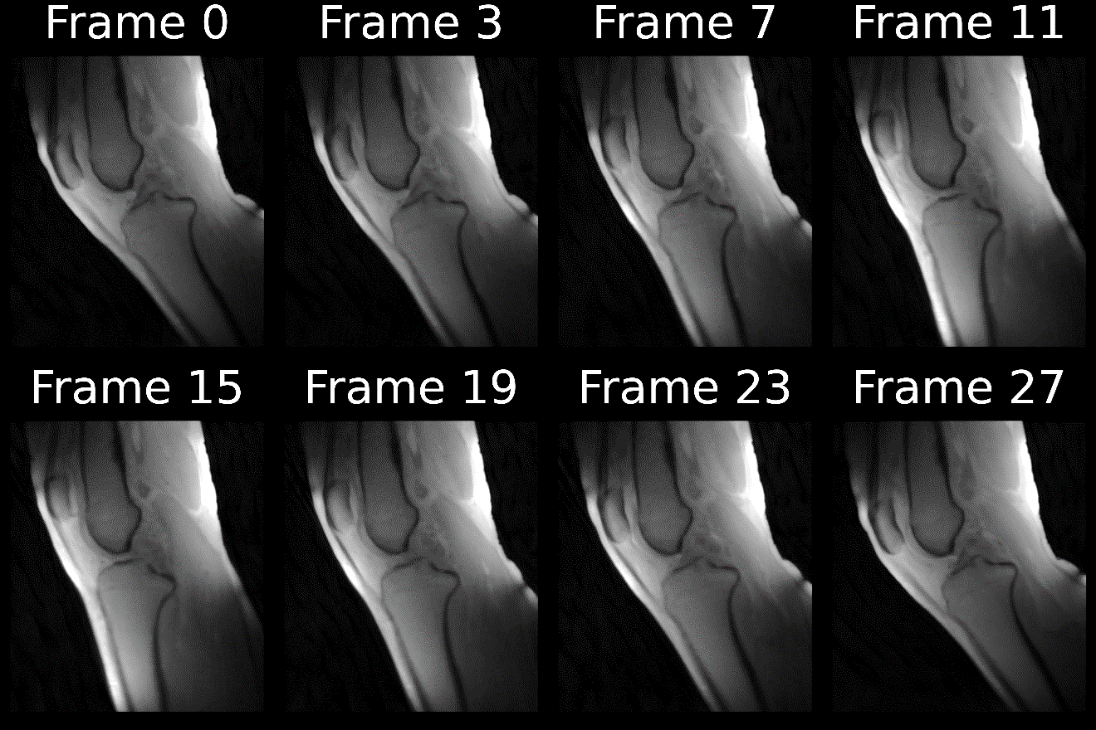

**Figure 1:** Dynamic MRI frames of knee motion during an extension-flexion cycle. Each frame represents a 2° increment in knee angle. Frame 0 shows maximum knee flexion, with subsequent frames progressing into extension and returning to flexion in the final frame.

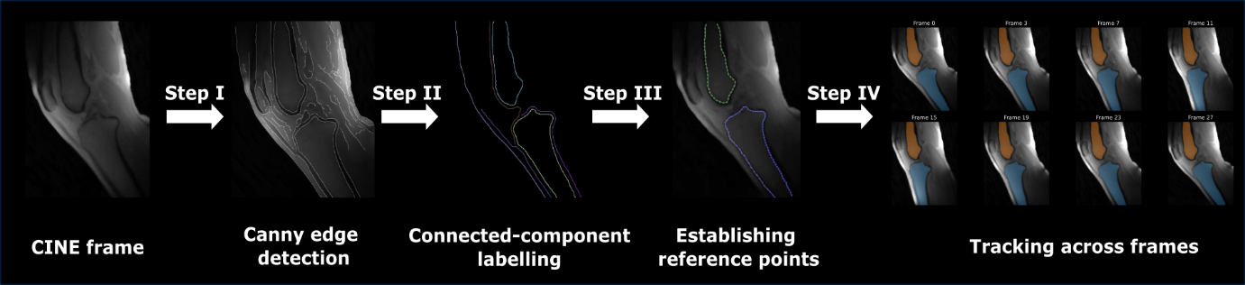

**Figure 2:** Schematic overview of the semi-automated pipeline for bone shape tracking. The process includes: (I) Canny edge detection to detect bone edges; (II) Connected-component labeling to isolate cortical bone edges; (III) Establishing reference points along bone edges; and (IV) Computing transformation parameters for frame-to-frame tracking. The final panel shows the segmented tibia and femur overlaid on the MRI image after applying the transformations obtained from semi-automated tracking to manual segmentation performed in the first frame.

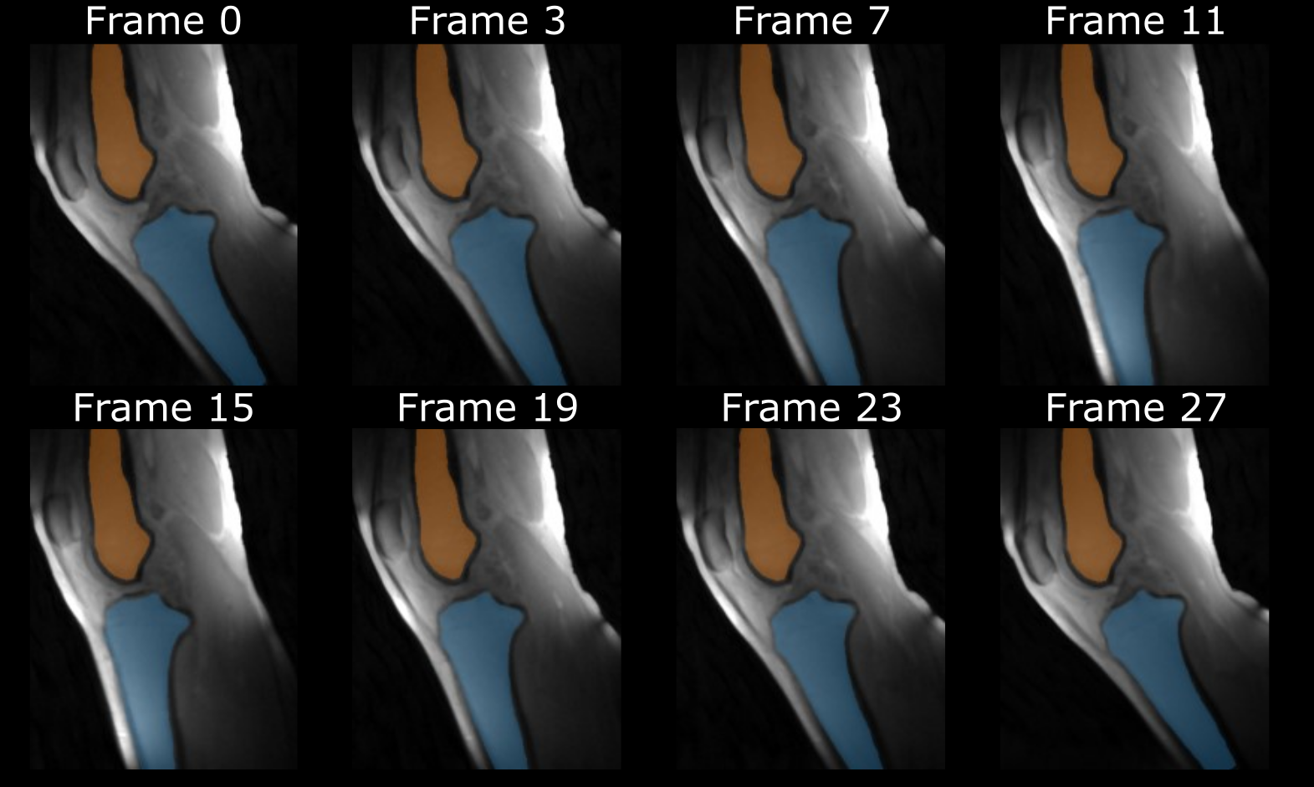

**Figure 3:** Example of semi-automated tracking of the tibia (blue) and femur (orange) segmentations overlaid on the base CINE frames at different flexion angles during the knee motion cycle.

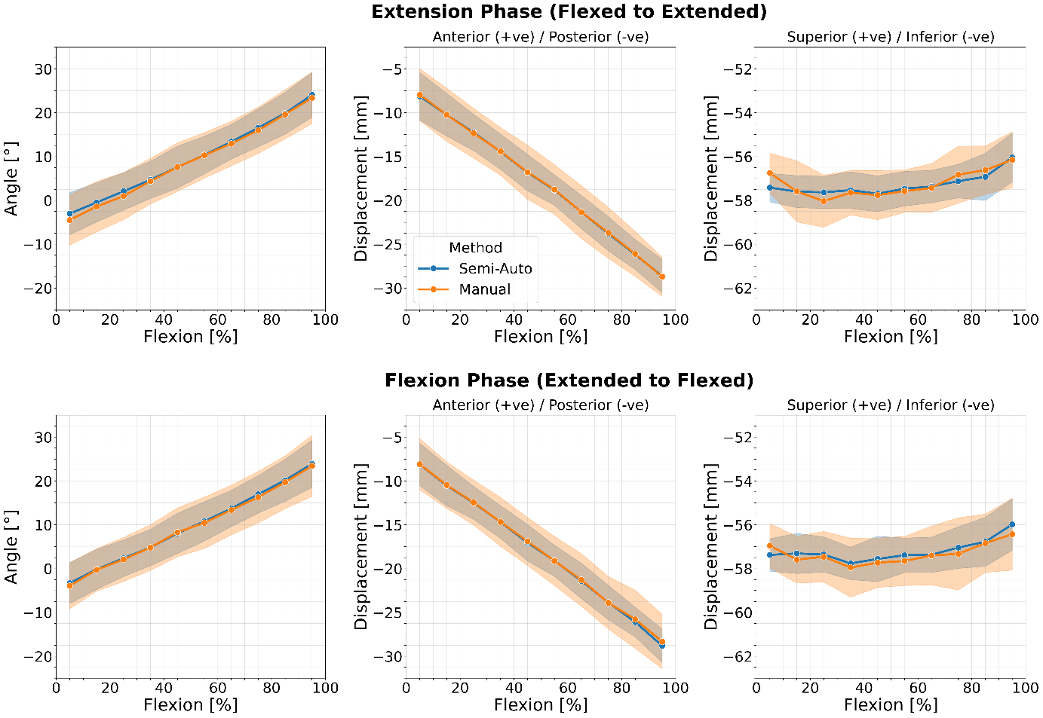

**Figure 4:** Comparison of kinematic parameters during knee flexion-extension cycles using semi-automated and manual segmentations. Panels show the knee flexion-extension angle (left), anterior-posterior displacement (center), and superior-inferior displacement (right). Top row represents the extension phase (flexed to extended position), bottom row shows flexion phase (extended to flexed position). Shaded areas indicate the standard deviations around the group means.