Manuscript body

Introduction(abstract)

The study of tibiofemoral kinematics often employs three-dimensional MRI datasets to accurately capture the complex motion patterns of the knee joint [1]. Typically, these studies require a combination of static and dynamic

scans, alongside sophisticated modelling techniques and algorithms to extract kinematic parameters [2]. While this approach is comprehensive, it is time intensive; other alternatives may simplify and hasten the acquisition and analysis.

This study introduces a semi-automated pipeline designed to segment the tibia and femur during knee flexion-extension cycles from single slice CINE images in the sagittal view, and to track kinematic parameters from these segments. By bypassing the need for high-resolution static scans and complex computational approaches like machine learning, this streamlined process offers a practical, less resource-intensive alternative for conducting kinematic assessments.

Introduction(poster)

This study utilizes a novel MRI-compatible device designed to facilitate controlled, repetitive knee flexion-extension cycles [1,2]. Equipped with an optical sensor to synchronize motion data, the device enables the precise reconstruction of CINE MRI images that capture the knee during these movements, as illustrated in **Fig. 1**. Traditional kinematic analyses often rely on on manually segmenting each frame to track the tibia and femur which can be prone to inaccuracies. To address these challenges, we developed a semi-automated segmentation pipeline that segments the tibia and femur across the motion cycle with minimal manual intervention.

Introduction (thesis)

The knee joint, a crucial structure in human movement, consists of various tissues with distinct structural and mechanical properties, including articular cartilage and meniscus. These components are regularly subjected to mechanical pressure loads, making them susceptible to degenerative conditions such as osteoarthritis (OA). OA affects a significant portion of the global population and the knee joint is one of the most common targets, leading to functional impairments and increased healthcare costs (WHO 2023).A comprehensive survey across 15 European countries and Israel found that knee pain is the third most commonly reported type of chronic pain, underscoring the significant public health concern it represents (Breivik et al. 2006). Furthermore, OA was identified as the most common cause of this pain.This situation has not improved over time. In Germany, for instance, a recentretrospective study found that the number of patients with OA is steadily rising(Oberm¨uller et al. 2024). As society ages, the prevalence and impact of OA areexpected to rise, posing significant public health challenges (Yelin et al. 2016). Knee-related issues are prevalent and impactful due to the inherent complexity of theknee joint. As a hub of various anatomical structures working in unison, the kneesupports a range of movements and bears significant loads, making it susceptibleto a variety of injuries and conditions. Early diagnosis of OA is crucial for timelyintervention, and understanding the anatomy of the knee is the first step in tacklingthis problem. Magnetic resonance imaging (MRI) has emerged as a promising non-invasive technique for early diagnosis of OA due to its excellent soft tissue contrastand high spatial resolution (Kijowski et al. 2020).

Conventionally, MRI studies aimed at assessing the structure and function of theknee joint have been performed with the joint at rest or under non-weight-bearingconditions, which, however, do not accurately reflect the physiological state of theknee during daily activities (Blankevoort et al. 1988). For instance, research hasshown that bone marrow lesions, which are associated with OA progression, aresignificantly related to mechanical loading during activities like walking, highlightingthe limitations of non-weight-bearing MRIs in detecting early-stage OA (Bennell etal. 2010).

Given these limitations, the development of dynamic MRI techniques has becomeessential to more accurately reflect the knee’s behavior under realistic conditions.For example, one dynamic MRI study demonstrated that knee kinematics duringcontinuous movement reveal significant differences in several parameters—such astibial abduction, internal rotation, anterior translation—compared to static posi-tions (d’Entremont et al. 2013). Additionally, studies like Mahmoudian et al. (2017)have shown that both dynamic and static knee alignments are predictive of struc-tural abnormalities on MRI associated with medial compartment knee osteoarthritis,underscoring the clinical relevance of dynamic imaging techniques (Mahmoudian etal. 2017).

Various studies on tibiofemoral kinematics of the knee in motion using dynamicMRI have been conducted. For example, Conconi et al. (2023) used a low-fieldMRI to study the knee in deep flexion under weight-bearing conditions, manuallysegmenting static images and using an automated system to track bone movementin dynamic scans. (Conconi et al. 2023). Similarly, Lansdown et al. (2014) com-pared three methods for measuring knee movement using T2-weighted MRI images,evaluating the reproducibility of these methods for tracking certain knee movementsTheir study aimed to evaluate the reproducibility of these methods for measuringanterior tibial translation and internal tibial rotation (Lansdown et al. 2015). Inanother study, Kaiser et al. (2013) utilized a 3D MR sequence to acquire dynamicvolumetric images. They created subject-specific bone models from high-resolutionstatic images and registered these to the dynamic images to measure 3D tibiofemoraltranslations and rotations during knee flexion-extension cycles, using a knee loadingdevice to simulate the load acceptance phase of gait (Kaiser et al. 2013).Maz-zoli et al. (2017) developed a different method for capturing high-resolution, imagesof the knee without needing external triggers.They scanned the knee during aflexion/extension task using a special sampling technique and imaging sequence tocollect data. Kinematic parameters were derived through a two-step rigid registra-tion process of the segmented femur and tibia masks from high-resolution anatomicalscans (Mazzoli et al. 2017).

Despite these innovative approaches, several studies share common limitations thatwarrant further consideration. For instance, Mazzoli et al. (2017), Kaiser et al. (2013),d’Entremont et al. (2013), and Conconi et al. (2023) all rely on high-resolution staticscans to create models of the bones, which are then combined with dynamic scansto derive kinematic parameters. The need to acquire a static scan in addition to thedyanamic scans increases the overall scanning time and complexity of the procedure,which might make them impractical for routine clinical use. Moreover, manual seg-mentation of musculoskeletal tissues, where an operator delineates the boundaries ofeach joint structure on every MR image slice, is a widely used but extremely time-consuming process. The efficiency and repeatability of the process is dependent on1INTRODUCTION3the operator’s level of experience (McWalter et al. 2005). For example, Lansdownet al. (2014) highlight these challenges, noting that the segmentation process for thefemur and tibia in both extended and flexed positions took up to 144 minutes. Onthe other hand, machine learning techniques like Convolutional Neural Networksand U-Nets are being widely used to automate the segmentation process (Liu et al.2018). Unfortunately, these methods typically require large annotated datasets fortraining, which are not available for the dynamic knee imaging performed in these projects.

To address these limitations, this thesis aims to develop a semi-automated pipelinespecifically designed to segment the tibia and femur from dynamic MRI of the knee.This pipeline processes high-resolution single-slice 2D images in the sagittal view,captured during the flexion-extension cycle of the knee under different loading con-ditions. Additionally, the methodology will track and analyze specific kinematic pa-rameters—such as the angle between the long axes of the tibia and femur segmentsand the distance between specific anatomical landmarks on these bones—throughoutthe motion cycle. This analysis will investigate how these kinematic parameterschange under loaded and unloaded conditions.

The expected outcomes of this thesis are twofold. First, the development of thesemi-automated segmentation pipeline will eliminate the need for high-resolutionstatic scans to model the bone, relying solely on dynamic images themselves. Thisapproach is anticipated to significantly reduce the overall scanning time and com-plexity of the procedure, making it more practical for routine clinical use. Addition-ally, by automating the segmentation process, the pipeline aims to reduce the timeand variability associated with manual segmentation, enhancing both efficiency andrepeatability.

Second, by conducting this study on healthy volunteers, the analysis will establishnormative trends in knee joint kinematics under various loading conditions. These benchmarks will serve as crucial reference points for future comparisons with patient data, aiding in the early diagnosis and treatment of conditions like osteoarthritis. Establishing these normative trends will be essential for assessing knee joint stability and functionality.

This thesis is structured as follows: Chapter 2 delves into the fundamentals of theknee joint and dynamic MRI, providing the necessary anatomical and technical back-ground. Dynamic MRI is further subdivided into sections on CINE imaging, Gat-ing, Knee loading device, Gradient echo FLASH sequence and radial golden-angleacquisition. Chapter 3 outlines the methodology, detailing the data collection, MRIsequence parameters, and the development of the semi-automated segmentationpipeline. Chapter 4 presents the results, highlighting the performance of the edge-tracking algorithm and the biokinematic analysis under varying loading conditions.Chapter 5 discusses the findings in detail, and explores their clinical implications.Finally, Chapter 6 concludes the thesis with a summary of key contributions, limi-tations of the experimental setup and suggestions for future research directions. In particular, Chapters 4 and 5 are organized to clearly delineate the topics of edge tracking and segmentation, angle calculation, and distance calculation, in that order.

Methods

Dynamic MRI scans were conducted on five healthy volunteers (ages 28-39) using a Siemens 3T Prisma scanner. Volunteers underwent scans of the left leg through controlled extension-flexion cycles, guided by a 60-bpm metronome, under both loaded and unloaded conditions.

MRI data was captured using a 2D radial golden-angle gradient echo FLASH sequence with echo time of 2.51 ms, flip angle of 8 degrees and repetition time of 5.8 ms. 276 spokes were acquired per k-space, with each spoke consisting of 352 data points. Each scan session lasted 160 seconds, during which volunteers performed multiple extension-flexion cycles, with a total of 100 k-space repetitions being acquired.

The semi-automated segmentation process was executed in five main steps: first, the Canny edge detector was used to identify edges in the image for the tibia and femur. Next, connected-component labeling technique was used to pick out the relevant edges. Key reference points were then established on the binary edge outputs facilitating frame-to-frame transformations using greedy nearest neighbor sorting and cubic spline interpolation. Transformation matrices, that map the position of the bone edge from one frame to the next were determined through optimization of a cost function. This function quantified the alignment error between subsequent frames by calculating the minimal distances between transformed and target coordinates. Optimization of this function was conducted by using the nonlinear least squares approach to obtain the optimal set of translation and rotation parameters. Finally, these matrices were applied to the boundaries of tibia and femur segments in the first frame, automating segmentation across the remaining frames in the motion cycle.

Post-segmentation, kinematic analysis focused on the angle between the long axes of the femur and tibia, derived from principal component analysis, and the Euclidean distance between key anatomical landmarks (distal and proximal points of femur and tibia), providing insights into orientation and spatial relationship of the bones.

Results

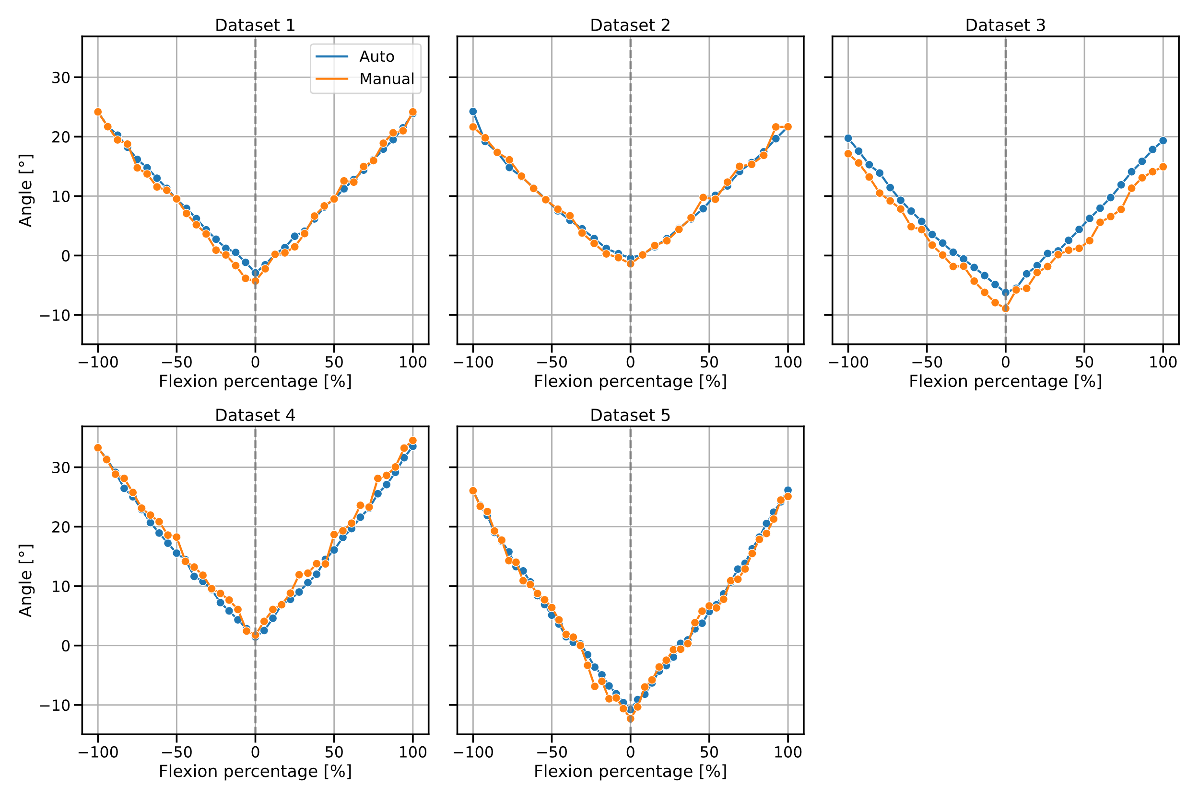

The tibia and femur were segmented twice: once using the semi-automatic pipeline described in the Methods section, and once manually. Using these segmented models, the angle between the long axis of tibia and femur was measured and compared across both methods.

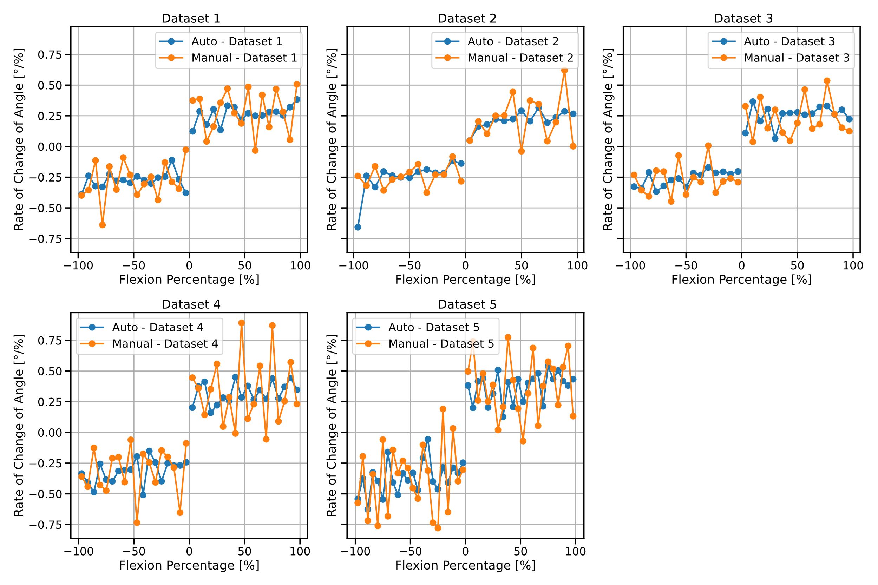

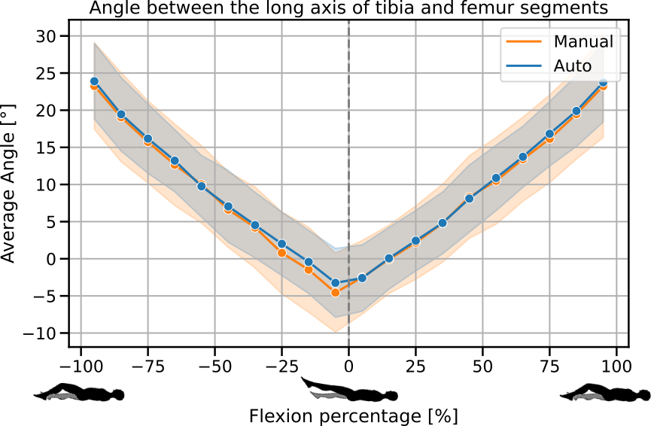

Discussion