MINI PROJECT 4
ANURAG NEPAL

Introduction and Motivation
In modern statistical modeling, it is increasingly common to encounter high-dimensional settings where the number of predictors (p) is large relative to the sample size (n). In these scenarios, traditional Ordinary Least Squares (OLS) regression fails because the design matrix becomes non-invertible, and the variance of the coefficient estimates inflates infinitely. To overcome this, the LASSO (Least Absolute Shrinkage and Selection Operator) is a widely used method for regularization and variable selection. By applying an $L_{1}$ penalty to the regression coefficients, the lasso shrinks less important coefficients exactly to zero, yielding sparse and interpretable models.
However, a fundamental challenge exists in high-dimensional inference: strong predictive performance does not necessarily imply correct identification of the true underlying variables. A model might achieve an incredibly low test error by relying on a combination of spurious correlations, completely missing the true causal drivers. This project is to explore this critical distinction through a carefully designed simulation study. Specifically, the feature-selection consistency of the lasso and examining when it correctly identifies the true set of relevant predictors and how this consistency depends on factors such as sample size, signal strength, and correlation among predictors.

Simulation Design
To evaluate the lasso's selection properties, we simulate data from a sparse linear model:
$$Y = Xβ+ ϵ$$
where $X∈R^{n×p}$ is the predictor matrix, $β∈R^{p}$ is a sparse coefficient vector, and $ϵ_{i}∼N\left(0,σ^{2}\right)$ is Gaussian noise, for $i=1,…,n$.
In this fixed design specification, the baseline true coefficient vector contains exactly 5 non-zero entries representing the active set:
$$β=\left(A,-A,A,-A,A,0,…,0\right)$$
where A dictates the signal strength. The noise variance is fixed at $ϵ_{i}∼N\left(0,1\right)$
To examine the model's limitations, each row of $X$ is generated from a multivariate normal distribution. We explore both an independent case where $X_{i}∼N\left(0,I\right)$ and a correlated case where the covariance structure is defined by an autoregressive (Toeplitz) matrix $Σ_{jk}=ρ^{\left|j-k\right|}$
Then a full factorial experiment was executed by varying the following parameters:
- Sample size (n): 50, 100, 200
- Dimensionality (p): 200, 400, 600
- Signal strength (A): 0.5, 1.0, 1.5
- Correlation $(ρ$): 0, 0.5, 0.8

Method
For each unique combination of experimental parameters, we generated a training dataset and fit a lasso regression model using 10-fold cross-validation. The results were reported for two distinct penalty tuning thresholds:
- $λ_{min}$: The penalty that yields the minimum cross-validated error.
- $λ_{1se}$: The one-standard-error rule, selecting the most regularized model whose error is within one standard error of the minimum.
Variables with nonzero estimated coefficients were defined as the selected set, denoted as $\hat{S}$. Let $S = \{1, 2, 3, 4, 5\}$denote the true active set. We evaluated model performance across 100 independent replications using Sensitivity (True Positive Rate), False Positive Rate (FPR), Precision, and Exact Recovery. To evaluate prediction, we computed the Estimation Error (${\left|\left|\hat{β}-β\right|\right|}_{2}^{2}$) and the Test Mean Squared Error (MSE) on an independently generated test dataset.
Given the scale of the full factorial experiment is 81 unique parameter combinations, each replicated 100 times, and evaluated using 10-fold cross-validation, the simulation required fitting over 81,000 distinct lasso models. To render this computationally feasible and highly efficient, the simulation loop was parallelized.
The experimental settings were distributed across a multi-core CPU architecture using asynchronous background worker processes. To maintain strict statistical independence and ensure reproducibility across the parallel clusters, unique random seeds were deterministically assigned to each worker node prior to data generation. The metrics evaluated by each parallel thread were subsequently aggregated and averaged to form the final global simulation results.

Results
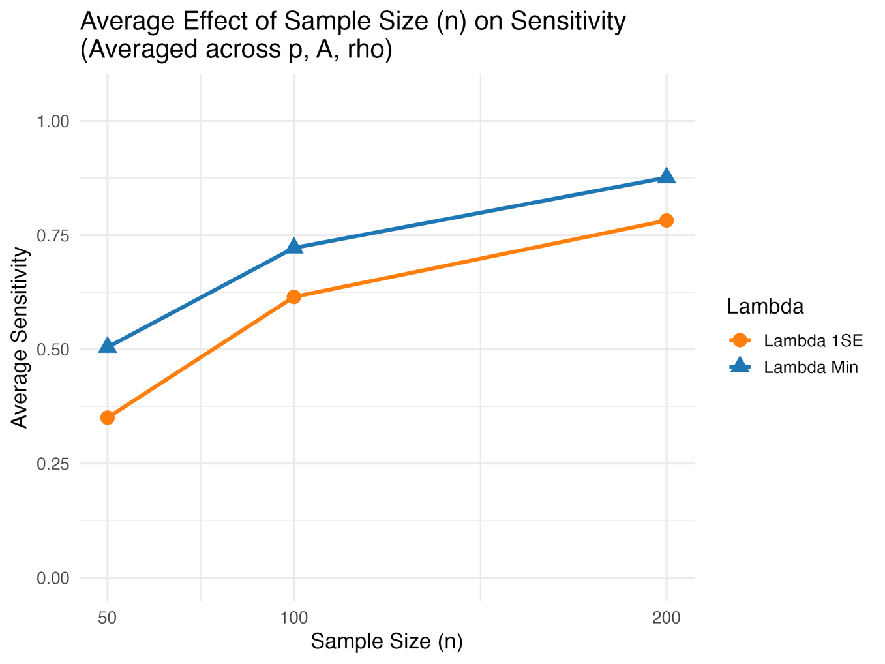
- How does increasing sample size affect feature selection accuracy?
Figure 1 Average Sensitivity across increasing sample sizes for both tuning parameters
When the sample size is small (e.g., 50), the lasso lacks sufficient information to reliably distinguish true signals from background noise. As the sample size increases to 200, Sensitivity rises significantly. A larger sample reduces the variance of the parameter estimates, allowing the cross-validation process to isolate the true active variables more accurately without over-penalizing them. So, Increasing the sample size consistently improves all feature selection metrics.
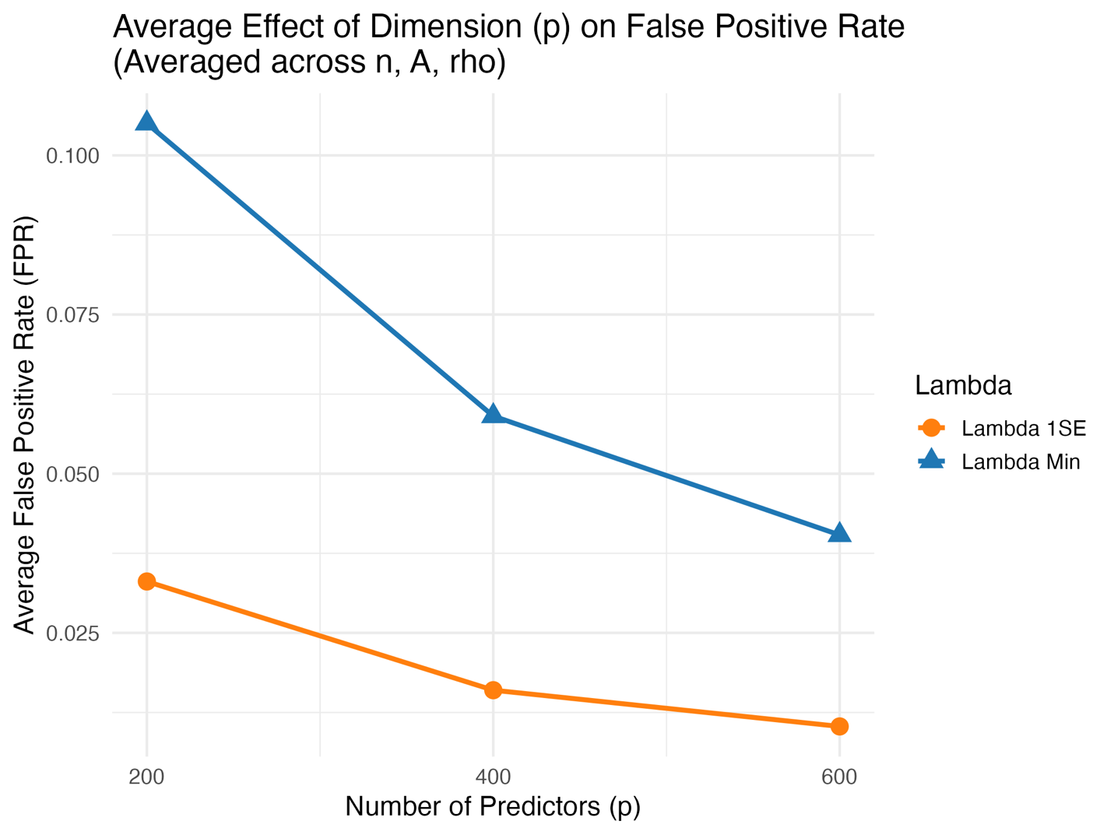
- How does increasing dimension affect feature selection accuracy?
Figure 2 Average False Positive Rate (FPR)
At first glance, the plot suggests that increasing the dimension $(p$) from 200 to 600 improves performance by lowering the False Positive Rate (FPR). However, this is because of the metric itself. FPR is defined as the number of incorrectly selected variables divided by the total number of irrelevant variables. As p increases to 600, the denominator expands massively While the absolute number of false positives selected by the $λ_{min}$ model increases roughly from $p=200$ to $p=600$, the rate drops because the pool of non-active variables grows much faster than the model's capacity to select them. Therefore, increasing the dimension inherently brings the FPR down but the actual feature selection accuracy could be impacted, the model drags more noise into the active set even though the traditional FPR metric appears to improve.
- How does predictor correlation affect false positives and recovery?
Exact Recovery requires the model to select all true variables and exactly 0 noise variables. As seen in the plot, in the independent case $(ρ=0.0$), the lasso achieves its highest Exact Recovery. However, as correlation increases to 0.8, Exact Recovery collapses to near zero. The lasso mathematically struggles with highly correlated features, and it tends to arbitrarily select one variable from a correlated group while heavily shrinking the others to zero, immediately failing the Exact Recovery criteria. And, highly correlated noise variables are frequently dragged into the model alongside the true variables, massively inflating the False Positive Rate.
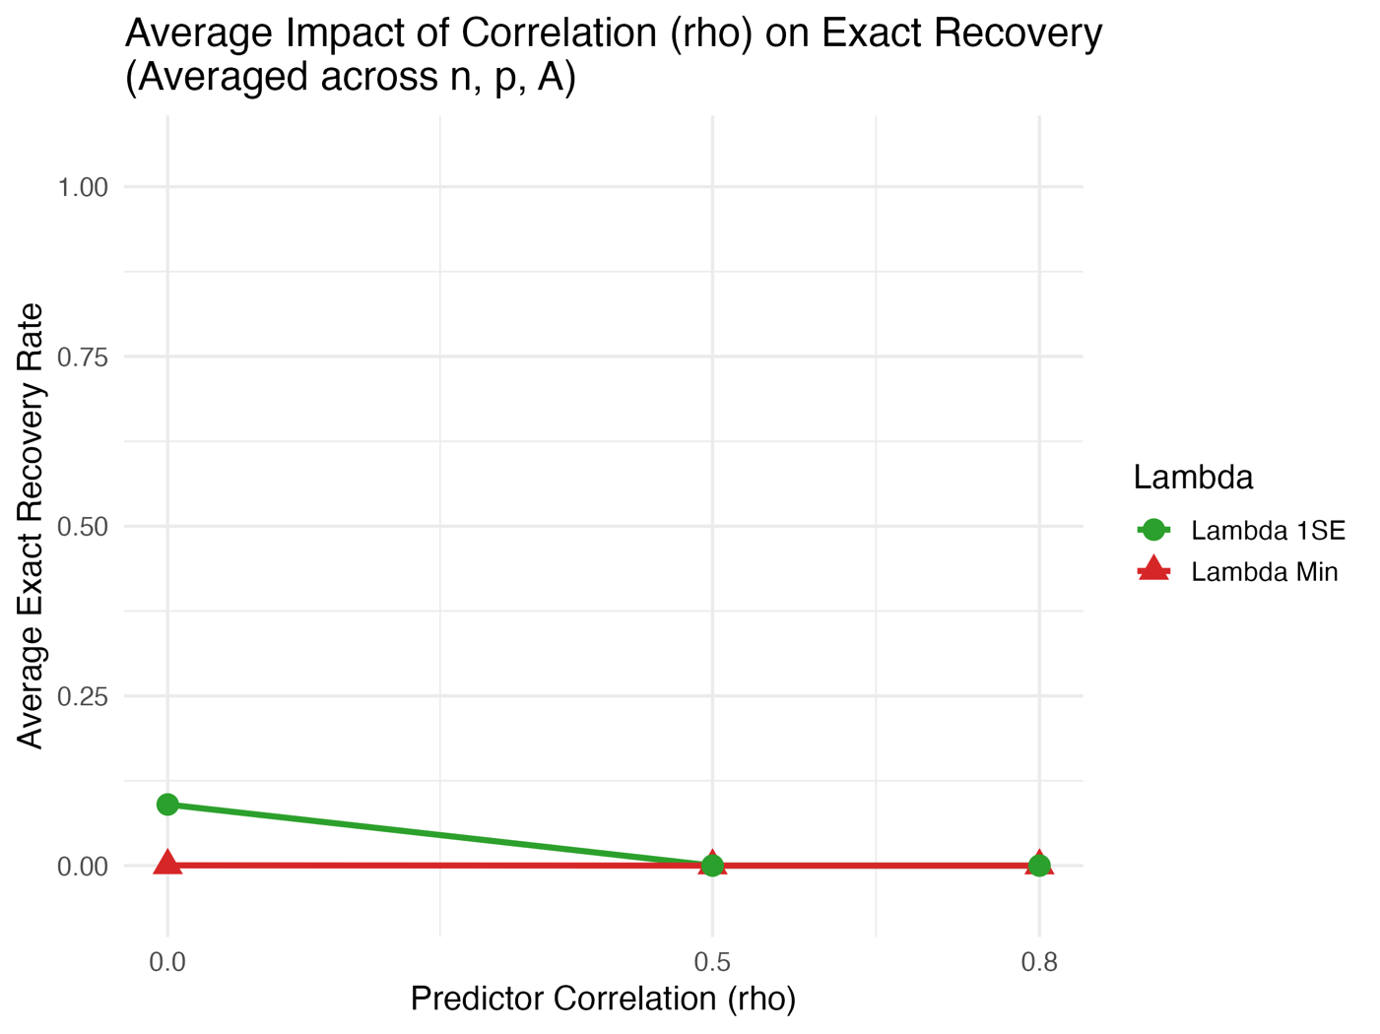
Figure 3 The collapse of Exact Recovery as predictor correlation increases
- How does signal strength influence performance?
When the signal is weak (0.5), the lasso struggles. The $L_{1}$ penalty required to filter out the background noise often shrinks the weak true coefficients entirely to zero, resulting in poor Sensitivity and Precision. Conversely, when the signal is strong (1.5), the true predictors dominate the noise variance. The model flawlessly filters out noise, reaching near-perfect Precision. So, the magnitude of the non-zero coefficients (A) dictates how easily the signal can be isolated from the standard Gaussian noise.
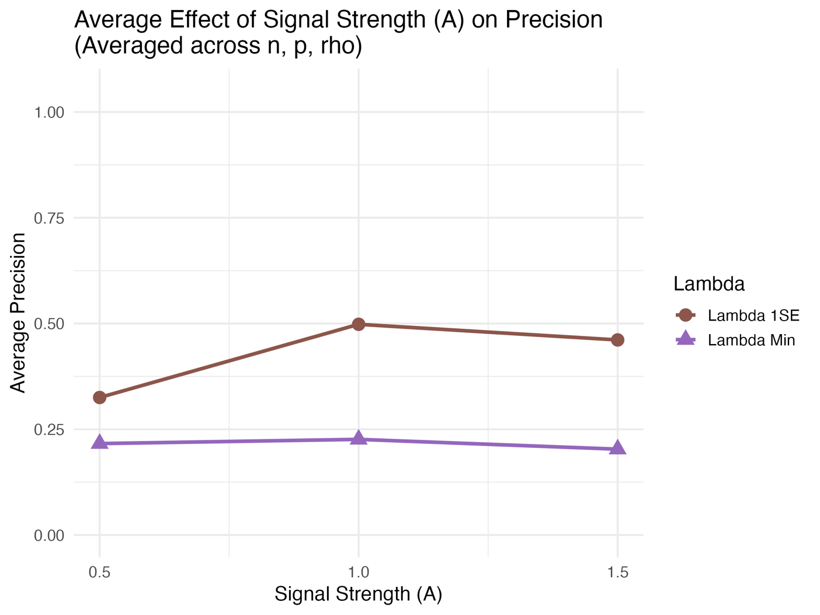
Figure 4 Average Precision as signal strength increases
- How do $λ_{min}$ and $λ_{1se}$ compare?
Metric | Lambda Min | Lambda 1SE
Sensitivity | 0.701 | 0.582
False Positive Rate (FPR) | 0.068 | 0.020
Precision | 0.215 | 0.428
Exact Recovery Rate | 0.000 | 0.030
Test MSE | 1.858 | 2.015
Table 5 Global Average Comparison
$λ_{min}$ applies less penalty. It consistently achieves higher Sensitivity (capturing more true variables) but at a steep cost of inflated False Positive Rate and low Precision. It hoards irrelevant variables to optimize sample fit.
$λ_{1se}$ applies a heavier penalty and this rule produces a conservative, sparse model. It aggressively filters out noise, yielding a near-zero False Positive Rate and high Exact Recovery. However, it sacrifices some Sensitivity by incorrectly shrinking weak true variables to zero.
- Does strong predictive performance imply correct variable selection?
The simulation demonstrates that a model can achieve good predictive performance while still missing true variables or including irrelevant variables. Across all settings, models tuned using $λ_{min}$ achieved the lowest Test MSE, indicating optimal predictive capability. However, these exact same models exhibited terrible Exact Recovery and high False Positive Rates. To minimize predictive error, $λ_{min}$ includes many irrelevant variables that explain tiny fractions of specific sample variance. Therefore, strong predictive performance does not imply the causal structure of the data has been accurately modeled.

Discussion and Conclusions
This simulation study highlights the fundamental limitations of lasso regression in high-dimensional sparse models and understanding the tradeoff between predictive performance and variable selection is a central goal of this project While the lasso is exceptionally powerful, its feature-selection consistency is highly sensitive to the underlying data architecture.
We observed that the lasso successfully recovers true variables when signals are strong, sample sizes are adequate, and features are independent. However, when predictors are highly correlated, exact variable recovery fails. Also, evaluating performance in high dimensions requires careful metric selection, as traditional rates (like FPR) can appear artificially depressed due to expanding denominators. We must consciously choose their tuning parameter based on their objective: $λ_{min}$ is optimal for pure prediction, while $λ_{1se}$ is required for reliable variable selection and causal inference, even if it results in slightly higher prediction error.

