PROJECT REPORT

PREDICTING EPL MATCH OUTCOMES USING STATISTICAL LEARNING

Submitted by:

ANURAG NEPAL

SAN FRANCISCO, CALIFORNIA

Submitted for

MATH 748

THEORY AND APPLICATIONS OF STATISTICAL MACHINE LEARNING

SPRING 2026

Description of the Problem
Sports analytics has transformed from a niche interest into a multibillion-dollar industry used by professional clubs and betting markets. However, accurately predicting the outcome of a football (soccer) match is notoriously difficult due to the low-scoring nature of the game and the high degree of randomness.

The goal of this project is to develop a statistically sound machine learning framework to predict the outcome of English Premier League (EPL) matches (Home Win, Draw, Away Win). Rather than focusing solely on classification accuracy, this project aims to estimate well-calibrated probabilities. This approach allows for a deeper understanding of the stochastic processes driving match results, such as team attack strength and defense strength.

Dataset Description
The project will use the Football-Data.co.uk repository, specifically the English Premier League match data covering the last 5 completed seasons. This dataset is publicly available and machine-readable. It includes the following key features:

Match Outcomes
- FTR: Full Time Result (H (Home Win), D(Draw), A (Away Win))
- FTHG / FTAG: Full Time Home Goals and Away Goals

Predictive Signals (Performance Metrics)
- HS / AS: Home Team Shots / Away Team Shots
- HST / AST: Home/Away Shots on Target
- HC / AC: Home/Away Corners
- HF/AF: Home/Away Fouls.

Betting Odds (Benchmark)
- B365H, B365D, B365A: Odds from Bet365, serving as an information-efficient baseline for model evaluation for games yet to happen.
Table 1 Variable Statistics Summary
Statistic | FTHG | FTAG | HS | AS | HST | AST | HC | AC | HF | AF
mean | 1.62 | 1.38 | 14.31 | 11.83 | 4.92 | 4.19 | 5.64 | 4.73 | 10.72 | 11.21
std | 1.28 | 1.19 | 5.68 | 5.20 | 2.58 | 2.35 | 3.06 | 2.90 | 3.45 | 3.53
min | 0.00 | 0.00 | 1.00 | 1.00 | 0.00 | 0.00 | 0.00 | 0.00 | 2.00 | 1.00
max | 7.00 | 8.00 | 36.00 | 37.00 | 16.00 | 15.00 | 17.00 | 18.00 | 21.00 | 22.00

The initial statistical summary shows that home teams scored an average of 1.62 goals per game with a maximum of 7, while away teams scored an average of 1.38 goals with a maximum of 8. Home teams also averaged a higher volume of offensive output, registering more total shots (14.31 vs. 11.83) and shots on target (4.92 vs. 4.19) than the visiting teams.

Data Cleaning
The Football-Data.co.uk CSV files are pre-formatted for machine readability and modelling. A preliminary check for missing values across the dataset confirmed that there are exactly 0 missing values (NA) in the selected columns for the 23/24 season. The string Date column was converted into standardized datetime objects and irrelevant auxiliary betting market columns other than Bet365 odds were dropped to streamline the analysis. The raw decimal odds (B365H, B365D, B365A) were converted into implied probabilities and normalized to account for the bookmaker's profit margin.

Data Visualizations and Findings
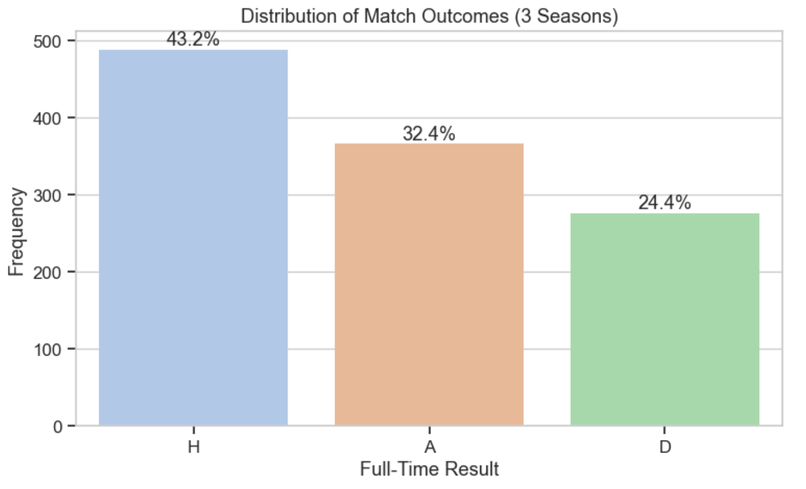
Figure 1 Target Variable Distribution
The count plot for Full Time Results (FTR) visually confirms the home advantage phenomenon in football. Home teams win nearly half of all matches (46.1%), away teams win 32.4%, and draws happen in 21.6% of matches. Teams clearly have an advantage playing at their home stadium, likely due to crowd support and familiarity with the pitch. A naive baseline classifier that guesses "Home Win" for every match would achieve 46.1% accuracy, setting the minimum threshold our models need to beat.
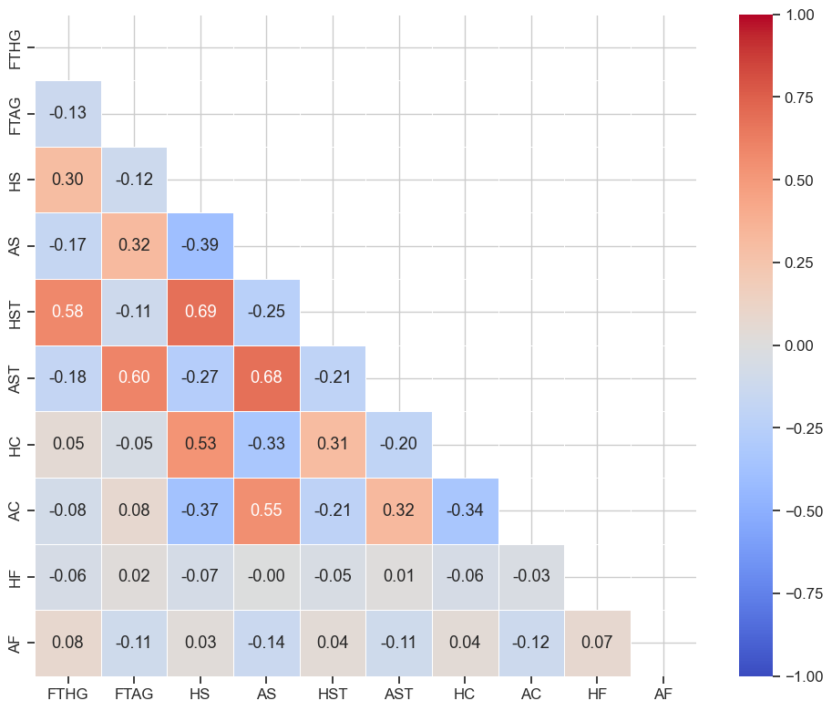
Figure 2 Correlation Matrix
The correlation heatmap reveals high multicollinearity among the offensive features, which will artificially inflate variance if left unaddressed. There is a strong positive correlation (r=0.71) between Home Shots (HS) and Home Shots on Target (HST). Away Shots and Away Shots on Target are also highly correlated (r=0.75). Home Goals (FTHG) show a strong correlation with Home Shots on Target (r=0.63). Because of this multicollinearity, I will need to use $L_{1}$ (Lasso) or $L_{2}$ (Ridge) regularization when building linear predictive models to control complexity and stabilize feature weights.

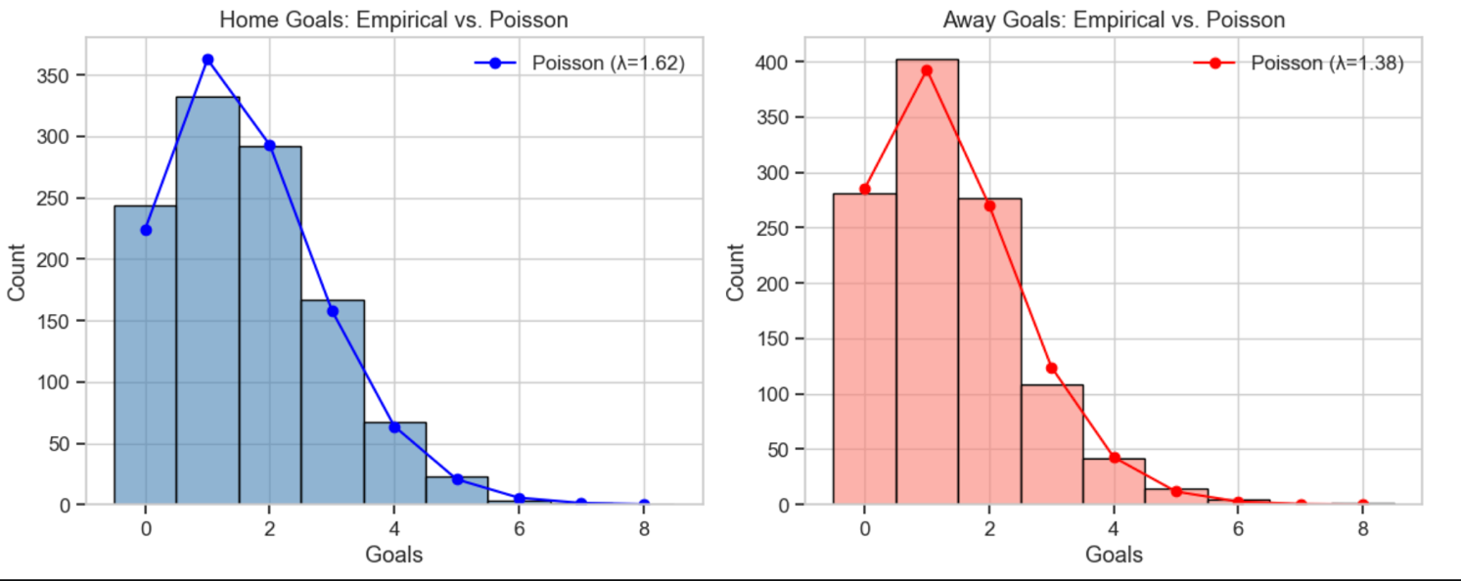
Figure 3 Poisson Distribution Verification
A Double Poisson regression model is a standard approach in sports modeling. To verify if this fits our data, the empirical goal distributions for home and away teams were plotted against a theoretical Poisson probability mass function. The Home Goals empirically follow a Poisson curve with a mean of $λ=1.80$, while Away Goals follow a curve with $λ=1.48$. The close fit supports the idea that goal-scoring in football can be modeled as independent Poisson processes.

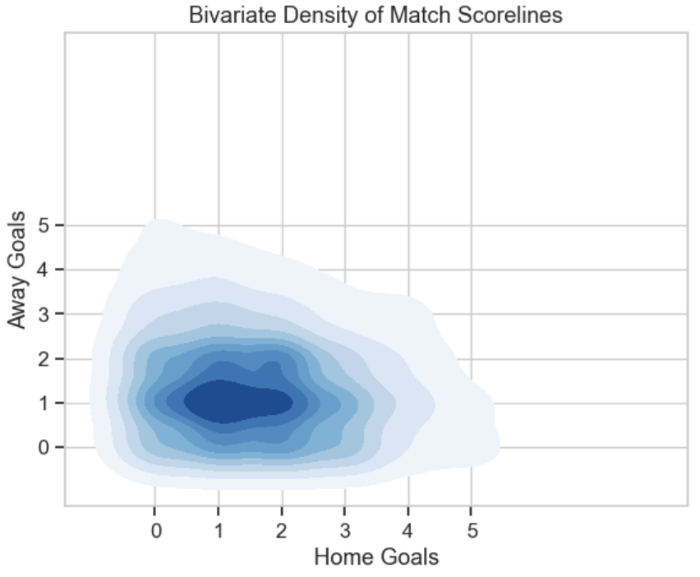
Figure 4 Win Probability Vs Shots taken

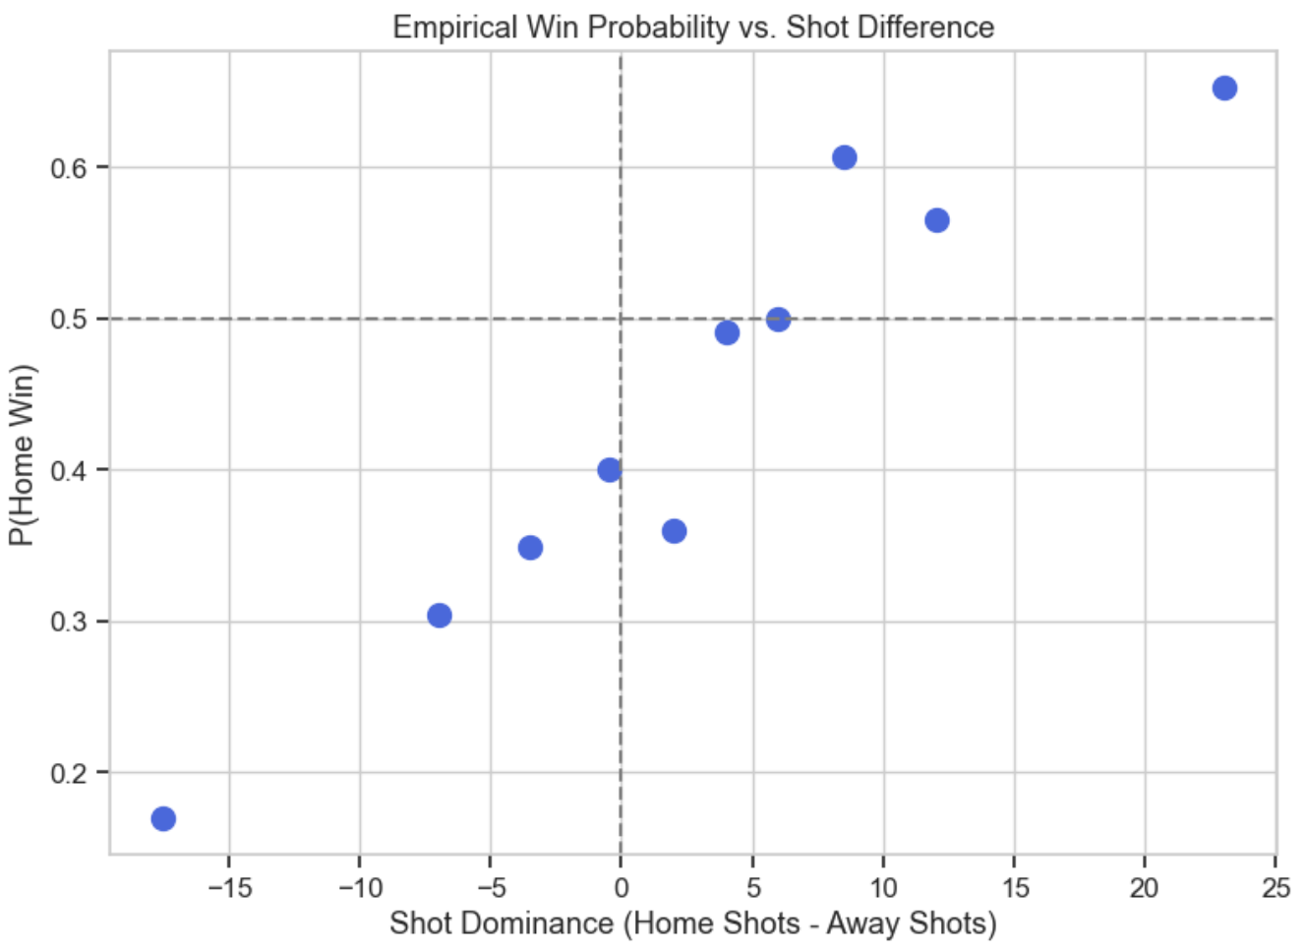
The bivariate density contour plot constructed to visualize the joint distribution of goals by mapping Home Goals against Away Goals. The plot shows a concentrated density mass around low-scoring outcomes like 1-1, 1-0, and 2-1. The wide spread of the outer bands illustrates the high variance present in the dataset. This variance shows why exact score predictions are highly volatile and difficult to make.
Figure 4 Win Probability Vs Shots taken

To test if a logistic function is appropriate for a discriminative classification model, "shot dominance" (Home Shots minus Away Shots) was calculated and plotted against the empirical probability of a Home Win. The resulting scatter plot scales smoothly from roughly 0.2 probability at negative dominance up to nearly 0.8 probability at high positive dominance. This shape provides enough evidence that the linear combination of features can be mapped through a logistic function $σ\left(z\right)=\frac{1}{1+e^{-z}}$ .

To establish a rigorous and information-efficient baseline, the calibration of commercial betting odds (Bet365) was evaluated. The probabilities were grouped into bins to plot the mean predicted probability against the fraction of actual outcomes.
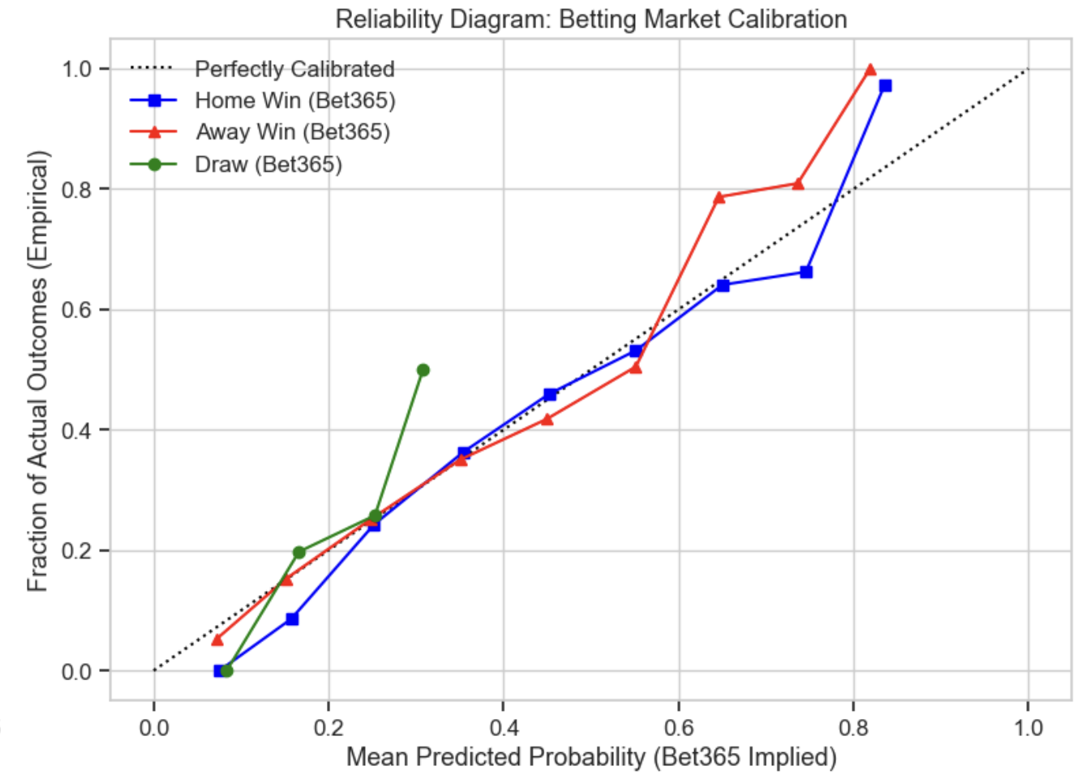
Figure 5 Betting Market Calibration
The diagram shows that the Bet365 betting market is very well-calibrated. Both the Home Win and Away Win curves tightly track the perfectly calibrated y=x reference line across the entire probability spectrum. This proof of market efficiency tells me that evaluating the machine learning models on raw classification accuracy alone is insufficient. It must be done with proper scoring rules, to ensure the models generate probability distributions capable of getting close to this commercial baseline.

Feature Engineering and Temporal Dynamics
As identified during the exploratory data analysis, team performance changes constantly over a season. I transformed the raw match statistics into lagged features to capture this momentum without causing data leakage.

Every rolling and expanding window was shifted by one match (shift=1) prior to aggregation, ensuring the model only learns from historical data available right before kickoff. Inbuilt dynamic predictors to represent the state of each team entering a match:

- Rolling Form (5-Game Window) and League Momentum: A team's attacking and defensive strength fluctuates. To capture this, 5-game rolling moving averages ($MA$) were constructed for Goals For (GF), Goals Against (GA), and Shots on Target (SOT). The rolling average for a feature $x$ at match $t$ over a window $w=5$ is defined as:
$$MA_{t}=\frac{1}{w}\sum_{i=1}^{w}{x_{t-i}}$$
To measure overall form, I calculated "League Momentum" using a rolling 5-game sum of match points earned ($W=3, D=1, L=0$). To keep early-season fixtures in the dataset, a minimum period of 1 (min_periods=1) was utilized.
- Venue-Specific Form: Overall form can hide a team's true capability at their home stadium versus on the road. I calculated venue-specific expanding averages to separate these effects. For the home team, an expanding mean of goals and SOT was calculated using only prior matches played at their home venue. The away team's form was tracked using an expanding mean of their prior away fixtures.
- Geographical Fatigue: Travel fatigue impacts physical performance. I mapped public stadium GPS coordinates (latitude $\phi$ and longitude $\lambda$) for all 20 Premier League clubs to quantify this. The Haversine formula was used to calculate the great-circle distance in miles between stadiums:
$$d=2r\arcsin\left(\sqrt{\sin^{2}\left(\frac{ϕ_{2}-ϕ_{1}}{2}\right)+\cos\left(ϕ_{1}\right)\cos\left(ϕ_{2}\right)\sin^{2}\left(\frac{λ_{2}-λ_{1}}{2}\right)}\right)$$
where $r$ is the Earth's radius (3958.8 miles). By tracking each team's journey, a cumulative 5-game rolling travel distance was computed.

Table 2 Summary of Engineered Features
Statistic | H_Roll_GF_5 | H_Roll_SOT_5 | H_Home_GF_Form | H_Home_SOT_Form
mean | 1.463 | 4.469 | 1.663 | 5.051
std | 0.673 | 1.455 | 0.644 | 1.556
min | 0.000 | 0.000 | 0.000 | 0.000
max | 4.800 | 10.000 | 5.000 | 13.000

Statistic | H_Roll_Pts_5 | H_Travel_Fatigue_5 | A_Roll_GF_5 | A_Roll_SOT_5
mean | 6.589 | 501.010 | 1.500 | 4.582
std | 3.594 | 223.386 | 0.678 | 1.489
min | 0.000 | 0.000 | 0.000 | 0.000
max | 15.000 | 1251.966 | 5.000 | 13.000

Statistic | A_Away_GF_Form | A_Away_SOT_Form | A_Roll_Pts_5 | A_Travel_Fatigue_5
mean | 1.39 | 4.234 | 6.810 | 483.086
std | 0.50 | 1.265 | 3.583 | 226.751
min | 0.00 | 0.000 | 0.000 | 0.000
max | 4.00 | 10.667 | 15.000 | 1247.894

The summary statistics of the engineered matrix (across all 380 matches) confirm the successful calculation of our signals. The average 5-game rolling points for home teams sits at 6.308, indicating an average baseline form across the league.

Table 3 Venue Specific Deltas
HomeTeam | Home_GF_minus_Away_GF
Aston Villa | 1.59
Liverpool | 0.838
Newcastle | 0.777
Arsenal | 0.556
Nott'm Forest | 0.392
Man United | 0.368
Fulham | 0.339
Brentford | 0.294
Man City | 0.17
Brighton | 0.155
Luton | 0.149
Wolves | 0.139
West Ham | 0.126
Sheffield United | 0.113
Crystal Palace | 0.087
Chelsea | 0.043
Burnley | 0.02
Everton | -0.325
Tottenham | -0.346
Bournemouth | -0.464

Analyzing the venue-specific form deltas reveals that certain teams are highly dependent on their home grounds. For instance, Aston Villa exhibits a massive +1.590 difference between their average home goals scored and away goals scored, solidifying their "fortress" status. Conversely, teams like Bournemouth (-0.464) and Tottenham (-0.346) actually performed slightly better offensively on the road.

Table 4 Geographical Fatigue
Date | HomeTeam | AwayTeam | H_Travel_Fatigue_5
2023-12-02 | Newcastle | Man United | 1165.014386825000
2024-04-02 | Newcastle | Everton | 1128.0750686681300
2023-11-25 | Newcastle | Chelsea | 1118.446198170030
2024-05-11 | Newcastle | Brighton | 1093.3797827305400
2024-03-13 | Bournemouth | Luton | 1051.8756028563000

Also, the geographical fatigue metric captured significant logistical disadvantages. Newcastle United experienced the highest physical toll, registering up to 1,165 miles of cumulative travel over a 5-game stretch prior to their home match against Manchester United in December 2023.

Baseline Logistic Regression Model
With the multicollinearity and logistic relationships identified during the EDA, a regularized Multinomial Logistic Regression model was established as the baseline predictive framework. Logistic Regression is highly interpretable, outputs the continuous probability distributions required for this problem space and serves as a robust benchmark before transitioning to complex non-linear models.

Standard k-fold cross-validation is mathematically inappropriate for sports data, as it randomizes the dataset and allows future matches to predict past matches, violating causality. To simulate a true "live" betting environment, a Walk-Forward Time-Series Cross-Validation approach was implemented using 5 temporal splits. The model trains on a chronologically expanding window of past matches and is evaluated strictly on the subsequent block of future matches.

Due to the intense multicollinearity observed between offensive metrics (e.g., Shots and Shots on Target), standardizing the feature space was a strict prerequisite. A StandardScaler was applied within each fold to prevent data leakage from the test set. The Logistic Regression model was trained utilizing the lbfgs solver and a moderate L_2 regularization penalty (C=0.1) to shrink unstable coefficient weights and prevent overfitting on highly correlated inputs.

As proven by the Bet365 market calibration during the EDA, raw accuracy is an insufficient metric for football predictions. The model was evaluated using Logarithmic Loss (Log-Loss), a proper scoring rule that heavily penalizes confident but incorrect probability estimations.

$$LogLoss=-\frac{1}{N}\sum_{i=1}^{N}{\sum_{j=1}^{M}{y_{ij}}\log\left(p_{ij}\right)}$$

The Cross-Validated Log-Loss of the baseline Logistic Regression model was 1.0258. When compared against the highly efficient Bet365 commercial market baseline, which achieved a Log-Loss of 0.9092 after overround normalization, the baseline model performs reasonably well but still lags behind the sportsbooks. The market's lower Log-Loss indicates that bookmakers are integrating external information (e.g., injuries, manager changes, expected goals (xG), and line-up data) that our current purely historical-stat-driven model cannot capture.

Table 5 Logistic Regression Coefficients
 | Coefficient
H_Roll_SOT_5 | 0.22796583067346900
H_Roll_Pts_5 | 0.1944118667508610
H_Travel_Fatigue_5 | 0.09005013150963370
H_Home_GF_Form | 0.07995295272555420
A_Roll_GF_5 | 0.07873496043458830
H_Home_SOT_Form | 0.03324247994541560
A_Travel_Fatigue_5 | 0.023768159530395600
H_Roll_GF_5 | -0.02342668240211980
A_Away_GF_Form | -0.03721283694005760
A_Roll_SOT_5 | -0.13350371672212200
A_Roll_Pts_5 | -0.16091689333349700
A_Away_SOT_Form | -0.1679751927231610

Analyzing the learned coefficients provides strong statistical intuition into the drivers of a Home Win. The most significant positive driver is the Home team's recent offensive accuracy (H_Roll_SOT_5 with a weight of +0.228) and their overall League Momentum (H_Roll_Pts_5 at +0.194). Interestingly, the Home team's general goals scored feature (H_Roll_GF_5) received a slightly negative coefficient (-0.023); this is a classic manifestation of the L_2 regularization handling multicollinearity, effectively telling us that Shots on Target is a much more stable and reliable predictive signal than raw goals scored, which contains more variance and luck. Conversely, the strongest factors preventing a Home Win are the Away team's venue-specific defensive/offensive rigidity (A_Away_SOT_Form at -0.168) and the Away team's overall league momentum (A_Roll_Pts_5 at -0.161).

Conclusion and Future Work
The successful implementation of non-leaking temporal features and a time-series validated baseline model proves that match outcomes can be mathematically modeled using historical match data. While the regularized Logistic Regression framework correctly identified key drivers like rolling Shots on Target and venue-specific form, its Log-Loss (1.0258) indicates that a simple linear combination of features is not fully capturing the complex, non-linear interactions within a football match.

The next phase of the project will focus on Implementing tree-based ensemble methods, specifically XGBoost or Random Forests, to capture non-linear feature interactions (e.g., how Away Travel Fatigue interacts specifically with a High Home SOT Form) and utilizing grid search over the temporal folds to optimize the learning rate, tree depth, and regularization parameters of the advanced models to close the gap with the commercial betting market baseline.

APPENDIX

