PROJECT PROPOSAL

PREDICTING EPL MATCH OUTCOMES USING STATISTICAL LEARNING

Submitted by:

ANURAG NEPAL

SAN FRANCISCO, CALIFORNIA

Submitted for

MATH 748

THEORY AND APPLICATIONS OF STATISTICAL MACHINE LEARNING

SPRING 2026

Description of the Problem
Sports analytics has transformed from a niche interest into a multibillion-dollar industry used by professional clubs and betting markets. However, accurately predicting the outcome of a football (soccer) match is notoriously difficult due to the low-scoring nature of the game and the high degree of randomness.
The goal of this project is to develop a statistically sound machine learning framework to predict the outcome of English Premier League (EPL) matches (Home Win, Draw, Away Win). Rather than focusing solely on classification accuracy, this project aims to estimate well-calibrated probabilities. This approach allows for a deeper understanding of the stochastic processes driving match results, such as team attack strength and defense strength.

Dataset Description
The project will use the Football-Data.co.uk repository, specifically the English Premier League match data covering the last 5 completed seasons. This dataset is publicly available and machine-readable. It includes the following key features:

Match Outcomes
- FTR: Full Time Result (H (Home Win), D(Draw), A (Away Win))
- FTHG / FTAG: Full Time Home Goals and Away Goals
Predictive Signals (Performance Metrics)
- HS / AS: Home Team Shots / Away Team Shots
- HST / AST: Home/Away Shots on Target
- HC / AC: Home/Away Corners
- HF/AF : Home/Away Fouls.
Betting Odds (Benchmark)
- B365H, B365D, B365A: Odds from Bet365, serving as an information-efficient baseline for model evaluation for games yet to happen.
Table 1 Variable Statistics Summary
 | FTHG | FTAG | HS | AS | HST | AST | HC | AC | HF | AF
mean | 1.80 | 1.48 | 15.40 | 12.18 | 5.44 | 4.43 | 6.12 | 4.71 | 10.74 | 11.35
std | 1.37 | 1.28 | 6.26 | 5.47 | 2.89 | 2.53 | 3.22 | 2.91 | 3.46 | 3.67
min | 0.00 | 0.00 | 1.00 | 2.00 | 0.00 | 0.00 | 0.00 | 0.00 | 2.00 | 2.00
max | 6.00 | 8.00 | 36.00 | 30.00 | 15.00 | 15.00 | 17.00 | 15.00 | 20.00 | 22.00

From the initial statistical summary prior to visualization, Home teams scored an average of 1.80 goals per game (with a max of 6), while Away teams scored an average of 1.48 goals (with a max of 8). Home teams also averaged a higher volume of offensive output, registering more shots (15.40 vs. 12.18) and shots on target (5.44 vs. 4.43) than their visiting opponents.

Data Cleaning
The Football-Data.co.uk CSV files are pre-formatted for machine readability and modelling. A preliminary check for missing values across the dataset confirmed that there are exactly 0 missing values (NA) in the selected columns for the 23/24 season. The string Date column was converted into standardized datetime objects and dropping irrelevant auxiliary betting market columns to streamline the analysis. The raw decimal odds (B365H, B365D, B365A) were converted into implied probabilities and normalized to account for the bookmaker's profit margin.

Data Visualizations and Findings

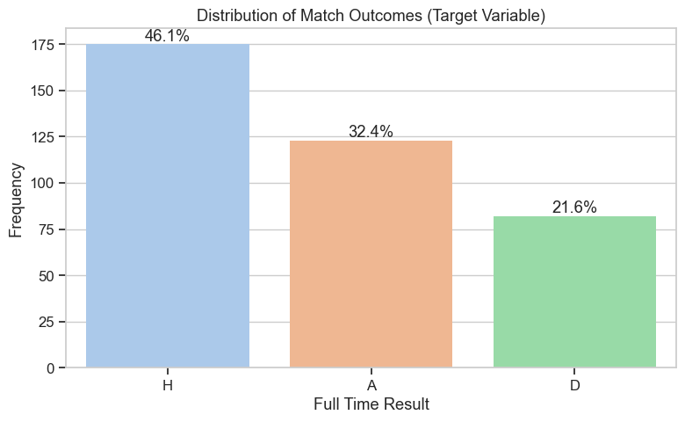
Figure 1 Target Variable Distribution
The count plot of the target variable, Full Time Results (FTR), visually confirms the well-documented phenomenon of "Home Advantage" in football. Home teams win nearly half of all matches (46.1%), while Away Wins account for 32.4%, and Draws occur in 21.6% of the matches. So, it becomes apparent that the teams have an advantage playing at home compared to away grounds. This could be because of the supporter numbers or just the teams being used to play at their own ground where they can train. A naive baseline classifier that simply guesses "Home Win" for every single match would achieve 46.1% accuracy, so that the models must exceed this threshold to be considered useful.

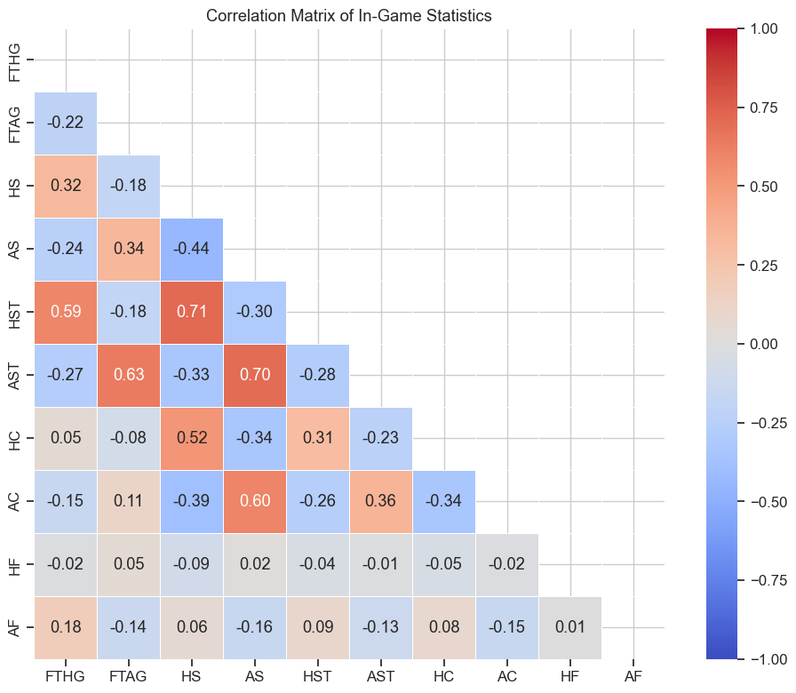
Figure 2 Correlation Matrix
The correlation heatmap reveals that there is intense multicollinearity among the offensive features, which will artificially inflate variance if they are left unaddressed. There is a strong positive correlation (r = 0.71) between Home Shots (HS) and Home Shots on Target (HST). Similarly, Away Shots and Away Shots on Target are highly correlated (r = 0.75). Furthermore, Home Goals (FTHG) show a strong correlation with Home Shots on Target (r = 0.63). This mathematical relationship tells me that $l_{1}$ (Lasso) or $l_{2}$ (Ridge) regularization will be necessary when building linear predictive models to control model complexity and feature weight instability.

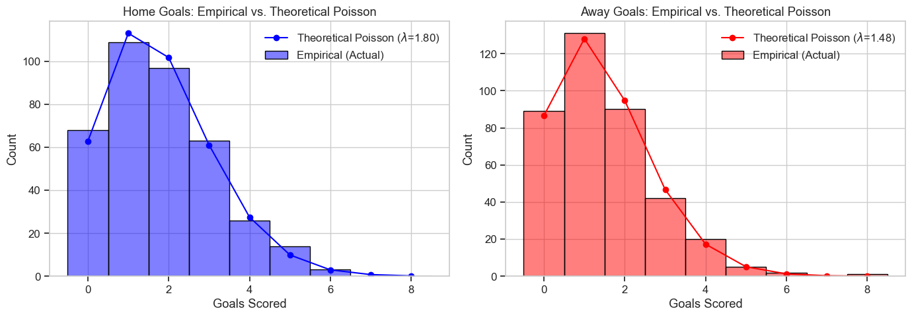
Figure 3 Poission Distribution Verification
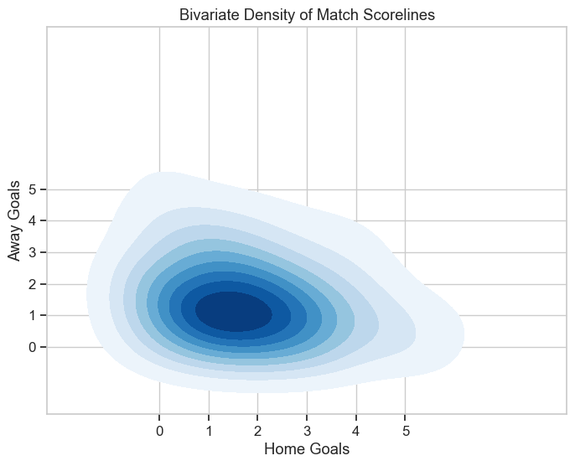
A Double Poisson regression model is a standard approach in sports modeling. To justify this, the empirical goal distributions for both home and away teams were plotted against a theoretical Poisson probability mass function. The Home Goals empirically follow a Poisson curve with a mean of $λ$= 1.80, while Away Goals follow a curve with $λ$ = 1.48. The exceptionally close fit visually and mathematically validates the theoretical assumption that goal-scoring in football can be modeled as independent Poisson processes.
Figure 4 Uncertainity in Scorelines
The bivariate density contour plot constructed to visualize the joint distribution of goals by mapping Home Goals against Away Goals. The contour plot shows a tight, concentrated density mass around low-scoring outcomes (specifically 1-1, 1-0, and 2-1). The wide, rapidly scattering outer bands demonstrate the high variance and uncertainty present in the dataset, and it visually proves why precise score, prediction is highly volatile and will be a challenge to correctly predict. There can never be enough data to correctly predict the scoreline as the game is very fluid and the game state defines the result. And with the advent of VAR( Video Assisted Refreeing), there is even more scrutiny when a goal is scored.
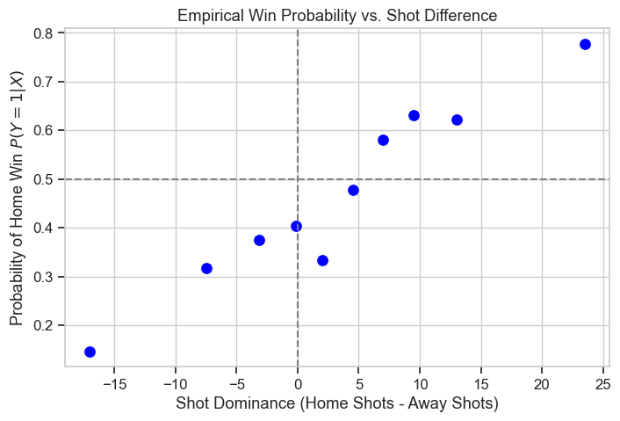
Figure 5 Win Probability Vs Shots taken

To test if a logistic function is appropriate for a discriminative classification model, "shot dominance" (Home Shots minus Away Shots) was calculated and plotted against the empirical probability of a Home Win. The resulting scatter plot forms a sigmoid curve, scaling smoothly from roughly 0.2 probability at negative dominance up to nearly 0.8 probability at high positive dominance. This shape provides enough evidence that the linear combination of features can be mapped through a logistic function $σ\left(z\right)=\frac{1}{1+e^{-z}}$ .

To establish a rigorous and information-efficient baseline, the calibration of commercial betting odds (Bet365) was evaluated. The probabilities were grouped into bins to plot the mean predicted probability against the fraction of actual outcomes.

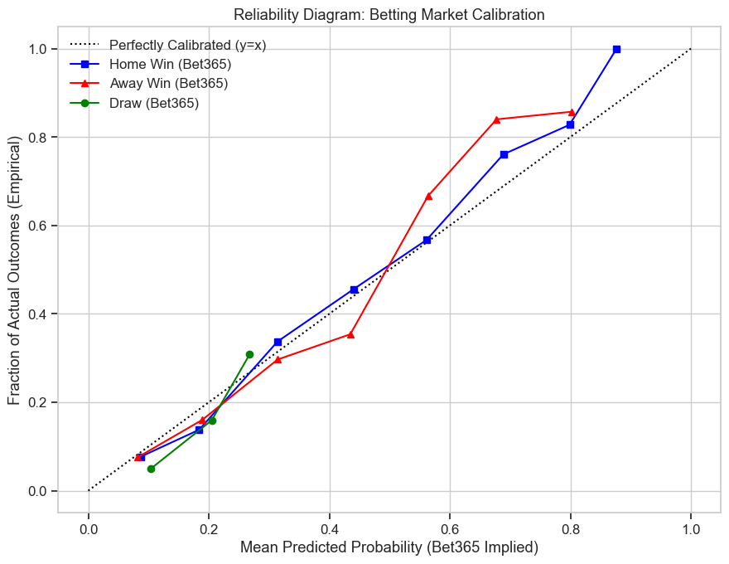
Figure 6 Betting Market Calibration

The diagram shows that the Bet365 betting market is very well-calibrated. Both the Home Win and Away Win curves tightly track the perfectly calibrated y=x reference line across the entire probability spectrum. This proof of market efficiency tells me that evaluating the machine learning models on raw classification accuracy alone is insufficient. It must be done with proper scoring rules, to ensure the models generate probability distributions capable of getting close to this commercial baseline.

Conclusion and Future Phase Work
This exploratory data analysis confirms that the Goal counts reliably follow a Poisson distribution, empirical win probabilities will scale logistically with match dominance metrics, and the strong multicollinearity among in-game statistics requires regularization. Furthermore, the volatility of team form proves the necessity of temporal awareness in the dataset.
The next phase of the project will focus on data transformation, specifically constructing rolling averages (lagged features) for team statistics over k-game windows to capture dynamic form and address non-stationarity without causing data leakage. Also, adding travel distance as well as historical matchups between the teams to add win probabilities to make the model more robust.

