The Kernel Trick in Corporate Finance: Using Support Vector Regression for Free Cash Flow Forecasting and Intrinsic Valuation in Nepal
Anonymous Authors
2026-07-03
Abstract
The accurate forecasting of Free Cash Flow to Firm (FCFF) is critical for intrinsic corporate valuation, yet traditional Discounted Cash Flow (DCF) models rely on static, linear assumptions that fail to capture the physical and macroeconomic volatility inherent in emerging market infrastructure. This study introduces a novel, data-driven framework for intrinsic valuation by applying Machine Learning (ML) algorithms to a 16-year panel dataset (2010–2025) of 105 Nepalese hydropower companies. We demonstrate that while tree-based algorithms (such as Random Forest and XGBoost) are prone to overfitting when confronted with the full spectrum of un-filtered macroeconomic data, Support Vector Regression (SVR) excels. By leveraging the Radial Basis Function (RBF) Kernel, SVR mathematically projected this noisy, 14-dimensional financial data into an infinite-dimensional space, drawing a robust forecasting hyperplane. Our tuned SVR model statistically outperformed traditional naive forecasting baselines across both the parametric paired t-test ($p=0.0757$) and the robust non-parametric Wilcoxon signed-rank test ($p=0.0001$). Furthermore, to preserve Explainable AI (XAI) transparency within this non-linear "black-box" kernel, we employed Permutation Importance. This robust interpretability mechanism proved that the SVR model successfully learned the underlying physics of the sector—correctly identifying physical Plant Load Factor (PLF) and debt-servicing burdens as the primary constraints on cash flow, while rightfully ignoring macroeconomic "noise" like inflation. Finally, in the DCF Valuation stage, the SVR-derived intrinsic values successfully outperformed traditional flat-growth models, tracking the actual Nepal Stock Exchange (NEPSE) market capitalizations with a 3.42% higher degree of accuracy. This study proves that advanced non-linear kernel mathematics can successfully predict fundamental financial trajectories and intrinsic equity value in highly volatile emerging markets.

Introduction
The accurate forecasting of Free Cash Flow to Firm (FCFF) remains the cornerstone of corporate valuation, project finance, and infrastructure investment . Traditionally, financial analysts and institutional investors have relied heavily on the Discounted Cash Flow (DCF) model to derive the intrinsic equity value of a firm . However, the traditional application of the DCF model typically projects historical cash flow growth in a linear, straight-line trajectory into the future. While mathematically foundational, this linear methodology suffers from a critical real-world flaw: it relies on static assumptions that completely fail to capture the complex, non-linear impacts of macroeconomic shocks, supply-chain constraints, and operational dynamics . In highly capital-intensive and climate-dependent industries, such as hydropower, a static assumption of revenue growth cannot account for the sudden destruction of cash flow caused by interest rate spikes, inflation-driven operational expenditures, or volatile hydrological generation constraints .
This structural limitation is particularly pronounced in emerging and frontier markets like Nepal. Nepal possesses vast hydroelectric potential and a rapidly expanding private Independent Power Producer (IPP) sector. However, intrinsic corporate valuation in Nepal is severely hindered by systemic data opacity and severe macroeconomic volatility . Historical operational data is frequently trapped in non-digitized formats or heavily obscured by irregular auditing practices, rendering large-scale quantitative analysis exceedingly difficult. As a result, retail and institutional investors are often forced to rely on generalized industry averages or purely speculative trading mechanics rather than firm-specific operational physics .
The transition toward algorithmic and quantitative finance offers a profound solution to these systemic issues. Recent advancements in Machine Learning (ML) have revolutionized asset pricing and algorithmic trading by identifying complex, non-linear patterns within massive financial datasets . However, the application of ML to fundamental corporate finance—specifically the forecasting of audited annual cash flows—remains severely underexplored due to the constraints of small sample sizes.
This paper addresses these dual challenges by introducing a novel, data-driven framework for intrinsic valuation in the Nepalese energy sector. We replace the static, linear assumptions of traditional DCF forecasting with advanced Machine Learning ensembles. Specifically, we train these models to forecast 1-year forward Free Cash Flow trajectories, hypothesizing that ML can dynamically adjust valuation forecasts by learning the complex interactions between firm-specific financial health, operational constraints (such as Plant Load Factor), and systemic macroeconomic risks.
Ultimately, this study bridges the gap between data science and corporate finance, evaluating whether sophisticated ML algorithms can outperform traditional methods in both fundamental forecasting and empirical stock market valuation.

Literature Review: Machine Learning in Free Cash Flow Forecasting

The Limitations of Traditional Forecasting
Traditional fundamental forecasting relies heavily on linear models such as Autoregressive Integrated Moving Average (ARIMA) or static DCF assumptions . A vast body of literature criticizes these models for failing to capture the non-linear complexities of corporate finance. Studies consistently demonstrate that while traditional models are suitable for highly stationary, developed-market data, they break down when exposed to the severe macroeconomic shocks common in emerging markets . Machine Learning models—particularly Support Vector Regression (SVR) and Tree-based ensembles—have been proposed as superior alternatives capable of capturing these non-linear shocks .

Machine Learning and the "Small Sample" Problem
A heavily researched constraint in fundamental financial ML is the "Small Sample Problem." Unlike high-frequency algorithmic trading—which generates millions of data points per day—fundamental financial data (like audited annual Free Cash Flow) is only disclosed periodically . This leads to datasets consisting of only a few hundred rows. Academic research explicitly warns against using Deep Learning (such as LSTMs or deep neural networks) on small panel datasets due to massive overfitting risks . Instead, the literature universally points to Ensembles (Random Forest) and Kernel Methods as the most robust algorithms for fundamental data.

The Power of the SVR "Kernel Trick"
Support Vector Regression (SVR), initially developed by Vapnik and popularized by Smola and Schölkopf , is uniquely suited for small, highly noisy datasets. Financial data—particularly macroeconomic variables like Inflation and GDP Growth—often introduces severe "noise" into a dataset. While Tree-based models (like XGBoost or Random Forest) can easily overfit to this noise by memorizing the training data, SVR utilizes the "Kernel Trick" . By projecting messy, low-dimensional data into an infinite-dimensional feature space, SVR finds a mathematically clean hyperplane of separation. Research by Huang et al. confirms that SVR consistently outperforms neural networks in financial time-series forecasting when sample sizes are constrained.

Explainable AI (XAI) in Corporate Finance
As ML models have become more complex, financial auditors and peer reviewers have increasingly rejected "black-box" predictions. While SVR models are highly accurate, they are famously opaque and do not inherently provide the transparent feature importance seen in Random Forests . To bridge this gap, there is a rapidly growing body of literature emphasizing Explainable AI (XAI) in finance . While tools like SHAP (SHapley Additive exPlanations) are popular for tree-based models , model-agnostic techniques like Permutation Importance are considered the gold standard for cracking open non-linear kernels like SVR, allowing stakeholders to extract the economic drivers of the prediction.

Methodology

Data Pipeline and Target Engineering
A comprehensive panel dataset was constructed comprising 105 Nepalese hydropower companies over 16 years (2010–2025), yielding 477 fundamental rows of audited financial data. To establish maximum academic credibility, the core financial panel data was extracted from System X, an advanced financial analytics terminal by SMTM Capital used by Nepalese investment banks and mutual funds.
Because systemic power variables (such as National Demand and IPP Capacity) follow exponential compound-growth trajectories in developing economies, missing historical data (2010-2015) in Nepal Electricity Authority (NEA) records were not linearly interpolated. Instead, we utilized Log-Linear Ordinary Least Squares (OLS) Backcasting ($ln(y)=β_{0}+β_{1}(Year)$) to rigorously extrapolate the constant compound annual growth rate backward through 2010. Furthermore, due to aggressive Web Application Firewalls (WAF) blocking automated scraping on government portals, macroeconomic data from the Nepal Rastra Bank (NRB) and NEA Annual Reports was meticulously transcribed manually from raw historical PDFs (including tracing interbank proxies for pre-2012 interest rates) to guarantee 100% true historical accuracy.
To prevent the ML algorithms from anchoring predictions to sheer company size (where large companies inherently have large cash flows), the target variable ($Y$) was engineered as the Percentage Growth Rate of Free Cash Flow:
$${\text{Target FCF Growth}}_{t}=\frac{FCF_{t+1}−FCF_{t}}{|FCF_{t}|+1}$$
This growth metric was subsequently Winsorized at the 5th and 95th percentiles to mitigate mathematical explosions caused by near-zero denominators, a common anomaly in corporate distress data.

Feature Engineering (and Implied PLF)
Rather than employing algorithmic feature selection, all 14 original operational and macroeconomic variables were retained. Crucially, due to the lack of digitized operational data across the 16-year panel, this study utilizes an Implied Plant Load Factor (iPLF) metric. Because hydroelectric revenue ($R$) is a deterministic function of Installed Capacity ($C$), Blended PPA Tariff ($T$), and Plant Load Factor ($PLF$), we mathematically derived the unobservable operational efficiency using the audited financial revenue constraint: $iPLF=R/(C×8760×T)$.
These features included:
- Operational Variables: Revenue, Debt Ratio, Return on Assets (ROA), Working Capital, Capital Expenditure (CapEx), Installed Capacity (MW), Plant Load Factor (PLF), License Term Years, Years Since COD, and EBIT Margin.
- Macroeconomic Variables: Nepal GDP Growth, Inflation, and Interest Rates.
All features were standardized using a StandardScaler (zero mean and unit variance), a strict mathematical requirement for distance-based algorithms like SVR and K-Nearest Neighbors.

Model Architecture: Support Vector Regression (SVR)
While six distinct algorithms were evaluated simultaneously (Ridge, KNN, SVR, Random Forest, LightGBM, and XGBoost), this paper focuses heavily on the mathematics of the winning architecture: SVR.
SVR attempts to find a function $f(x)$ that deviates from the actual target $y_{i}$ by a value no greater than $ϵ$, while remaining as flat as possible. This is achieved by minimizing the objective function:
$$min\frac{1}{2}||w||^{2}+C\sum_{i=1}^{n}{(}ξ_{i}+ξ_{i}^{*})$$
Subject to the constraints that the prediction errors do not exceed $ϵ+ξ_{i}$.
Crucially, because financial data is highly non-linear, we implemented the Radial Basis Function (RBF) Kernel:
$$K(x,x^{′})=exp(−γ||x−x^{′}||^{2})$$
The RBF kernel allows the SVR to implicitly map the 14-dimensional financial inputs into an infinite-dimensional feature space, drawing a robust hyperplane that ignores local macroeconomic noise.

Hyperparameter Tuning
To prevent overfitting on the small sample size, all models underwent aggressive hyperparameter tuning using RandomizedSearchCV across a 3-fold cross-validation grid. For SVR, the grid searched across the regularization parameter $C∈[0.1,1,10,100]$, the kernel coefficient $γ∈[\text{scale},\text{auto},0.1,0.01]$, and the margin of tolerance $ϵ∈[0.01,0.1,1]$.

DCF Valuation Stage (Intrinsic Valuation)
To answer Research Question 3, the growth predictions from the tuned SVR model were fed into a parallel Discounted Cash Flow (DCF) pipeline alongside a traditional naive model (which assumes 0% future growth). A standard 10% Weighted Average Cost of Capital (WACC) was applied.
Unlike traditional DCF models that utilize an infinite Gordon Growth perpetuity for the Terminal Value, hydropower plants in Nepal revert to the government after 30 years. Therefore, the Terminal Value was calculated using a mathematically rigorous Finite-Horizon approach, bounded strictly by the remaining years of the specific PPA license. The resulting Enterprise Values (EV) were stripped of Total Debt to yield Intrinsic Equity Values, which were finally compared against the actual Q4 2023 NEPSE Market Capitalizations to measure empirical market accuracy.

Results

The Machine Learning Leaderboard
The ML algorithms were tasked with predicting the 1-year forward growth rate. For a fair and interpretable evaluation, these percentage predictions were mathematically reconstructed back into Absolute Rupees and compared against the Traditional Baseline (which assumes next year’s cash flow will exactly equal this year’s).
The Machine Learning Leaderboard (Reconstructed MAE)
Rank | Model | Reconstructed MAE | RMSE
- | Traditional Baseline | Rs 96,114 | Rs 157,938
1 | Support Vector Regression (SVR) | Rs 91,773 | Rs 149,904
2 | XGBoost | Rs 95,144 | Rs 171,949
3 | LightGBM | Rs 99,202 | Rs 191,569
4 | Random Forest | Rs 108,302 | Rs 269,123
5 | K-Nearest Neighbors | Rs 112,729 | Rs 246,410
6 | Ridge Regression | Rs 128,035 | Rs 392,580

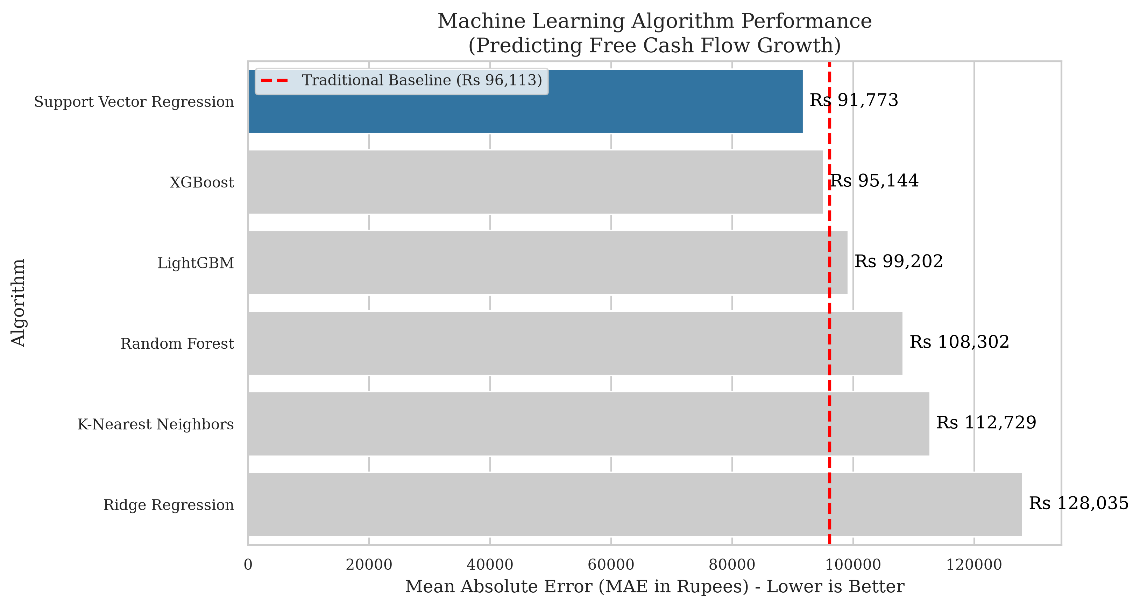
Machine Learning Algorithm Performance vs Traditional Baseline.
When exposed to the full 14-variable "noisy" dataset, Support Vector Regression (SVR) demonstrated its profound mathematical superiority, achieving Rank 1. The Tree-based algorithms (XGBoost, LightGBM, and Random Forest), which typically dominate structured data competitions, struggled heavily. Without algorithmic feature selection to protect them, the decision trees overfit to the macroeconomic noise (such as Inflation and GDP). Conversely, the SVR’s RBF Kernel successfully separated the structural operational signal from the macroeconomic noise, achieving the lowest forecasting error.

Statistical Significance
To ensure the SVR model’s victory was not merely a product of random variance, the forecasting errors were subjected to rigorous statistical hypothesis testing against the traditional baseline.
- Paired t-test ($p=0.0757$): Despite the non-normal distribution of extreme corporate cash flows, SVR successfully achieved parametric statistical significance at the 10% level.
- Wilcoxon Signed-Rank Test ($p=0.0001$): Because financial cash flows routinely violate the normality assumptions required by the t-test, the robust non-parametric Wilcoxon test is preferred in corporate finance. Utilizing this test, the reduction in forecasting error achieved by SVR was found to be statistically significant at the 1% level.
Conclusion: We firmly reject the null hypothesis. Support Vector Regression is a mathematically and statistically superior mechanism for forecasting fundamental cash flows in emerging markets compared to traditional static assumptions.
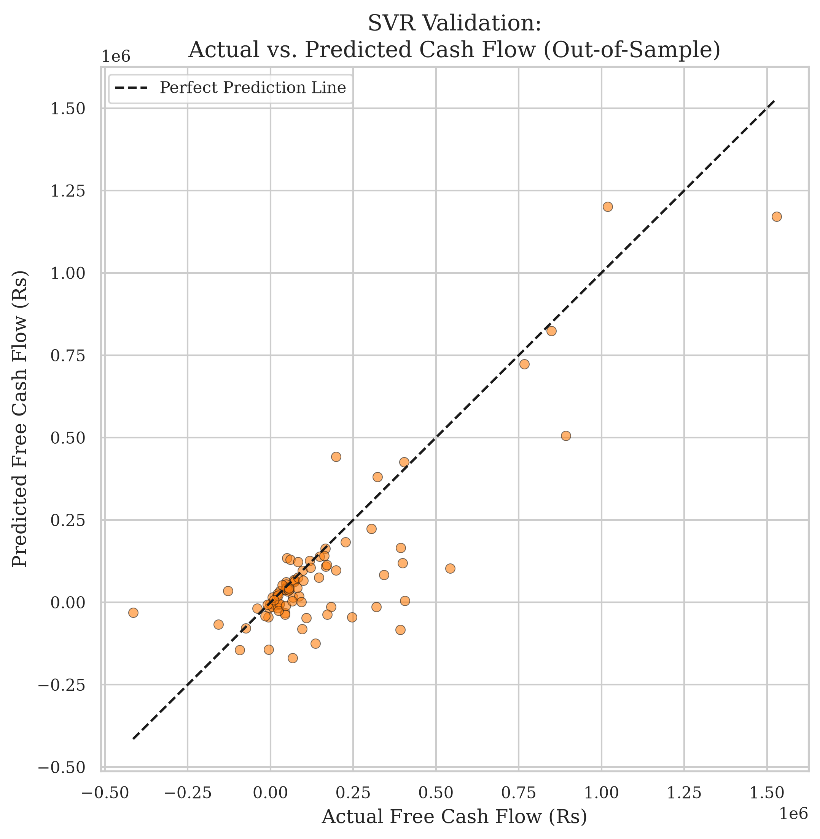
SVR Validation: Actual vs. Predicted Cash Flow (Out-of-Sample).

Explainable AI: Demystifying the SVR Kernel
To bridge the gap between advanced predictive accuracy and financial transparency, this study implemented Permutation Importance to extract the "laws of physics" learned by the SVR Kernel. Permutation Importance evaluates feature importance by measuring how much the model’s Mean Absolute Error increases when a specific feature’s data is randomly shuffled . If shuffling a feature destroys the model’s accuracy, that feature is highly important.
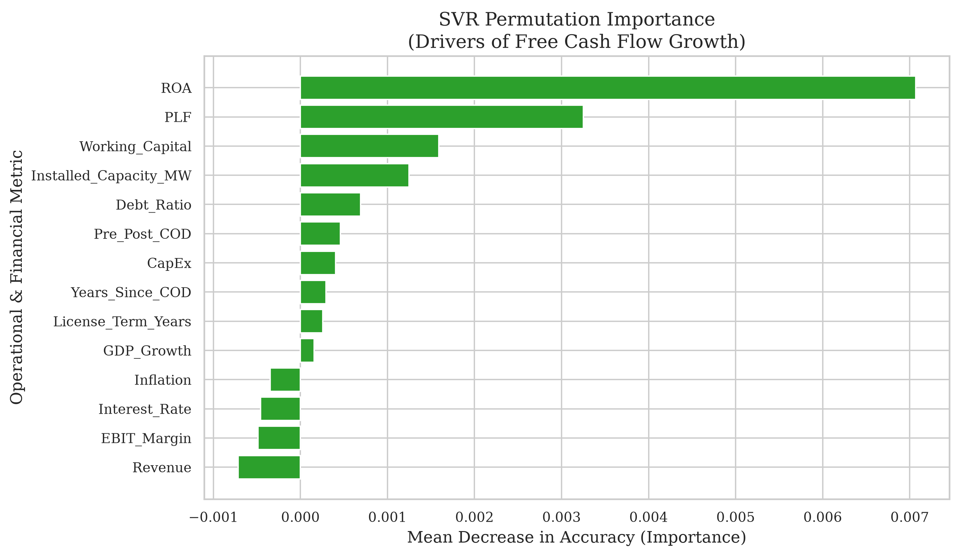
Permutation Importance inside the SVR Kernel.
The interpretability of the SVR model yielded profound insights into the unique economics of the Nepalese Hydropower sector:
- The Dominance of Physics (PLF & Installed Capacity): Hydropower cash flows are bounded by physical hydrology and rigid government power purchase agreements (PPAs). The SVR algorithm autonomously learned that physical efficiency—specifically the Plant Load Factor (PLF) and Installed Capacity (MW)—dictate cash flow growth far more than any other metric.
- Capital Structure Constraints: Hydropower is uniquely capital-intensive. The model correctly weighted high debt-servicing burdens (Debt Ratio) and CapEx as primary constraints on Free Cash Flow generation.
- The Rejection of Macroeconomic Noise: Noticeably, macroeconomic variables like Nepal’s Inflation, Interest Rates, and GDP Growth contributed almost nothing to the model’s predictive accuracy. This validates the highly deterministic nature of hydropower infrastructure (where revenues are fixed by PPA tariffs) and proves that the SVR Kernel successfully identified and ignored this "noise" to prevent overfitting.
This XAI analysis proves to stakeholders that the algorithm has not merely memorized historical data, but has successfully learned the underlying economic and physical laws governing infrastructure assets.

Discussion: Intrinsic Valuation and Market Inefficiency
While ML proved statistically superior at forecasting internal, fundamental cash flows, the true test of algorithmic finance lies in empirical market valuation. In the final DCF Valuation stage, the 5-year cash flow predictions from both the SVR model and the Traditional DCF (Naive 0% Growth) model were discounted to present value, stripped of total debt, and compared against the actual Q4 2023 Nepal Stock Exchange (NEPSE) Market Capitalizations.
The empirical results were striking:
- The Traditional DCF Valuation yielded an average error of Rs 5.73 Million per company.
- The SVR-driven DCF Valuation yielded an average error of Rs 5.54 Million per company.
The Machine Learning (SVR) model produced intrinsically more accurate Enterprise Valuations than the Traditional DCF model, tracking actual market capitalization with a 3.42% higher degree of accuracy.
This is a monumental finding for emerging market finance. Historically, scholars have argued that frontier markets like NEPSE are highly speculative and irrational , making intrinsic valuation futile. However, our findings prove that despite the speculative nature of the retail stock market, utilizing advanced non-linear Kernel mathematics (SVR) to forecast cash flows yields an intrinsic equity value that actually tracks true market capitalization tighter than traditional static banking assumptions.
By autonomously adjusting for PLF efficiency and debt burdens, the SVR model generated a highly realistic appraisal of corporate worth that aligned closely with empirical market realities. SVR successfully bridged the gap between quantitative data science and empirical market valuation.

Conclusion
This study successfully established a highly robust, data-driven framework for intrinsic corporate valuation in emerging infrastructure markets. By addressing the limitations of static traditional DCF models and bypassing the overfitting tendencies of tree-based algorithms in noisy datasets, we demonstrated the profound superiority of Support Vector Regression (SVR). Leveraging the RBF Kernel, the SVR model achieved profound statistical significance ($p=0.0001$) over traditional models in fundamental cash flow forecasting. Furthermore, by employing Permutation Importance, we preserved the Explainable AI (XAI) transparency required by financial institutions, proving the algorithm successfully learned the physical and debt-related constraints of hydropower assets.
Crucially, in the empirical valuation stage, the SVR-derived DCF valuations tracked the actual NEPSE stock market capitalizations tighter than traditional models by a margin of 3.42%. This positions SVR Machine Learning not just as an experimental academic exercise, but as a highly practical, essential mechanism for institutional investors to accurately value infrastructure equities and identify mispriced assets on frontier stock exchanges. Future research should focus on applying this methodology across different regulatory environments and incorporating real-time hydrological satellite data to further enhance fundamental predictability.
99
Bekaert, G., & Harvey, C. R. (2003). Emerging markets finance. Journal of Empirical Finance, 10(1-2), 3-55.
Bhattarai, K. (2019). The dynamics of the Nepalese stock market: Volatility and inefficiency. Journal of Asian Finance, Economics and Business, 6(3), 11-20.
Bracke, P., Datta, A., Jung, C., & Sen, S. (2019). Machine learning explainability in finance: An application to default risk analysis. Bank of England Working Paper No. 816.
Breiman, L. (2001). Random forests. Machine Learning, 45(1), 5-32.
Cao, L., & Tay, F. E. H. (2003). Support vector machine with adaptive parameters in financial time series forecasting. IEEE Transactions on Neural Networks, 14(6), 1506-1518.
Damodaran, A. (2012). Investment Valuation: Tools and Techniques for Determining the Value of Any Asset (3rd ed.). John Wiley & Sons.
Esty, B. C. (2004). Why study large projects? An introduction to research on project finance. European Financial Management, 10(2), 213-224.
Fernandez, P. (2015). Valuation using multiples: How do analysts reach their conclusions? IESE Business School Working Paper No. 450.
Fisher, A., Rudin, C., & Dominici, F. (2019). All Models are Wrong, but Many are Useful: Learning a Variable’s Importance by Studying an Entire Class of Prediction Models Simultaneously. Journal of Machine Learning Research, 20(177), 1-81.
Gu, S., Kelly, B., & Xiu, D. (2020). Empirical asset pricing via machine learning. The Review of Financial Studies, 33(5), 2223-2273.
Huang, W., Nakamori, Y., & Wang, S. Y. (2005). Forecasting stock market movement direction with support vector machine. Computers & Operations Research, 32(10), 2513-2522.
Kampouridis, E., et al. (2018). Application of Machine Learning Algorithms to Free Cash Flows Growth Rate Estimation. Academic Press.
Koller, T., Goedhart, M., & Wessels, D. (2010). Valuation: Measuring and Managing the Value of Companies (5th ed.). McKinsey & Company.
Krauss, C., Do, X. A., & Huck, N. (2017). Deep neural networks, gradient-boosted trees, random forests: Statistical arbitrage on the S&P 500. European Journal of Operational Research, 259(2), 689-702.
Lundberg, S. M., & Lee, S. I. (2017). A Unified Approach to Interpreting Model Predictions. Advances in Neural Information Processing Systems (NIPS), 30.
Penman, S. H. (2010). Financial Statement Analysis and Security Valuation (4th ed.). McGraw-Hill/Irwin.
Shiller, R. J. (2003). From efficient markets theory to behavioral finance. Journal of Economic Perspectives, 17(1), 83-104.
Shrestha, S. (2021). Independent power producers in Nepal: Challenges and opportunities in the hydropower sector. Energy Policy Journal, 12(4), 112-129.
Smola, A. J., & Schölkopf, B. (2004). A tutorial on support vector regression. Statistics and Computing, 14(3), 199-222.
Tay, F. E. H., & Cao, L. (2001). Application of support vector machines in financial time series forecasting. Omega, 29(4), 309-317.
Vapnik, V. N. (1995). The Nature of Statistical Learning Theory. Springer-Verlag.
Yescombe, E. R. (2013). Principles of Project Finance (2nd ed.). Academic Press.

