AWS Databricks Architecture Overview
This document summarizes the AWS Databricks architectural components discussed in this chat, including control plane, data plane, compute, storage, networking, and security.

Architecture Diagram
The following diagram illustrates the AWS Databricks reference architecture.
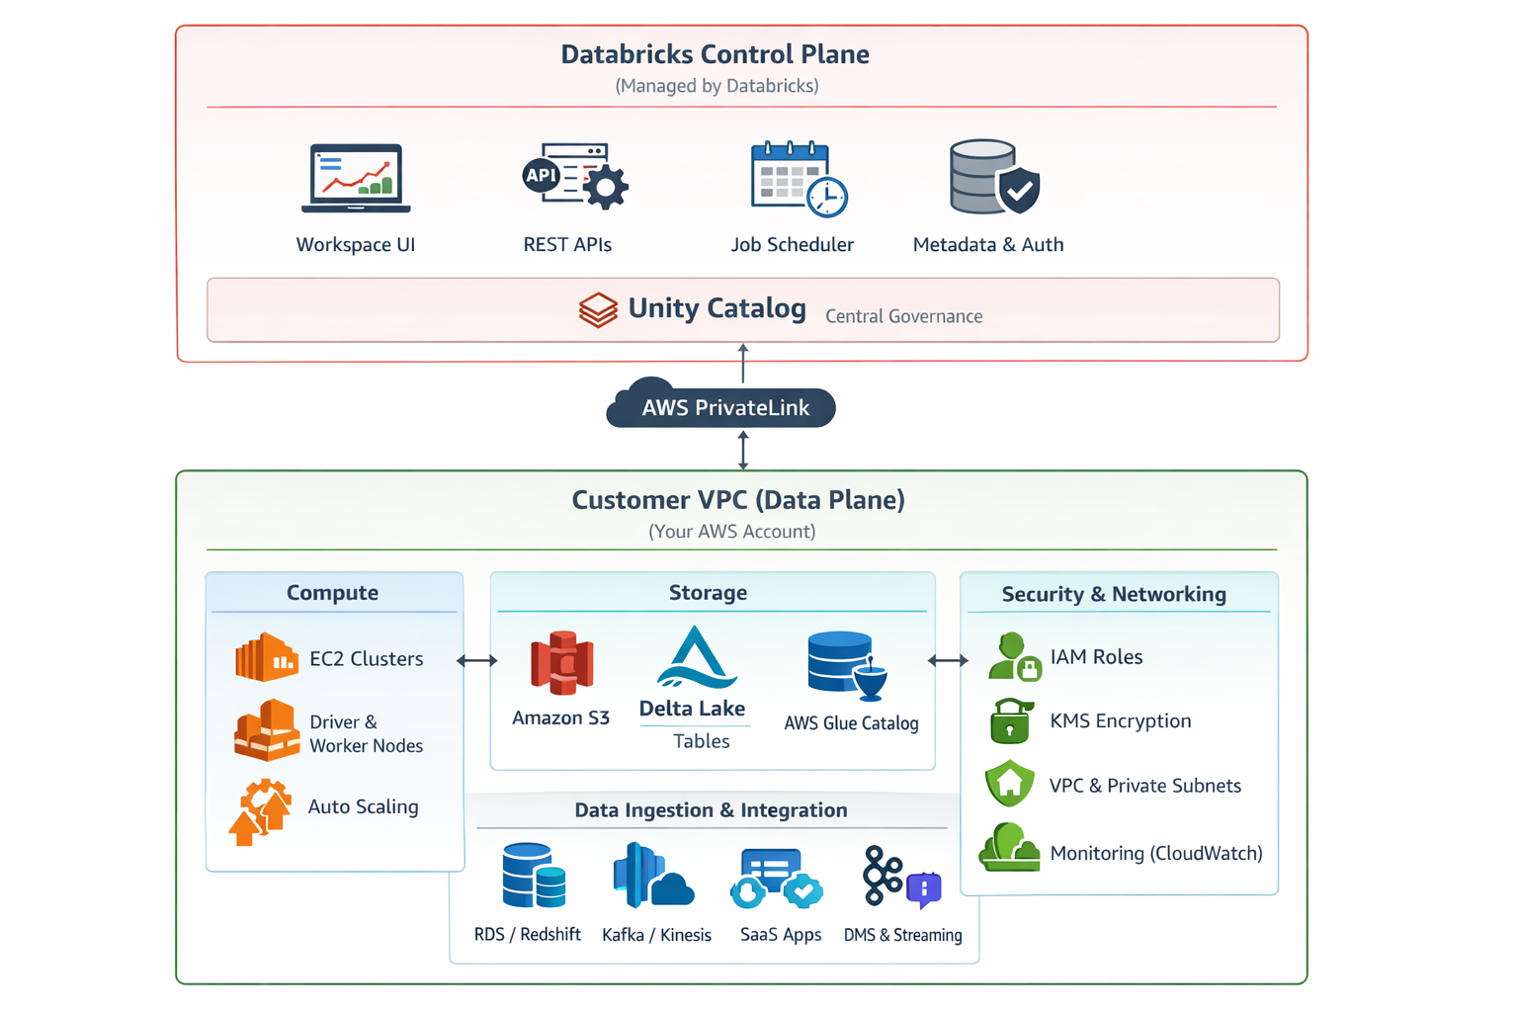

Key Components
- Databricks Control Plane: Managed by Databricks, includes Workspace UI, REST APIs, Job Scheduler, Metadata, and Unity Catalog.
- Customer Data Plane (AWS Account): Runs in customer VPC and handles all data processing.
- Compute Layer: EC2-based Spark clusters with driver and worker nodes, autoscaling enabled.
- Storage Layer: Amazon S3 with Delta Lake tables for ACID-compliant storage.
- Security & Networking: IAM roles, KMS encryption, private subnets, and AWS PrivateLink.
- Data Ingestion: Integration with RDS, Redshift, Kafka, Kinesis, SaaS apps, and streaming pipelines.

High-Level Architecture (Control Plane vs Data Plane)

A. Databricks Control Plane (Managed by Databricks)
Runs in Databricks’ AWS account.
Key components:
- Workspace UI (notebooks, jobs, clusters)
- REST APIs
- Job Scheduler
- Cluster Manager
- Metadata services
  - Notebooks metadata
  - Job definitions
  - Cluster configurations
- Authentication & Authorization
- Unity Catalog control services (if enabled)
📌 No customer data is stored here by default.

B. Databricks Data Plane (Your AWS Account)
Runs inside your VPC.
Key components:
- EC2 instances
  - Driver node
  - Worker nodes
- Auto Scaling Groups
- Elastic Network Interfaces (ENIs)
- Security Groups
- VPC Subnets (Private preferred)
📌 All data processing happens here.

2. Compute Layer

Databricks Clusters
- Interactive clusters (notebooks)
- Job clusters (ephemeral, recommended)
- SQL Warehouses (for BI / Databricks SQL)
Node Types:
- Driver node
- Worker nodes
- Spot / On-Demand instances
- Auto-termination & autoscaling

3. Storage Layer

A. Data Storage
- Amazon S3
  - Raw data
  - Delta Lake tables
  - Checkpoints
- Delta Lake
  - ACID transactions
  - Time travel
  - Schema enforcement

B. Metadata Storage
- Unity Catalog
  - Central governance
  - Table, view, schema permissions
  - Data lineage
- AWS Glue Data Catalog (legacy / optional)

4. Networking Components

VPC Architecture
- Customer-managed VPC
- Private subnets (recommended)
- NAT Gateway (outbound traffic)
- VPC Endpoints (PrivateLink)

Secure Connectivity
- AWS PrivateLink
- VPC Peering
- Transit Gateway
- No public IPs (best practice)

5. Security & Identity

Authentication
- AWS IAM roles
- SSO (Okta, Azure AD, Ping, etc.)
- Instance profiles

Authorization
- Unity Catalog
- Table / column / row-level security
- Cluster policies

Encryption
- At rest: AWS KMS
- In transit: TLS
- Customer-managed keys (CMK)

6. Data Ingestion & Integration

Sources
- S3
- RDS / Aurora
- Redshift
- Kafka / Kinesis
- SaaS apps

Ingestion Tools
- Auto Loader
- Structured Streaming
- Databricks Workflows
- AWS DMS

7. Analytics & ML Components

Analytics
- Databricks SQL
- SQL Warehouses
- BI tools (Power BI, Tableau, Looker)

Machine Learning
- MLflow
- Feature Store
- Model Registry
- SageMaker integration (optional)

8. Monitoring & Operations

Monitoring
- CloudWatch metrics
- Ganglia
- Databricks system tables

Logging
- Cluster logs to S3
- Audit logs
- Unity Catalog logs

