**Chapter 2**

**Lab 1**

**Objective: To check whether address is IPv4 or IPv6.**

**Source Code:**

import java.net.*;

public class CheckIPType {

public static void main(String[] args) {

try {

*// InetAddress object banaune (example: google.com ko lagi)*

InetAddress address = InetAddress.getByName("google.com");

*// Address ko type check garne*

if (address instanceof Inet4Address) {

System.out.println("Yo IPv4 address ho: " + address.getHostAddress());

} else if (address instanceof Inet6Address) {

System.out.println("Yo IPv6 address ho: " + address.getHostAddress());

} else {

System.out.println("Unknown address type: " + address.getHostAddress());

}

} catch (Exception e) {

System.out.println("Error aayo: " + e.getMessage());

}

}

}

**Output:**

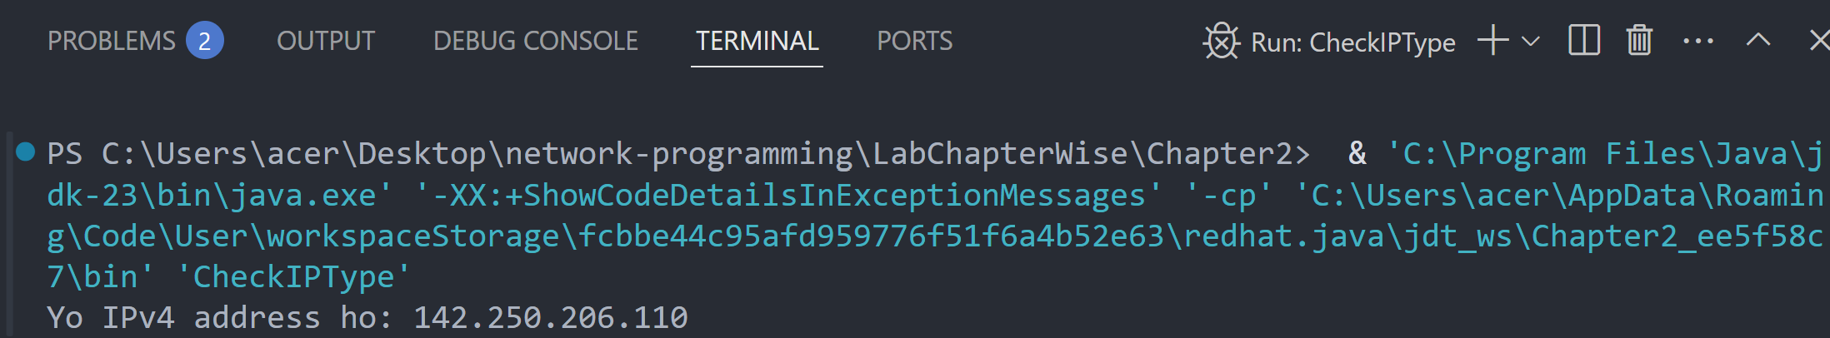

**Lab 2**

**Objective: To find the address of local machine.**

**Source Code:**

import java.net.*;

public class LocalAddress {

public static void main(String[] args) {

try {

*// Local machine ko address lina*

InetAddress local = InetAddress.getLocalHost();

System.out.println("Local Address: " + local.getHostAddress());

} catch (Exception e) {

System.out.println("Error aayo: " + e.getMessage());

}

}

}

**Output:**

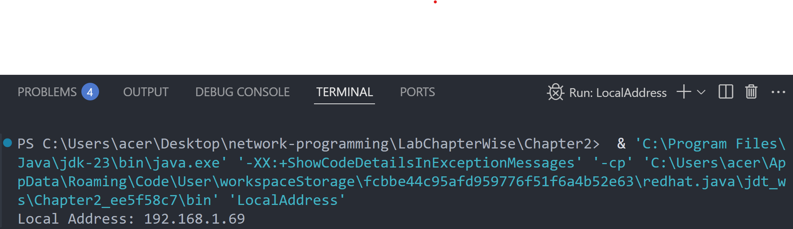

**Lab 3**

**Objective: To find the IP Address and host name of local machine.**

**Source Code:**

import java.net.*;

public class LocalIPHost {

public static void main(String[] args) {

try {

*// Local machine ko IP ra Hostname print garne*

InetAddress local = InetAddress.getLocalHost();

System.out.println("IP Address: " + local.getHostAddress());

System.out.println("Host Name: " + local.getHostName());

} catch (Exception e) {

System.out.println("Error aayo: " + e.getMessage());

}

}

}

**Output:**

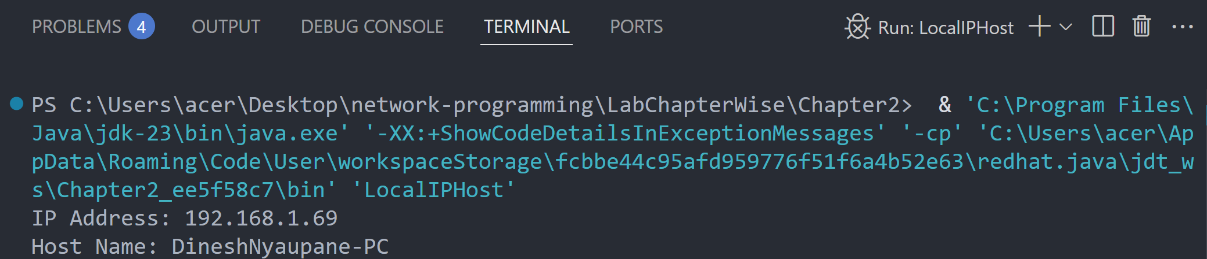

**Lab 4**

**Objective: To demonstrate the SpamCheck.**

**Source Code:**

import java.net.*;

public class SpamCheck {

public static void main(String[] args) {

try {

*// Domain name ko address khojne*

InetAddress address = InetAddress.getByName("www.google.com");

*// Hostname spam chaina bhane reply garne*

if (!address.isAnyLocalAddress()) {

System.out.println("Yo spam address huna sakcha!");

} else {

System.out.println("Yo safe address ho.");

}

} catch (Exception e) {

System.out.println("Error aayo: " + e.getMessage());

}

}

}

**Output:**

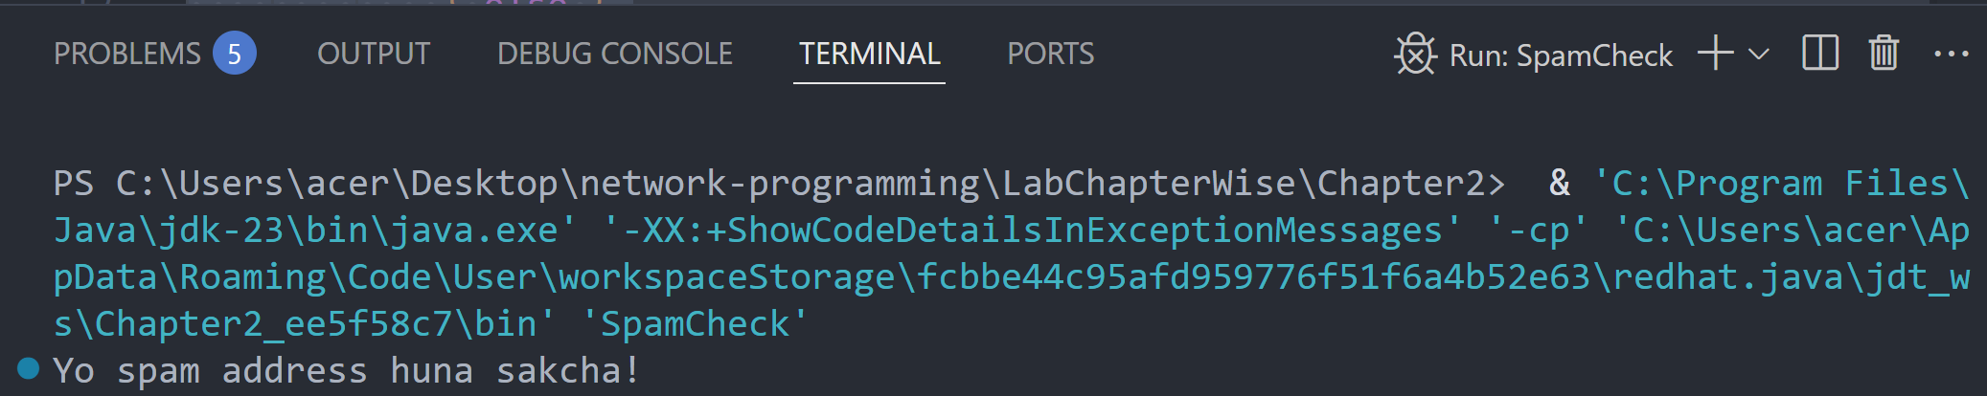

**Lab 5**

**Objective: To compare the domain names “*www.ibiblio.org*” and “*helios.ibiblio.com*”.**

**Source Code:**

import java.net.*;

public class CompareDomain {

public static void main(String[] args) {

try {

*// Duita domain ko IP address khojne*

InetAddress addr1 = InetAddress.getByName("www.ibiblio.org");

InetAddress addr2 = InetAddress.getByName("helios.ibiblio.org");

*// Address compare garne*

if (addr1.equals(addr2)) {

System.out.println("Domain haru same address ma point garcha.");

} else {

System.out.println("Domain haru different address ma chha.");

}

} catch (Exception e) {

System.out.println("Error aayo: " + e.getMessage());

}

}

}

**Output:**

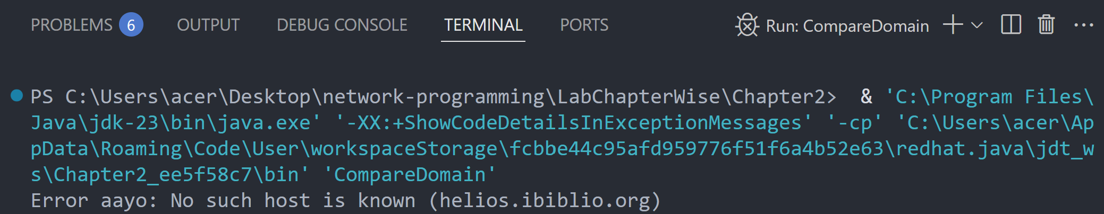

If we check [www.google.com](http://www.google.com) and [www.youtube.com](http://www.youtube.com) :

