# **Unit-3**

1. What is URL? Give an example of a URL that shows each components of URL. Diagrammatic representation is more preferred.

= A URL (Uniform Resource Locator) is a web address that provides a unique, specific location for a particular resource on the internet. It contains information about what you're looking for as well as the protocol used to access it. URLs are typically used to locate web pages, but they can also be used to locate other resources such as images, videos, audio files and documents. In other words, URLs make it possible to identify where something is located online so that you can view or download it.

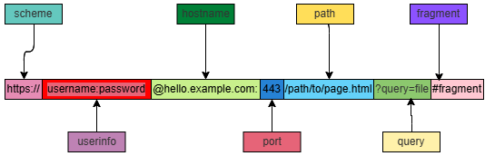

**Example URL:**

<https://www.example.com/resources/articles/page.html?search=topic&page=2#section3>

**Breakdown of Components:**

* **Scheme (Protocol)**: https specifies the protocol used to access the resource (e.g., http, https, ftp).
* **Subdomain:** www A subdivision of the main domain (optional; not always present).
* **Domain**: example.com The main address of the website, consisting of a domain name (example) and top-level domain (.com).
* **Port**: 8080 Specifies the port number used for the connection (optional; defaults to 80 for HTTP, 443 for HTTPS).
* **Path:** /path/to/resourceIndicates the specific resource or directory on the server.
* **Query String:**? query=example&sort=asc Provides parameters for the resource, typically for searches or filtering (starts with ?, parameters separated by &).
* **Fragment**: #section1 Refers to a specific section within the resource (e.g., an anchor or ID on a webpage).

1. URLs vs URIs with examples for each. Can all URLs be URIs? Why?

= The difference between of URLs vs URIs with examples for each are:

| **URL** | **URI** |
| --- | --- |
| URL is used to describe the identity of an item. | URI provides a technique for defining the identity of an item. |
| URL links a web page, a component of a web page or a program on a web page with the help of accessing methods like protocols. | URI is used to distinguish one resource from other regardless of the method used. |
| URL provides the details about what type of protocol is to be used. | URI doesn’t contains the protocol specification. |
| URL is a type of URI. | URI is the superset of URL. |
| It comprises of protocol, domain, path, hash, and so on. | It comprises of scheme, authority, path, query and many more. |
| Ex-https://www.geeksforgeeks.org/ | Ex- urn:isbn:0-294-56559-3 |

Yes, all URLs are URIs. This is because a URL is a specific type of URI. It's a subset of the broader URI concept. A URL provides the location and access method of a resource, which also serves to identify it.