Chapter 2: InetAddress
Lab 1
Objective: To check whether address is IPv4 or IPv6.
Source Code:
import java.net.*;

public class CheckIPType {
public static void main(String[] args) {
try {
// InetAddress object banaune (example: google.com ko lagi)
InetAddress address = InetAddress.getByName("google.com");

// Address ko type check garne
if (address instanceof Inet4Address) {
System.out.println("Yo IPv4 address ho: " + address.getHostAddress());
} else if (address instanceof Inet6Address) {
System.out.println("Yo IPv6 address ho: " + address.getHostAddress());
} else {
System.out.println("Unknown address type: " + address.getHostAddress());
}
} catch (Exception e) {
System.out.println("Error aayo: " + e.getMessage());
}
}
}

Output:
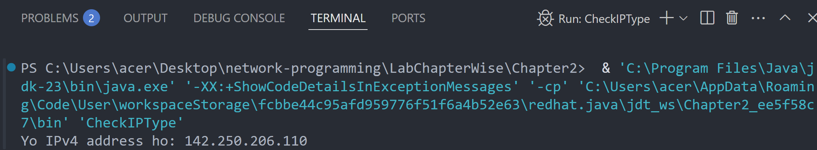

Lab 2
Objective: To find the address of local machine.
Source Code:
import java.net.*;

public class LocalAddress {
public static void main(String[] args) {
try {
// Local machine ko address lina
InetAddress local = InetAddress.getLocalHost();
System.out.println("Local Address: " + local.getHostAddress());
} catch (Exception e) {
System.out.println("Error aayo: " + e.getMessage());
}
}
}

Output:
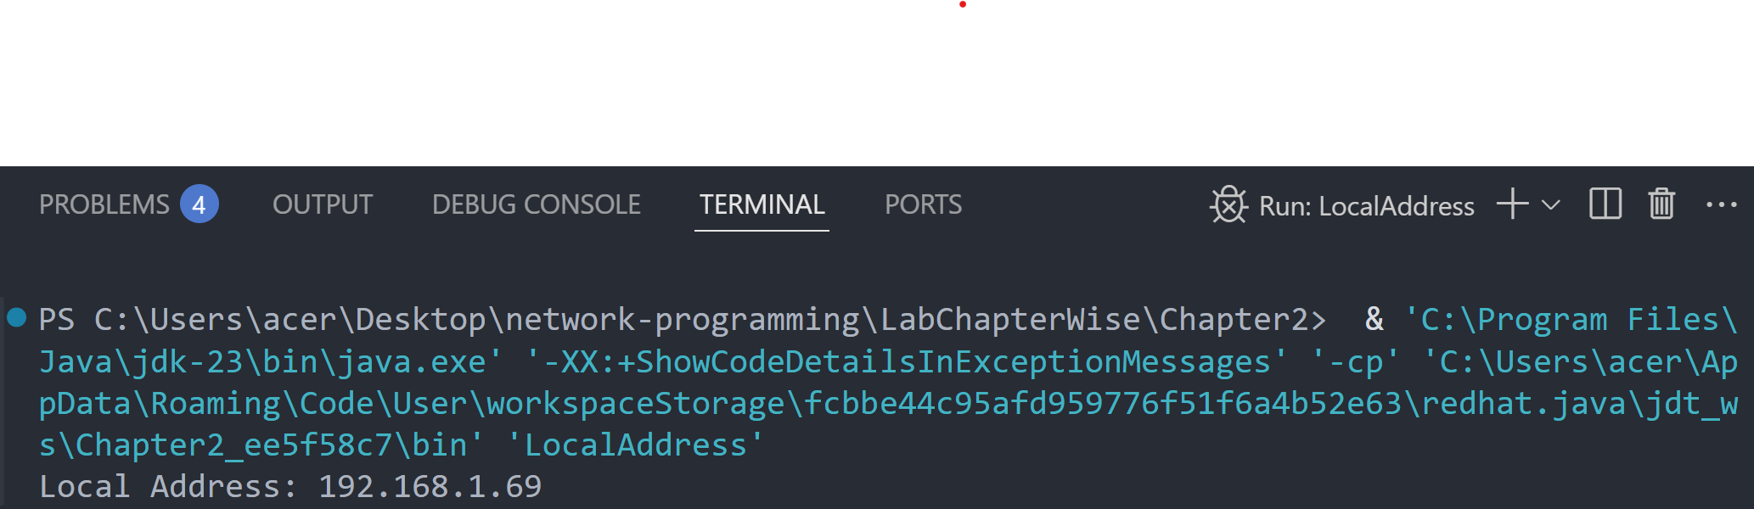

Lab 3
Objective: To find the IP Address and host name of local machine.
Source Code:
import java.net.*;

public class LocalIPHost {
public static void main(String[] args) {
try {
// Local machine ko IP ra Hostname print garne
InetAddress local = InetAddress.getLocalHost();
System.out.println("IP Address: " + local.getHostAddress());
System.out.println("Host Name: " + local.getHostName());
} catch (Exception e) {
System.out.println("Error aayo: " + e.getMessage());
}
}
}

Output:
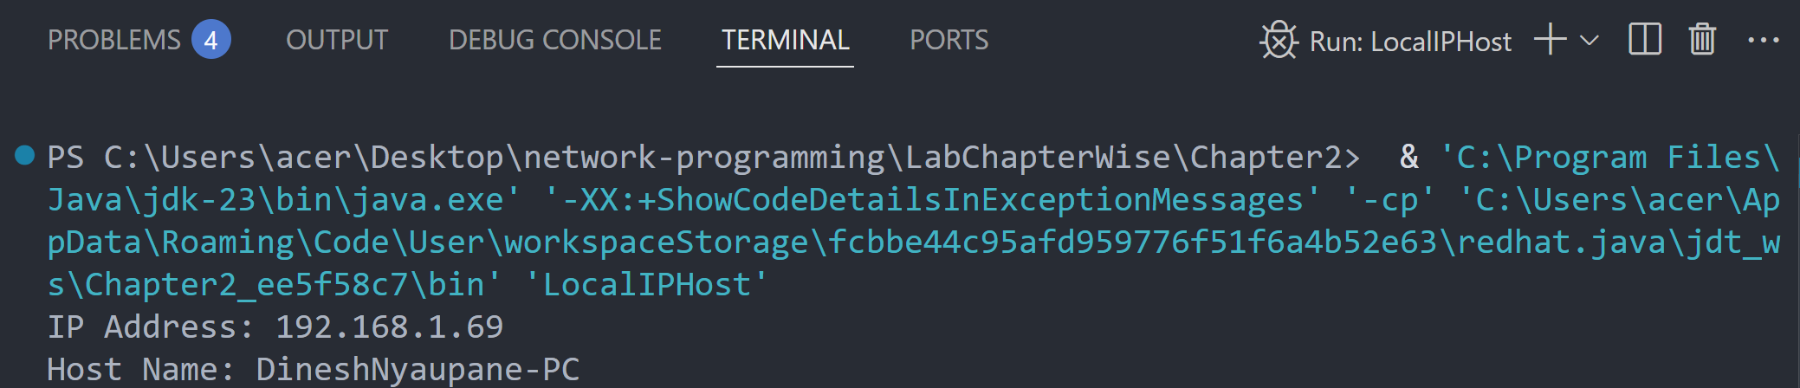

Lab 4
Objective: To demonstrate the SpamCheck.
Source Code:
import java.net.*;

public class SpamCheck {
public static void main(String[] args) {
try {
// Domain name ko address khojne
InetAddress address = InetAddress.getByName("www.google.com");

// Hostname spam chaina bhane reply garne
if (!address.isAnyLocalAddress()) {
System.out.println("Yo spam address huna sakcha!");
} else {
System.out.println("Yo safe address ho.");
}
} catch (Exception e) {
System.out.println("Error aayo: " + e.getMessage());
}
}
}

Output:
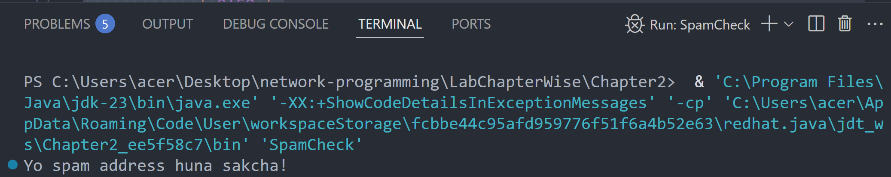

Lab 5
Objective: To compare the domain names “www.ibiblio.org” and “helios.ibiblio.org”.
Source Code:
import java.net.*;
public class CompareDomain {
public static void main(String[] args) {
try {
// Duita domain ko IP address khojne
InetAddress addr1 = InetAddress.getByName("www.ibiblio.org");
InetAddress addr2 = InetAddress.getByName("helios.ibiblio.org");
// Address compare garne
if (addr1.equals(addr2)) {
System.out.println("Domain haru same address ma point garcha.");
} else {
System.out.println("Domain haru different address ma chha.");
}
} catch (Exception e) {
System.out.println("Error aayo: " + e.getMessage());
}
}
}

Output:
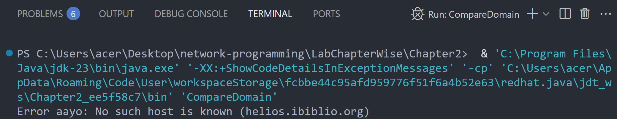
If we check www.google.com and www.youtube.com :
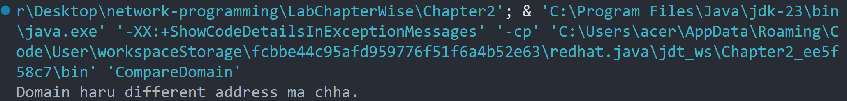

Chapter 3: URLs and URIs
Lab 6
Objective: To write a program that splits the parts of a URL [Splitting URL into pieces information]
Source Code:
import java.net.URL;

public class SplitURL {
public static void main(String[] args) {
try {
URL url = new URL("https://www.example.com:8080/path/to/resource?query=nepal#section");
System.out.println("Protocol: " + url.getProtocol());
System.out.println("Host: " + url.getHost());
System.out.println("Port: " + url.getPort());
System.out.println("Path: " + url.getPath());
System.out.println("Query: " + url.getQuery());
System.out.println("Reference: " + url.getRef());
} catch (Exception e) {
System.out.println("URL ko parts split garna error: " + e);
}
}
}

Output:
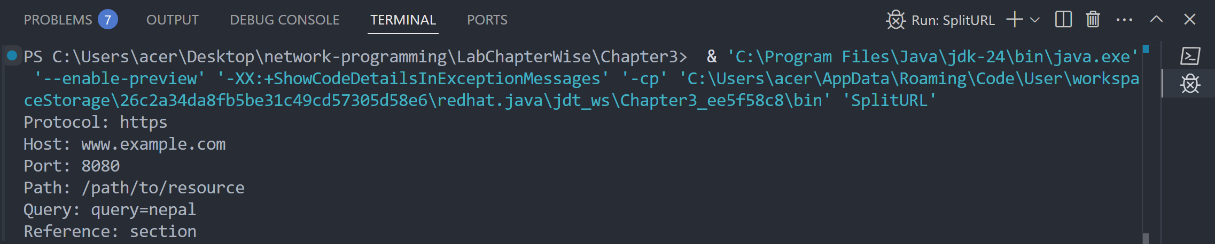

Lab 7
Objective: To write a program that checks the which protocols does a virtual machine support or not?
Source Code:
import java.net.URLConnection;
import java.util.Arrays;
import java.util.List;

public class CheckProtocols {
public static void main(String[] args) {
List<String> protocols = Arrays.asList("http", "https", "ftp", "file", "mailto");

for (String protocol : protocols) {
try {
URLConnection connection = new java.net.URL(protocol + "://test.com").openConnection();
System.out.println(protocol + " is supported.");
} catch (Exception e) {
System.out.println(protocol + " is NOT supported.");
}
}
}
}

Output:
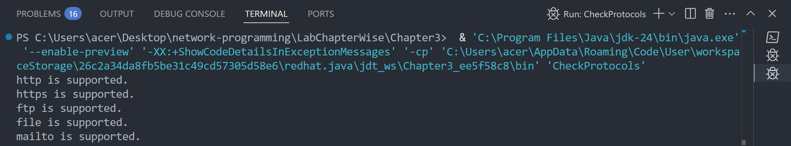

Lab 8
Objective: To write a program to download a web page of a given web address.
Source Code:
import java.io.BufferedReader;
import java.io.InputStreamReader;
import java.net.URL;
public class DownloadWebPage {
public static void main(String[] args) {
try {
URL url = new URL("https://example.com");
BufferedReader reader = new BufferedReader(new InputStreamReader(url.openStream()));
String line;
while ((line = reader.readLine()) != null) {
System.out.println(line);
}
reader.close();
} catch (Exception e) {
System.out.println("Webpage download garna error: " + e);
} } }

Output:
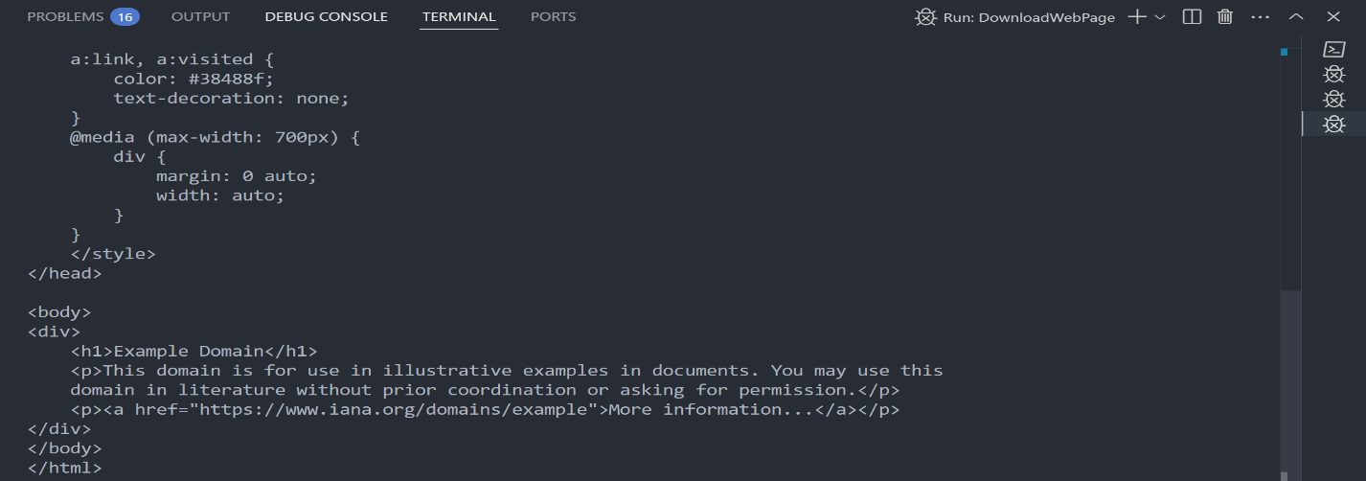
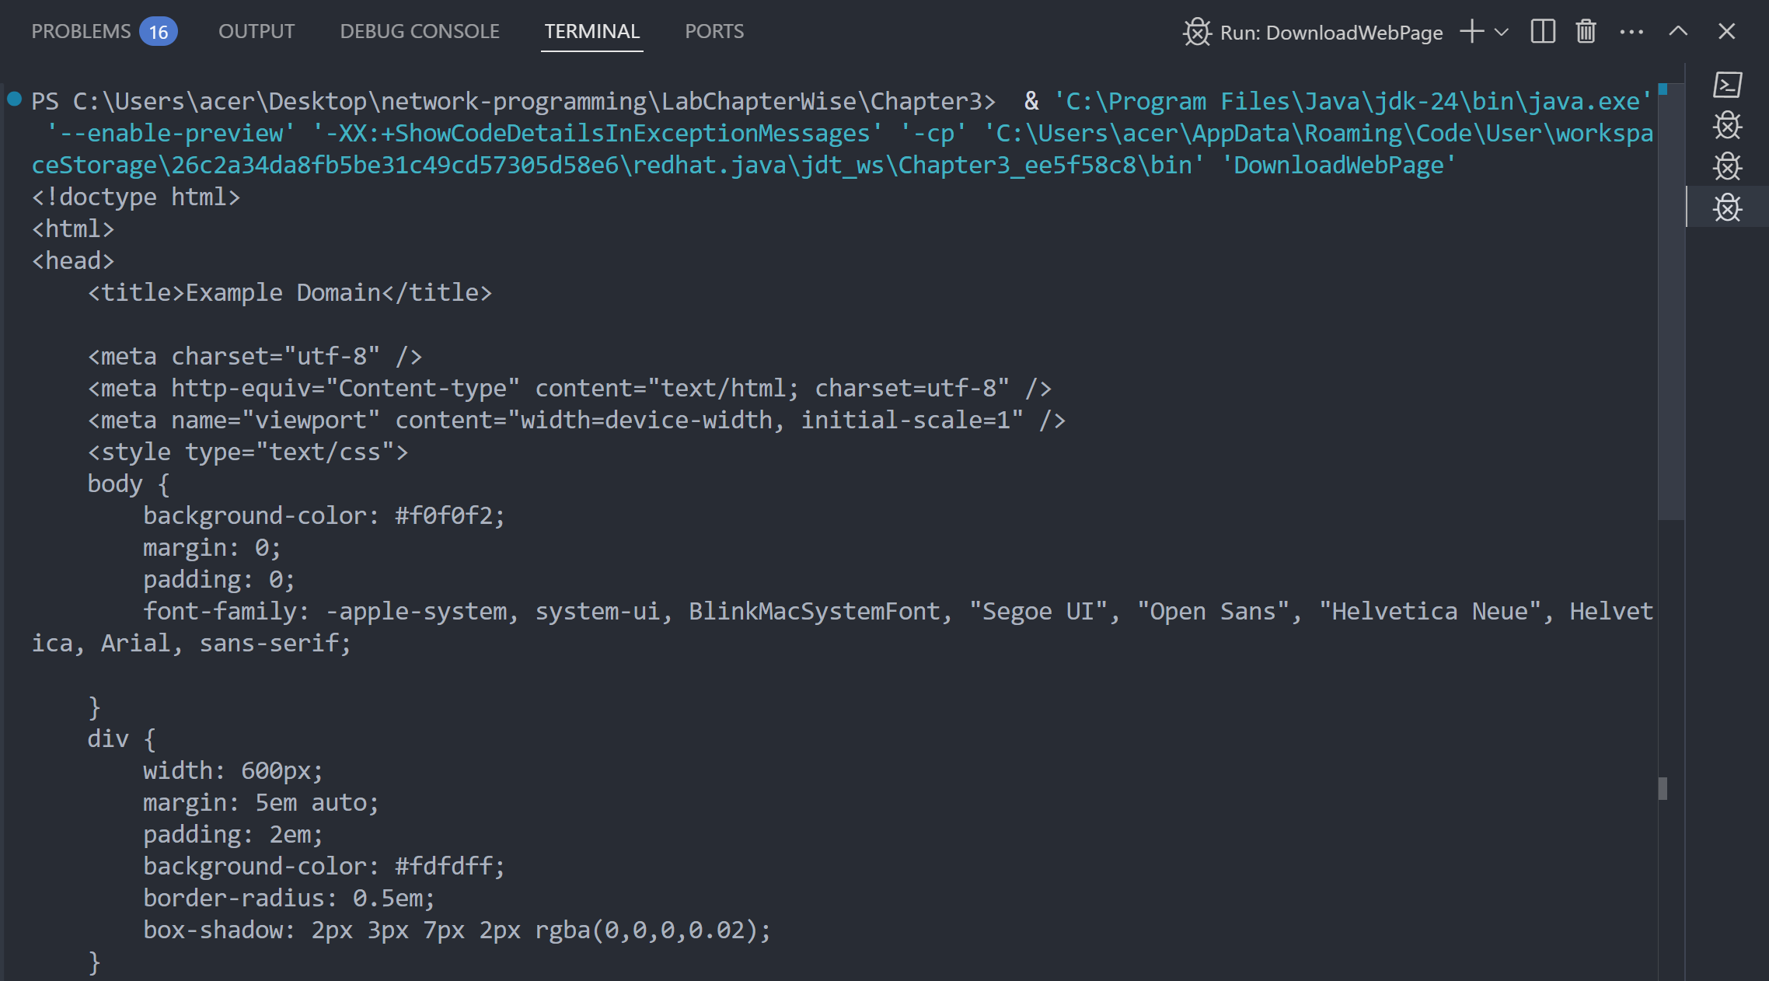

Lab 9
Objective: To write a program for resolving relatives URI
Source Code:
import java.net.URI;

public class ResolveRelativeURI {
public static void main(String[] args) {
try {
URI base = new URI("https://www.example.com/folder/");
URI relative = new URI("file.html");
URI resolved = base.resolve(relative);

System.out.println("Resolved URI: " + resolved.toString());
} catch (Exception e) {
System.out.println("Relative URI resolve garna error: " + e);
}
}
}

Output:
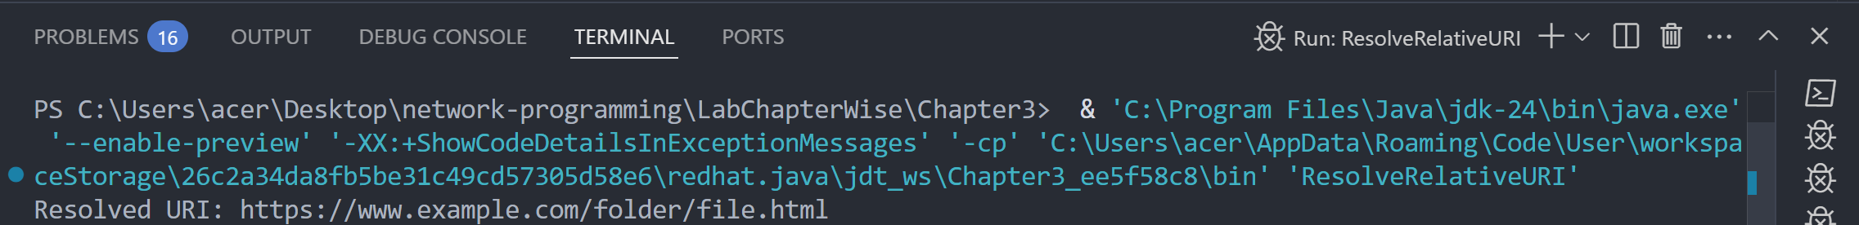

Lab 10
Objective: To write a program to download an object.
Source Code:
import java.io.FileOutputStream;
import java.io.InputStream;
import java.net.URL;

public class DownloadObject {
public static void main(String[] args) {
try {
URL url = new URL("https://www.example.com");
InputStream input = url.openStream();
FileOutputStream output = new FileOutputStream("downloaded_sample.pdf");

byte[] buffer = new byte[2048];
int bytesRead;

while ((bytesRead = input.read(buffer)) != -1) {
output.write(buffer, 0, bytesRead);
}

input.close();
output.close();
System.out.println("File download successfully.");
} catch (Exception e) {
System.out.println("File download garna error: " + e);
}
}
}

Output:
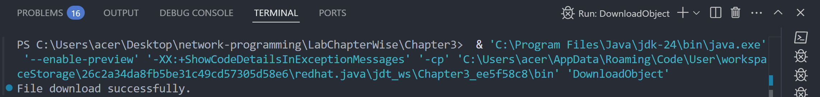
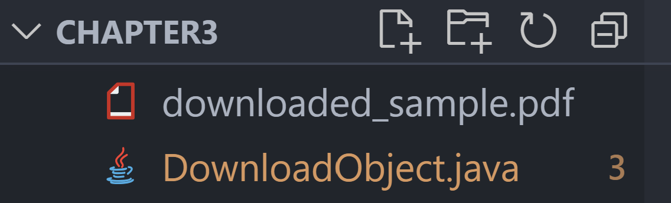
Lab 11
Objective: To write a program to demonstrate the x-www-form-URL encoded strings.
Source Code:
import java.net.URLEncoder;
import java.nio.charset.StandardCharsets;

public class FormURLEncoding {
public static void main(String[] args) {
try {
String name = "Ram Bahadur";
String location = "Nepal Kathmandu";

String encodedName = URLEncoder.encode(name, StandardCharsets.UTF_8);
String encodedLocation = URLEncoder.encode(location, StandardCharsets.UTF_8);

System.out.println("Encoded form data:");
System.out.println("name=" + encodedName + "&location=" + encodedLocation);
} catch (Exception e) {
System.out.println("Form URL encoding garna error: " + e);
}
}
}

Output:
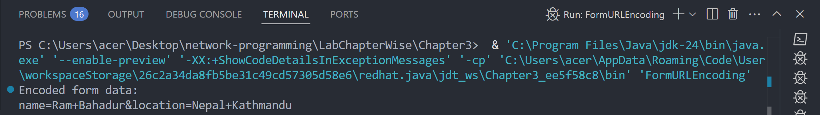

Lab 12
Objective: To write a program that communicating with Server-Side Programs Through GET.
Source Code:
import java.io.BufferedReader;
import java.io.InputStreamReader;
import java.net.HttpURLConnection;
import java.net.URL;

public class HTTPGetRequest {
public static void main(String[] args) {
try {
URL url = new URL("https://jsonplaceholder.typicode.com/posts/1");
HttpURLConnection conn = (HttpURLConnection) url.openConnection();

conn.setRequestMethod("GET");
int responseCode = conn.getResponseCode();

System.out.println("Response Code: " + responseCode);

BufferedReader reader = new BufferedReader(new InputStreamReader(conn.getInputStream()));
String line;

while ((line = reader.readLine()) != null) {
System.out.println(line);
}

reader.close();
} catch (Exception e) {
System.out.println("Server sanga GET communication garna error: " + e);
}
}
}

Output:
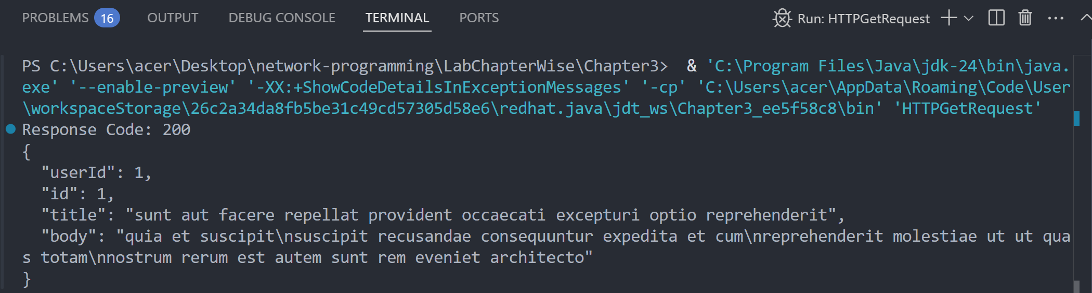
Chapter 4: HTTP
Lab 13
Objective: To write a program that shows a simple CookiePolicy that blocks cookies from .gov domains, but allows others.
Source Code:
import java.net.*;

public class CookiePolicyExample {
public static void main(String[] args) throws Exception {
CookiePolicy policy = new CookiePolicy() {
@Override
public boolean shouldAccept(URI uri, HttpCookie cookie) {
String host = uri.getHost();
return !host.endsWith(".gov.np");
}
};

CookieManager manager = new CookieManager();
manager.setCookiePolicy(policy);
CookieHandler.setDefault(manager);

URI govUri = new URI("http://mofaga.gov.np"); // blocked
URI eduUri = new URI("http://nepathya.edu.np"); // allowed

HttpCookie govCookie = new HttpCookie("session", "gov_cookie");
HttpCookie eduCookie = new HttpCookie("session", "edu_cookie");

boolean isGovAccepted = policy.shouldAccept(govUri, govCookie);
boolean isEduAccepted = policy.shouldAccept(eduUri, eduCookie);

System.out.println("mofaga.gov.np cookie accepted? " + isGovAccepted);
System.out.println("nepathya.edu.np cookie accepted? " + isEduAccepted);
}
}

Output:
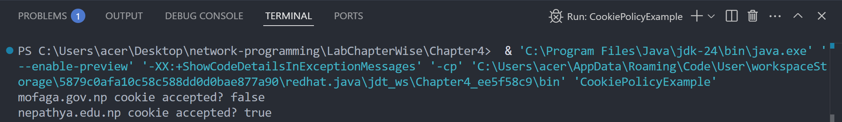
Lab 14
Objective: To implement the CookieStore Methods (add, read, delete) cookies.
Source Code:
import java.net.*;
import java.util.*;

public class CookieStoreExample {
public static void main(String[] args) throws Exception {
CookieManager manager = new CookieManager();
CookieHandler.setDefault(manager);
CookieStore store = manager.getCookieStore();

URI nepUri = new URI("http://nepathya.edu.np");

// Add a cookie
HttpCookie cookie = new HttpCookie("user", "Dinesh-SixthSemester");
store.add(nepUri, cookie);

System.out.println(" Cookie added for nepathya.edu.np: " + cookie);
System.out.println("\n Cookies after addition (" + store.getCookies().size() + "):");
for (HttpCookie c : store.getCookies()) {
System.out.println(" " + c);
}

// Delete cookie
store.remove(nepUri, cookie);
System.out.println("\n Cookie deleted.");

// Verify deletion
List<HttpCookie> cookies = store.getCookies();
System.out.println("\n Cookies after deletion (" + cookies.size() + "):");
for (HttpCookie c : cookies) {
System.out.println("➡️ " + c);
}
}
}

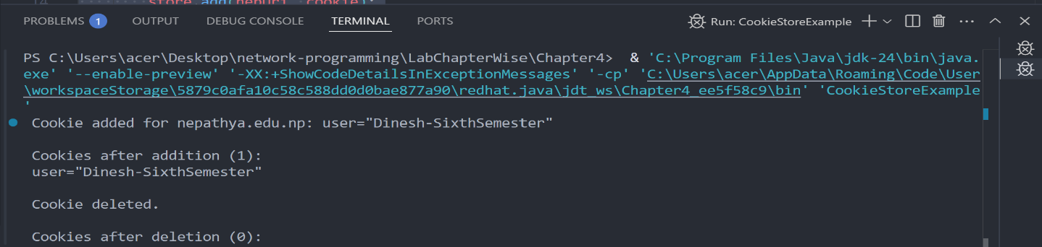
Output:

Chapter 5: URL Connections
Lab 15
Objective: To write a program to download a web page using URLConnection.
Source Code:
import java.io.*;
import java.net.*;

public class DOwnloadWebPage {
public static void main(String[] args) {
String website = "http://nepathyacollege.edu.np";

try {
URL url = new URL(website);
URLConnection connection = url.openConnection();

BufferedReader reader = new BufferedReader(
new InputStreamReader(connection.getInputStream()));
BufferedWriter writer = new BufferedWriter(
new FileWriter("DownloadedPage.html"));

String line;
while ((line = reader.readLine()) != null) {
writer.write(line);
writer.newLine();
}

reader.close();
writer.close();

System.out.println("Web page downloaded successfully as 'DownloadedPage.html'");
} catch (Exception e) {
System.out.println("Error: " + e.getMessage());
}
}
}

Output:
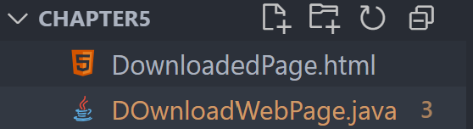
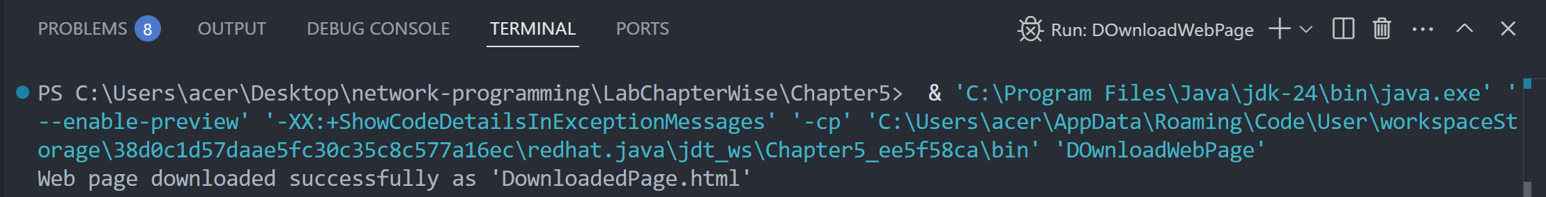
Lab 16
Objective: To write a program to read value of HTTP Header fields.
Source Code:
import java.net.*;

public class ReadHTTPHeaderFields {
public static void main(String[] args) {
try {
URL url = new URL("http://nepathyacollege.edu.np");
URLConnection connection = url.openConnection();

String contentType = connection.getHeaderField("Content-Type");
String server = connection.getHeaderField("Server");

System.out.println("Content-Type: " + contentType);
System.out.println("Server: " + server);
} catch (Exception e) {
System.out.println("Error: " + e.getMessage());
}
}
}

Output:
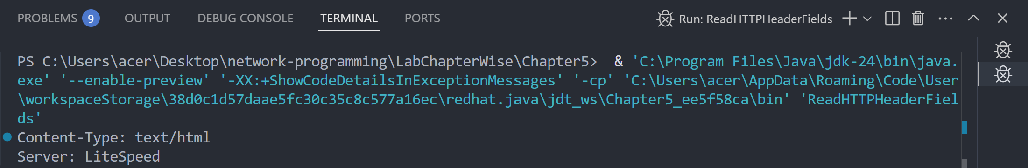

Lab 17
Objective: To write a program to print the entire HTTP header
Source Code:
import java.net.*;
import java.util.*;

public class PrintEntireHTTPHeader {
public static void main(String[] args) {
try {
URL url = new URL("http://nepathyacollege.edu.np");
URLConnection connection = url.openConnection();

Map<String, List<String>> headers = connection.getHeaderFields();

for (Map.Entry<String, List<String>> entry : headers.entrySet()) {
String key = entry.getKey();
List<String> values = entry.getValue();
System.out.println(key + ": " + String.join(", ", values));
}
} catch (Exception e) {
System.out.println("Error: " + e.getMessage());
}
}
}

Output:
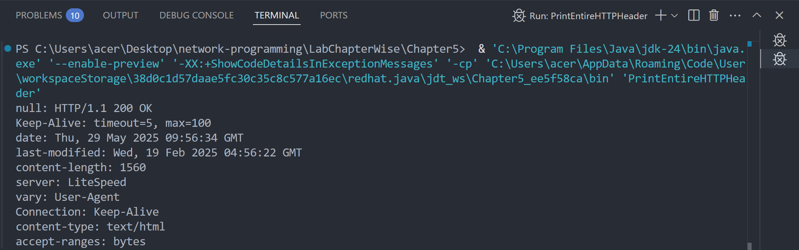
Lab 18
Objective: To write a program for HTTP Request Method.
Source Code:
import java.net.*;

public class HTTPRequestMethod {
public static void main(String[] args) {
try {
URL url = new URL("http://nepathyacollege.edu.np");
HttpURLConnection connection = (HttpURLConnection) url.openConnection();

connection.setRequestMethod("GET"); // You can try "POST", "HEAD" etc.

System.out.println("HTTP Request Method: " + connection.getRequestMethod());
} catch (Exception e) {
System.out.println("Error: " + e.getMessage());
}
}
}

Output:
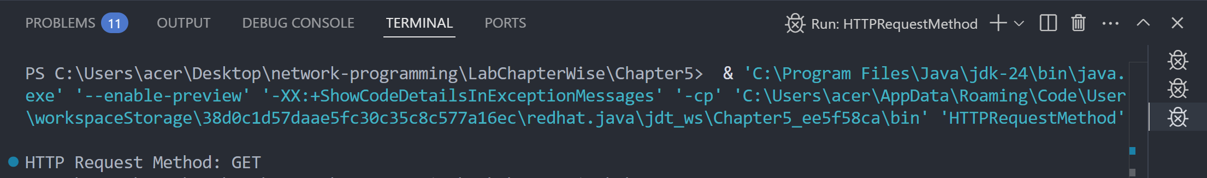

Lab 19
Objective: To write a program to print the URL of a URL Connection to “nepathyacollege.edu.np”
Source Code:
import java.net.*;

public class PrintURLConnectionURL {
public static void main(String[] args) {
try {
URL url = new URL("http://nepathyacollege.edu.np");
URLConnection connection = url.openConnection();

System.out.println("URL of the connection: " + connection.getURL());
} catch (Exception e) {
System.out.println("Error: " + e.getMessage());
}
}
}

Output:
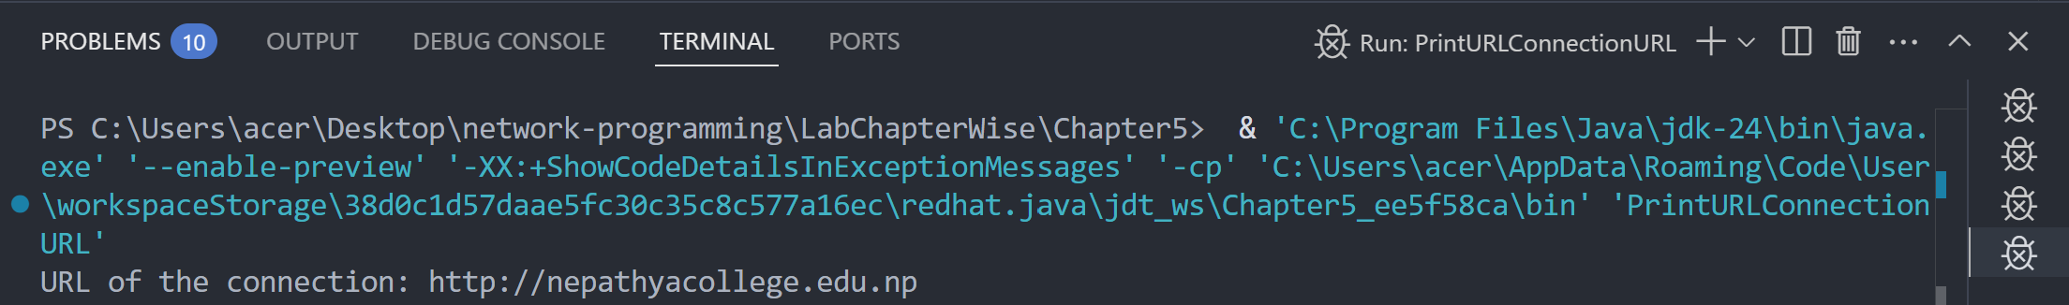

Lab 20
Objective: To write a program to get the time when a URL was last changed.
Source Code:
import java.net.*;
import java.text.SimpleDateFormat;
import java.util.Date;

public class URLLastModifiedTime {
public static void main(String[] args) {
try {
URL url = new URL("http://nepathyacollege.edu.np");
URLConnection connection = url.openConnection();

long lastModified = connection.getLastModified();
if (lastModified == 0) {
System.out.println("No Last-Modified information.");
} else {
Date date = new Date(lastModified);
SimpleDateFormat sdf = new SimpleDateFormat("dd MMM yyyy HH:mm:ss");
System.out.println("Last Modified: " + sdf.format(date));
}
} catch (Exception e) {
System.out.println("Error: " + e.getMessage());
}
}
}

Output:
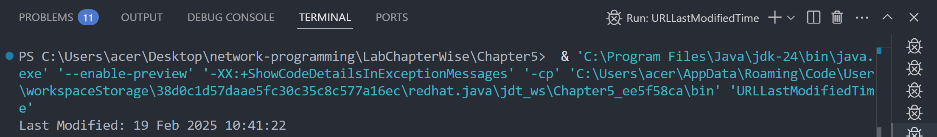

Chapter 6: Socket for Clients
Lab 21
Objective: To write a program socket to client.
Source Code:
import java.io.*;
import java.net.*;

public class SimpleSocketClient {
public static void main(String[] args) {
String serverAddress = "localhost"; // or IP address of the server
int port = 5000; // port number the server is listening on

try (Socket socket = new Socket(serverAddress, port);
PrintWriter out = new PrintWriter(socket.getOutputStream(), true);
BufferedReader in = new BufferedReader(new InputStreamReader(socket.getInputStream()));
BufferedReader userInput = new BufferedReader(new InputStreamReader(System.in))) {

System.out.println("Connected to server at " + serverAddress + ":" + port);

// Read user input and send to server
System.out.print("Enter message to send: ");
String message = userInput.readLine();
out.println(message);

// Read and print server response
String response = in.readLine();
System.out.println("Server response: " + response);

} catch (IOException e) {
System.err.println("Error: " + e.getMessage());
}
}
}

Output:
(before connecting to server)
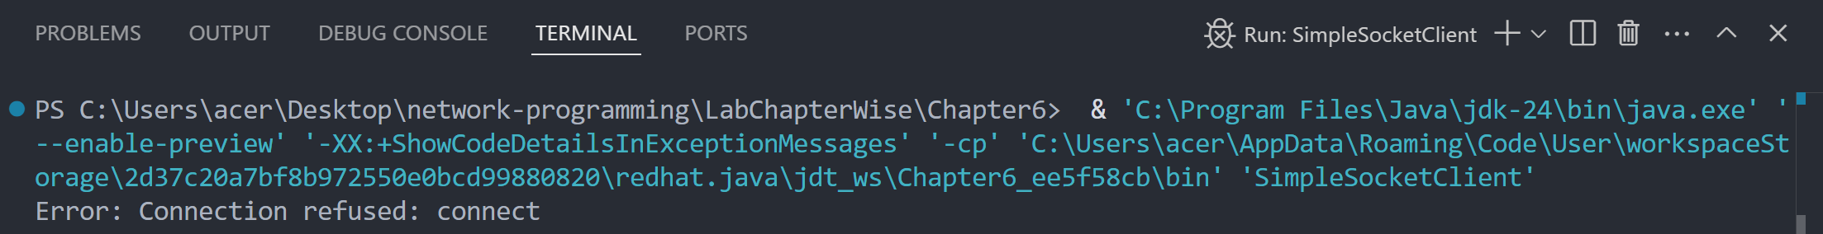

(after connecting to server)
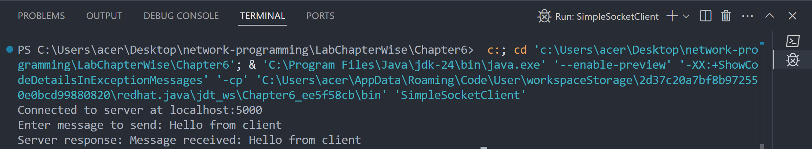

Chapter 7: Socket for Server
Lab 22
Objective: To write a program socket to server.
Source Code:
import java.io.*;
import java.net.*;

public class SimpleSocketServer {
public static void main(String[] args) {
int port = 5000; // Server will listen on this port

try (ServerSocket serverSocket = new ServerSocket(port)) {
System.out.println("Server started. Waiting for client connection on port " + port);

Socket clientSocket = serverSocket.accept(); // Accept client connection
System.out.println("Client connected: " + clientSocket.getInetAddress());

BufferedReader in = new BufferedReader(
new InputStreamReader(clientSocket.getInputStream()));
PrintWriter out = new PrintWriter(clientSocket.getOutputStream(), true);

// Read message from client
String message = in.readLine();
System.out.println("Received from client: " + message);

// Send response to client
out.println("Message received: " + message);

// Close client connection
clientSocket.close();
System.out.println("Client connection closed.");
} catch (IOException e) {
System.err.println("Error: " + e.getMessage());
}
}
}

Output:

(before any client connects)
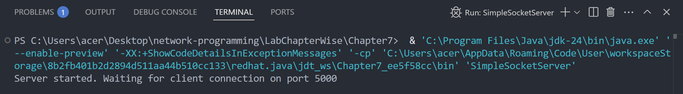

(after client connects)
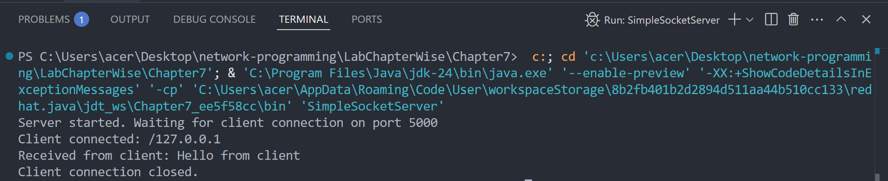

Chapter 8: Secure Sockets
Lab 23
Objective: To write a program for Creating Secure Sockets with tufohss.edu.np.
Source Code:
import java.io.*;
import javax.net.ssl.SSLSocket;
import javax.net.ssl.SSLSocketFactory;

public class SecureSocketClient {
public static void main(String[] args) {
String host = "tufohss.edu.np";
int port = 443; // HTTPS default port

try {
// Create SSL socket factory and socket
SSLSocketFactory factory = (SSLSocketFactory) SSLSocketFactory.getDefault();
SSLSocket sslSocket = (SSLSocket) factory.createSocket(host, port);

// Start handshake (optional, but recommended)
sslSocket.startHandshake();

// Output stream to send data to server
PrintWriter out = new PrintWriter(new BufferedWriter(
new OutputStreamWriter(sslSocket.getOutputStream())));

// Input stream to read server response
BufferedReader in = new BufferedReader(
new InputStreamReader(sslSocket.getInputStream()));

// Send HTTP GET request
out.println("GET / HTTP/1.1");
out.println("Host: " + host);
out.println("Connection: Close");
out.println(); // blank line to end request headers
out.flush();

// Read and print the response line by line
String line;
while ((line = in.readLine()) != null) {
System.out.println(line);
}

// Close streams and socket
in.close();
out.close();
sslSocket.close();

} catch (Exception e) {
System.err.println("Error: " + e.getMessage());
e.printStackTrace();
}
}
}

Output:
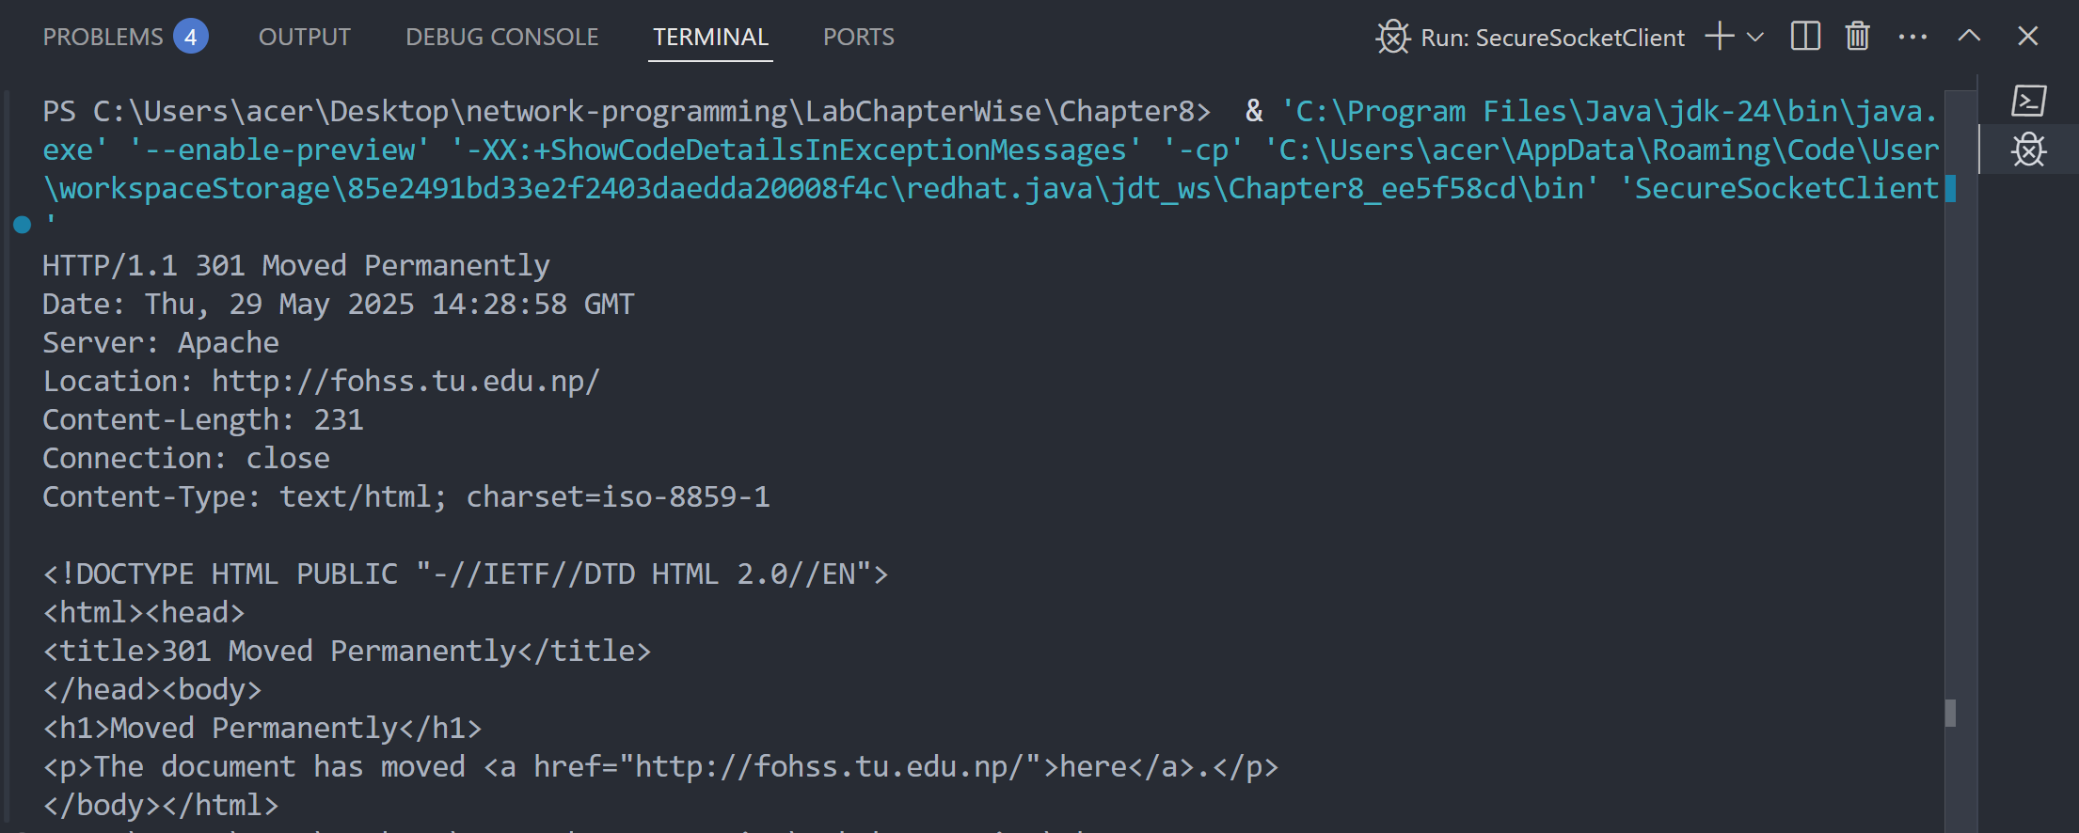

Lab 24
Objective: To write a program for Creating Secure Server Sockets and Client Sockets.
Source Code:
SecureClient.java
import java.io.*;
import java.security.KeyStore;
import javax.net.ssl.*;

public class SecureClient {
public static void main(String[] args) throws Exception {
char[] password = "password".toCharArray();

// Set system properties to point to the truststore file containing server cert or CA cert
System.setProperty("javax.net.ssl.trustStore", "clienttruststore.jks");
System.setProperty("javax.net.ssl.trustStorePassword", "password");

// Load the truststore file (this step is optional if you want to create SSLContext manually)
KeyStore ts = KeyStore.getInstance("JKS");
try (FileInputStream fis = new FileInputStream("clienttruststore.jks")) {
ts.load(fis, password);
}

// Initialize TrustManagerFactory with the truststore
TrustManagerFactory tmf = TrustManagerFactory.getInstance("SunX509");
tmf.init(ts);

// Set up SSL context using the trust managers from the truststore
SSLContext sc = SSLContext.getInstance("TLS");
sc.init(null, tmf.getTrustManagers(), null);

// Create SSLSocketFactory from SSL context
SSLSocketFactory ssf = sc.getSocketFactory();

// Create an SSL socket connected to the server
try (SSLSocket socket = (SSLSocket) ssf.createSocket("localhost", 12345);
BufferedReader in = new BufferedReader(new InputStreamReader(socket.getInputStream()))) {

// Read response from server
String response = in.readLine();
System.out.println("Message from Server: " + response);
}
}
}

SecureServer.java
import java.io.*;
import java.security.KeyStore;
import javax.net.ssl.*;

public class SecureServer {
public static void main(String[] args) throws Exception {
char[] password = "password".toCharArray();

// Load keystore
KeyStore ks = KeyStore.getInstance("JKS");
ks.load(new FileInputStream("serverkeystore.jks"), password);

// Initialize KeyManagerFactory
KeyManagerFactory kmf = KeyManagerFactory.getInstance("SunX509");
kmf.init(ks, password);

// Set up SSL context
SSLContext sc = SSLContext.getInstance("TLS");
sc.init(kmf.getKeyManagers(), null, null);

SSLServerSocketFactory ssf = sc.getServerSocketFactory();
SSLServerSocket serverSocket = (SSLServerSocket) ssf.createServerSocket(12345);

System.out.println("Secure Server started on port 12345...");

while (true) {
SSLSocket socket = (SSLSocket) serverSocket.accept();
PrintWriter out = new PrintWriter(socket.getOutputStream(), true);
out.println("Hello from secure server!");
socket.close();
}
}
}

Output:
(SecureServer.java)
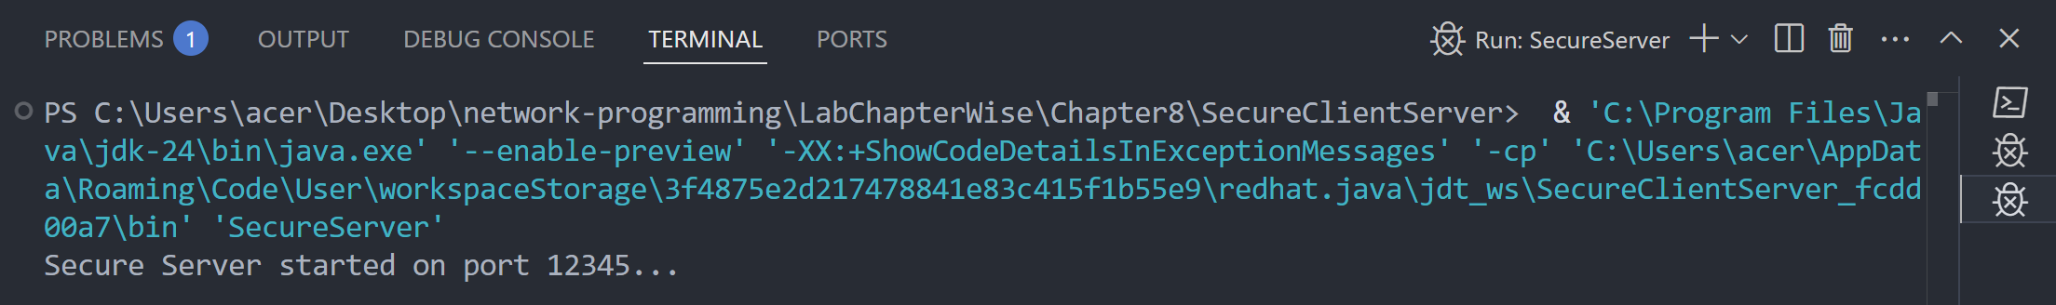

(SecureClient.java)
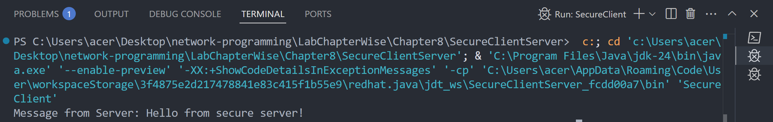

Chapter 9: Non Blocking I/O
Lab 25
Objective: To write program to list all supported socket options for the different types of network channels
Source Code:
import java.net.*;
import java.nio.channels.*;
import java.util.Set;

public class ListSocketOptions {
public static void main(String[] args) throws Exception {
System.out.println("SocketChannel options:");
SocketChannel socketChannel = SocketChannel.open();
Set<SocketOption<?>> socketOptions = socketChannel.supportedOptions();
for (SocketOption<?> option : socketOptions) {
System.out.println(" - " + option.name());
}

System.out.println("\nServerSocketChannel options:");
ServerSocketChannel serverSocketChannel = ServerSocketChannel.open();
Set<SocketOption<?>> serverSocketOptions = serverSocketChannel.supportedOptions();
for (SocketOption<?> option : serverSocketOptions) {
System.out.println(" - " + option.name());
}

System.out.println("\nDatagramChannel options:");
DatagramChannel datagramChannel = DatagramChannel.open();
Set<SocketOption<?>> datagramOptions = datagramChannel.supportedOptions();
for (SocketOption<?> option : datagramOptions) {
System.out.println(" - " + option.name());
}
}
}

Output:
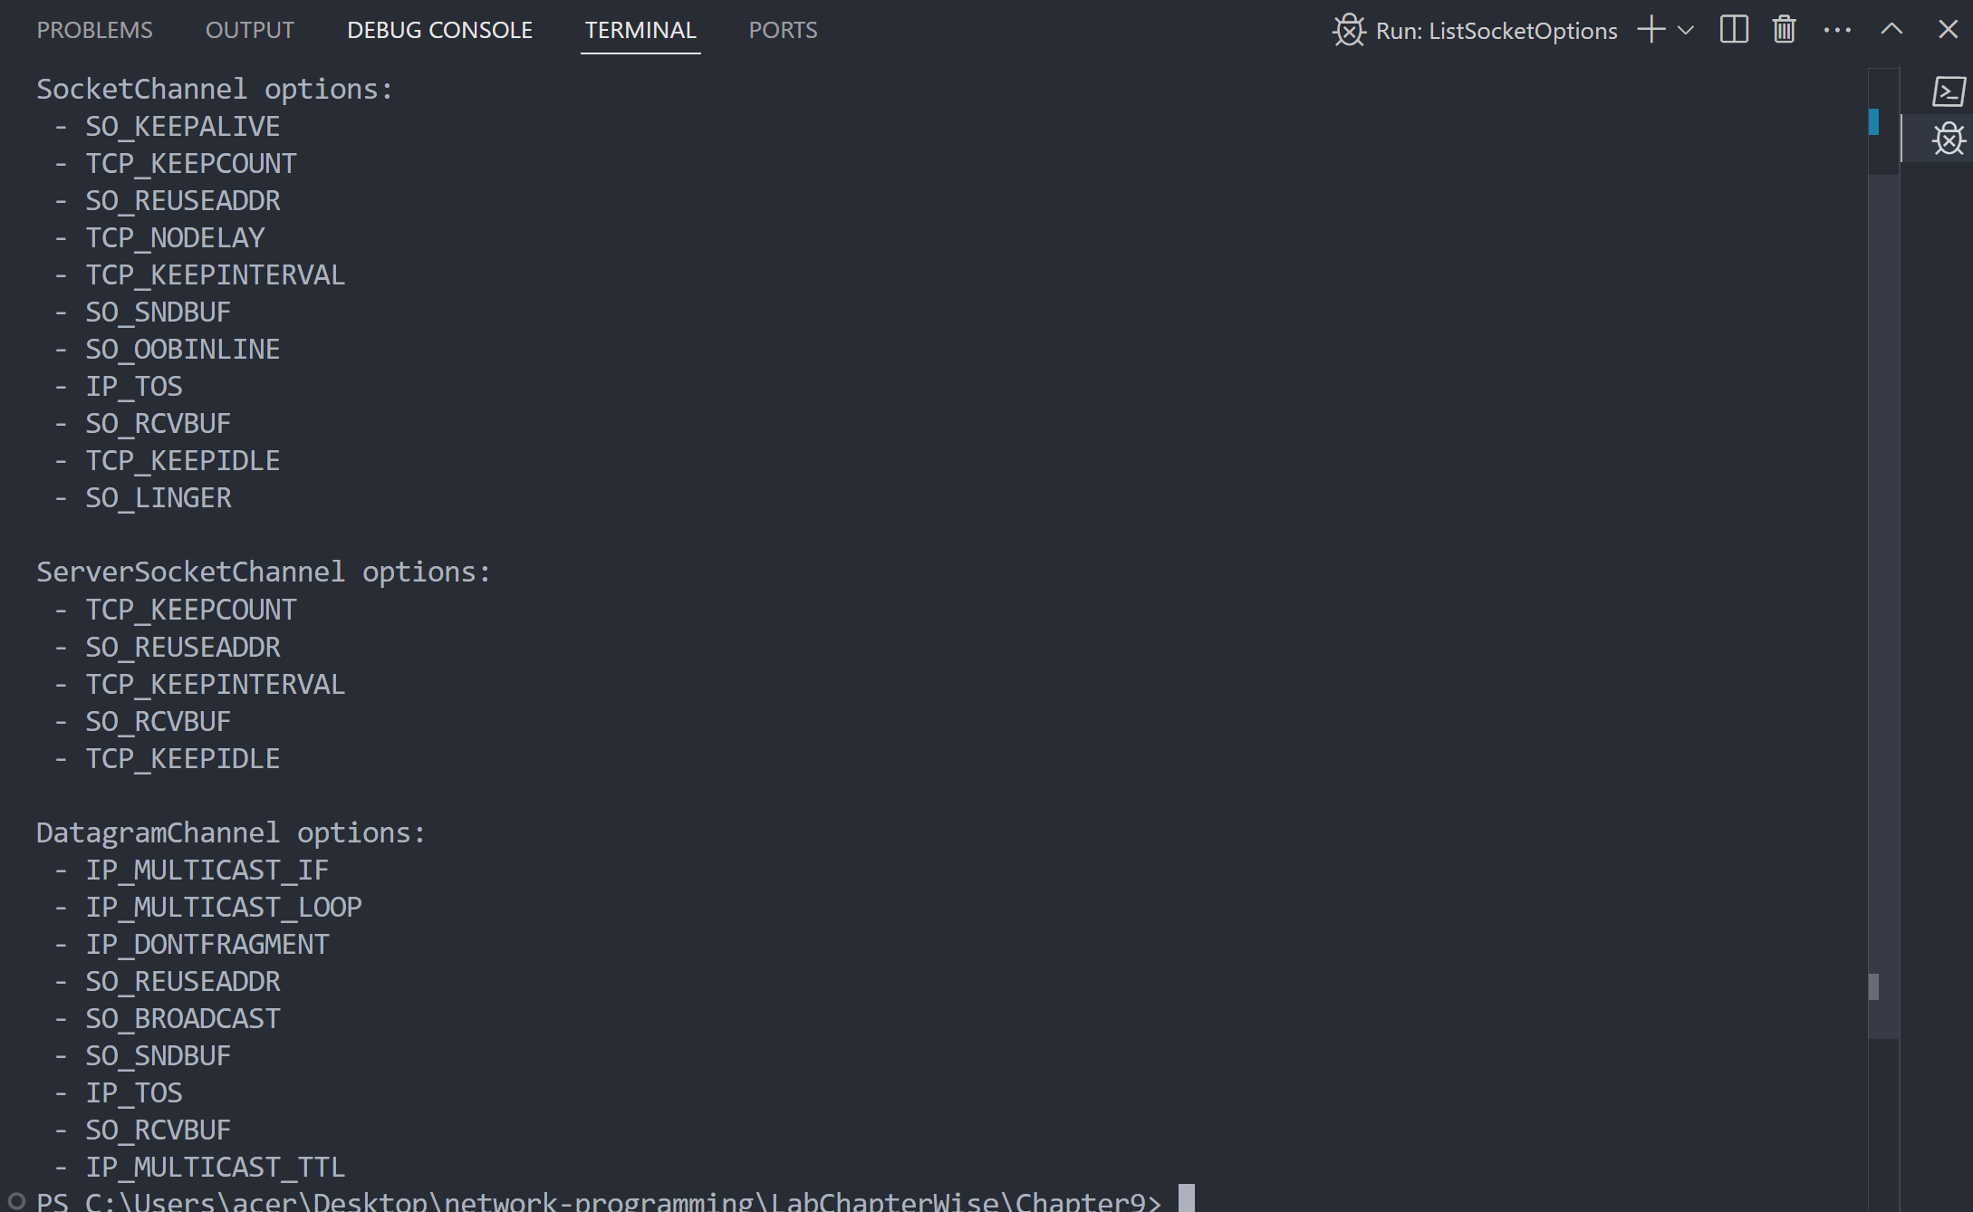

Lab 26
Objective: To write program to implement the concept on Filling and Draining buffer, duplicating buffer, Slicing buffer, Compact buffer.
Source Code:
import java.nio.ByteBuffer;
public class BufferOperations {
public static void main(String[] args) {
// Fill buffer
ByteBuffer buffer = ByteBuffer.allocate(10);
for (byte i = 0; i < 10; i++) {
buffer.put(i);
}

// Flip (prepare for reading)
buffer.flip();

// Drain buffer
System.out.print("Draining buffer: ");
while (buffer.hasRemaining()) {
System.out.print(buffer.get() + " ");
}

// Refill
buffer.clear();
for (byte i = 10; i < 20; i++) {
buffer.put(i);
}

// Duplicate
ByteBuffer duplicate = buffer.duplicate();
duplicate.flip();
System.out.print("\nDuplicate buffer: ");
while (duplicate.hasRemaining()) {
System.out.print(duplicate.get() + " ");
}

// Slice buffer
buffer.position(2);
buffer.limit(6);
ByteBuffer slice = buffer.slice();
System.out.print("\nSliced buffer: ");
for (int i = 0; i < slice.capacity(); i++) {
System.out.print(slice.get(i) + " ");
}

//compact
buffer.clear();
buffer.put((byte) 1);
buffer.put((byte) 2);
buffer.put((byte) 3);
buffer.flip();
buffer.get(); // read one byte
buffer.compact(); // move remaining bytes to beginning
buffer.put((byte) 4); // add more
buffer.flip();
System.out.print("\nCompact buffer: ");
while (buffer.hasRemaining()) {
System.out.print(buffer.get() + " ");
}
}
}

Output:
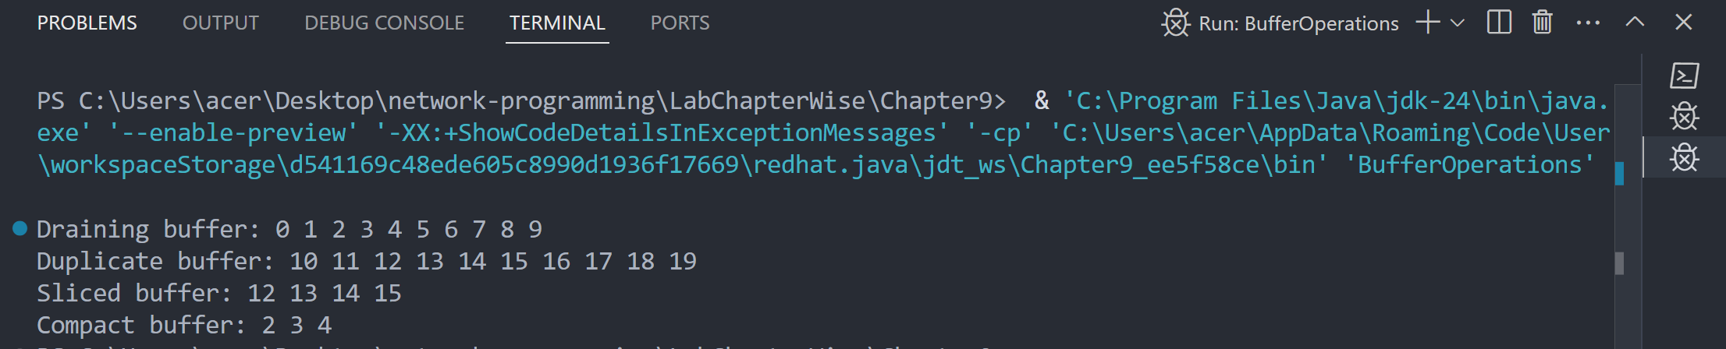
Lab 27
Objective: To write a program to implement the concept on Data Conversion
Source Code:
import java.nio.ByteBuffer;
import java.nio.CharBuffer;
import java.nio.charset.Charset;
import java.nio.charset.StandardCharsets;

public class DataConversion {
public static void main(String[] args) {
String input = "Hello, buffer world!";
System.out.println("Original String: " + input);

Charset charset = StandardCharsets.UTF_8;
ByteBuffer byteBuffer = charset.encode(input);

System.out.print("Encoded Bytes: ");
while (byteBuffer.hasRemaining()) {
System.out.print(byteBuffer.get() + " ");
}

byteBuffer.rewind();
CharBuffer decoded = charset.decode(byteBuffer);
System.out.println("\nDecoded String: " + decoded.toString());
}
}

Output:
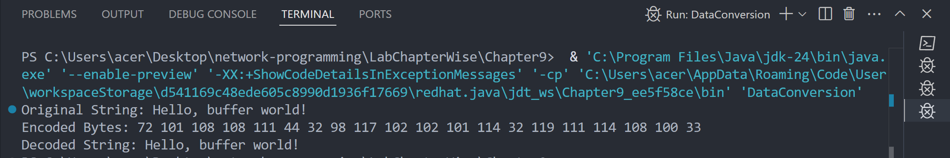

Chapter 10: UDP
Lab 28
Objective: To write a program for UDP Client
Source Code:
import java.net.DatagramPacket;
import java.net.DatagramSocket;
import java.net.InetAddress;
import java.util.Scanner;

public class UDPCLient {
public static void main(String[] args) {
try {
DatagramSocket clientSocket = new DatagramSocket();
InetAddress serverAddress = InetAddress.getByName("localhost");
Scanner scanner = new Scanner(System.in);

System.out.print("Enter message to send: ");
String message = scanner.nextLine();
byte[] sendBuffer = message.getBytes();

DatagramPacket sendPacket = new DatagramPacket(sendBuffer, sendBuffer.length, serverAddress, 9876);
clientSocket.send(sendPacket);

// Receive response
byte[] receiveBuffer = new byte[1024];
DatagramPacket receivePacket = new DatagramPacket(receiveBuffer, receiveBuffer.length);
clientSocket.receive(receivePacket);

String response = new String(receivePacket.getData(), 0, receivePacket.getLength());
System.out.println("Server replied: " + response);

clientSocket.close();
scanner.close();
} catch (Exception e) {
e.printStackTrace();
}
}
}

Output:
(before connecting to server)
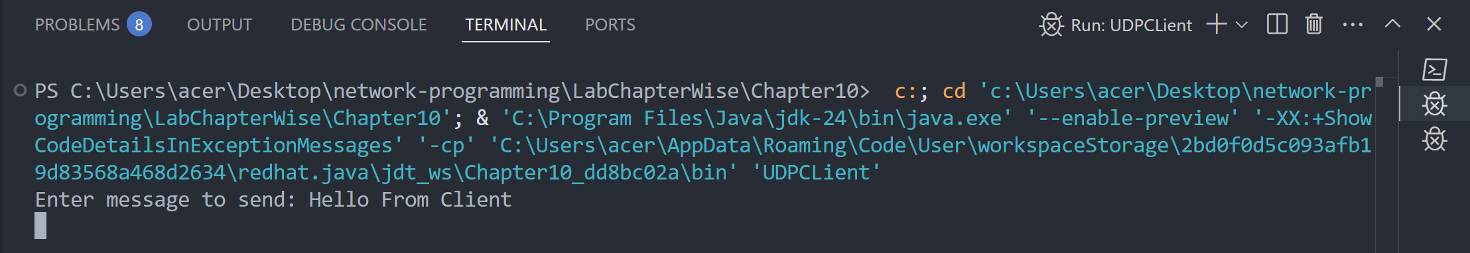
(after connecting to server)
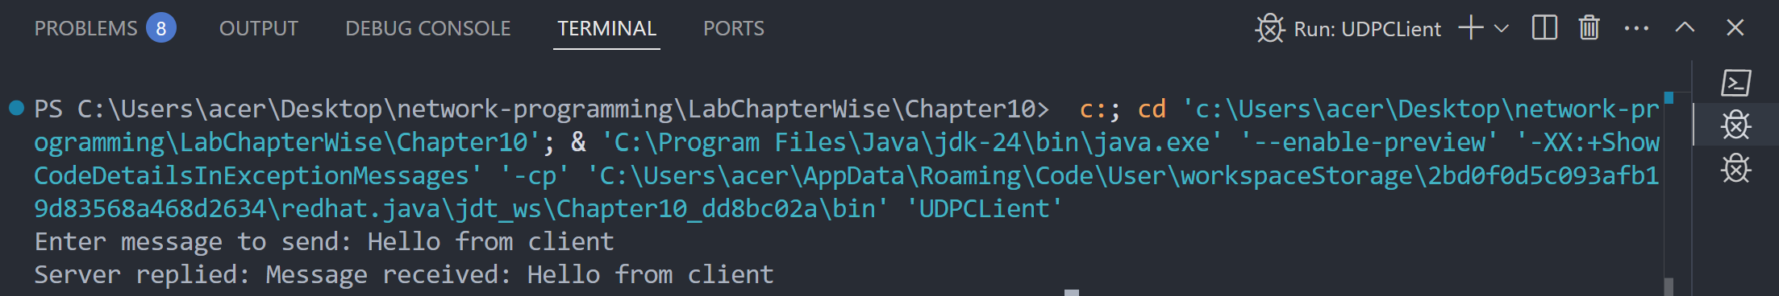

Lab 29
Objective: To write a program for UDP Server.
Source Code:
import java.net.DatagramPacket;
import java.net.DatagramSocket;

public class UDPServer {
public static void main(String[] args) {
try {
DatagramSocket serverSocket = new DatagramSocket(9876);
byte[] receiveBuffer = new byte[1024];

System.out.println("Server is running and waiting for data...");

// Receive packet
DatagramPacket receivePacket = new DatagramPacket(receiveBuffer, receiveBuffer.length);
serverSocket.receive(receivePacket);
String clientMessage = new String(receivePacket.getData(), 0, receivePacket.getLength());
System.out.println("Client says: " + clientMessage);

// Send response
String reply = "Message received: " + clientMessage;
byte[] sendBuffer = reply.getBytes();

DatagramPacket sendPacket = new DatagramPacket(
sendBuffer,
sendBuffer.length,
receivePacket.getAddress(),
receivePacket.getPort()
);
serverSocket.send(sendPacket);

serverSocket.close();
} catch (Exception e) {
e.printStackTrace();
}
}
}

Output:
(before any client connects)
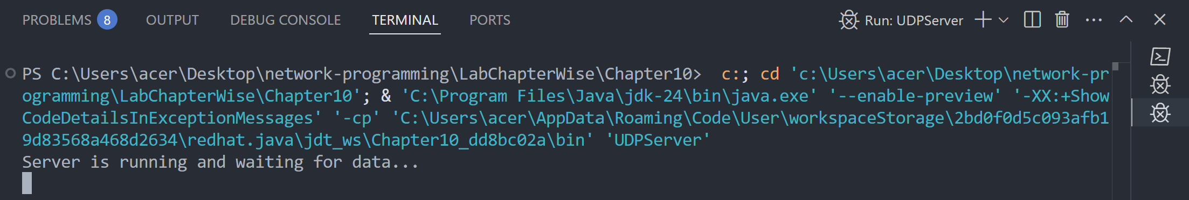
(after client connects)
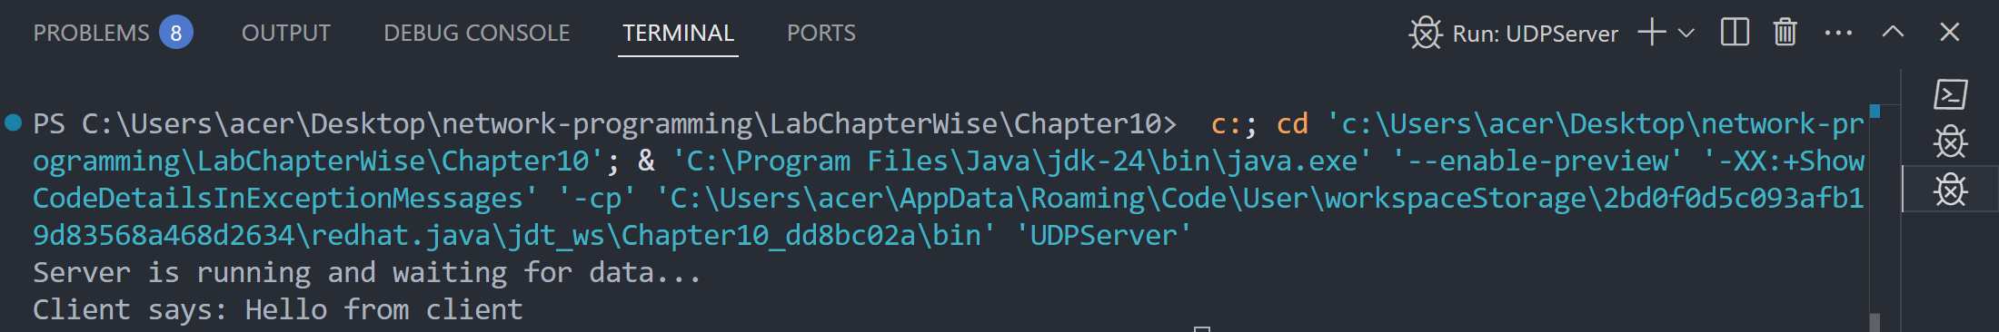

Chapter 11: IP Multicast
Lab 30
Objective: To verify that you are receiving multicast data at a particular host.
Source Code:
import java.io.IOException;
import java.net.DatagramPacket;
import java.net.InetAddress;
import java.net.MulticastSocket;

public class MulticastReceiver {
public static void main(String[] args) {
final int PORT = 4446; // Use the same port as sender
final String MULTICAST_GROUP = "230.0.0.0"; // A valid multicast IP

try {
MulticastSocket socket = new MulticastSocket(PORT);
InetAddress group = InetAddress.getByName(MULTICAST_GROUP);

socket.joinGroup(group);
System.out.println("Joined multicast group. Listening for messages...");

byte[] buffer = new byte[1024];
DatagramPacket packet = new DatagramPacket(buffer, buffer.length);

socket.receive(packet);
String received = new String(packet.getData(), 0, packet.getLength());

System.out.println("Received multicast message: " + received);

socket.leaveGroup(group);
socket.close();
} catch (IOException e) {
e.printStackTrace();
}
}
}

Output:
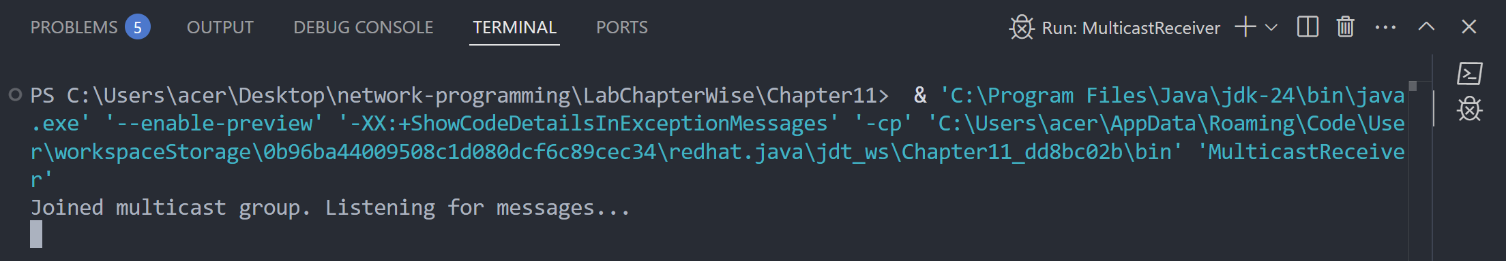

Chapter 12: RMI
Lab 31
Objective: To add two numbers using RMI
Source Code:
Calculator.java
import java.rmi.Remote;
import java.rmi.RemoteException;

public interface Calculator extends Remote{
int add(int a, int b) throws RemoteException;
}

CalculatorRemote.java
import java.rmi.RemoteException;
import java.rmi.server.UnicastRemoteObject;

public class CalculatorRemote extends UnicastRemoteObject implements Calculator{
//constructor
public CalculatorRemote() throws RemoteException {
super();
}

@Override
public int add(int a, int b){
return a + b;
}
}

Server.java
import java.rmi.registry.LocateRegistry;
import java.rmi.registry.Registry;

public class Server {
public static void main(String[] args) {
try{
CalculatorRemote objCalculatorRemote = new CalculatorRemote();
Registry registry = LocateRegistry.createRegistry(9000);
registry.bind("Multiply", objCalculatorRemote);
System.out.println("Server is ready to accept requests...");
}catch (Exception e) {
System.out.println("Server exception: " + e.getMessage());
e.printStackTrace();
}
}
}

Client.java
import java.rmi.registry.LocateRegistry;
import java.rmi.registry.Registry;

public class Client {
public static void main(String[] args) {
try {
Registry registry = LocateRegistry.getRegistry("localhost", 9000);
Calculator calculator = (Calculator) registry.lookup("Multiply");
int value = calculator.add(60, 10);
System.out.println("Result is: "+value);

} catch (Exception e) {
System.out.println("Client exception: " + e.getMessage());
e.printStackTrace();
}
}
}

Output:
(server)
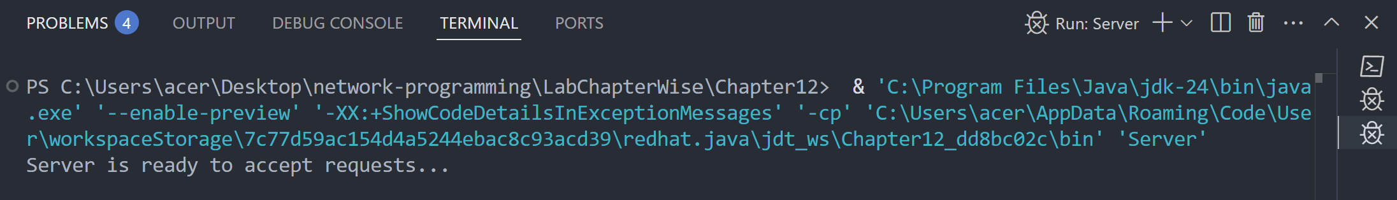
(client)
