**Database Normalization:**

Database normalization provides the efficiency to the database by organizing the data with mainly two reasons:

1. Reducing redundant data from database: This means that it helps to manage the store management of same data into different tables.
2. To create data dependency for tables: It refers to create or consumes the database reduction with efficient data structure and eliminates the space of data amount.

In general, Database normalization is just the normal forms or representation of data structure in the database to guide the proper database structure.

Different Types of Normalization Forms are described in below:-

* First Normal Form (1NF)
* Second Normal Form (2NF)
* Third Normal Form (3NF)

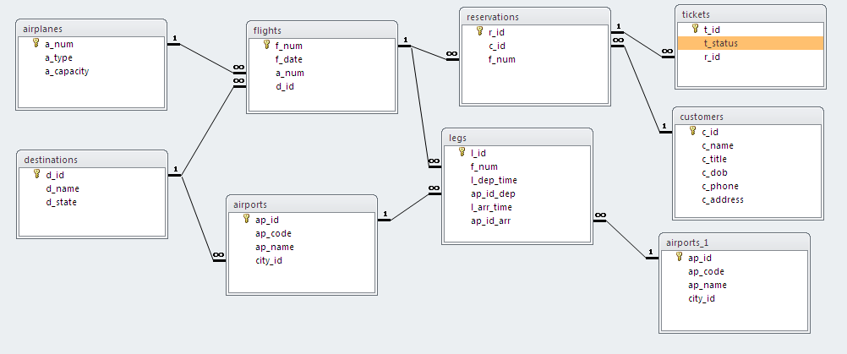

*Figure: Relationship in MS Access (ERD)*

As per assignment (given scenario), the ERD diagram is shown in above figure representing tables relationships, unique fields and cardinality between tables or entities. Here, flights entity consumes the second normal form that means, there is also data reduction with respective to that table with foreign id for another table. The diagram provides different structure of normal forms such as 3NF, 2NF or simple normal form representation between the tables. The form input design are created with the help of MS Access, and dependencies list are show in below figure.

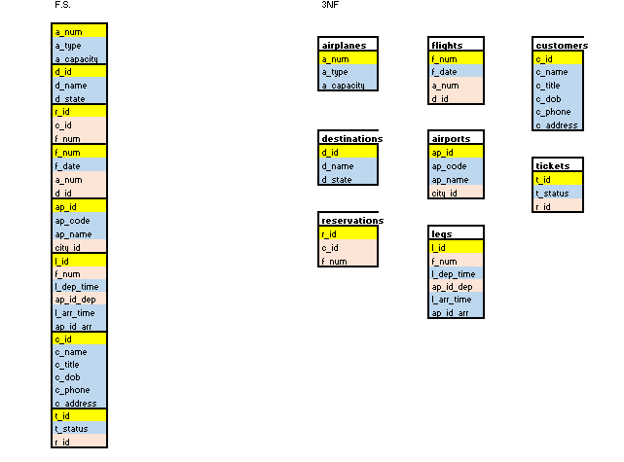

Figure: 3NF Dependency Entity

**Queries:**

1. SELECT Student.ID, Student.FirstName, Student.LastName, Student.Phone, Student.Address FROM Student;
2. SELECT customers.c_id, customers.c_name, customers.c_title, customers.c_dob, customers.c_phone, customers.c_address, reservations.r_id, flights.f_date, flights.f_num FROM flights INNER JOIN (customers INNER JOIN reservations ON customers.c_id = reservations.c_id) ON flights.f_num = reservations.f_num GROUP BY flights.f_date;
3. SELECT airplanes.a_num, airplanes.a_type, airplanes.a_capacity, flights.f_num, flights.f_date, flights.d_id, destinations.d_name, destinations.d_state FROM destinations INNER JOIN (airplanes INNER JOIN flights ON airplanes.a_num = flights.a_num) ON destinations.d_id = flights.d_id;