LCS Lab

1. Write a function: string LCS(string s, string t) which given two string returns the LCS of the string
   1. The function will create the C table and B table.
   2. Calculate the C and B table.
   3. Print out the contents of the C table at the end (for debugging purposes).
   4. Return the LCS (using the C and B tables to find the LCS).
2. Main:

a. Ask the user for two different strings.

b. Call LCS

c. Display the LCS string

d. Display the C table.

Test Examples:

**Case 1) Answer 8 characters**

abacabaca

bacbacbacbac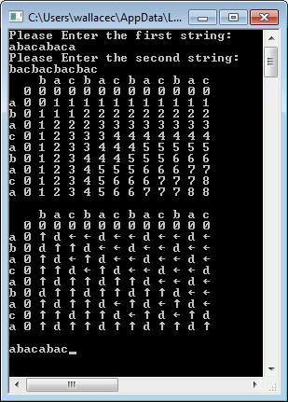

**Case 2) Answer 8 characters**

abacabac

bacbacbacbac

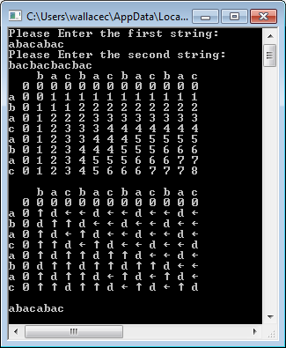

**Case 3) Answer 7 characters**

abacaba

bacbacbacbac

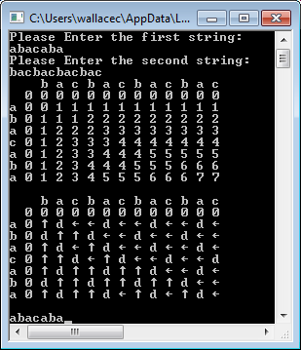

**Case 4) Answer 7 characters**

abacabac

bacbacbacba

