AEM 412 Homework 1 Solutions

1. Farmer Jones must determine how many acres of corn and wheat to plant this year.
An acre of wheat yields 25 bushels of wheat and requires 10 hours of labor per week. An acre of corn yields 10 bushels of corn and requires 4 hours of labor per week. All wheat can be sold at $4 a bushel, and all corn can be sold at $3 a bushel. Seven acres of land and 40 hours per week of labor are available. Government regulations require at least 30 bushels of corn be produced during the current year. Let x₁ = number of acres of corn planted and x₂ = number of acres of wheat planted.

- Using these decision variables, formulate an LP whose solution will tell Farmer Jones how to maximize the total revenue from wheat and corn.
- Is (x₁ = 2, x₂ = 3) in the feasible region?
- Is (x₁ = 4, x₂ = 3) in the feasible region?
- Is (x₁ = 2, x₂ = -1) in the feasible region?
- Is (x₁ = 3, x₂ = 2) in the feasible region?
- Graphically solve the problem - your answer should include the identification of the feasible region, optimal solution, binding constraints and isoprofit line.
- Using the variables x₁ = number of acres of bushels of corn produced and x₂ = number of bushels wheat produced reformulate Farmer Jones’s LP.

2. Read the article about the United Airlines Station Manpower Planning System.
(you can download it from www.cs.cornell.edu/gomes/412/FILES/UnitedAirlines.pdf).

Write a summary (max 2 pages) addressing the following issues:

- Background that led to undertaking this project.
- Outline the system developed describing:
  - Main project objectives.
  - How the requirements for the system are determined.
  - How schedules are produced and employees assigned.
  - Optimization techniques used.
  - How they address the issue of the integrality of solutions and how the information provided by the continuous solution is used.
  - Implications of the size of the problem.
- Importance of getting the users of the system involved in its development.
- The various tangible and intangible benefits that resulted from the project

Solution:

1. max z = 30x₁ + 100x₂
s.t. x₁ + x₂≤7 (Land Constraint)
4x₁ + 10x₂≤40(Labor Constraint)
10x₁ ≥30(Govt. Constraint)
x₁≥0, x₂≥0

2. No, government constraint is violated.

3. No; Labor constraint is not satisfied.

4. No, x₂≥0 is not satisfied.

5. Yes, all constraints and sign restrictions are satisfied.

6. Graphical solution

EF is 4x1 + 10x2 = 40, CD is x1 = 3, and AB is x1 + x2 = 7. The feasible region bounded by ACGH. The arrow is the gradient of the objective function. The dotted line in graph is isoprofit line 30x1 + 100x2 = 120.
Point G is optimal. At G the constraints 10x1≥30 and 4x1 + 10x2≤40 are binding. Thus optimal solution has x1 = 3, x2 = 2.8 and z = 30(3) + 100(2.8) = 370.

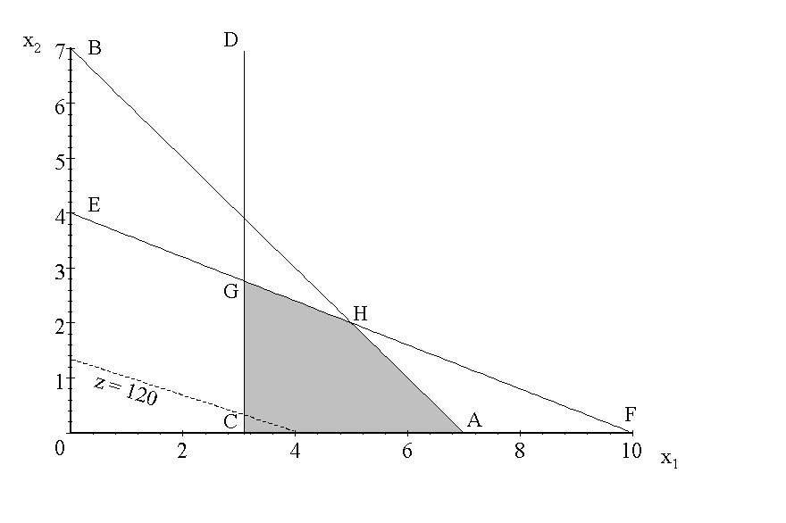

7. 1 bushel of corn uses 1/10 acre of land and 4/10 hours of labor while 1 bushel of wheat uses 1/25 acre of land and 10/25 hours of labor. This yields the following formulation:

max z = 3x₁ + 4x₂
s.t. x₁/10 + x₂/25≤7 (Land Constraint)
4x₁/10 + 10x₂/25 ≤ 40 (Labor Const.)
x₁ ≥30 (Govt. Const.)
x₁≥0, x₂≥0

2. United Airlines Station Manpower Planning System Summary: Key Points

Background:

- highly competitive industry: minimizing costs is essential to firm’s survival
- expansion and increased complexity associated with this led management to take on cost-control measures, including the rationalization of staff schedule planning.
- shift schedules at airports and reservations offices were done by hand prior to the study

Project objectives:

- overall objective: minimize staffing costs in the context of increasing volume and associated complexity
- sub-objectives: develop shift schedules to:
- determine needs for increased manpower
- identify excess manpower for reallocation
- reduce time required for preparing schedules
- make manpower allocation more day- and time-sensitive
- quantify costs associated with scheduling

How requirements for the system are determined

- Coverage requirements are based on historical data of activity loads over the day / month / year.
- Shifts are defined by work hours, required briefing and break periods, and alternative placement times for breaks (most of which are determined by labor law; also perhaps by company norms and / or contracts with unions)
- All combinations of days off are permitted but weak preference is given to those preferred by employees.
- Manpower costs are also set by existing company norms and / or labor law / contracts.
- Available manpower is limited by total staff number, and the legally required number of part-time staff as a proportion of total staff.
- Operational restrictions include the number of employees coming into and leaving shifts at the same time.

How schedules produced and employees assigned:

- 30-minute intervals based on coverage requirements are used to construct a seven-day schedule according to shift definitions, operational restrictions, etc. This seven-day schedule is repeated to form month-long bloc; month blocs (which may differ) are then put together to form trimester employee work schedules based on month-to-month transition rules and considering employee schedule preferences, and using the day-off pairing module.

- employees list trimester schedules in order of preference; schedules are then assigned according to seniority.

Optimization techniques used:

- mixed integer linear programming
- linear programming
- heuristic rounding routine
- network assignment model

Integrality:

- The system contains an option for solving the full integer model, which has been used for employee work groups with fewer shift alternatives.

- For airports and reservations offices (the two main staffing units), linear programming is used, and a heuristic rounding algorithm is used to convert fractional LP solutions to integer values. This works because the solution set is large, so integer solutions exist which do not differ much from noninteger solutions (typically 2-5%)

- The continuous solution provides a lower bound obtainable on staffing costs. It serves as an indicator of what gains might be realized through manual manipulation of the schedule, and provides schedulers with a gauge to evaluate the quality of the final schedules produced by the system. The narrow margin between optimal (continuous) and final (integer) solutions was a key selling point for the system to senior management.

Implications of problem size:

- Original run times were sometimes excessive; some design changes were required to produce a viable modeling system.

Importance of getting the users of the system involved in its development:

- Reservations managers resisted the first work schedules, which had been developed without much consultation, and ignored non-economic considerations they deemed essential. Subsequent reservations work schedules developed with more participation were better accepted.

Benefits:

- labor cost savings of $6 million per annum (plus additional savings through contract negotiation application)
- improved customer service
- improved employee schedules
- quantified manpower planning and evaluation
- additional revenue from improved service
- savings from: reduced support staff requirements, reduced manual scheduling efforts, smaller work groups, and reduced training requirements
- application is expected to grow to include 20% of United’s work force

