A Modular Platform for Capturing and Preserving Digital Evidence for OSINT
Carlos Marques  BSc in Computer Engineering  Department of Science and Technology, Universidade Aberta, Lisbon, Portugal  Postgraduate qualification in Cybersecurity and Corporate Resilience, NOVA FCT Executive Education, in partnership with ISACA Lisbon Chapter  Cybersecurity Director, Prosegur Cybersecurity, Portugal  Email: 2003851@estudante.uab.pt  Permanent email: cmarques1985@outlook.pt  ORCID: 0009-0002-2551-5927 | Pedro Duarte Pestana  Department of Science and Technology, Universidade Aberta, Lisbon, Portugal  Research Centre for Arts and Communication (CIAC), Lisbon, Portugal  Centre of Statistics and Applications, Faculty of Sciences (CEAUL), Universidade de Lisboa, Lisbon, Portugal  Email: pedro.pestana@uab.pt  ORCID: 0000-0002-3406-1077

Abstract
Web content changes with time, session state, and browser execution. This paper presents a modular platform that captures browser artefacts and preserves them in a portable, verifiable evidence package for OSINT. A browser extension invokes a local FastAPI service and a Playwright-based Python engine. The engine inventories the captured files in a manifest, records their SHA-256 digests, and signs the manifest with Ed25519. A standalone verifier accepts both directories and ZIP packages. The complete regression suite passed all 25 tests. Browser evaluation comprised 87 capture attempts: three repetitions of nine controlled fixtures and 20 public websites. All 27 fixture attempts produced packages, and 24 met every behavioural assertion. Content inserted after a three-second delay was absent in the remaining three runs. The live corpus yielded 44 packages from 60 attempts, including 38 HTTP 200 responses and six access-error responses. All 142 intact directory and ZIP checks passed, and all 852 checks across six mutation classes rejected modified inputs. These results demonstrate the tested tamper-detection workflow and identify capture readiness and timeout handling as the main acquisition problems. The architecture, authenticated package format, and reproducible evaluation provide an inspectable basis for further OSINT preservation work.
Keywords: OSINT, digital evidence, digital preservation, SHA-256, Ed25519.
1. Introduction
The Web has become a routine source for research, journalism, cybersecurity, auditing, and open-source intelligence. What a user sees at a particular moment is often temporary. Pages are revised or removed, scripts rebuild content during loading, and external resources change independently of the main site. Location, session state, and browser configuration may also affect the result. A stored URL may therefore lead to a different page later, while a screenshot records only the visible layer of the original observation.
Reliable preservation needs a documented process. RFC 3227 recommends contemporaneous notes, time references, cryptographic checks, and custody records during evidence collection (Brezinski & Killalea, 2002). NIST guidance places the same emphasis on consistent handling, integrity, and documentation when forensic techniques form part of incident response (Kent et al., 2006). The prototype applies these principles to the collection and later verification of Web observations.
The project began with a practical question: how could a Web observation be converted into a package that another person could inspect and verify later? The resulting prototype runs locally and keeps the user close to the normal browsing context. Its design separates user interaction from capture, cryptographic preservation, packaging, and verification.
Capture starts in a browser extension and reaches the Python engine through a local HTTP API. Playwright controls the browser and produces several views of the page and its execution context. The engine then calculates SHA-256 digests, creates and signs the manifest with Ed25519, records basic custody events, writes reports, and builds a verifiable ZIP package. The public key travels with the package. The private key remains in a separate storage area.
The platform combines Web capture and cryptographic preservation in a workflow that can be inspected at each stage. The paper makes three contributions:
1. A modular architecture that separates Web acquisition, cryptographic preservation, packaging, and verification, enabling each responsibility to be inspected, tested, and extended independently.
2. A self-contained evidence package format and workflow in which heterogeneous artefacts from a browser capture session are inventoried in a manifest authenticated with Ed25519 and linked to their contents through SHA-256 digests.
3. A reproducible implementation and evaluation using controlled fixtures, a fixed live-site corpus, and automated tampering experiments. The 87 capture attempts assess acquisition behaviour, while directory and ZIP checks test the rejection of changes to artefacts, manifests, and signatures.
The package can be inspected and verified without running the capture service. This separation allows a recipient to check the files against the signed inventory using a standalone tool.
The remainder of the article is organised as follows. Section 2 presents the background and related work. Section 3 describes the requirements, development methodology, and threat model. Section 4 details the architecture and implementation. Section 5 presents the validation strategy and results. Section 6 discusses the guarantees and limitations of the proposal. Section 7 summarises the conclusions and identifies directions for future development.
2. Background and related work
The literature review was updated on 29 July 2026 through a focused search of scholarly services and official repositories. The query families combined “web evidence”, “forensic acquisition”, “digital chain of custody”, “OSINT”, “preservation”, “integrity”, “timestamp”, and “self-verification”. Backward reference searching started from the Berkeley Protocol, Ćosić et al. (2011), Prayudi and Azhari (2015), and WEFT. Forward citation checks were also carried out for these seed works.
The review used a directed search, deduplication, and title or abstract assessment. Records were retained when they addressed live network acquisition, evidence containers, Web archiving, FIT, WEFT, or verifiable preservation. Marketing material, duplicate versions, sources without sufficient technical detail, and work unrelated to Web acquisition were excluded. The resulting selection situates the prototype within Web acquisition and evidence-preservation research.
Digital evidence handling depends on documented and repeatable procedures. Casey (2011) treats integrity, authenticity, and chain of custody as central to the evidential value of digital material. The International Organization for Standardization (2012) provides guidance for identification, collection, acquisition, and preservation in ISO/IEC 27037:2012. RFC 3227 separately recommends detailed notes, explicit time references, cryptographic checks, and custody records (Brezinski & Killalea, 2002). Ćosić et al. (2011) organise custody information around the questions of who, what, when, where, why, and how. Prayudi and Azhari (2015) identify documentation, interoperability, storage security, and understandable presentation as recurring challenges.
The Berkeley Protocol applies these concerns to digital open-source investigations. It distinguishes routine screenshots from material collected for possible evidential use and recommends preserving context at the point of collection, retaining content close to its native form, recording transformations, and assigning hashes when stronger assurance is needed (Office of the United Nations High Commissioner for Human Rights & Human Rights Center, 2022). Accuracy, data minimisation, preservation, and security by design provide a useful methodological basis for automated OSINT collection.
Cryptographic controls support later verification. SHA-256 produces a 256-bit digest and makes unrecorded changes detectable with overwhelming probability (National Institute of Standards and Technology, 2015). A digest does not identify the party that established the reference value, so the prototype signs the manifest with Ed25519. RFC 8032 specifies the underlying Edwards-curve signature mechanism and the public-key verification model used here (Josefsson & Liusvaara, 2017).
Web preservation systems pursue different balances between fidelity, replay, portability, and evidential assurance. Zannettou et al. (2018) documented the large-scale use of archiving services to preserve online material that might later disappear. The Library of Congress (2024) describes WARC as a container for request, response, resource, and metadata records. Memento adds datetime negotiation for earlier representations of Web resources (Van de Sompel et al., 2013). ArchiveBox (2026) retains pages in several user-controlled formats, while Browsertrix uses real-browser capture for high-fidelity archiving (Webrecorder, 2026). Conifer was a hosted service for creating and revisiting collections. Rhizome stopped new captures in May 2026 and replaced Conifer with a read-only access application in June 2026, with migration paths based on Browsertrix and WACZ (Rhizome, 2025).
Earlier work on live network evidence established several ideas used by current Web acquisition systems. Nikkel (2006) presented a portable collector for traffic associated with remote services. Castiglione et al. (2019) extended live acquisition to Web pages and other online content through a guided process that recorded network data and client-side output, with a trusted third party certifying the acquisition. Evidence-container research has followed a related path. ECo-Bag uses a Merkle-tree structure to manage content, provenance, and integrity within a flexible digital evidence container (Han et al., 2024).
FIT provides a dedicated ecosystem for forensic acquisition of online content. Its 2.x line is no longer supported, and the project is being reorganised as a modular suite with separate acquisition components (FIT Project, 2026). WEFT evaluated FIT as an open-source reference and proposed a single pcapng artefact, chained blocks, trusted timestamps, and automated verification (Cantelli-Forti et al., 2025). Its four challenges provide the comparison framework used here: C1 evidence tampering, C2 timestamp tampering, C3 a single source of truth, and C4 self-verification.
Modern pages depend on scripts, redirects, asynchronous requests, and browser state, which makes browser automation necessary for the proposed capture method. Playwright supports Chromium, Firefox, and WebKit and exposes network and console events (Microsoft, 2026a). Its Trace Viewer records DOM snapshots and execution information that can later help explain the capture sequence (Microsoft, 2026b). The prototype uses these capabilities while keeping preservation and verification in separate modules.
Table 1 - Comparison against the WEFT challenge framework.
Criterion | FIT version evaluated by WEFT | WEFT | Proposed platform
C1 Evidence tampering | Partial. Files are hashed during finalisation, leaving a pre-finalisation interval. | Addressed through chained blocks whose endpoints are protected by trusted timestamps. | Partial. SHA-256 and Ed25519 expose post-capture changes, but the capture-to-signature interval is not externally anchored.
C2 Timestamp integrity | Limited. The evaluated workflow does not provide a continuous trusted timeline. | Addressed with certified start and end timestamps linked to the event chain. | Not addressed. The prototype records local timestamps without an external timestamp authority.
C3 Single source of truth | Not addressed. Evidence is distributed across several output files. | Addressed through one pcapng evidence artefact. | Partial. The manifest and ZIP form a coherent package, although the captured artefacts remain separate files.
C4 Self-verification | Partial. Hash validation is available without automatic cross-source content correlation. | Addressed through automated integrity checking and partial correlation of captured content. | Partial. Signature and hash checks are automatic, but screenshot, HAR, HTML, PDF, and trace content are not cross-correlated.

Table 1 locates the prototype within the WEFT comparison framework. Its signed manifest supports post-capture integrity checking across several artefact formats. WEFT additionally addresses a trusted timeline, a single evidence representation, and correlation between captured sources.
3. Requirements, methodology and threat model
Development followed an iterative, requirements-driven approach. An initial command-line proof of concept validated the feasibility of automating navigation and generating artefacts. The solution was subsequently reorganised into a modular architecture comprising a browser extension, an API, and an internal engine. This evolution made it possible to test each responsibility independently and demonstrate the complete workflow without concentrating all logic in a single script.
The functional requirements covered the complete lifecycle of a run. Capture had to start from the active browser URL and create an independent directory containing page and session artefacts. The engine then had to hash the files, build and sign a manifest, record basic custody events, produce reports, and create a ZIP export. The same verifier had to accept either the directory or the exported package. Modularity, readable output, local execution, private-key exclusion, and clear error messages guided the non-functional design.
Evaluation combines software regression tests, controlled browser fixtures, a fixed corpus of public websites, and mutations of signed packages. The browser experiment records package production, HTTP status, behavioural assertions, and integrity verification as separate outcomes. Section 5 presents the execution conditions and results.
The threat model assumes that a third party may obtain a package after capture and modify files, remove entries, or edit the manifest without access to the signing key. The verifier should expose those changes. The model excludes a compromised capture machine, manipulation during navigation, private-key theft, replacement of both the package and public key when no external trust anchor exists, and falsification of the local clock.
The verification result concerns the files listed in the manifest and the public key supplied to the verifier. External key trust and temporal assurance are discussed in Section 6.
4. Architecture and implementation
The architecture separates responsibilities among user interaction, the HTTP boundary, and technical processing. Figure 1 presents the main components. The extension obtains the active URL and triggers the request. The API validates the parameters and forwards the operation. The engine creates the run, controls the browser, produces the artefacts, protects the manifest, and provides verification.
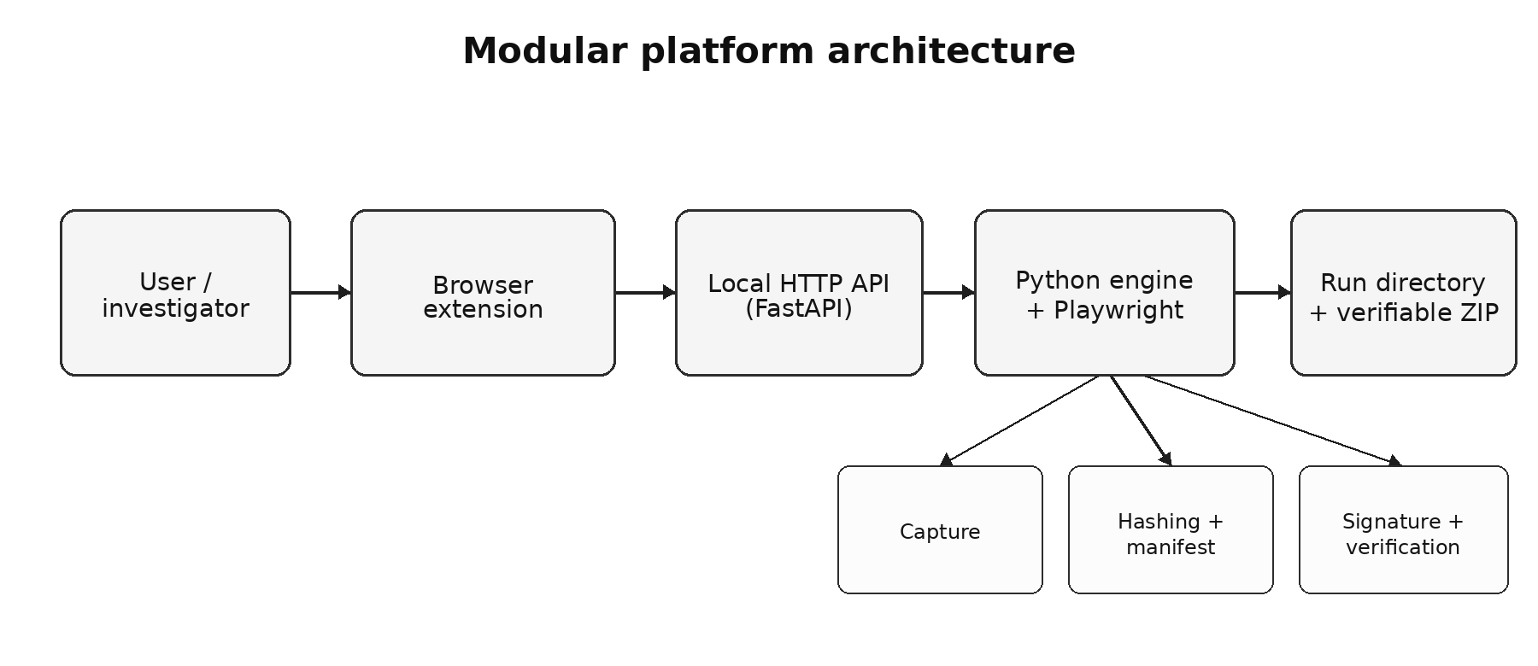
Figure 1 - Modular architecture of the platform.
Table 2 - Main components and responsibilities.
Component | Primary responsibility
Browser extension | Browser interface, reading the active URL, and starting the capture.
Local API (FastAPI) | Receipt and validation of the HTTP request, with decoupling between the interface and the engine.
Orchestration service | Coordination of the capture, preservation, signing, reporting, and packaging pipeline.
Playwright module | Automated navigation and production of page and session artefacts.
Hashing and manifest | SHA-256 computation and construction of the structured inventory.
Signing and keys | Ed25519 signing of the manifest and provision of the public key.
Verifier | Signature validation, hash recomputation, and presentation of discrepancies.

The browser extension starts capture from the active tab by sending its URL to the local API. The engine handles file creation, hashing, and key management. This keeps the browser interface small and places preservation operations in modules with direct access to the file system.
The FastAPI service validates input, normalises parameters, and returns structured results (FastAPI, 2026). Its HTTP interface separates the client from the capture engine, allowing a desktop application or another client to invoke the same workflow.
Each request creates a run directory identified by the domain and timestamp. The directory groups the captured files, metadata, manifest, and verification material. This organisation provides a self-contained unit for inspection, export, and archiving.
The output set represents several dimensions of the observation. HTML retains the acquired document structure, PDF provides a paginated representation, and the screenshot records the visible page. HAR describes network requests and responses, while console logs and the Playwright trace retain execution context that is absent from a static image. Capture and HTTP metadata record the target, final URL, title, browser, response, and time information. Table 3 summarises the artefacts produced for each run.
Table 3 - Artefacts generated for each run.
Artefact | Content and purpose
capture_metadata.json | Capture summary: source and final URL, title, time, browser, and execution parameters.
http_metadata.json | HTTP status, relevant headers, content type, and information about the main response.
console_logs.json | Messages, warnings, and errors emitted by the browser console.
network.har | Structured record of requests and responses observed during navigation.
page.html | Snapshot of the HTML obtained at the time of collection.
page.pdf | Paginated representation of the page for inspection and archiving.
screenshot.png | Visual representation of the captured page.
trace.zip | Playwright trace containing events, snapshots, and diagnostic information.
manifest.json | Inventory of files, SHA-256 hashes, sizes, types, and run metadata.
manifest.sig | Ed25519 signature computed over the manifest.
keys/public_key.pem | Public key required to validate the signature.
evidence_bundle.zip | Exportable evidence package without the private key.

The capture and preservation pipeline is shown in Figure 2. After receiving the URL, the service creates the run directory and starts a browser context. Navigation is performed with Playwright, taking advantage of real-browser control and network observation capabilities (Microsoft, 2026a). Once collection is complete, the system closes browser resources in a controlled manner and begins the preservation phase.
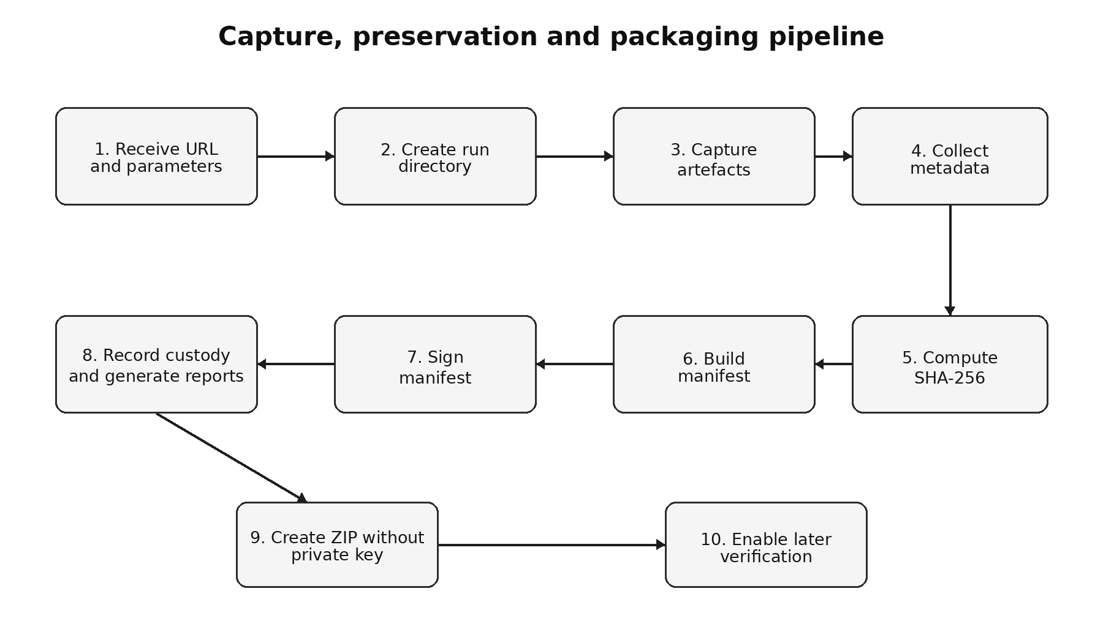
Figure 2 - Capture, preservation and packaging pipeline.
During the preservation phase, the engine processes the files that should form part of the evidence and computes their SHA-256 values. For each entry, the manifest records at least the relative path, cryptographic digest, size, and logical classification of the artefact. The manifest also aggregates global metadata such as the requested URL, the final URL after redirects, the page title, capture time, browser information, and references to the generated reports. This centralisation prevents hashes from existing without context and turns the manifest into the verifiable index of the run.
SHA-256 links each inventoried artefact to its recorded digest, and Ed25519 authenticates the manifest. Changing a file causes a digest mismatch. Rewriting the corresponding digest changes the signed manifest and invalidates its signature. The verifier therefore requires the signature as well as matching hashes.
The private key is stored outside the run directory and excluded from the ZIP export. The public key accompanies the package for signature verification. Key protection, distribution, rotation, and retirement follow a separate lifecycle from evidence packaging (Barker, 2020).
The chain-of-custody record is intentionally simplified. It records creation of the run, completion of capture, generation and signing of the manifest, packaging, and verification. These events improve technical auditability. A complete procedural chain would also identify every responsible person, transfer, period of possession, storage location, and organisational control.
The final ZIP package facilitates transport and archiving. The directory remains available for local inspection, and the verifier accepts both forms. For a ZIP input, the verifier extracts the contents to a controlled temporary location and applies the same checks used for a directory. This symmetry limits differences between the working run and its exported form.
Figure 3 shows the verification workflow used in the evaluated correction. The verifier requires the manifest, signature, and public key, checks the signature, and then compares the inventoried file hashes. For a parseable manifest with an invalid signature, it also collects hash discrepancies to support diagnosis. The final result remains a failure.
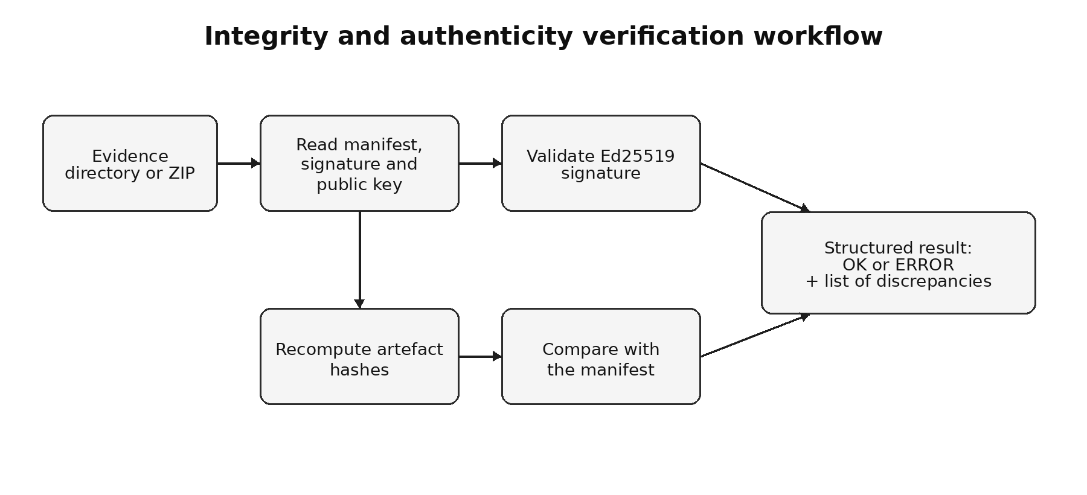
Figure 3 - Integrity and authenticity verification workflow.
Verification succeeds only when the required authentication material is present, the signature validates, and every inventoried file passes its content check. The same conditions apply to a run directory and its ZIP export.
5. Validation and results
5.1 Regression tests and verification checks
The original evaluation reported 15 passing tests and an end-to-end capture of example.com. A subsequent reproduction ran 12 tests, with three browser tests blocked by an unavailable Chromium binary. A synthetic audit then exposed an optional-signature check that accepted packages after signature removal, including cases with rewritten artefact hashes. The verifier was corrected to require authentication material, and ten regression checks were added. This development history led to the 25-test suite and the broader browser experiment reported below.
The corrected suite comprises 25 tests: the 15 original tests and ten parameterised regression checks. The added checks cover missing signatures, altered content with rewritten hashes and a removed signature, malformed signatures, missing public keys, and malformed manifest JSON. Each scenario is exercised through directory and ZIP inputs.
The complete 25-test suite was executed on 13 October 2026 on Linux with Python 3.14.4, pytest 9.1.1, pluggy 1.6.0, and anyio 4.15.1. All 25 tests passed in 6.22 s, with no failures or skipped tests. This execution included the three browser-dependent tests for HTTP and console artefacts, PDF output, and HAR and trace generation. The run produced a verbose text log and a JUnit XML report. Section 5.2 describes the separate 87-attempt browser experiment conducted on 6 October 2026.
The corrected verifier also passed a synthetic integrity check using three independently signed packages. Each package was verified as a directory and a ZIP, then subjected to the six mutation classes described in Section 5.2. All six intact inputs were accepted and all 36 modified inputs were rejected. The correction is published at commit a998681ab00290b9619bbb33dbb26e1de76d9174.
5.2 Browser evaluation design
The capture experiment ran on 6 October 2026 with the corrected verifier. It scheduled three repetitions of nine local fixtures and 20 public URLs, giving 87 attempts. Every scheduled attempt, including timeouts, appears in the recorded results. The SHA-256 values of all 13 engine Python files match the corrected implementation, and the fixture sources and fixed URL list match the evaluation materials.
Twenty public URLs on distinct domains formed the live corpus, with four from each of five categories: institutional portals, news, documentation, reference resources, and Web services. The selection covered different page structures and uses. Targets were fixed before execution and retained after failures. The supplementary materials list the URLs and selection rationales, and Table 6 reports each target’s outcome.
Nine locally served fixtures supplied known behaviour and expected markers (Table 4). DOM assertions inspected target elements. PDF checks extracted known text, screenshot checks counted distinctive colours, and HAR and console checks tested specified URLs, response codes, message levels, and markers. Trace-file availability was also checked.
Table 4 - Controlled fixtures, behavioural checks, and observed outcomes.
Fixture | Behaviour and principal checks | Packages | All checks met
static.html | HTML, external CSS and image; DOM/PDF markers, HAR resources and screenshot colours. | 3/3 | 3/3
delayed-dom.html | Marker inserted after 3 s; DOM/PDF marker and screenshot background. | 3/3 | 0/3
fetch.html | Asynchronous JSON fetch; request/status in HAR and rendered marker. | 3/3 | 3/3
redirect (A → B) | HTTP 302 and final URL; target content and resources. | 3/3 | 3/3
console.html | Known log, warning and error messages with expected levels. | 3/3 | 3/3
failed-resource.html | Deliberate missing resource; HTTP 404 recorded in HAR. | 3/3 | 3/3
iframe.html | Same-origin iframe request, PDF inner text and screenshot marker colour. | 3/3 | 3/3
dynamic.html | New per-load marker; three distinct observed markers, each independently verified. | 3/3 | 3/3
state.html | Rendered synthetic cookie/storage markers and fresh-storage console event. | 3/3 | 3/3
Captures ran on Ubuntu 26.04, x86-64 Linux 7.0.0-34, with 12 reported logical CPUs, Python 3.14.4, Playwright 1.63.0, and Chromium 153.0.8010.12. Three worker processes ran concurrently. Each capture used a fresh browser context with a 1280 × 720 viewport and the default locale. Navigation waited for networkidle with a 30 s timeout. Screenshot, HTML, and PDF collection then followed without an additional observation delay. The whole job had a 90 s worker limit. HTTPS errors were ignored, matching the original engine configuration.
For each attempt, the driver invoked the engine, recorded its outcome, checked artefact availability, and verified both directory and ZIP inputs. Fixture assertions tested the captured behaviour against known values. Cookie and storage fixtures used synthetic values rendered inside the engine’s fresh browser context.
Each produced package was first verified intact as a directory and a ZIP. Copies were then subjected to six mutation classes: artefact alteration, artefact removal, manifest alteration, artefact alteration with a rewritten digest and retained signature, signature removal, and artefact alteration with a rewritten digest and removed signature. The original public key was retained. Across 71 packages, this procedure generated 142 intact checks and 852 modified-input checks. Verifier exceptions were recorded separately from rejection results.
Package-production rates use all scheduled attempts as their denominator. A fixture run passes only when every specified behavioural assertion succeeds. Live-site results report package production, HTTP status, and cryptographic verification separately. Timing and size summaries describe completed captures, with incomplete attempts reported in the failure counts.
5.3 Results and failure analysis
Table 5 - Results of the 87 scheduled browser-capture attempts.
Measure | Controlled fixtures | Live websites
Scheduled attempts | 27 | 60
Packages produced | 27/27 (100%) | 44/60 (73.3%)
All fixture assertions met | 24/27 (88.9%) | Not assessed
HTTP 200 packages | 27/27 | 38/60 (63.3%)
Non-2xx packages | 0 | 6/60 (10.0%)
No completed package | 0 | 16/60 (26.7%)
Intact directory/ZIP checks accepted | 54/54 | 88/88
Modified-input checks rejected | 324/324 | 528/528
All 27 fixture attempts produced the eight expected non-empty capture artefacts and a verifiable package. Eight of the nine scenarios met every assertion in all three repetitions. In the delayed-DOM fixture, the marker inserted after three seconds was absent from the DOM, PDF, and screenshot checks in every repetition. Overall, 24/27 runs and 114/123 individual assertions passed. The dynamic fixture produced three distinct captured markers. The iframe marker appeared in the PDF and the expected screenshot region, while the top-level HTML snapshot omitted the frame’s inner content.
The live corpus produced 44 packages from 60 attempts. Fourteen targets completed all three repetitions, Universidade Aberta completed two, and five targets produced no completed package. Of the 44 packages, 38 recorded HTTP 200 across 13 targets. The other six preserved access-error responses: three CNCS captures with HTTP 517 and the title “Access Denied | DiamWall”, and three Reuters captures with HTTP 401. The title-based block-page flag detected CNCS and missed Reuters, showing the value of recording response status alongside page titles.
Table 6 - Live-site outcomes for all scheduled targets.
Target | Packages | Recorded HTTP status | Failed attempts
European Union | 3/3 | 200 | None
NASA | 0/3 | Not returned | 3 worker timeout
Universidade Aberta | 2/3 | 200 | 1 navigation timeout
CNCS | 3/3 | 517 | None
RTP Notícias | 0/3 | Not returned | 3 worker timeout
Público | 0/3 | Not returned | 1 navigation timeout, 2 worker timeout
BBC News | 3/3 | 200 | None
Reuters | 3/3 | 401 | None
Python documentation | 3/3 | 200 | None
MDN Web Docs | 3/3 | 200 | None
FastAPI | 3/3 | 200 | None
Playwright Python | 3/3 | 200 | None
Wikipedia | 3/3 | 200 | None
Project Gutenberg | 3/3 | 200 | None
Internet Archive | 3/3 | 200 | None
Open Library | 3/3 | 200 | None
GitHub repository | 3/3 | 200 | None
Stack Overflow | 0/3 | Not returned | 3 navigation timeout
OpenStreetMap | 3/3 | 200 | None
npm | 0/3 | Not returned | 3 navigation timeout
Eight attempts failed during Page.goto after waiting 30 s for networkidle: Universidade Aberta once, Público once, Stack Overflow three times, and npm three times. Another eight reached the 90 s worker limit: NASA three times, RTP three times, and Público twice. The worker-timeout records do not identify the interrupted stage, so these failures cannot be assigned more precisely to navigation, artefact generation, or packaging.
Every completed package contained the eight expected non-empty capture artefacts, and no exported package contained a private key. All 142 intact directory and ZIP checks passed. Every mutation class was rejected in all 142 corresponding checks, giving 852 rejections with no verifier exceptions.
Under the three-worker configuration, median capture-job time was 1.805 s for fixtures (range 1.573–2.115 s) and 7.578 s for completed live-site runs (1.815–27.684 s). Median ZIP size was 34,834 bytes for fixtures (30,802–56,021) and 3,902,128.5 bytes for live captures (215,878–18,999,523). Median verification times for directory and ZIP inputs were 2.29 and 7.10 ms for fixtures, and 25.51 and 58.76 ms for live packages.
The supplementary materials provide the fixed URL list, fixture server, evaluation driver, correction patch, environment records, source hashes, and per-attempt JSON/CSV results. These records expose the individual observations behind the aggregate tables.
5.4 Inspection of retained live-site packages
On 13 October 2026, six selected packages from the 6 October experiment underwent AI-assisted visual and structural inspection. The sample included FastAPI, Universidade Aberta, BBC News, OpenStreetMap, CNCS, and Reuters, spanning four HTTP 200 responses and both observed access-error types. Screenshots and all 35 PDF pages were visually reviewed and compared with HTML content and capture metadata. This purposive sample was used to identify concrete acquisition and representation issues, not to estimate a corpus-wide fidelity rate.
All six Ed25519 signatures validated over the stored manifest bytes using the included public keys. SHA-256 digests and byte lengths matched for all 72 inventoried files, and no private key was present in the six exports. Source and final URLs, titles, status codes, and capture times agreed across the manifest, capture metadata, and JSON report. HAR records corroborated the main-response status, accounting for the OpenStreetMap URL fragment and the CNCS redirect. All trace archives passed ZIP integrity checks and contained parseable event and network records, frame snapshots, and screencast frames. These checks establish internal consistency with the supplied keys, not external signer identity.
Table 7 - Observations from six retained live-site packages.
Sample identifier | HTTP / PDF pages | Visual observations
live-docs-fastapi-1 | 200 / 19 | Documentation text and illustrations retained. Terminal panels appear empty in screenshot and PDF; the PDF footer overlaps body text on page 17.
live-institution-uab-3 | 200 / 4 | Portal header, carousel and course links retained. Large empty “Em Destaque” region; PDF page 2 is blank and the carousel differs from the screenshot.
live-news-bbc-2 | 200 / 9 | News text and images retained beneath a cookie-consent overlay. Some images differ between screenshot and PDF; the last PDF page contains only a cookie banner.
live-service-openstreetmap-2 | 200 / 1 | Map tiles and welcome panel visible. Portrait PDF changes the layout and displayed map extent relative to the screenshot.
live-institution-cncs-1 | 517 / 1 | Screenshot and PDF show the DiamWall mitigation response rather than institutional content.
live-news-reuters-1 | 401 / 1 | Screenshot and PDF show an access-restriction notice rather than news content.
The inspected packages preserve different aspects of the browser observation. CNCS and Reuters HTML files retain iframe elements but omit the inner warning text visible in the screenshot and PDF. At HTTP 200 targets, consent overlays, empty regions, and PDF layout changes affect what a reader can recover. The UAb carousel difference and BBC image differences are consistent with state changes between sequential artefact captures, although their precise causes were not established. No comparison with a contemporaneous independent reference page was available.
6. Discussion
The evidence package links several representations of the same browser observation. HTML and PDF retain document content, the screenshot records its visual appearance, and HAR, console logs, and the trace preserve network and execution context. The signed manifest supplies a common inventory for these files.
The architecture separates acquisition from preservation and verification. A change to browser automation can therefore be tested without rewriting the signature or packaging modules. The same separation allows additional clients to use the API and recipients to verify exported packages independently.
Browser execution makes rendered content and session diagnostics available to the capture engine. Its cost and behaviour depend on page scripts, network activity, and external resources. The timeout distribution and missed delayed marker show where this dependency affects the current implementation.
The experiment gives concrete examples of the distinction between acquisition and preservation. The delayed-DOM packages retained an observation made before the expected insertion. CNCS and Reuters packages retained access-error responses. All passed integrity checks because the verifier correctly checked the files that had actually been collected. Acquisition decisions must therefore consider behavioural checks and response status alongside the verification result.
Signing the manifest provides a compact authenticity check whose value depends on trust in the public key. If an attacker replaces the package and the included key, a verifier with no trusted copy of the original key may accept the attacker’s signature. A real deployment should distribute the public key through an authenticated channel, associate it with a certificate, register it in a trusted repository, or use another external anchor. The local clock also provides no independent temporal proof. An RFC 3161 timestamp authority could show that a digest existed before a certified point in time (Adams et al., 2001).
6.1 Legal and data-protection considerations
Public availability does not remove legal and ethical constraints from OSINT collection. The General Data Protection Regulation requires a lawful basis when captured pages contain personal data and applies purpose limitation, minimisation, accuracy, storage limitation, integrity, and confidentiality (European Parliament & Council, 2016). Portugal implements this framework through Law No. 58/2019 (Portugal, 2019). A production deployment should document the purpose of each capture, restrict collection to relevant material, control access, and apply retention and deletion rules.
Portuguese Law No. 109/2009 regulates cybercrime investigation measures, including expedited preservation, searches, seizure, and the handling of computer data under judicial authority. The prototype confers no investigative powers and cannot replace the authorisations, safeguards, or procedural records required in a criminal case. It may support technical preservation after lawful access has been established. The legitimacy of collection still depends on the actor, purpose, source, and applicable procedure (Portugal, 2009).
At European level, Regulation (EU) 2023/1543 establishes European Production Orders and European Preservation Orders for electronic evidence in criminal proceedings (European Parliament & Council, 2023a). Directive (EU) 2023/1544 sets harmonised rules for designated establishments and legal representatives (European Parliament & Council, 2023b). These instruments concern compelled access to provider-held data in cross-border cases. A local capture of publicly accessible content follows a different legal path. Both settings remain subject to rules on authority, disclosure, admissibility, and individual rights.
Technical preservation addresses only part of evidential reliability. Legal use also depends on lawful authority, competent personnel, documented procedures, secure storage, retention rules, disclosure obligations, and the requirements of the competent court. The simplified custody record supports technical auditing. It is not a complete procedural chain of custody and does not guarantee admissibility.
6.2 Operational limitations
Live-content review covers six selected packages out of the 44 produced, with no independent reference capture or quantitative fidelity score. The review was assisted by AI and was not an independent human assessment. It identified visible obstructions and differences between representations, but cannot establish completeness across the live corpus. Trace checks were limited to archive integrity, parseable event records, and the presence of snapshots and network records; replay and exhaustive event-level consistency were not assessed. The experiment invoked the engine directly and did not test repeated extension operation or transfer of the user’s browser session.
The current networkidle policy can finish before delayed DOM changes occur and can also prevent completion when a page remains active. Explicit readiness conditions, bounded observation windows, and partial-capture handling should be evaluated on the same corpus. Finer-grained timeout records would identify where jobs stop. The configured acceptance of HTTPS errors also leaves transport-authentication failures outside the acquisition checks.
The purposive 20-site sample and three repetitions describe one execution date and environment. They do not estimate population-wide success rates or isolated throughput. The 852 mutation checks repeat six classes across package instances and input forms. Broader robustness testing should include additional malformed inputs and an independent security review. The prototype also requires stronger key protection and organisational custody controls before operational use at scale.
7. Conclusions and future work
The platform turns a browser capture into a portable evidence package with a signed inventory and standalone verification. Its modular design separates Web acquisition, cryptographic preservation, packaging, and verification, making the workflow inspectable and reproducible.
The complete regression suite passed all 25 tests in 6.22 s. Across 87 capture attempts, the engine produced 27 fixture packages and 44 live-site packages. Twenty-four fixture runs met every behavioural assertion. The three delayed-DOM runs missed content, six live packages preserved access errors, and 16 live attempts timed out. All 142 intact checks passed and all 852 modified-input checks were rejected. The principal acquisition priorities are readiness conditions, response classification, and timeout diagnosis. Review of six retained live packages confirmed valid signatures and inventoried file hashes while exposing visual obstructions and PDF rendering differences.
The authenticated package format connects heterogeneous browser artefacts through one manifest. The regression checks and recorded browser experiment provide a reproducible basis for testing changes to both acquisition and verification.
Further development should add authenticated public-key distribution, stronger private-key protection, and RFC 3161 timestamping. A trusted timestamp could establish that a digest existed before a certified time, while an HSM or KMS would support key protection and lifecycle management.
WARC or WACZ export would improve interoperability with preservation repositories. A case-management layer could provide indexing, permissions, retention rules, and custody records while retaining the self-contained export.
Further evaluation should extend the artefact review to the remaining live packages and repeat the fixed corpus across dates, networks, and browser versions. Independent human review against reference captures would support a quantitative assessment of fidelity. Tests of cross-origin frames, authenticated sessions, and browser-profile transfer would extend the current fixture coverage. The published code and per-attempt records allow these extensions to be compared with the present results.
Data and software availability
The source code and test suite are available at https://github.com/nepttunus/Osint-evidence-preservation. The baseline was evaluated at commit abe721dfb95ce812b35d10eeaed286f2079e10e9. The verifier correction is recorded in commit a998681ab00290b9619bbb33dbb26e1de76d9174; commit 6de403dbf6044e8595cfefdcb9018470e4f39c2b adds the reproducible evaluation and recorded results under evaluation/journal-2026/. This published version includes regression-test output, the synthetic integrity audit, fixture sources, the fixed live-site corpus, the evaluation driver, environment records, and per-attempt results for all 87 browser capture attempts. The corrected engine’s file hashes recorded in the browser environment match the correction commit. The publication history is documented in pull request #1 (https://github.com/nepttunus/Osint-evidence-preservation/pull/1). Supplementary materials also provide the correction patch needed to reconstruct the evaluated version. Browser-generated evidence packages are retained separately and are not included in the public repository or the shared results archive. The complete regression run of 13 October 2026 is recorded separately in pytest.txt and pytest.xml under testes-completos-20261013-185747, alongside ambiente.txt with the Python version and installed package versions. Six retained packages were supplied in pacotes_para_inspecao_RCC.zip for the review described in Section 5.4; their sample identifiers appear in Table 7.
Declaration on the use of artificial intelligence
A generative artificial intelligence tool assisted language revision, consistency checks, evaluation-harness development, verifier correction, regression-test preparation, aggregation of recorded experimental outputs, and visual and structural inspection of six retained live-site packages. Experimental results are reported from executed tests and retained per-attempt records. The package inspection was AI-assisted and does not constitute independent human validation. The authors are responsible for the manuscript, code, references, and interpretation of the findings.
References
Adams, C., Cain, P., Pinkas, D., & Zuccherato, R. (2001). Internet X.509 Public Key Infrastructure Time-Stamp Protocol (TSP) (RFC 3161). RFC Editor. https://doi.org/10.17487/RFC3161
ArchiveBox. (2026). ArchiveBox documentation. https://docs.archivebox.io/
Barker, E. (2020). Recommendation for Key Management: Part 1—General (NIST SP 800-57 Part 1 Rev. 5). National Institute of Standards and Technology. https://doi.org/10.6028/NIST.SP.800-57pt1r5
Brezinski, D., & Killalea, T. (2002). Guidelines for Evidence Collection and Archiving (RFC 3227). RFC Editor. https://doi.org/10.17487/RFC3227
Cantelli-Forti, A., Longo, G., Lupia, F., & Russo, E. (2025). WEFT: A consistent and tamper-proof methodology for acquisition of automatically verifiable forensic web evidence. International Journal of Information Security, 24, Article 81. https://doi.org/10.1007/s10207-025-00991-8
Castiglione, A., Cattaneo, G., De Maio, G., De Santis, A., & Roscigno, G. (2019). A novel methodology to acquire live big data evidence from the cloud. IEEE Transactions on Big Data, 5(4), 425–438. https://doi.org/10.1109/TBDATA.2017.2683521
Casey, E. (2011). Digital evidence and computer crime: Forensic science, computers, and the Internet (3rd ed.). Academic Press.
Ćosić, J., Ćosić, Z., & Bača, M. (2011). An ontological approach to study and manage digital chain of custody of digital evidence. Journal of Information and Organizational Sciences, 35(1), 1–13.
European Parliament & Council. (2016). Regulation (EU) 2016/679 on the protection of natural persons with regard to the processing of personal data and on the free movement of such data. Official Journal of the European Union, L 119, 1–88. https://eur-lex.europa.eu/eli/reg/2016/679/oj
European Parliament & Council. (2023a). Regulation (EU) 2023/1543 on European Production Orders and European Preservation Orders for electronic evidence in criminal proceedings. Official Journal of the European Union, L 191, 118–180. https://eur-lex.europa.eu/eli/reg/2023/1543/oj
European Parliament & Council. (2023b). Directive (EU) 2023/1544 laying down harmonised rules on designated establishments and legal representatives for gathering electronic evidence in criminal proceedings. Official Journal of the European Union, L 191, 181–190. https://eur-lex.europa.eu/eli/dir/2023/1544/oj
FastAPI. (2026). FastAPI documentation. https://fastapi.tiangolo.com/
FIT Project. (2026). Freezing Internet Tool. https://github.com/fit-project
Han, J., Han, M. L., Lee, S., & Park, J. (2024). ECo-Bag: An elastic container based on Merkle tree as a universal digital evidence bag. Forensic Science International: Digital Investigation, 49, Article 301725. https://doi.org/10.1016/j.fsidi.2024.301725
International Organization for Standardization. (2012). ISO/IEC 27037:2012: Information technology—Security techniques—Guidelines for identification, collection, acquisition and preservation of digital evidence. ISO.
Josefsson, S., & Liusvaara, I. (2017). Edwards-Curve Digital Signature Algorithm (EdDSA) (RFC 8032). RFC Editor. https://doi.org/10.17487/RFC8032
Kent, K., Chevalier, S., Grance, T., & Dang, H. (2006). Guide to Integrating Forensic Techniques into Incident Response (NIST SP 800-86). National Institute of Standards and Technology. https://doi.org/10.6028/NIST.SP.800-86
Library of Congress. (2024). WARC, Web ARChive file format. https://www.loc.gov/preservation/digital/formats/fdd/fdd000236.shtml
Microsoft. (2026a). Playwright for Python documentation. https://playwright.dev/python/
Microsoft. (2026b). Trace Viewer: Playwright for Python. https://playwright.dev/python/docs/trace-viewer
National Institute of Standards and Technology. (2015). Secure Hash Standard (SHS) (FIPS PUB 180-4). https://doi.org/10.6028/NIST.FIPS.180-4
Nikkel, B. J. (2006). A portable network forensic evidence collector. Digital Investigation, 3(3), 127–135. https://doi.org/10.1016/j.diin.2006.08.012
Office of the United Nations High Commissioner for Human Rights & Human Rights Center, University of California, Berkeley. (2022). Berkeley Protocol on Digital Open Source Investigations. United Nations.
Portugal. (2009). Lei n.º 109/2009, de 15 de setembro: Lei do Cibercrime. Diário da República, 1.ª série, n.º 179. https://diariodarepublica.pt/dr/detalhe/lei/109-2009-489693
Portugal. (2019). Lei n.º 58/2019, de 8 de agosto: Execução do Regulamento Geral sobre a Proteção de Dados. Diário da República, 1.ª série, n.º 151. https://diariodarepublica.pt/dr/detalhe/lei/58-2019-123815982
Prayudi, Y., & Azhari, S. N. (2015). Digital chain of custody: State of the art. International Journal of Computer Applications, 114(5), 1–9.
Rhizome. (2025, December 15). Conifer twilight announcement. https://blog.conifer.rhizome.org/2025/12/15/twilight-announcement.html
Van de Sompel, H., Nelson, M., & Sanderson, R. (2013). HTTP Framework for Time-Based Access to Resource States—Memento (RFC 7089). RFC Editor. https://doi.org/10.17487/RFC7089
Webrecorder. (2026). Browsertrix documentation. https://docs.browsertrix.com/
Zannettou, S., Blackburn, J., De Cristofaro, E., Sirivianos, M., & Stringhini, G. (2018). Understanding Web archiving services and their (mis)use on social media. Proceedings of the International AAAI Conference on Web and Social Media, 12(1). https://doi.org/10.1609/icwsm.v12i1.15018

 | Carlos Marques holds a BSc in Computer Engineering from Universidade Aberta and a postgraduate qualification in Cybersecurity and Corporate Resilience from NOVA FCT Executive Education, delivered in partnership with ISACA Lisbon Chapter. He is Cybersecurity Director at Prosegur Cybersecurity. He developed his final degree project on a modular platform for capturing and preserving digital evidence for OSINT. His main areas of interest include cybersecurity, digital evidence, OSINT, and software development.
 | Pedro Duarte Pestana holds a PhD in Music Informatics from the Catholic University of Portugal. He has served as an Assistant Professor in the Section of Informatics, Physics and Technology at Universidade Aberta since 1 March 2022. His work lies at the intersection of multimedia signal processing and the perception and cognition of auditory and visual phenomena. He has worked as a consultant for international signal-processing software companies and contributed to the formation of a Montreal-based startup focused on artificial-intelligence systems for audio processing. He publishes regularly in venues such as the Audio Engineering Society, DAFx, and ISMIR, for which he is also an active reviewer and member. He is Portugal’s national representative for ISO/TC 43/SC 1. He received a Gulbenkian Professorship between 2015 and 2019 and served as Director of the Research Centre for Science and Technology of the Arts, where he is currently a collaborating researcher. He is also an integrated researcher at the Research Centre for Arts and Communication at Universidade Aberta. CiênciaVitae: https://www.cienciavitae.pt/portal/2714-8A7B-5CCA.

