ER DIAGRAM
SCHEMA
NORMALIZATION STEPS

FOR

LEARNING MANAGMENT SYSTEM

TEAM MEMBERS
Noorain Eqbal – 230953454
Dyaneshwar Hawal – 230953376
Ratul Jha - 230953338

Entity relationship diagram
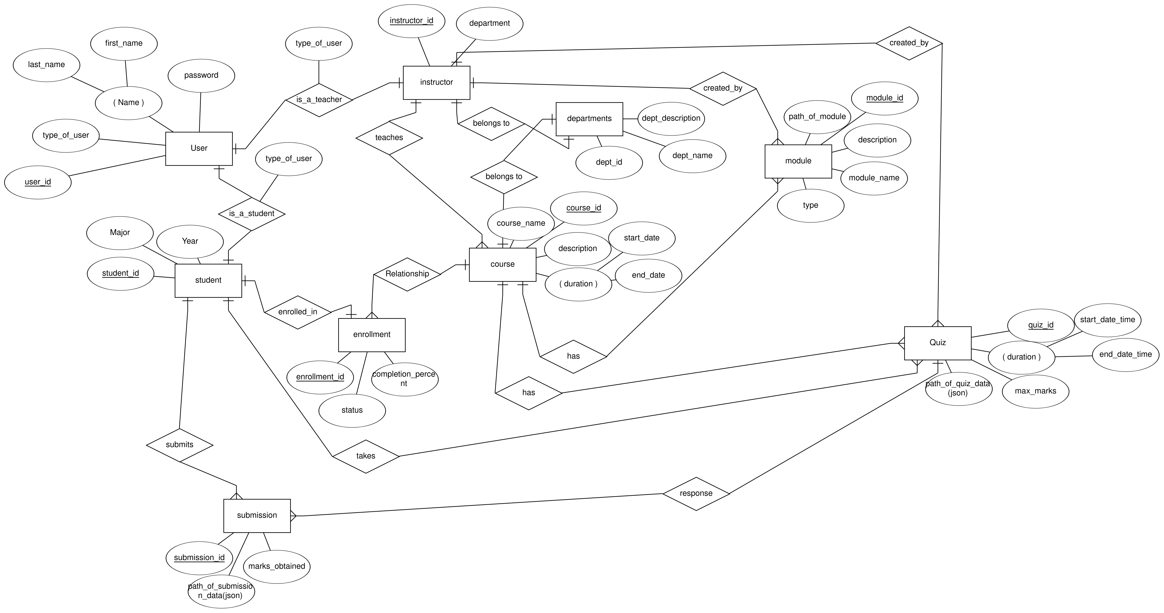

SCHEMA

1. USER(user_id, password, first_name, last_name, type_of_user)

2. STUDENT(student_id, user_id ,major, year)

3. INSTRUCTOR(instructor_id, user_id, department_id)

4. ENROLLMENT(student_id, course_id, status, completion_percentage)

5. COURSE(course_id, dept_id, desc, start_date_time, end_date_time)

6. MODULE(module_id, course_id, name, type, path_of_module)

7. MODULE_CREATED_BY(instructor_id, module_id, upload_date)

8. QUIZ(quiz_id, course_id, start_date_time, end_date_time, max_marks, path_on_server)

9. QUIZ_CREATED_BY(instructor_id, quiz_id)

10. SUBMISSION(submission_id, student_id, quiz_id, marks_obtained, path_on_server)

11. TEACHES(instructor_id, course_id)

NORMALIZATION

USER(user_id, password, first_name, last_name, type_of_user)
- Primary Key: user_id
- Analysis: Every attribute is atomic, and all non-key attributes (password, first_name, last_name, type_of_user) depend solely on user_id. There are no partial or transitive dependencies.
- Conclusion: In 1NF, 2NF, 3NF, and BCNF.

STUDENT(student_id, user_id, major, year)
- Primary Key: student_id
- Analysis: All attributes (user_id, major, year) are fully functionally dependent on student_id. The user_id is a foreign key linking to USER, and its attributes are stored in that table.
- Conclusion: In 1NF, 2NF, 3NF, and BCNF.

INSTRUCTOR(instructor_id, user_id, department_id)
- Primary Key: instructor_id
- Analysis: The non-key attributes (user_id, department_id) depend entirely on instructor_id.
- Conclusion: In 1NF, 2NF, 3NF, and BCNF.

ENROLLMENT(student_id, course_id, status, completion_percentage)
- Primary Key: A composite key (student_id, course_id)
- Analysis: The attributes status and completion_percentage depend on the full combination of (student_id, course_id). No attribute depends on only one part of the composite key.
- Conclusion: In 1NF, 2NF, 3NF, and BCNF.

COURSE(course_id, dept_id, desc, start_date_time, end_date_time)
- Primary Key: course_id
- Analysis: All other attributes depend solely on course_id.
- Conclusion: In 1NF, 2NF, 3NF, and BCNF.

MODULE(module_id, course_id, name, type, path_of_module)
- Primary Key: module_id
- Analysis: The attributes (course_id, name, type, path_of_module) depend only on module_id.
- Conclusion: In 1NF, 2NF, 3NF, and BCNF.

MODULE_CREATED_BY(instructor_id, module_id, upload_date)
- Primary Key: Likely a composite key (instructor_id, module_id)
- Analysis: Assuming that a module can be created by one or more instructors, the combination of instructor_id and module_id is the key and upload_date depends on that combination. If, however, business rules state that a module is created by only one instructor, then module_id could determine instructor_id and upload_date—but the given design supports the composite key scenario.
- Conclusion: In 1NF, 2NF, 3NF, and BCNF.

QUIZ(quiz_id, course_id, start_date_time, end_date_time, max_marks, path_on_server)
- Primary Key: quiz_id
- Analysis: All other attributes are fully functionally dependent on quiz_id.
- Conclusion: In 1NF, 2NF, 3NF, and BCNF.

QUIZ_CREATED_BY(instructor_id, quiz_id)
- Primary Key: Likely a composite key (instructor_id, quiz_id)
- Analysis: This table maps which instructor created which quiz. If every quiz is created by exactly one instructor, a functional dependency may exist (quiz_id → instructor_id); however, the composite design covers both one-to-many and many-to-many scenarios.
- Conclusion: In 1NF, 2NF, 3NF, and BCNF.

SUBMISSION(submission_id, student_id, quiz_id, marks_obtained, path_on_server)
- Primary Key: submission_id
- Analysis: All non-key attributes depend entirely on submission_id.
- Conclusion: In 1NF, 2NF, 3NF, and BCNF.

TEACHES(instructor_id, course_id)
- Primary Key: Composite key (instructor_id, course_id)
- Analysis: This relation serves as a many-to-many mapping between instructors and courses with no additional non-key attributes.
- Conclusion: In 1NF, 2NF, 3NF, and BCNF.

Each relation in the schema:
- Uses atomic values (satisfies 1NF).
- Has non-key attributes fully functionally dependent on the entire primary key (satisfies 2NF).
- Has no transitive dependencies among non-key attributes (satisfies 3NF).
- Contains only candidate keys as determinants (satisfies BCNF).
Thus, the schema follows all the normal forms up to BCNF.

Therefore the final schema will be the same as derived above schema

