Title of your IS Project

A Project Report Submitted
to
MANIPAL ACADEMY OF HIGHER EDUCATION

For Partial Fulfillment of the Requirement for the
Award of the Degree
Of

Bachelor of Technology
in
Computer and Communication Engineering
by

Your Name, Your Name, Your name
210953XXX, 210953XXX, 210953XXXX

Under the guidance of
Dr. XYZ (Lab Faculty 1) Dr. ABC (Lab faculty 2)
Designation of Faculty Designation of Faculty
School of Computer Engineering School of Computer Engineering
Manipal Institute of Technology Manipal Institute of Technology
MAHE, Manipal, Karnataka, India MAHE, Manipal, Karnataka, India


November 2025

ABSTRACT

Good abstract to be written.

At the end add ACM taxonomy (You can search and write the keywords related to your project)
For example:
[Security and Privacy]: Cryptography management; Access Control; Symmetric Cryptography;

Write the suitable Sustainable Development Goal (There are about 17 SDGs proposed by Govt of India) to which your project belongs to (Please get the development goals from the Govt of India website)
For example:
[SDG]: Quality Education

Table of Contents

List of Tables

List of Figures

Abbreviations

Chapter 1

Chapter Title

This is an introduction chapter.
  - Section 1
This section is 1.1 and it describes the aspects of Introduction [1].

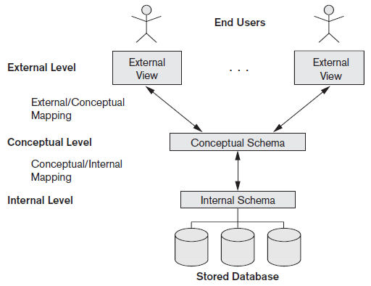

Figure 1.1: Three Tier Architecture

Chapter 2

Chapter Title

2.1 Section 1

References
[1] Y. Okada, K. Dejima, and T. Ohishi, \Analysis and comparison of PM synchronous motor and induction motor type magnetic bearings," IEEE Trans. on EE, vol. 31, pp. 1047{1053, Sep./Oct. 1995.

Specifications to be followed:
- Font size: 12 for regular text, font size: 14 for side headings and font size: 26 for chapter numbers and title
- Font Type: Times New Roman
- Text alignment: Justified (Both Sides)
- References to be put in IEEE format

For further clarifications contact the faculty.

Following list of chapters will be expected:
- Introduction
- Literature Survey / Background
- Objectives/Problem Statement
- Methodology (Implementation Details with block diagram to explain the project in detail. Do not put code here.)
- Results and Analysis (Add the results here and also Add the threat model analysis, and any testing that is performed and the results for the same)
- Conclusion and Future Work
- References
- Appendices (You can put the code here if needed)

