BUSINESS INTELLIGENCE

FINAL PROJECT REPORT

WPI’S GORDON LIBRARY

1. Executive Summary

Our group faced a significant challenge in selecting a client company for our final project. After evaluating multiple options—ranging from local pizza shops in Worcester to ride-hailing platforms, airport shuttle services, hardware companies, and even a museum—we ultimately identified the WPI George C. Gordon Library as the ideal client. This decision emerged after extensive brainstorming and assessing factors such as feasibility, data accessibility, and alignment with Professor Nima's guidance. The turning point occurred during a group session in the WPI library's tech suite, where we recognized the library's central role in our academic journey and its potential for meaningful impact.

The collaboration was solidified with the enthusiastic support of Mrs. Anna Gold, the University Librarian. Her assistance, along with the cooperation of the library staff, provided us with access to data, valuable insights, and critical resources, enabling us to pursue this project effectively.

The primary objective of our project was to support the library's mission of fostering inclusive education, research, and innovation by addressing key challenges and uncovering actionable insights. Specifically, we aimed to analyze library data to enhance resource allocation, improve user experience, and optimize operational efficiency.

1.1 Project Goals and Challenges Addressed

a. Goals

1. Support the library's mission by identifying patterns in patron usage, peak usage times, and resource allocation, including tech suites, study zones, and finances (e.g., for student employees).
2. Provide actionable recommendations to improve service delivery and user engagement, allowing students to use the library more effectively and staff to gain a better understanding of its operations.
3. Develop tools and visualizations to aid decision-making and strategic planning.

b. Challenges Addressed

1. Ensuring data accuracy and consistency for effective analysis. This included cleaning the data, identifying missing values, and addressing them appropriately.
2. Balancing the need for meaningful insights with data privacy considerations, as certain library data sources were unavailable due to privacy restrictions.
3. Delivering solutions that align with the library's strategic goals and operational constraints, focusing on gradual expansion guided by user preferences.

1.2 Summary of Project Deliverables

a. Interactive Dashboards**:** Developed two dashboards:

1. A student usage dashboard analyzing patron activities, such as library occupancy, resource usage, movement trends, and time spent in various areas of the library.
2. A library finance dashboard focusing on student employee finances, including trends in budget allocation and expenditure tracking.

b. Usage Patterns Analysis: Identified peak usage hours, popular resources, and underutilized spaces to optimize resource allocation and service delivery.

c. Conjoint Analysis: Conducted a conjoint analysis to understand student preferences for different library areas and the amount of time they spend there. These insights help inform decisions about space planning and enhance library experience.

d. Recommendations Report: Provided detailed strategies for improving operational efficiency, enhancing patron experiences, and aligning services with user needs.

The insights developed through this project can serve as a foundation for future studies on library usage trends, enabling continuous improvement and adaptation to the evolving student needs.

2. Introduction

2.1 Client Company Background: WPI George C. Gordon Library

a. Name and Industry

* Name: George C. Gordon Library
* Industry: Academic Libraries, Higher Education

b. Products and Services Offered  
The George C. Gordon Library provides a range of services that support WPI’s academic and research community:

* Borrowing and requesting books.
* Archives and special collections, including university archives, manuscripts, and rare books.
* Services for WPI alumni and retirees.
* Tech suite reservations for group collaboration.
* Research and instructional support, including digital resource access and scholarly communication assistance.

c. Geographic Market Area  
Located on the Worcester Polytechnic Institute (WPI) campus in Worcester, Massachusetts, the library primarily serves WPI students, faculty, staff, and alumni.

d. Size in Terms of Employees  
The library operates with a total of 19 permanent employees, divided across five departments:

* Administration: Oversees library operations and ensures alignment with strategic goals.
* Access Services & Outreach: Manages borrowing, customer service, and community engagement.
* Scholarly Communication and Open Strategies: Focuses on digital resources and open-access initiatives.
* Research & Instruction: Provides instructional services and research assistance.
* Archives and Special Collections: Maintains and manages historical archives and rare book collections.

e. Scope of the Project  
The scope of the project encompasses the entire library, with a particular focus on improving resource utilization and operational efficiency through data-driven insights.

* Student Tracker: The project uses sensor data from the library's entry points and various locations to measure student presence and activity levels, enabling a better understanding of usage patterns.
* Financial spending: The project also uses the data collected by the library in the form of student employee salaries, their positions and the number of employees working per day
* Library usage: The library does not have the data on which part of the library (zones and chairs) are utilized the most. And a part of the scope of our project would be to identify the same through conjoint analysis.

2.2 Current Status of Reporting and Business Intelligence/Analytics Systems

The George C. Gordon Library is in the early stages of adopting formal BI systems, with its current analytics infrastructure showing the following characteristics:

1. Primary Tools:
   * MS Excel is the primary tool for data analysis and reporting.
   * Other software includes:
     + LibSys/Catalog and Alma: These systems are part of the library's academic enterprise resource management, handling metadata and cost management.
     + Springshare: Used for interactions such as reservations and ticketing. Springshare is subscription-based and integrated with WPI’s Innovation Hub.
2. Data Management and Warehousing:
   * Borrower’s data is managed through internal systems but limited to post-2018 due to migration constraints from older systems.
   * Remos database is used to manage collections and book inventories.
   * Springshare and other tools manage tech suite and room reservations, as well as ticketing services.
3. Integration of Information Systems:
   * The library employs partially integrated systems for resource and metadata management but lacks a seamless, fully integrated BI system.
4. BI Team and Tools:
   * The library does not currently have a dedicated BI team.
   * Prior to COVID-19, student assistants were involved in supporting BI-related tasks.
   * Visualization and reporting needs are met through third-party tools like Springshare.
5. BI Maturity Model Position:
   * The library sits in the early stages of the BI maturity model (child stage), relying primarily on descriptive analytics with limited advanced reporting or predictive capabilities.

2.3 Summary of Case Studies

a. University of Texas Library

The University of Texas Library adopted a Business Intelligence (BI) system to better understand how its spaces were being used and to improve resource management.

* BI Adoption:  
  The library aimed to gain clearer insights into space utilization and make smarter decisions about how to allocate resources, using the BI tools.
* Data Sources:  
  The library installed foot traffic sensors to track how often different areas were being used. This provided real-time data to help the library understand usage patterns and adjust traffic accordingly.
* Outcomes:  
  With these insights, the library was able to manage resources more efficiently, ensuring that high-demand areas were prioritized. These changes not only improved how the library operated but also made students happier with their experience.

b. Harvard University Library

Harvard University Library used data analytics to improve its services and meet the needs of its users.

* Data-Driven Decisions:  
  Analytics helped the library track the following key areas:
  + Book borrowing trends: to understand what students and faculty were reading.
  + How spaces were being used: to identify areas that needed more attention or changes.
  + Digital resource access: to measure the growing demand for online materials.
* Resource Optimization:  
  By analyzing this data, the library was able to identify resources that were being underused. This allowed them to reallocate budgets and staff time toward services and spaces that were more in demand, ensuring better overall efficiency.
* Improved Engagement:  
  With these improvements, the library was able to better meet the needs of its users. These changes not only enhanced services but also made students feel more engaged and satisfied with what the library offered.

The George C. Gordon Library stands as an important resource for WPI, offering a diverse range of academic and research services. While its current BI infrastructure is in the early stages of maturity, there is significant potential to enhance operational efficiency, resource utilization, and user satisfaction through data-driven initiatives. Insights from the case studies of the University of Texas and Harvard University libraries illustrate how leveraging analytics can transform library operations, optimize resource allocation, and elevate user engagement. By adopting a similar approach, the George C. Gordon Library can transform through data driven management and efficiently use analysis tools for day to day operations.

1. The Proposed BI Solution

3.1. What is business intelligence?

Technically, Business intelligence is the process for collecting, analyzing and presenting data to make an organization take informed decisions. The process can involve using multiple tools, strategies and technologies to convert raw data into powerful insights. These insights can improve operational efficiency, planning and improving the performance of the business. Business Intelligence encompasses every component related to data collection, reporting, visualization, predictive, prescriptive and exploratory analysis.

3.2. Main Components of a BI Solution:

A BI solution usually includes multiple components through which the collection, processing and analyzing of the data is done. These components can include:

a. Data Sources: The various systems from which data is gathered. For the George C. Gordon Library, the primary sources of data included the library catalog system (LibSys/Alma), Springshare for reservations and ticketing, and internal systems like Remos for managing collections. They also had a lot of data stored in the form of excel files.

b. ETL (Extract, Transform, Load):This process involves extracting data from multiple sources, transforming it into a consistent format, and loading it into a data warehouse or data mart. This ensures that data from various systems can be used in BI tools for analysis. For the library, the ETL would work as follows:

b.1. Extract: Data is collected from multiple sources, including the Library Catalog System (LibSys/Alma), Springshare (reservations/ticketing), Remos database (collections), employee data systems, and sensor data (space usage).

b.2. Transform: Currently, the transformation is not done. We are proposing the data to be cleaned, standardized, aggregated, and integrated to create meaningful metrics and combine information from various systems, enhancing the data with additional context like demographics.

b.3. Load: The transformed data is loaded into a data warehouse structured with a star schema, featuring fact tables (e.g., library usage, financials) and dimension tables (e.g., time, library zones). The process is automated for regular updates and includes access controls for data security.

c. Data Warehouse/Data Mart: A data warehouse is a centralized repository where data from different sources is stored and organized for analysis. For the library, the data warehouse could include information about library usage patterns, student activity, book borrowings, and employee spending data. A simplified multidimensional model such as a star schema could be used to organize this data, with dimensions such as time (day, month, year), library zone (entry points, and the four floors), and user type (student, faculty, employee), and facts like the number of students present or books borrowed.

d. Analytics and Reporting Tools: These tools help analyze the data and present it in a meaningful way. In the context of the library, these tools could be used for operational and strategic reporting. For example, the library has used Springshare till now to create reports on library usage, reservations, and events, while data visualization tools could be used to generate interactive dashboards and perform deeper analysis.

e. Data Visualization: This component involves presenting the data in visual formats such as charts, graphs, and maps to make insights easier to understand and act upon. Dashboards can be customized to track key performance indicators (KPIs) such as library occupancy, student usage, or the financial spending of student employees.

f. Monitoring and Alerts: Monitoring allows real-time tracking of library usage, financial activities, and operational performance. Alerts can be set up to notify staff when certain thresholds are met, such as when a specific area of the library is overcrowded or when there are discrepancies in employee payroll data. This can be done when the real time tracking of the data is being done.

3.3. Role and Value of Each Component:

1. Data Sources: By consolidating data from different library systems, the library can get a holistic view of its operations. These sources provide essential data for analysis and decision-making.
2. ETL Process: The ETL process ensures that the data is consistent and reliable, making it ready for analysis. It helps integrate data from various platforms, which is critical for generating meaningful insights.
3. Data Warehouse/Data Mart: The data warehouse serves as the backbone of the BI solution, providing a structured place to store data for easy access and analysis. A star schema structure can facilitate efficient querying and reporting on different aspects of library usage and finance.
4. Analytics and Reporting Tools: These tools enable the library to make data-driven decisions, improving everything from resource allocation to student satisfaction. With the right BI tools, the library can track trends, uncover inefficiencies, and optimize its services.
5. Data Visualization: Dashboards make the data accessible and actionable by presenting complex data in simple, visual formats. For example, dashboards could track library occupancy in real time, making it easier to manage space usage.
6. Monitoring and Alerts: By monitoring key metrics, the library can react to changes as they occur. This enables staff to address issues proactively, such as overcrowding in certain areas or budget discrepancies.
   1. BI Framework for the George C. Gordon Library

To implement a BI solution for the George C. Gordon Library, we would propose a structure based on a star schema model with the following components:

3.4.1. Fact Table:

* 1. Library Usage Facts: Includes metrics such as the number of students present in each area, the number of books borrowed, and the number of reservations made for tech suites or study rooms.
  2. Financial Facts: Includes data related to student employee payroll, number of hours worked, and other financial metrics related to library operations such as leaves, and the budget.
     1. Dimension Tables:
     2. Time Dimension: Tracks data across dates, weeks, months, and years for trend analysis.
  3. Library Zone Dimension: Details library areas, their types, and capacities to analyze space utilization.
  4. User Type Dimension: Classifies users (students, faculty, staff) for understanding usage patterns.
  5. Employee Dimension: Provides insights into workforce contributions and payroll metrics.

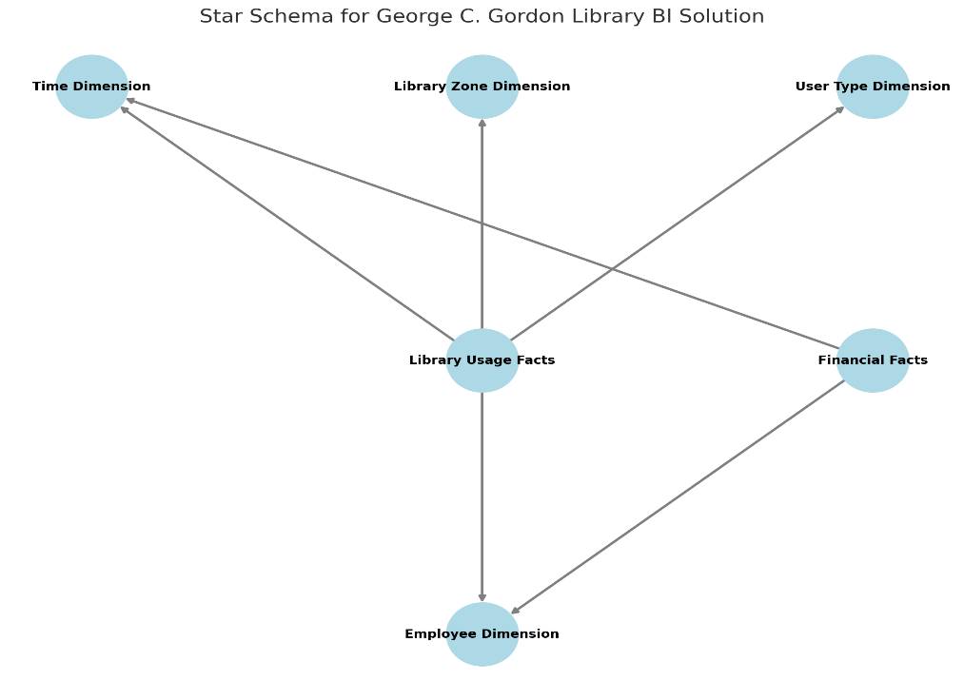

Fig 1. Star schema for WPI Library

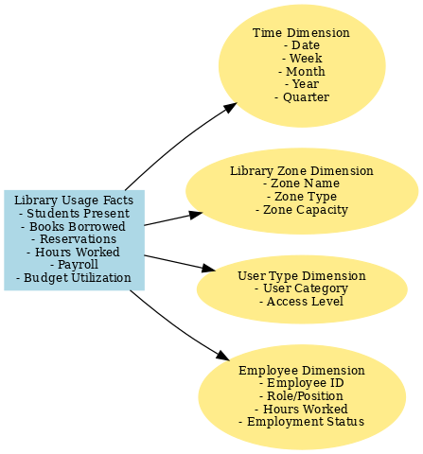

Fig 2. Library BI Solution Star Schema Diagram

* 1. Value from BI Functionalities

1. Operational Dashboards: These dashboards provide real-time insights into library operations. As the dashboard one tracks the number of students in each section of the library, helping to identify areas of high demand. This can inform decisions about space reallocation, resource availability, and staffing needs. This dashboard also tracks the highest rate of usage on each day, according to the day, month, term and week of the term.
2. Strategic Dashboards: A strategic dashboard could be used to track long-term trends in library usage, resource allocation, and financial performance. For instance, it could provide insights into how library services are meeting student needs, identify opportunities for cost savings, and guide decision-making on future investments. In dashboard two, the library executives can see what are they spending on student employment, at various positions, the difference in pay rates and the type distribution.
3. Analytics Techniques: In addition to dashboards, the library can leverage advanced analytics techniques such as conjoint analysis to understand student preferences for library spaces and how much time they spend in each area. This can provide valuable insights for optimizing library layouts, resource allocation, and improving student satisfaction.
4. Three Use Cases/Prototypes

4.1 Use Case 1: Library Occupancy Dashboard

4.1.1. Description:  
This dashboard provides a detailed overview of library resource usage to support strategic decision-making. Key metrics include the library occupancy rate per hour, per day, and per month, study room reservation trends, and the distribution of available seat types within the library.

4.1.2. Target Users:  
Library administrators, strategists, and decision-makers responsible for optimizing library space and resources.

4.1.3. Key Managerial Questions Answered:

a. What are the peak hours and days for library occupancy?

b. How does the occupancy rate vary across different days of the month?

c. Are tech-suites being reserved efficiently, and is there unmet demand, when are they the busiest?

d. When is the library open and least used?

e. What types of seating arrangements are most popular, and how many seats are present?

4.1.4. Dashboard Features:

1. Filters: Filters by date, day, quarter and tech suit for analysis.

Fig 3. Dashboard 1: Library Occupancy

Fig. 4 Filter by Date

Fig 5. Filter by Day

Fig. 6. Filter by Quater

1. KPIs:
   * Hourly occupancy rate.
   * Daily and quarterly occupancy trends.
   * Tech suites reservations over a term.
   * Proportion of seat types available (e.g., individual, group, soft seating and carrels).
2. Interactive Visuals:
   * Line graph: Displays hourly occupancy patterns across days.
   * Bar chart: Show daily occupancy trends over the month.
   * Area graph: Breakdown of tech suite reservation over the term.
   * Pie Chart: Proportions of available seat types in use.
   * Double area chart: Quarterly usage
3. Managerial Insights and Implications:  
   This dashboard helps library administrators:
   * Identify peak usage times to adjust staffing and resource allocation.
   * Assess whether seating and tech suite availability align with demand, leading to better layout planning.
   * Monitor occupancy trends to identify opportunities for promoting underutilized areas or times.
   * Make data-driven decisions about seating configurations and tech suite allocations to improve student satisfaction.

4.2. Use Case 2: Student Employment Dashboard

4.2.1. Description:  
This dashboard focuses on providing operational insights related to student employee management and payroll in the library. Key metrics include employee pay rates per position, distribution of employee types, total payroll expenses per position, daily working hours, and projected payroll spending for the next year.

4.2.1.Target Users:  
Library HR managers, operations managers, and finance personnel responsible for managing staff and budgeting payroll expenses.

4.2.2.Key Managerial Questions Answered:

* + How are employee pay rates distributed across different positions?
  + What is the current breakdown of employee types (e.g., student workers, student supervisors and FWS/Non-FWS workers)?
  + Which positions account for the highest payroll expenses?
  + How many hours are employees working daily?
  + What is the estimated payroll expenditure for the upcoming year?

4.2.3. Dashboard Features:

1. Filters: Filters by department, employee type, and date range for focused analysis.

Fig 7. Dashboard 2 for student employment

Fig 8. Filtered by pay rate as per position

Fig 9. Filtered by student type of employee distribution

Fig 10. We have created a average reference line in this graph

1. KPIs:
   * Pay rates per position.
   * Employee type distribution (FWS, Non-FWS ).
   * Types of employment
   * Average daily hours worked.
   * Projected payroll expenses for the next fiscal year.
2. Interactive Visuals:
   * Bar Chart: Total payroll expenses by position.
   * Stacked Bar Chart: Employee time duration.
   * Area chart: Pay per position for a specific post.
   * Line chart: Projections of payroll expenses for the next year.
   * Pie Chart: Type of employment
3. Drill-Down Capabilities: Allows users to drill down to individual employee-level details, such as hours worked, pay rates, and roles.

Managerial Insights and Implications:  
This dashboard empowers finance managers to:

* + Evaluate pay rate fairness and competitiveness across different roles.
  + Monitor the distribution of employee types to ensure balanced workforce management.
  + Identify roles with the highest payroll costs and analyze reasons behind them.
  + Optimize scheduling and staffing based on daily hours worked trends.
  + Plan and control payroll budgets effectively by leveraging spending projections.

4.3 Use Case 3: Conjoint Analysis for Library Seating Preferences

4.3.1.Description:  
This model focuses on applying conjoint analysis to understand the library users’ preferences regarding different seating options within the library. The analysis uses factors such as seat types (e.g., carrels, group seats), designated zones (e.g., silent zone, social zone), and preferred study duration (e.g., 1-2 hours, 3-5 hours). By analyzing the relative importance of these factors and the coefficients derived, the library can optimize seating arrangements and zoning to better meet user needs.

4.3.2. Target Users:  
Library operations managers, space planners, and decision-makers involved in library layout and user experience optimization.

4.3.3. Key Managerial Questions Answered:

1. What seating arrangements (e.g., carrels, group seats) are most preferred by library users?
2. How does the duration of stay influence seating preferences (e.g., quiet vs. social zones)?
3. How do different seating options impact overall satisfaction with the library environment?
4. Which seating arrangements should the library prioritize to enhance user experience?
5. How many hours do the students prefer to sit in the library?

4.3.4. Conjoint Analysis Results:

1. Factors Analyzed:
   * Seats (Carrels, Group Seats)
   * Zones (Quiet Zone, Social Zone)
   * Hours (1-2 hours, 3-5 hours)
2. Relative Importance of Factors:
   * Seats: 48% relative importance, indicating that users prioritize the type of seating over other factors.
   * Hours: 35% relative importance, showing that users' study duration is a significant consideration in their seating choice.
   * Zone: 17% relative importance, revealing that the designated zone (quiet or social) is less influential but still important.
3. Coefficient Analysis (Significance):
   * Carrels: Coefficient of -0.59 (p-value = 0.003), showing that users prefer group seating to carrels. This is a statistically significant finding.
   * Group Seats: Coefficient of -0.28 (p-value = 0.112), indicating a trend towards preference for group seating, though not statistically significant.
   * Quiet Zone: Coefficient of 0.03 (p-value = 0.857), showing no significant preference for the quiet zone.
   * Social Zone: Coefficient of 0.24 (p-value = 0.17), suggesting a mild preference for social zones, but not significant.
   * 1 to 2 hours: Coefficient of 0.43 (p-value = 0.007), showing a strong preference for 1-2 hour study durations.

Chart:

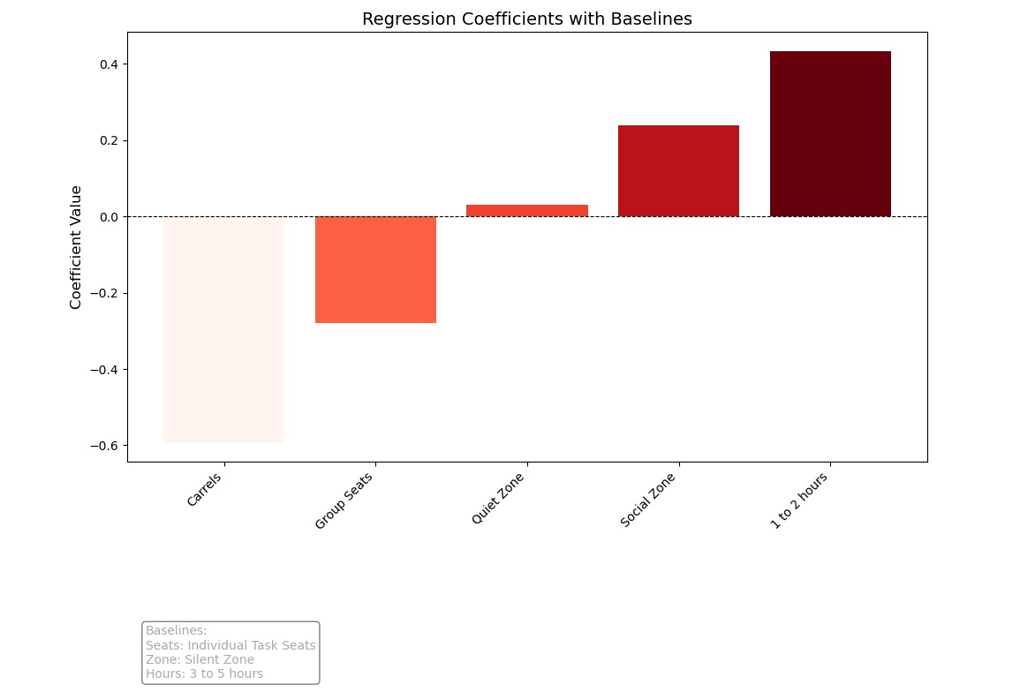

Fig. 11 Regression coefficient with baselines indicating preference

Fig 12. Relative importance of all the factors considered

Managerial Insights and Implications:

* + Seating Layout Optimization: The library can prioritize group seating over individual carrels based on user preferences.
  + Space Planning: Given that hours and zones have high relative importance, seating in quiet zones should be optimized for those preferring longer study durations (3-5 hours).
  + Targeted Improvements: The library can experiment with increasing or decreasing the proportion of seating options based on user preferences for a more user-centric design.

1. Implementation

Implementing Business Intelligence (BI) in the Gordon library is about transforming data into insights that improve decision-making and efficiency. The process involves addressing managerial, technical, and ethical challenges to ensure BI tools work effectively for everyone.

5.1 Managerial Challenges: Kotter’s 8-Step Model

Kotter's model provides a roadmap for implementing changes in the library. Here’s how we can apply it in the WPI’s library:

1. Create Urgency: We need to show that the current tools (Springshare, Alma) are inefficient and that better BI tools will improve library operations.
2. Form a Coalition: Build a team of library staff, IT, students, finance manager and faculty to advocate for change.
3. Create a Vision: Define a clear vision of using data visualization tools to make data-driven decisions, optimize resources, and improve user experience.
4. Communicate Vision: Regularly share updates and use visual tools like mock dashboards to show the benefits (i.e, the Dashboard 1 and 2 we have created).
5. Remove Obstacles: Address any financial or technical barriers with training and support for staff.
6. Create Short-Term Wins: Implement pilot dashboards that showcase quick, impactful results, such as space usage insights.
7. Scale Gradually: Expand the use of BI tools across other areas of the library, gathering feedback as we go.
8. Institutionalize Change: Make data visualization tools a standard part of library operations, ensuring ongoing improvements.

5.2 Technical Challenges and Solutions

Several technical issues need to be tackled for BI to work smoothly:

* + Data Completeness: Missing or incomplete data from old systems like Alma.  
    Solution: Cleanse data and ensure its mapped accurately.
  + Data Accuracy: Inaccurate data can lead to poor decisions.  
    Solution: Use validation tools and regular audits to ensure accuracy.
  + Data Consistency: Different formats across systems can cause confusion (eg, data from alma and springshare).  
    Solution: Standardize formats during data integration.
  + Data Timeliness: Outdated data can mislead real-time decisions(data from before the migration of 2018 and the covid year is redundant).  
    Solution: Implement regular data updates and real-time processing.
  + Data Integration: Merging data from multiple systems can be challenging.  
    Solution: Use integration tools to unify data from sources like Alma and Springshare.

5.3 Ethical Challenges and Solutions

There are ethical concerns to consider when using BI in the library:

* + Privacy Concerns: Student activity data could raise privacy issues.  
    Solution: Ensure compliance with privacy laws like FERPA and GDPR, anonymize data, and inform users about its use.
  + Bias in Data: Over-representation of certain areas or users can skew insights (e.g, if the students form a certain major prefer social zone, the analysis would lead to a bias).  
    Solution: Collect data from a variety of sources to ensure a fair representation (The data for conjoint analysis was collected from students from varying majors).
  + Misuse of Analytics: BI tools could be used for unintended purposes, like cutting funding.  
    Solution: Set clear guidelines on how data can be used and restrict access when necessary.
  + Over-Monitoring: Real-time tracking might make students feel uncomfortable.  
    Solution: Allow opt-in options for tracking and emphasize transparency in how the data is used.
  1. Policies applied for the privacy recommendations of the library:
  + Patron Data Privacy Policy: This would explain how the library collects, stores, and uses patron data within the analytics dashboards. It would comply with privacy laws like CCPA and FERPA, ensuring that personal data is securely protected and used responsibly.
  + Data Access Policy: This policy would limit access to patron data to authorized personnel only. It would also include mandatory privacy training for staff and vendors to make sure that everyone handles the data appropriately and with respect.
  + Digital Resource Usage Policy: This would regulate how e-books and other digital content are accessed, ensuring the library stays in compliance with licensing agreements and provides fair use to all patrons.
  + Technology and Equipment Lending Policy: This policy would define the process for borrowing library items like laptops and tablets, including how late returns or damage are handled, to ensure proper management of these resources.
  + Study Room Reservation Policy: This would streamline the process for reserving study rooms, making sure that space is efficiently allocated to patrons in need.

1. Summary and Conclusion

In this project, we developed and implemented Business Intelligence (BI) dashboards and conducted conjoint analysis to enhance the decision-making capabilities of the George C. Gordon Library at Worcester Polytechnic Institute (WPI). The dashboards provide a comprehensive view of key metrics related to library operations and employee management, while the conjoint analysis offers insights into optimizing study space allocation based on student preferences.

The BI dashboards were designed to support both strategic and operational decision-making:

* Strategic Dashboard: Focused on resource usage, library occupancy rates, and space utilization patterns. This dashboard helps with long-term planning, such as optimizing library spaces and improving user satisfaction.
* Operational Dashboard: Provides real-time insights into employee pay rates, time tracking, and projected spending. It allows library management to track employee distribution, manage budgets, and monitor day-to-day operations efficiently.

Additionally, the conjoint analysis was used to identify the key factors influencing students' preferences for study spaces, such as seating types, noise levels, and study duration. The analysis revealed the relative importance of each factor, allowing the library to make data-driven decisions about how to allocate study spaces based on user needs and preferences.

Recommendations:

1. Leverage BI Dashboards for Operational and Strategic Planning: The library should implement the dashboards as central tools for ongoing decision-making. They provide actionable insights that can improve resource management, optimize space utilization, and streamline employee management.
2. Utilize Conjoint Analysis for Space Optimization: The findings from the conjoint analysis should guide decisions about the library’s space allocation. For instance, creating more social zones or increasing group study areas could enhance student experience based on their preferences.
3. Ensure Data Quality and Accuracy: Implement regular data validation processes to ensure that the insights provided by the dashboards are based on accurate and up-to-date data. This is key to making informed, reliable decisions.
4. Focus on Data Privacy: As the dashboards involve patron and employee data, the library must adopt clear data privacy policies to protect sensitive information and ensure compliance with regulations like CCPA and FERPA.

In conclusion, by adopting these BI dashboards and leveraging the insights from the conjoint analysis, the library can make more informed decisions, improve resource allocation, and enhance the overall user experience. This approach will not only support immediate operational needs but also lay the groundwork for long-term strategic improvements in library services.

1. RFERENCES
2. ChatGPT for Proofreading and Formatting  
   ChatGPT can assist in proofreading and formatting content by providing grammar corrections, enhancing readability, and ensuring consistency in style. The tool can help improve the clarity of academic or professional documents, making them more polished and error-free.
3. Privacy Matters: How Academic Law Libraries Can Mitigate Privacy Risks Associated with Controlled Digital Lending  
   This article discusses how academic law libraries can navigate the privacy challenges related to Controlled Digital Lending (CDL). CDL allows libraries to lend digital copies of physical books while adhering to legal requirements. The piece emphasizes strategies to protect patron privacy, including compliance with data protection laws and privacy safeguards for digital resources (Legal Reference Services Quarterly, n.d.).

https://www.tandfonline.com/doi/full/10.1080/02763915.2020.1834823

1. Mastering Change with Kotter’s 8-Step Model  
   This article provides a practical guide for implementing organizational change using Kotter’s 8-Step Model. The model focuses on creating urgency, forming a powerful coalition, and embedding changes within the organization. By following these steps, organizations can successfully manage transitions and ensure lasting improvements (Change Management, n.d.).

<https://mychangemanagement.com/mastering-change-with-kotters-8-step-model/>

1. What is Conjoint Analysis?  
   Conjoint analysis is a statistical technique used to understand customer preferences by analyzing their choices among a set of product or service attributes. It is widely used in marketing and product development to predict consumer behavior and design optimal offerings based on consumer preferences (Harvard Business School Online, 2020).

<https://online.hbs.edu/blog/post/what-is-conjoint-analysis>

1. Star Schema in Data Warehousing  
   The star schema is a data warehouse schema that organizes data into fact and dimension tables. It simplifies querying by creating a central fact table and linking it to dimension tables through foreign keys. This structure improves performance and allows users to perform efficient analytical queries (Ultimate Prospect, n.d.).

<https://www.ultimateprospect.com/star-schema-in-data-warehouse/>

1. Star Schema Data Model  
   A star schema model facilitates the organization of large datasets into a central fact table surrounded by dimension tables. This data model is commonly used in OLAP (Online Analytical Processing) systems, where users need to retrieve large amounts of data for analysis quickly and efficiently (Vertabelo, n.d.).

<https://vertabelo.com/blog/star-chema-data-model/>

1. Appendix:

Excel:

Chart code for the conjoint analysis graph:

import matplotlib.pyplot as plt

import numpy as np

# Data

variables = ['Carrels', 'Group Seats', 'Quiet Zone', 'Social Zone', '1 to 2 hours']

coefficients = [-0.5917, -0.28, 0.03, 0.2383, 0.4322]

baselines = ['Seats: Individual Task Seats', 'Zone: Silent Zone', 'Hours: 3 to 5 hours'] # Baselines

# Normalize the coefficients for color mapping

min_coef = min(coefficients)

max_coef = max(coefficients)

# Define a function to map coefficients to a red color scale

def get_red_color(value, min_coef, max_coef):

# For negative values, the scale goes from light red (low values) to darker red (high negative values)

if value < 0:

return plt.cm.Reds((value - min_coef) / (0 - min_coef)) # Red for negative values

else:

# For positive values, the scale goes from light red (low values) to dark red (high positive values)

return plt.cm.Reds((value - min_coef) / (max_coef - min_coef)) # Red for positive values

# Apply the color function to the coefficients

bar_colors = [get_red_color(coef, min_coef, max_coef) for coef in coefficients]

# Bar Chart

plt.figure(figsize=(10, 7))

plt.bar(variables, coefficients, color=bar_colors)

plt.axhline(0, color='black', linewidth=0.8, linestyle='--')

plt.title('Regression Coefficients with Baselines', fontsize=14)

plt.ylabel('Coefficient Value', fontsize=12)

plt.xticks(rotation=45, ha='right')

# Add baseline information as a text block below the chart

baseline_text = "\n".join(baselines)

plt.figtext(0.1, -0.1, f"Baselines:\n{baseline_text}", fontsize=10, color='darkgrey', ha='left', bbox=dict(boxstyle='round', facecolor='white', alpha=0.5))

plt.tight_layout()

plt.subplots_adjust(bottom=0.25) # Add more space at the bottom for the text

plt.show()