# Major Practical

By John Doe, Jane Roe and Jack Moe

a1700000, a1700001, a1700002

OOP, 2019, Semester 1

### UML Diagram:

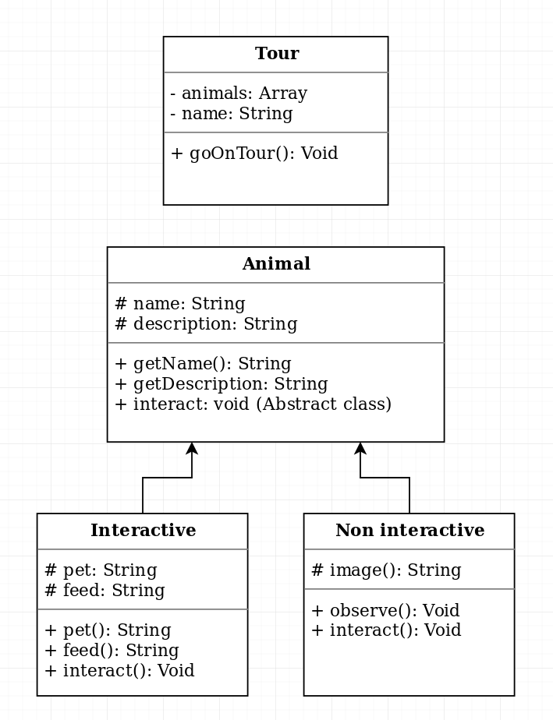

### Classes:

#### Tour:

Variables:

animals: An array that contains multiple animal objects.

name: Holds the name of the tour.

Methods:

goOnTour: Takes the user on a tour of all animals in the animals array.

#### Animal:

Variables:

name: Holds the name of the animal.

name: Holds a brief description of the animal.

Methods:

getName: Returns the name.

getDescription: Returns the description.

interact: An undefined abstract class.

#### Interactive:

Variables:

pet: A description of what happens when the user pets the animal.

feed: A description of what happens when the user feeds the animal.

Methods:

pet: Returns a description what happens when the user pets the animal.

feed: Returns a description what happens when the user feeds the animal.

interact: Extends from animal. Prompts the user to feed or pet the animal. Include chance to fail.

#### Non-Interactive:

Variables:

image: An ASCI image of the animal.

Methods:

observe: Prints image of animal.

interact: Extends from animal. Prints a message about the users failed attempt to interact with the animal.