**Adding Employee**

**From Dashboard under Admin ‘Add Employee’ option provides form to create a new user**

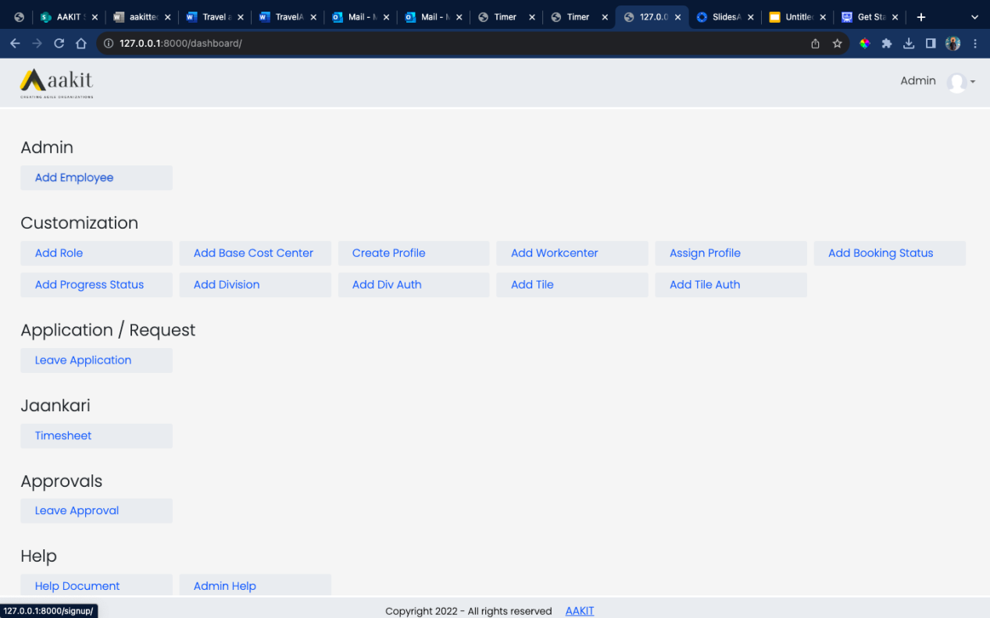

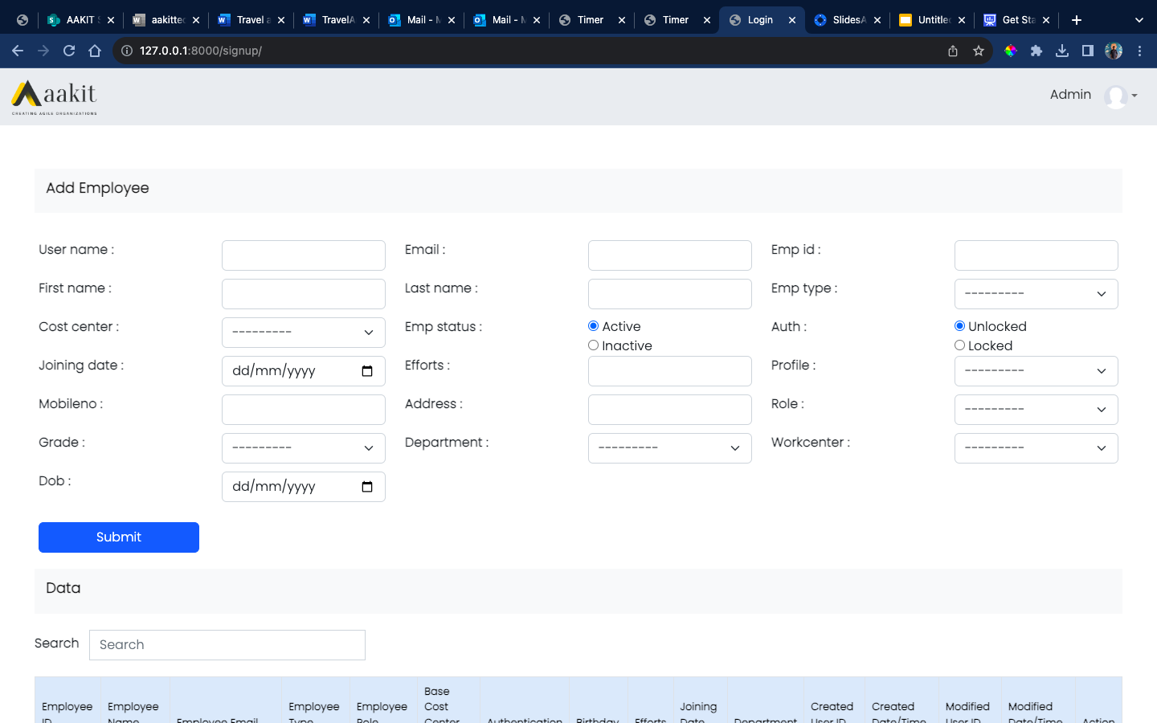

**Employee form includes employees personal details with other information like Cost Center, Profile, Role and Work center.**

**Employees added can be edited with Edit button again all employees added as shown in the image below.**

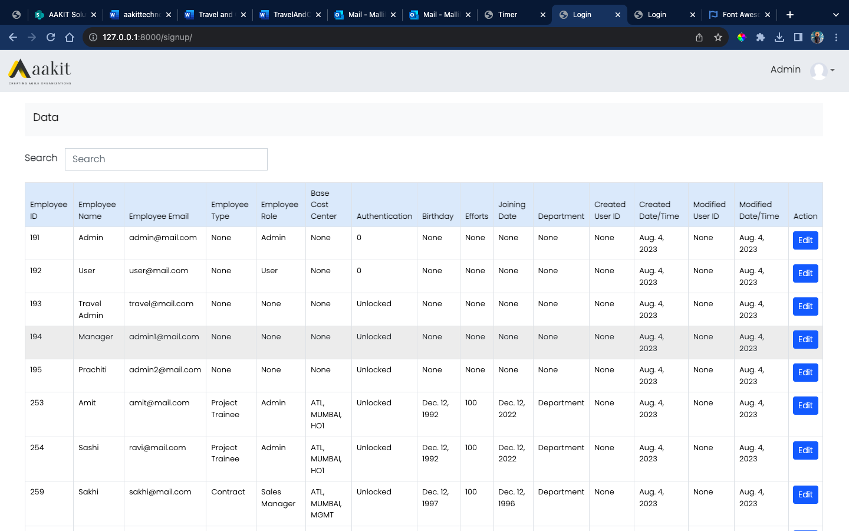

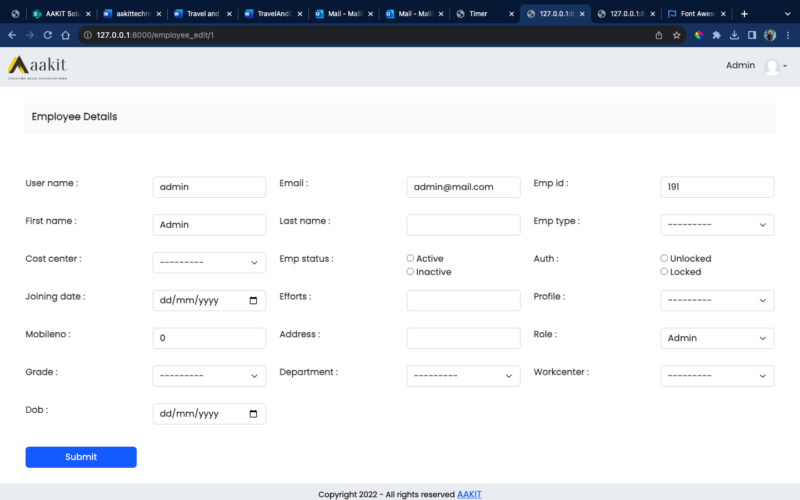

**Information like Cost Center, Profile, Role and Work center can be added by admin with options from Dashboard page under Customization.**

**Refer first image of Dashboard page where you can find options to add**

**information like Cost Center, Profile, Role and Work center.**

**Below are the images for the forms mentioned above.**

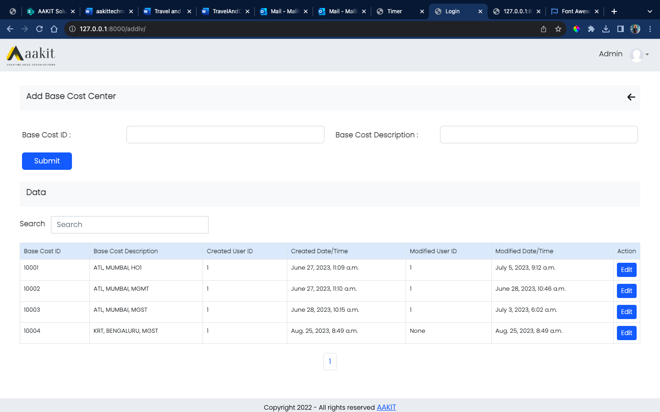

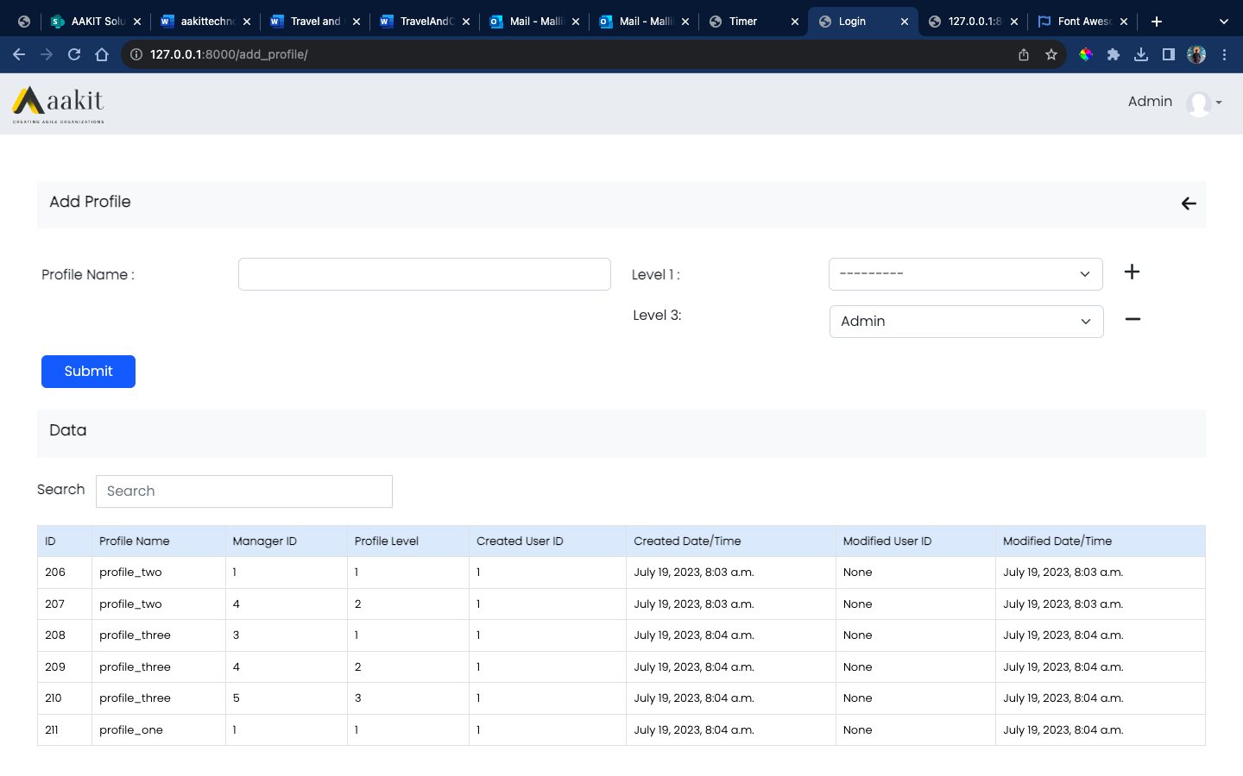

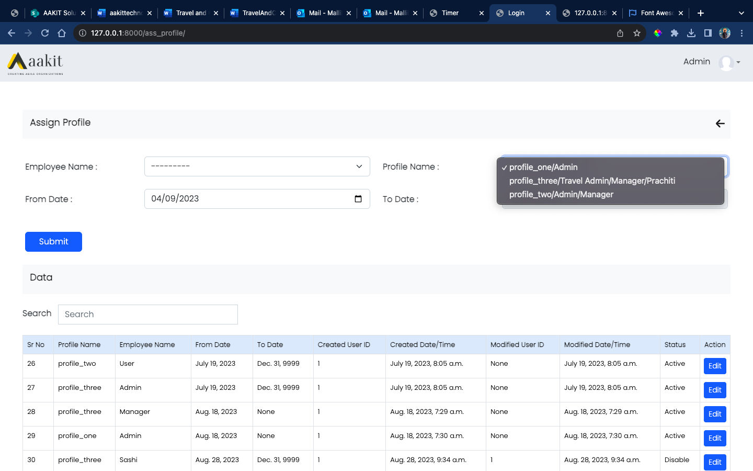

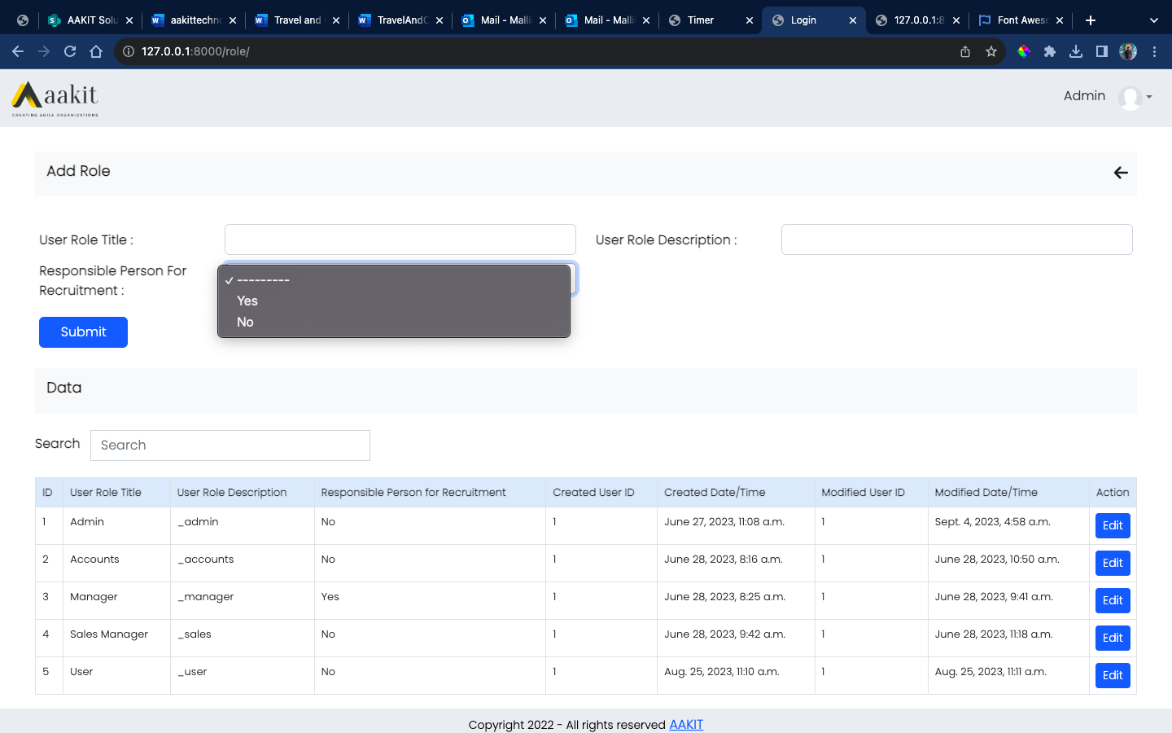

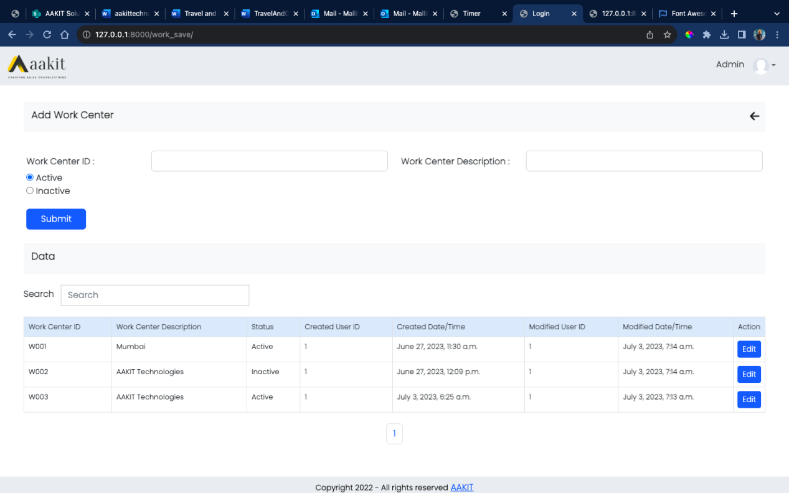

**As soon as the employee details are filled and added an email is sent to the email id provided while providing form details.  
Email contains Username provided and Temporary password with link asking employee to Reset the password.**

**After password is reset employee is then asked to login with the new password updated.**

**Refer images provided below for the same**

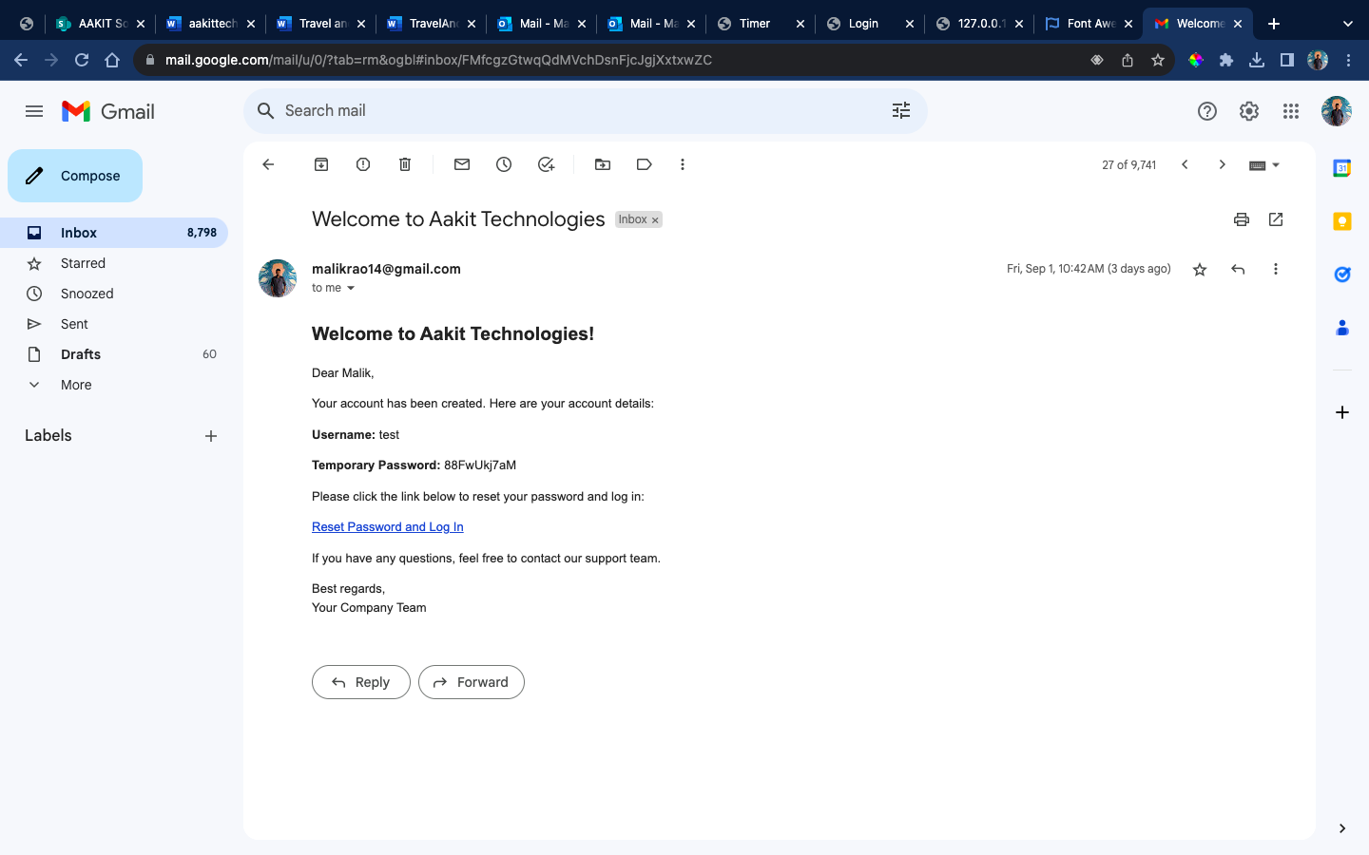

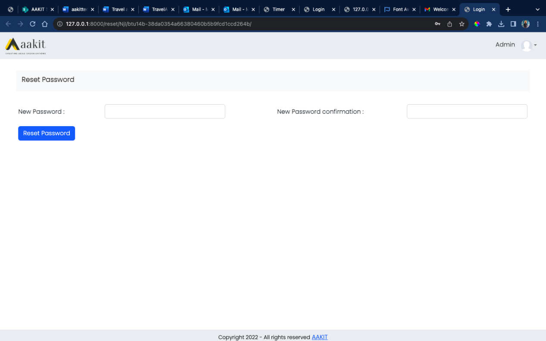

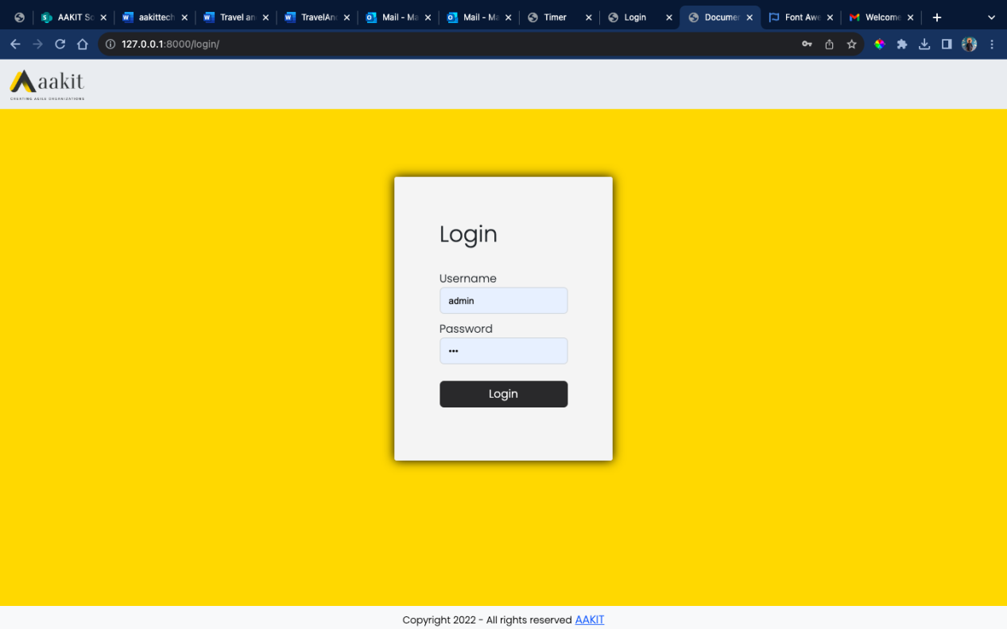

**Following the provided steps employee can be added to the system.**