**Adding Division and Tile**

**Dashboard:**

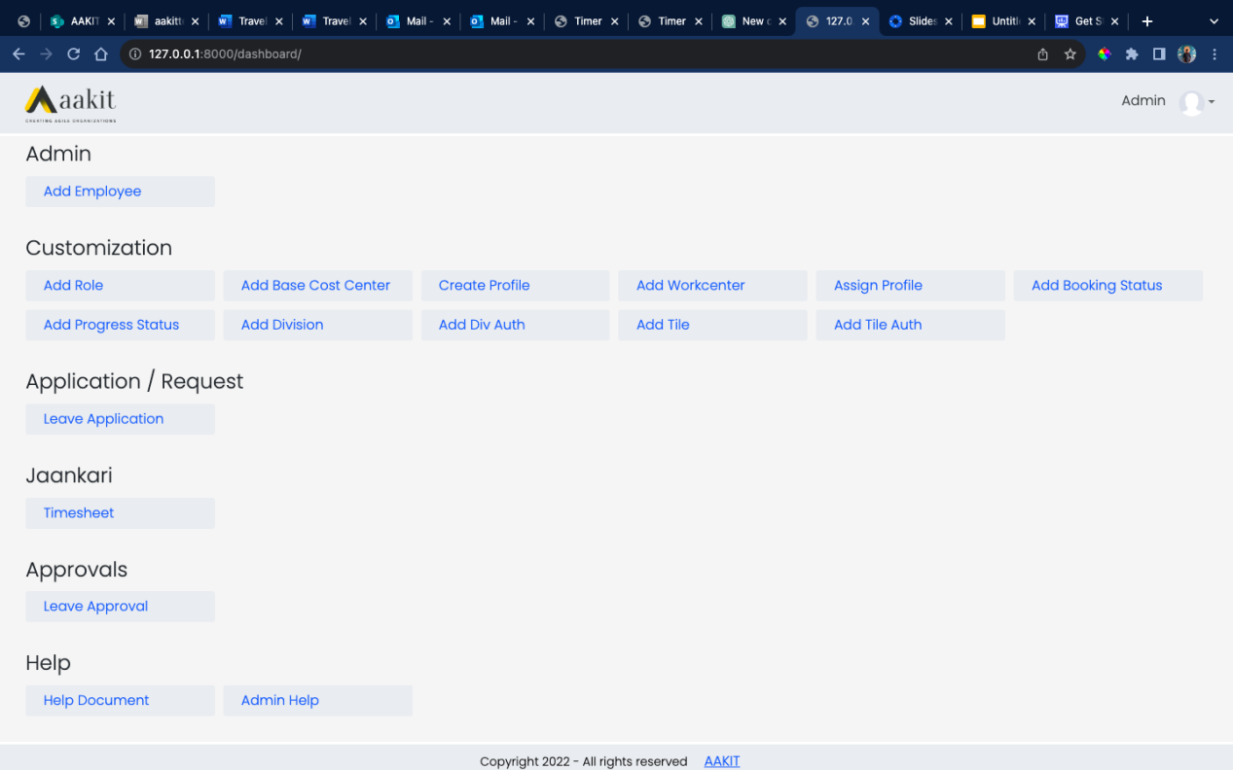

**Dashboard option from home page displays Divisions and Tiles with it which is visible to employee based on role assigned to the Div and Tiles.**

**Order of tiles can also be assigned providing sequence to Div and Tiles.  
Below are the steps to create and assign role to it.**

**Step 1**

**Under Customization select ‘Add Division’ to add new Division**

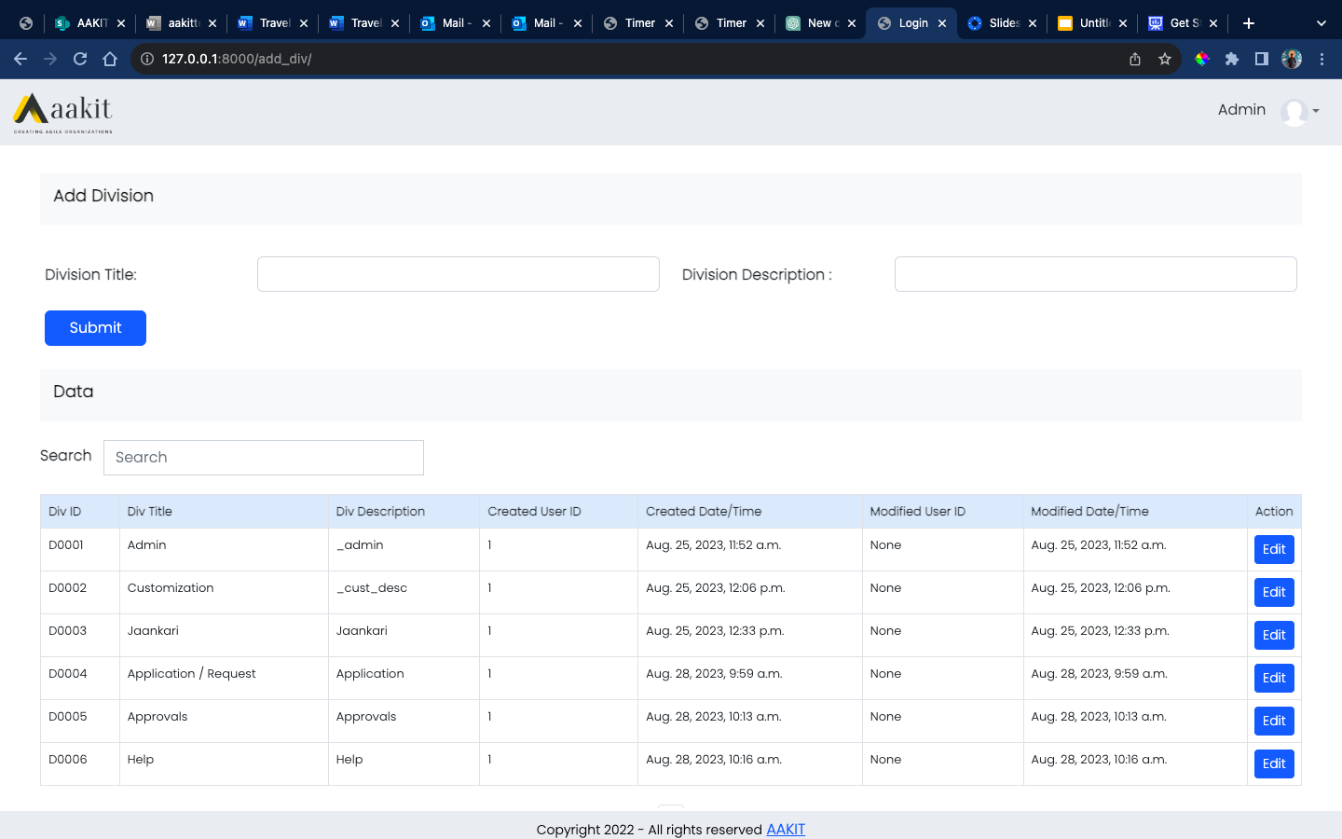

**Div form takes Title and Description.**

**Title represent the header of Div within Dashboard page and Description explains what it does.**

**Table shows list of all the Divisions created and option to edit any of them whenever needed.**

**Below image shoes the edit form**

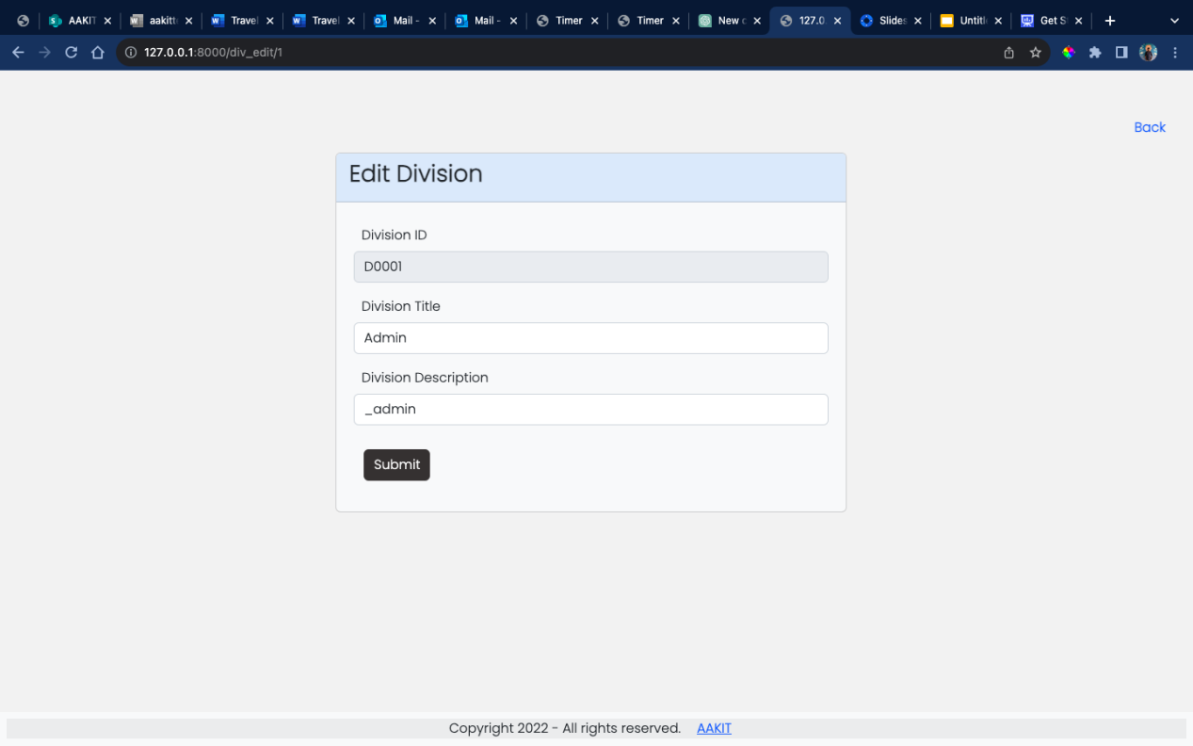

**Step 2**

**Under Customization select ‘Add Div Auth’ option to assign role to the created Division and based on the Role assigned it will be only visible to the employee of similar Role.**

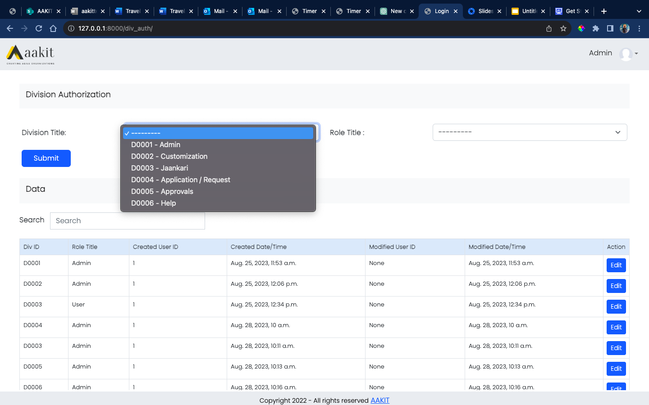

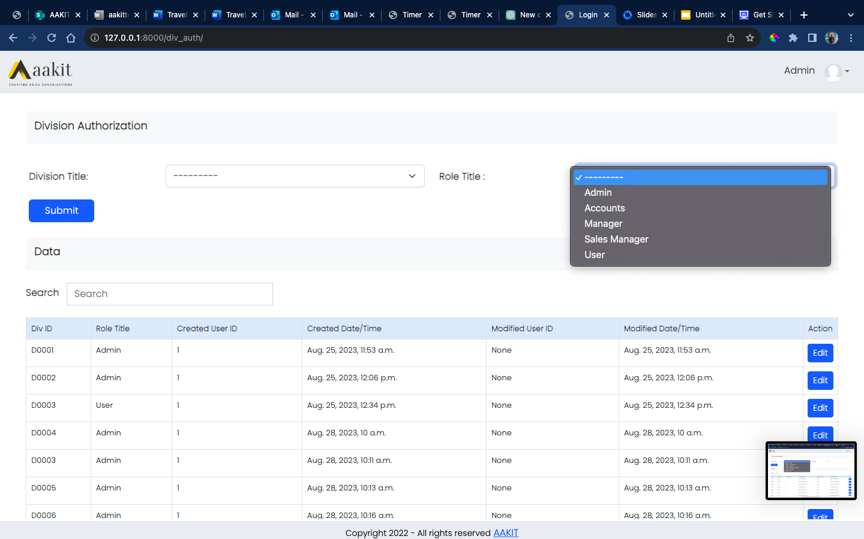

**As shown in the image above you can select the Division for which you want to assign the role and then select Role to apply.**

**Edit form where sequence of the Div can be set**

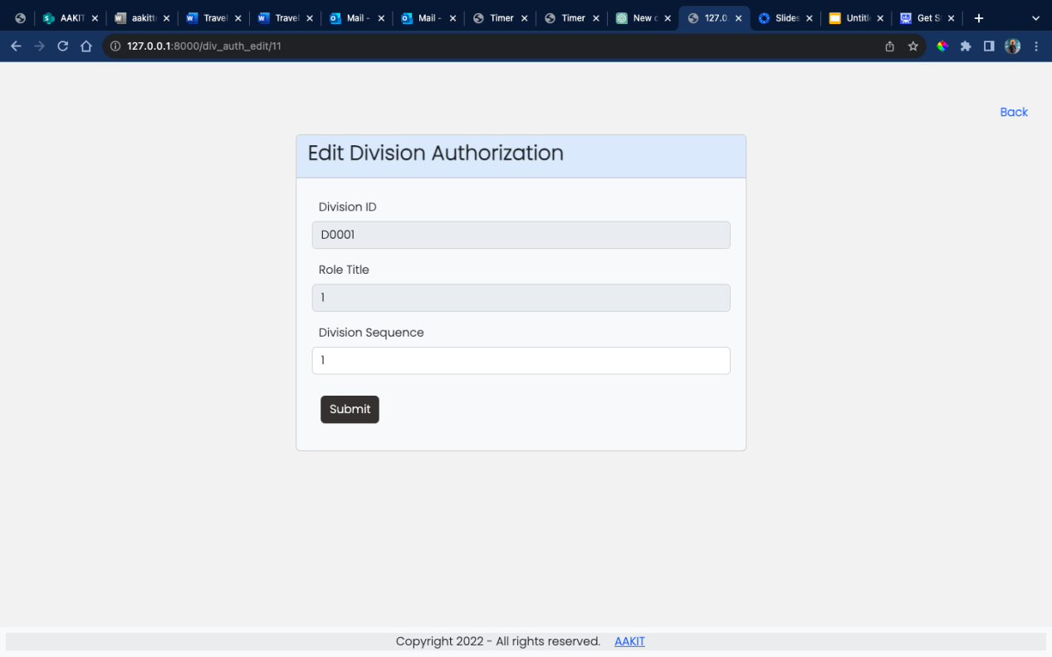

**Step 3**

**‘Add Tile’ option allows to add a new tile which takes Title, Description and Url**

**Title is the name of Tile displayed under Division created**

**Description as the name suggests and Url will be the name used for creating function responsible for logic to display details under tile in the project which is then used as url in settings.py file.**

**Note: The name provided for Url should be used as name of function**

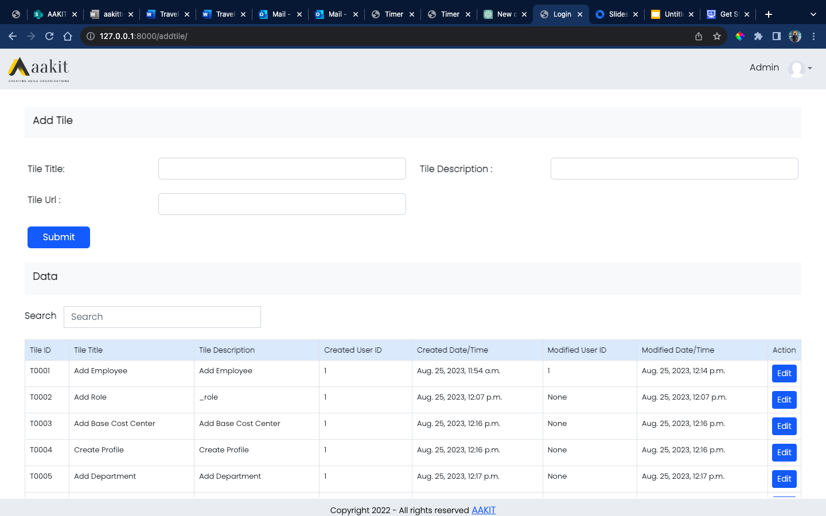

**Step 4**

**Assign the Tile created with Role with option ‘Add Tile Auth’ under Customization**

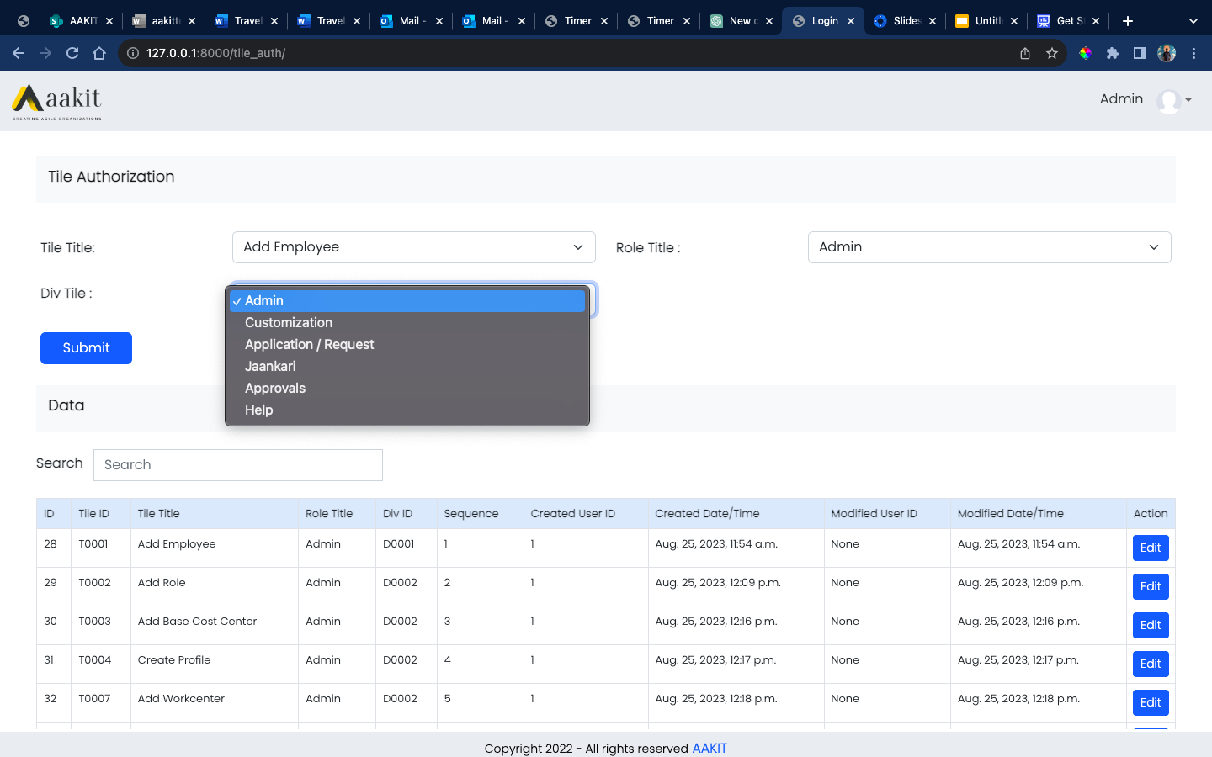

**After Tile is created the same should be assigned Role and based on Role assigned ‘Div Tile’ field will display Divisions which has same Role selected.**

**Edit form where sequence can be set**

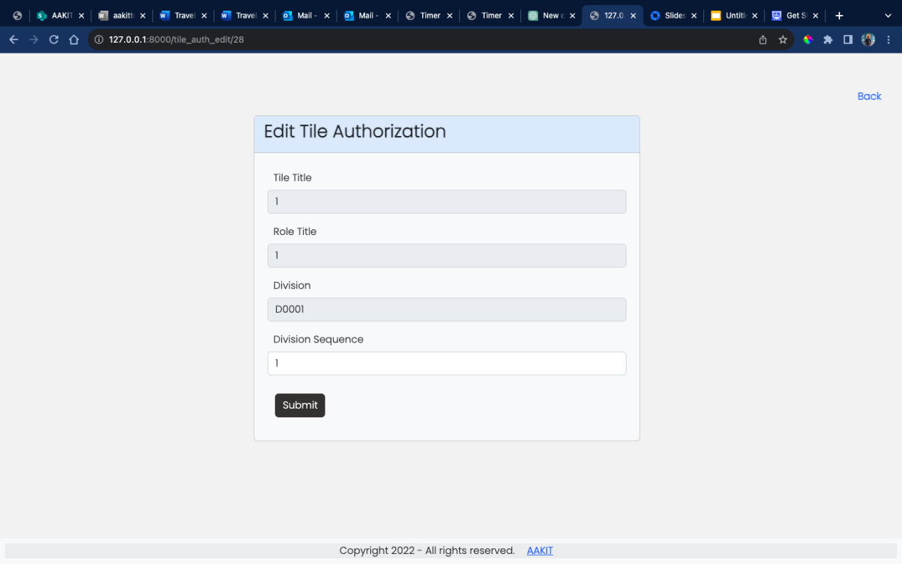

**Following the steps provided you can create and assign Divisions and Tiles.**