**Travel and Claims Specification**

**Home page with sidebar options**

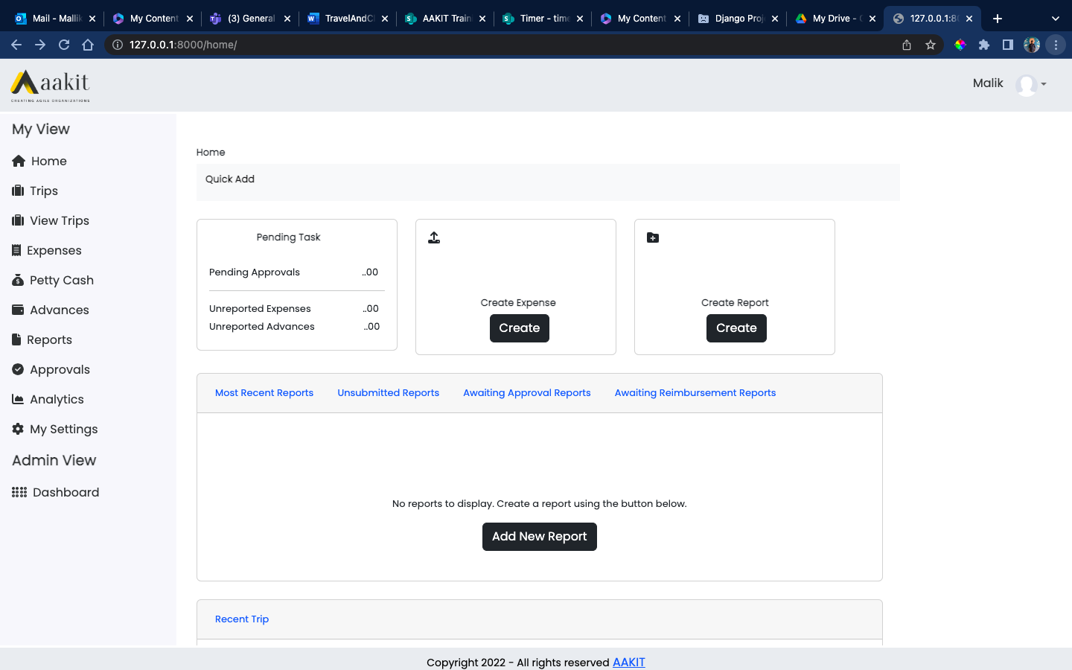

**Home**

**This page displays overview of all the tasks, types of reports and shortcut link to create trips.**

**Trips**

**This page contains form which allow user to create a new trip where Trip header is mandatory.**

**After entering header details by selecting Project traveling for and Travel Type user can then create trip with itinerary needed for trip  
Itineraries include Flight(One-way,Round-trip and Multi-city), Hotel, Car, Visa and Forex.**

**User can add multiple requests for each itinerary and also check ‘Not Required’ if any itinerary is not not needed for trip and then save the trip request.**

**This then first saves the Trip Header and attaches the header ID with Flight,Hotel,Car,Visa and Forex if entered by user**

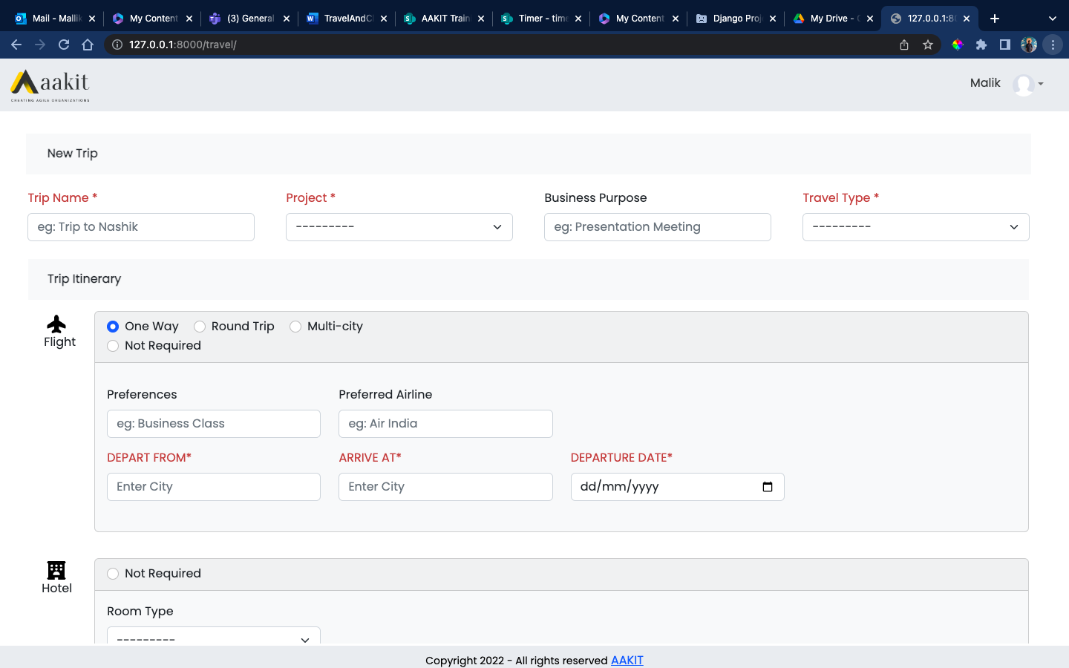

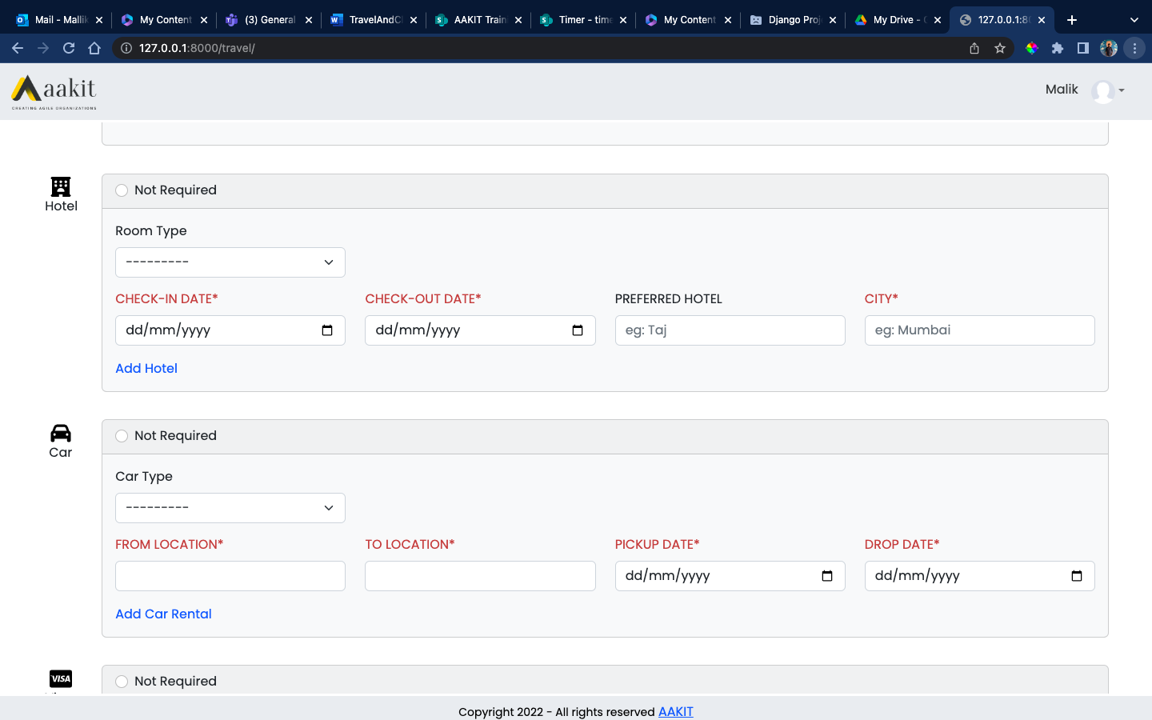

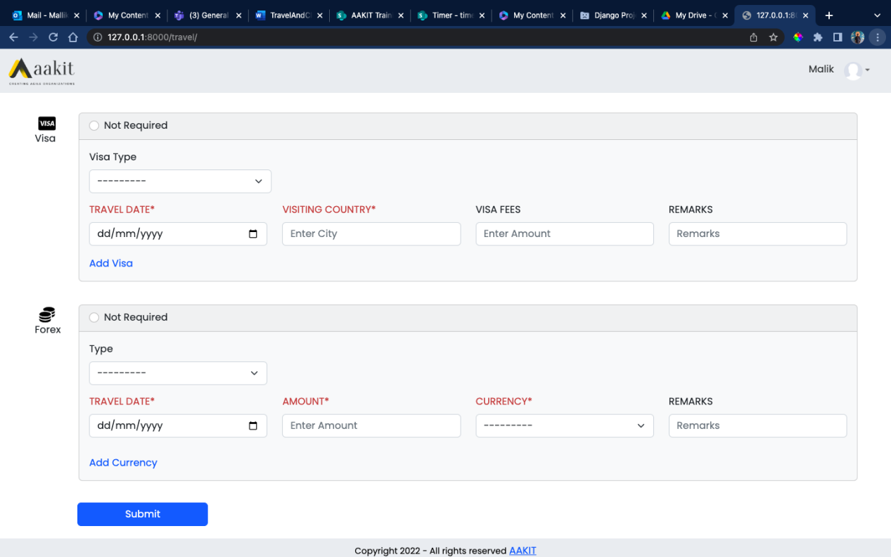

**Validations while form submission**

1. **Header form is required and if left blank error message is displayed.**
2. **After Header form is entered if for example user just want Hotel for the trip and checks ‘Not Required’ for other forms and then submits without entering Hotel details error message will be displayed.**
3. **Similarly for other form if left blank while submitting error message is displayed**
4. **All the fields highlighted in red are required and needs to be filled while submission**
5. **For all date fields past date cannot be selected**

**Flight**

**Flight form contains option for One-way, Round Trip and Multi-city flight details**

**Not Required if form is not needed for trip**

**Add Flight option is only available for Multi-city flight type**

**One-way**

**This flight form saves one-way flight details in database table with Trip Header ID attached**

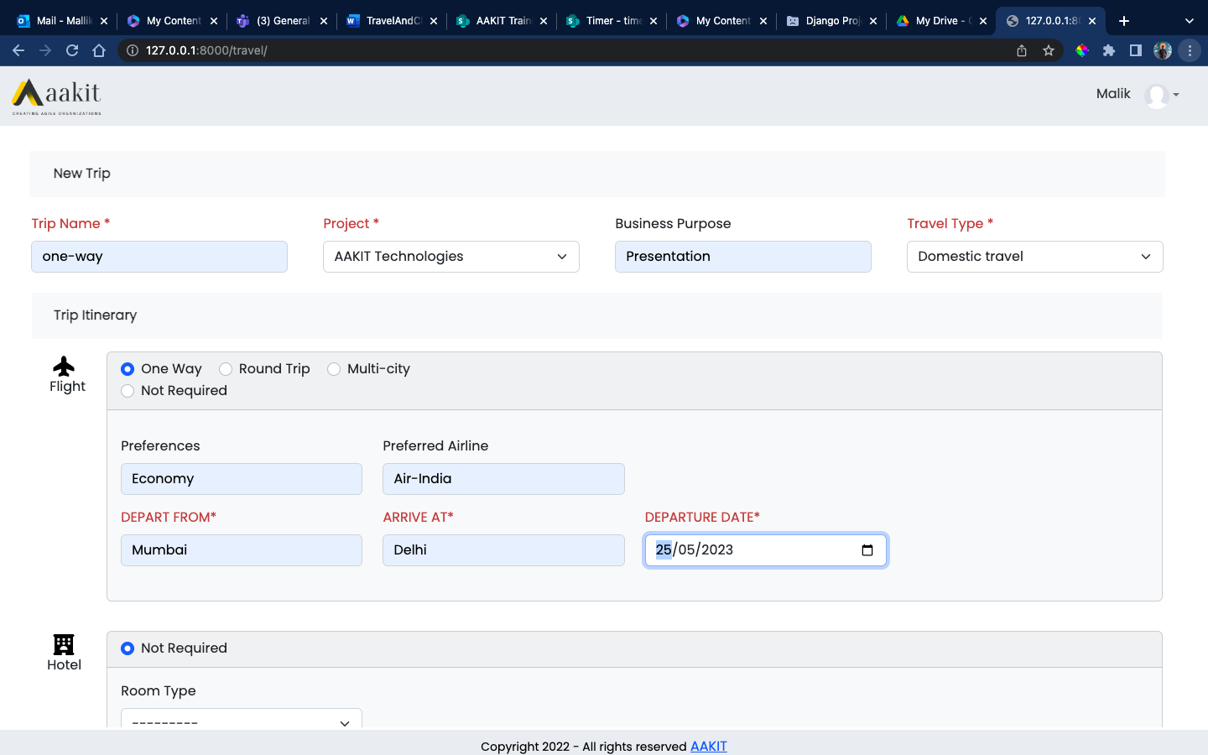

**Round Trip**

**This flight form saves two records in table with header ID**

**First record with depart from, arrive at and departure date entered**

**Second record with departure date as return date entered, depart from, arrive at values in reverse.**

**Example**

**If depart from value is Mumbai and arrive at is Delhi then second record values will be as follows  
Depart from -> Delhi**

**Arrive at -> Mumbai**

**Depart date -> Return date**

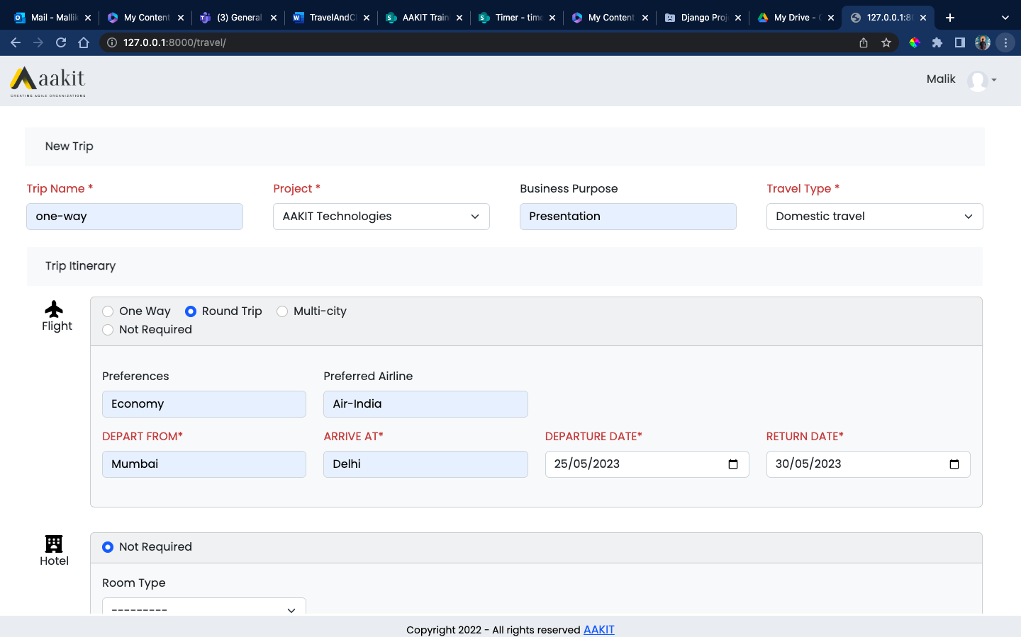

**Multi-city**

**This Flight form is used when employee is needed to travel multiple cities**

**No of records saved in database will be no of flight details added with header ID**

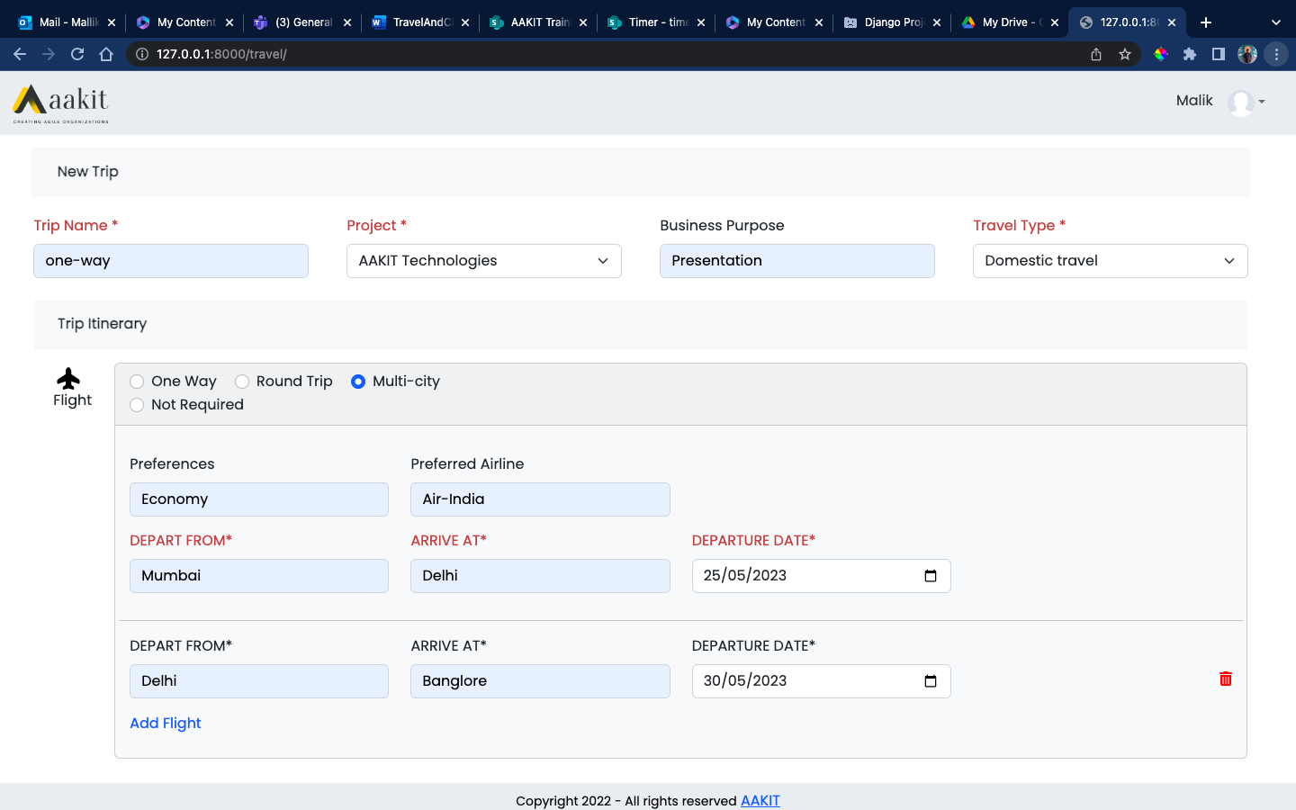

**Hotel**

**Hotel form contains option to Add Hotel which allows employee to add multiple hotel details for a trip**

**Not Required if form is not needed for trip**

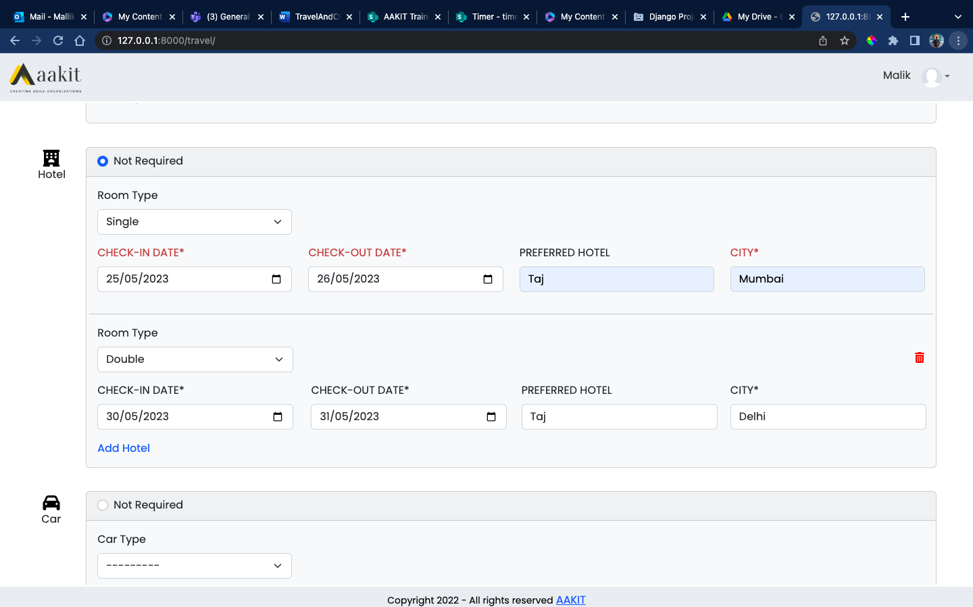

**No of records saved in database will be no of hotel details added with header ID**

**Car**

**Car form contains option to Add Car which allows employee to add multiple car details for a trip**

**Not Required if form is not needed for trip**

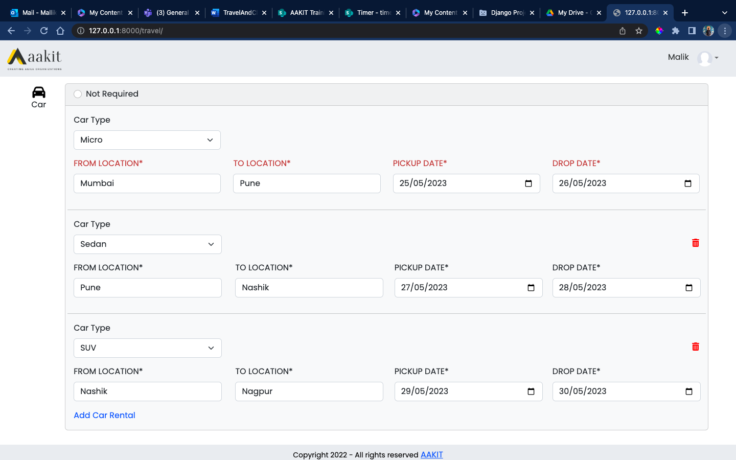

**No of records saved in database will be no of car details added with header ID**

**Visa**

**For International trip**

**Visa form contains option to Add Visa which allows employee to add multiple visa details for a trip**

**Not Required if form is not needed for trip**

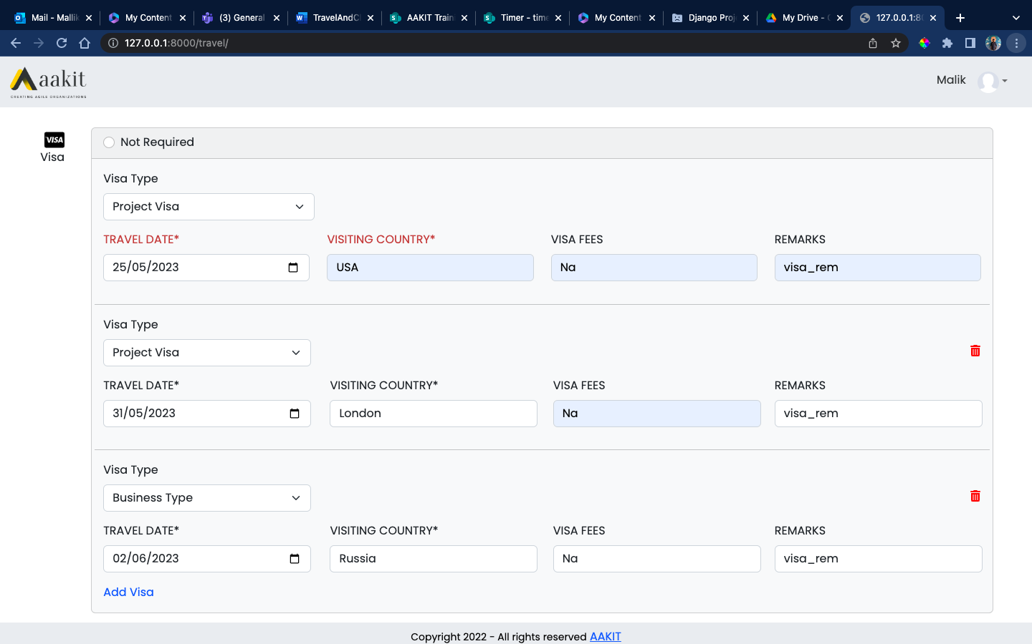

**No of records saved in database will be no of visa details added with header ID**

**Forex**

**For International trip**

**Forex form contains option to Add Forex which allows employee to add multiple forex details for a trip**

**Not Required if form is not needed for trip**

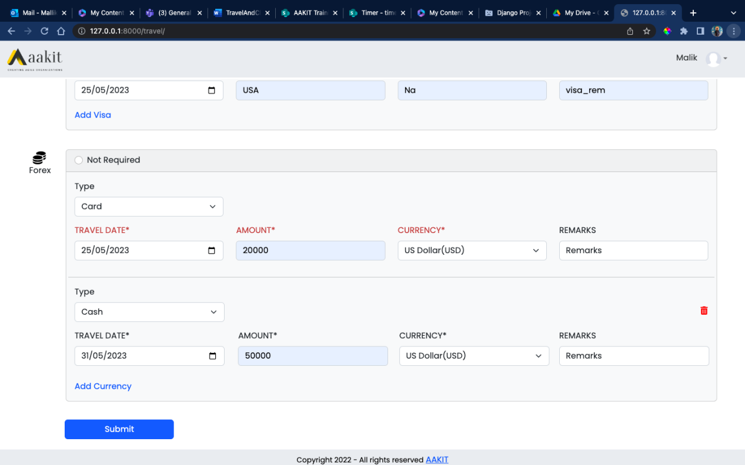

**No of records saved in database will be no of forex details added with header ID**