Assignment 3.2

Michelle Nesbitt

7/19/2020

Bellevue University – WEB-335

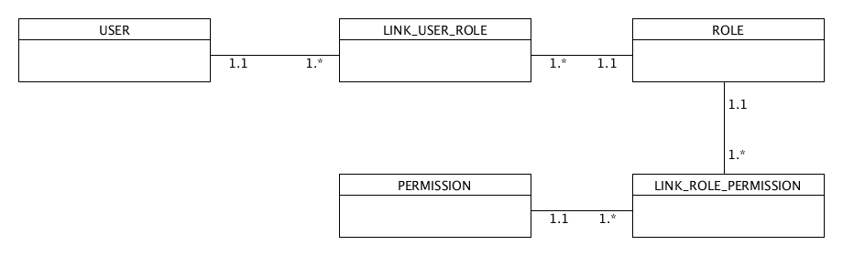

1. A user can have many roles.
2. A role can be linked to many users.
3. A permission can be linked to many roles.
4. A role can have many permissions.
5. A user can have many permissions.

