Assignment 4.3

Michelle Nesbitt

7/21/2020

Bellevue University – WEB420

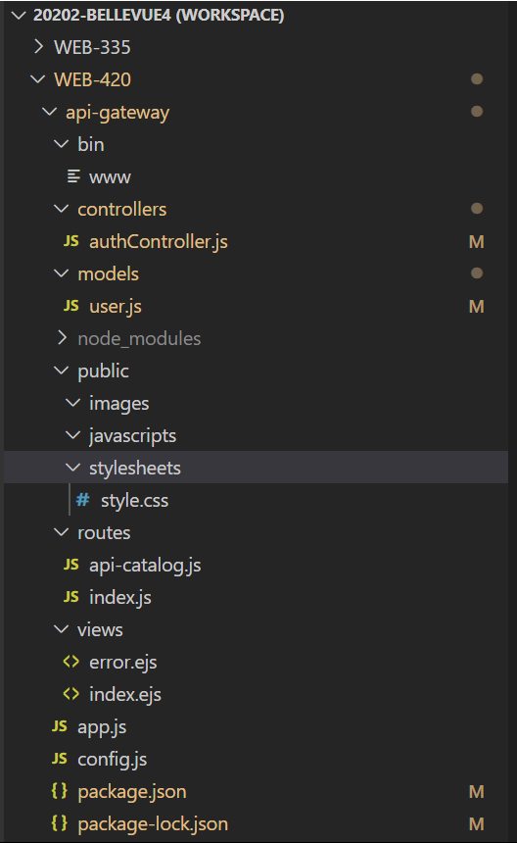

ps C: 
+ bcryptjs@2.4.3 
+ jsonwebtoken@8.5.1 
added 14 packages from 15 contributors and audited 214 
9 packages are looking for funding 
run fund' for details 
found ø vulnerabilities 
ps C: 
> api-gateway@e.e.ø devstart C: 
> nodemon . bin/l•me 
[nodemon] 2.ø.4 
[nodemon] to restart at any time, enter rs- 
[nodemon] watching path(s): 
[nodemon] watching extensions: 
[nodemon] starting node . /bin/'%'w . bin/nww• 
- gateway) 
packages 
- gateway> 
- gateway> 
rim' install jsonwebtoken bcryptjs 
in 1.564s 
set DEBUG=api-gateway: * 
npm run devstart 
-- save 
(node:31588) DeprecationWarning: current URL string parser is deprecated. and will be removed in a future version. To use the new parser, pass 
(node:31588) DeprecationWarning: current Server Discovery and Monitoring engine is deprecated. and will be removed in a future version. To use 
n { useunifiedTop010gy: true to the MongoC1ient constructor. 
connection successful 
GET /api/auth/register 4ø4 9.2ø4 ms - 2B62 
POST /api/auth/register 
50e 1.259 ms - 
221B 
undefined 
GET 
GET 
CET 
CET 
/api/auth/token 
see 
2.483 ms - 2167 
/ 2ee 1.352 ms - 2e7 
/stylesheets/style.css 2ee 1.852 ms - 111 
/favicon.ico 4ø4 1.164 ms - 2B74 

eBay 
Express 
We to Express 
ShippingE„ 