Assignment 5.4

Michelle Nesbitt

8/4/2020

Bellevue University – WEB420

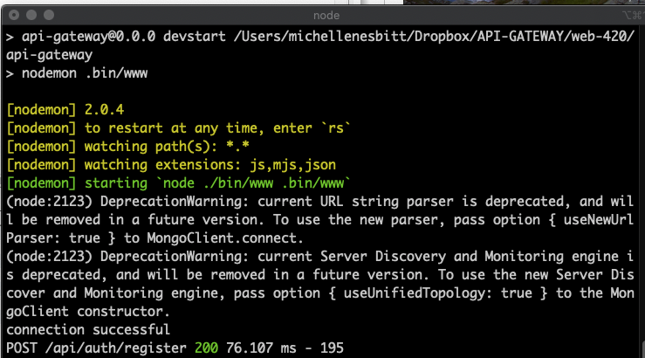

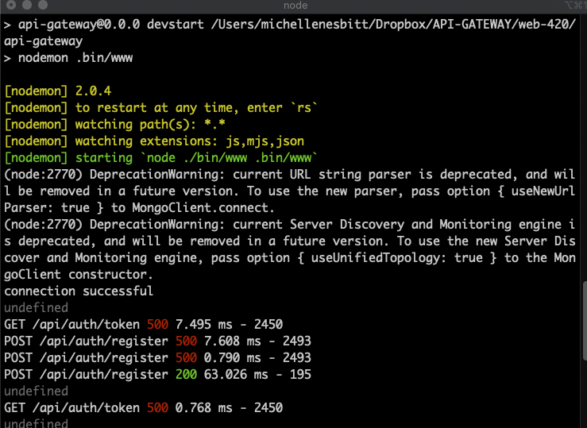

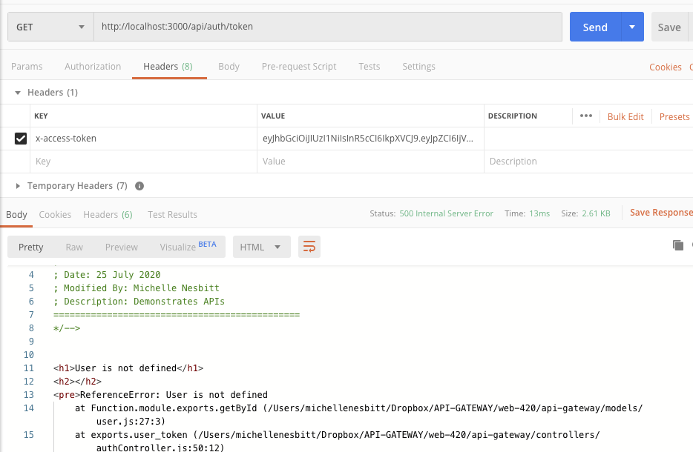

Sorry but followed the instructions exactly and nothing worked. I tried it in SOAP and also in POSTMAN. Looks like the mongodb is either down or is not returning the objects. However, the users are being registered successfully.