Assignment 8.4

Michelle Nesbitt

8/25/2020

Bellevue University – WEB-420

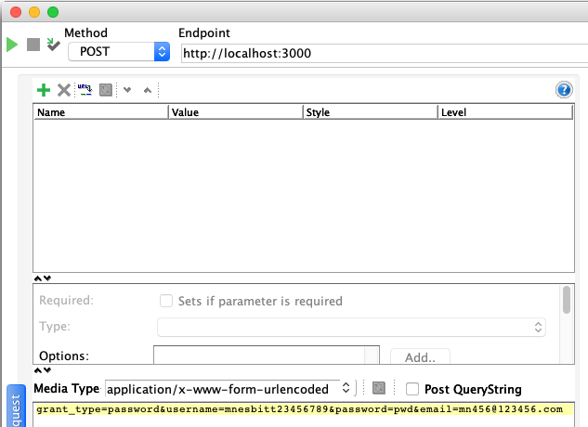

register request

username=mnesbitt23456789

password=pwd

email=mn456@123456.com

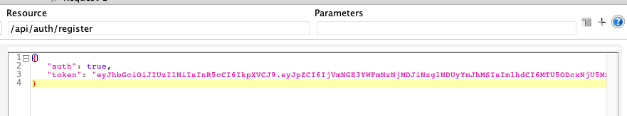

register response

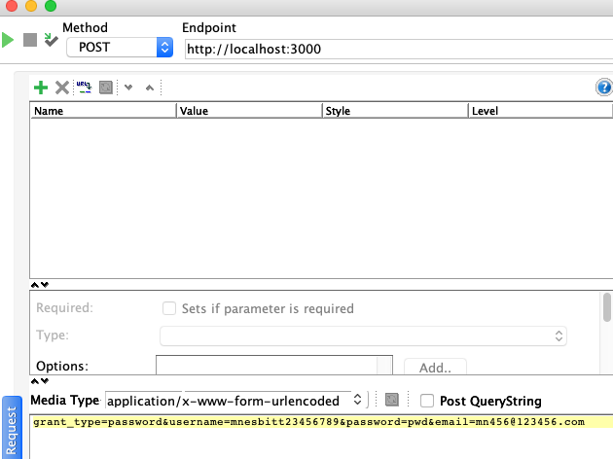

login - request

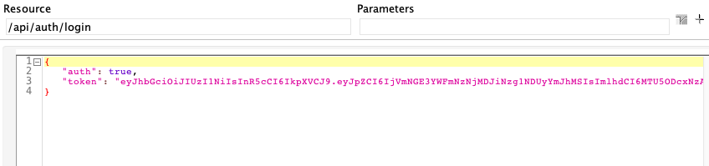

login response

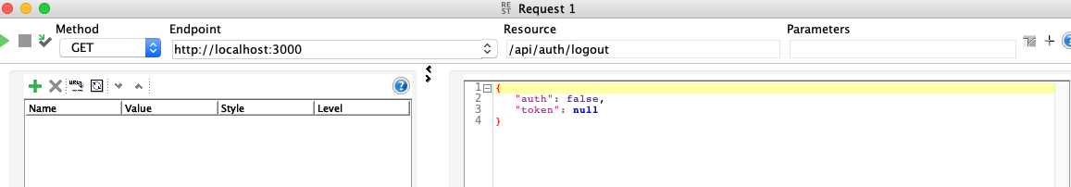

logout request & response

