BEANS IN A POT
Design
Documentation
A warm, editorial design system for a slow-coffee neighborhood shop.
PUBLIC WEBSITE · ADMIN PORTAL · 20 SCREENS

Espresso  #2C1810 | Noir  #090100 | Caramel  #994703 | Amber  #FC934F | Oat Cream  #FDF9F4 | Warm White  #FFFFFF
Prepared November 2026
Version 1.0 · Front-end prototype

CONTENTS

Contents
01 | Overview
02 | About the Business
03 | Design Process
04 | Typography
05 | Color Scheme
06 | Screens
Public Website · Admin Portal
Screens  20  Public and admin screens supplied with the prototype. | Typefaces  2  Playfair Display and DM Sans. | Palette  15+  Core color tokens across surfaces, text and feedback.
Document note Headings and body copy are set in Playfair Display and DM Sans. Word will substitute locally installed fallbacks if the brand fonts are unavailable.

01

Overview
Beans in a Pot is a neighborhood specialty coffee shop built around slow coffee, tactile craft and the pleasure of staying a little longer. The brand pairs wood-fired roasting with ceramic-pot brewing, presenting coffee as a ritual rather than a transaction. Its menu moves from short, intense espresso pulls to milk-based comfort, patient filter brews, regional preparations and cold infusions, with tea, pastries and small plates alongside.
The website translates that character into a digital experience. The public site introduces the shop, tells its story, previews the seasonal menu, explains catering and workshops, and invites visitors to join The Hearth Chronicle. A separate admin portal gives the team a practical view of sales, menu availability, offers, bookings and newsletter activity.
This document records the visual language and the screens that make up the front-end prototype. It is intended as a reference for design, content and implementation decisions rather than a technical specification.
Public Website  Home + Menu  A warm introduction to the coffee, the room and the ritual. | Admin Portal  5 screens  Overview, menu, offers, catering and Chronicle. | Prototype  Front-end only  React, TypeScript and a local mock data layer.
Source material Design_Tokens/DESIGN.md and the 20 supplied screenshots in Screenshots/.

02

About the Business
Beans in a Pot is a small, independent coffee shop with a simple belief: good coffee should make room for a slower day. The shop roasts in small batches over wood fire, brews in unglazed clay pots and serves each cup with the care of a hand-poured ritual. The room is warm and unhurried, designed for quiet mornings, informal meetings and neighbors who stay for one more cup.
The menu is broad without losing its point of view. Espresso, milk coffee, filter brews, cultural specialties and cold drinks sit alongside teas, pastries and small plates. Beyond the counter, the shop hosts tastings, workshops and private catering, and keeps its community close through a regular newsletter, The Hearth Chronicle.
The website is built to feel like an extension of the room: generous typography, warm paper tones, rich espresso browns and photography that leaves space for the coffee to breathe. Every public screen is designed to inform without rushing the visitor, while the admin screens give the team the practical tools to run the shop day to day.

03

Design Process
1. Research
2. Ideate
3. UI Designing
4. Implementation

04

Typography
Two families carry the system. Playfair Display gives the brand its editorial, hospitality-led voice; DM Sans keeps menus, labels and admin controls clear and direct. The contrast is deliberate: expressive headlines, functional details.

Type specimen
Aa  Playfair Display  Display · Headlines | Aa  DM Sans  Body · Labels · UI

Type scale
Role | Family | Size | Weight | Line height | Use
Display LG | Playfair Display | 56 px | 600 | 64 px | Desktop hero
Display LG mobile | Playfair Display | 36 px | 600 | 44 px | Small screens
Headline LG | Playfair Display | 40 px | 600 | 48 px | Section titles
Headline LG mobile | Playfair Display | 28 px | 600 | 36 px | Mobile sections
Headline MD | Playfair Display | 28 px | 500 | 36 px | Card titles
Headline SM | Playfair Display | 22 px | 500 | 28 px | Compact headings
Body LG | DM Sans | 18 px | 400 | 28 px | Intro copy
Body MD | DM Sans | 15 px | 400 | 24 px | Descriptions
Body SM | DM Sans | 13 px | 400 | 18 px | Supporting copy
Label LG | DM Sans | 14 px | 600 | 20 px | Controls
Label MD | DM Sans | 12 px | 600 | 16 px | Metadata
Label SM | DM Sans | 11 px | 700 | 14 px | Badges

Typesetting rules
- Headlines use standard to tight tracking (-0.01em to 0) with generous line height.
- Labels and badges use DM Sans medium or bold, with uppercase tracking (+0.05em) for origins, roast levels and weights.
- Body copy stays at 15–18 px on the web, with a relaxed 24–28 px line height for longer descriptions.
- The system uses no more than two families; weight and scale create hierarchy.

05

Color Scheme
The palette follows the roasting curve: unbleached parchment, warm caramel, sun-dried terracotta and deep espresso. Cream is the default canvas; espresso carries type and structural contrast; caramel and amber are reserved for actions and small highlights.
Espresso  #2C1810 | Noir  #090100 | Caramel  #994703 | Amber  #FC934F | Oat Cream  #FDF9F4 | Warm White  #FFFFFF

Core tokens
 | Token | Hex | Use
 | primary | #090100 | Brand ink; primary text on light surfaces
 | primary-container | #2C1810 | Dark roast panels, primary buttons, cover
 | secondary | #994703 | Caramel accent, links, active states
 | secondary-container | #FC934F | Warm highlights, chips, accent surfaces
 | background / surface | #FDF9F4 | Default page canvas
 | surface-container-lowest | #FFFFFF | Cards, inputs, quiet panels
 | surface-container-low | #F7F3EE | Alternate section background
 | surface-container | #F1EDE8 | Nested panels, wells, muted blocks
 | on-surface | #1C1C19 | Primary body and heading text
 | on-surface-variant | #504440 | Supporting copy, metadata, captions
 | outline | #827470 | Borders, inactive icons, secondary lines
 | outline-variant | #D3C3BE | Subtle dividers and disabled edges
 | error | #BA1A1A | Error states and destructive actions
 | error-container | #FFDAD6 | Error surfaces and alert backgrounds
 | on-error-container | #93000A | Error text on error container

Using the palette
- Use Oat Cream (#FDF9F4) as the default page canvas, with Warm White (#FFFFFF) for cards and inputs.
- Use Espresso (#2C1810) for primary type, dark panels and high-contrast buttons. Keep pure black for rare, high-impact moments.
- Use Caramel (#994703) for links, active states and primary accents; reserve Amber Crema (#FC934F) for highlights and warm chips.
- Use the peach and terracotta fixed tints as supporting surfaces, not as body-text backgrounds.
- The prototype uses one light theme. Dark espresso surfaces create contrast within that theme rather than a separate dark mode.

Contrast
Key pairings were checked against WCAG 2.1. The palette supports AA for body text in its intended combinations; amber is a decorative accent and fails body-text contrast on white.
Pair | Ratio | Result | Intended use
#1C1C19 on #FDF9F4 | 16.29:1 | AAA | Primary text on the page canvas
#504440 on #FDF9F4 | 8.94:1 | AAA | Supporting text and metadata
#FFFFFF on #2C1810 | 16.86:1 | AAA | Light text on espresso panels
#FFFFFF on #994703 | 6.45:1 | AA | Button and link text on caramel
#2C1810 on #FFDBC9 | 13.03:1 | AAA | Espresso text on warm fixed tint
#93000A on #FFDAD6 | 7.24:1 | AAA | Error text on error container
#FFFFFF on #FC934F | 2.23:1 | Decorative | Not suitable for body text
Ratios are calculated from the token hex values and rounded to two decimals. AA requires 4.5:1 for normal text; AAA requires 7:1.

06

Screens
The prototype has two public routes and five admin routes. The public site is designed for browsing and atmosphere; the admin portal is designed for operational clarity. The screenshots below are captured at desktop width, with the admin pages shown as full-page captures. Menu prices, offers, bookings and newsletter figures are sample prototype content.

Screen inventory
Route | Screen | Contents
/ | Home | Hero, specials, menu preview, services, reviews, visit and newsletter.
/menu | Menu | Hero, five drink categories, customization and newsletter.
/admin | Overview | KPIs, top brews, recent orders and a draft Chronicle prompt.
/admin/menu | Menu Management | Twenty-drink slate, filters, status and brew editor.
/admin/offers | Offers | Campaign cards, schedule, offer builder and redemption log.
/admin/catering | Catering | KPIs, booking ledger and equipment readiness.
/admin/newsletter | Chronicle | Composer, preview, subscriber stats and past issues.

Public Website

Homepage — Hero
A full-bleed coffee image and editorial headline establish the slow, tactile tone. Two actions lead to the visit section or today’s specials.
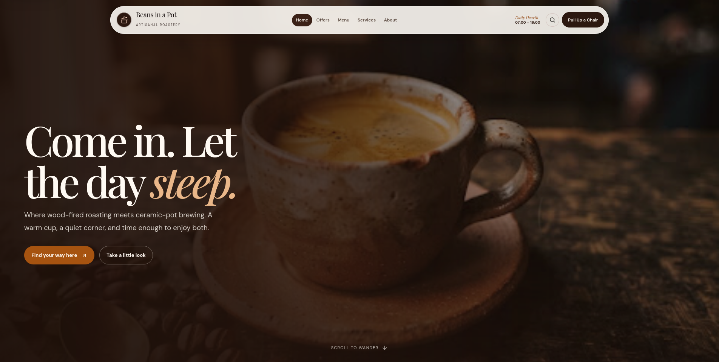
Figure 01 — Homepage — Hero. Captured at desktop width.

Homepage — Today’s Hearth & Pot Specials
Three daily specials are presented as numbered cards with imagery, tasting notes and links to the full menu.
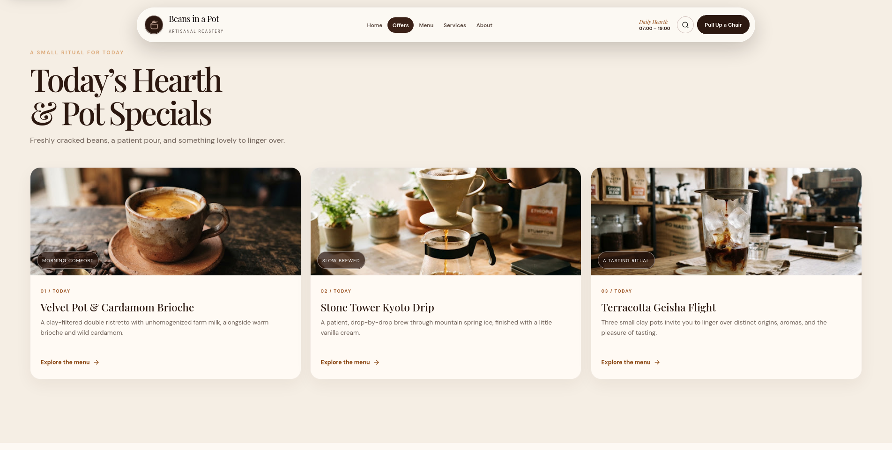
Figure 02 — Homepage — Today’s Hearth & Pot Specials. Captured at desktop width.

Homepage — Slow-Roast Shelf
A filtered menu preview lets visitors browse categories and scan signature drinks before opening the full menu.
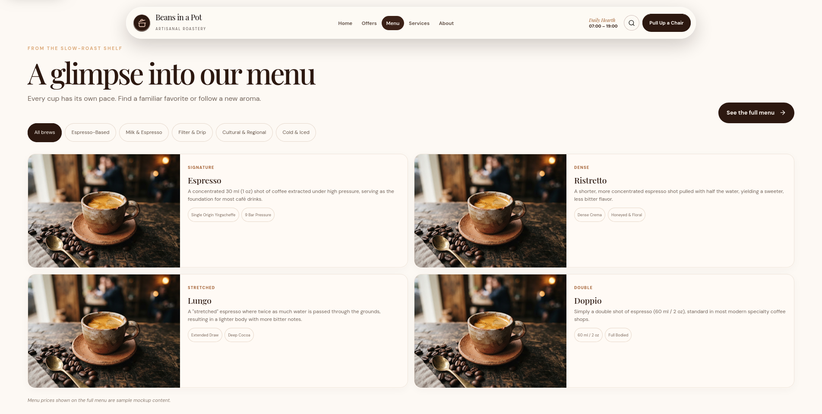
Figure 03 — Homepage — Slow-Roast Shelf. Captured at desktop width.

Homepage — More Than a Cup
Service cards for tea, gatherings and everyday rituals show the shop as a place to stay, not only a counter.
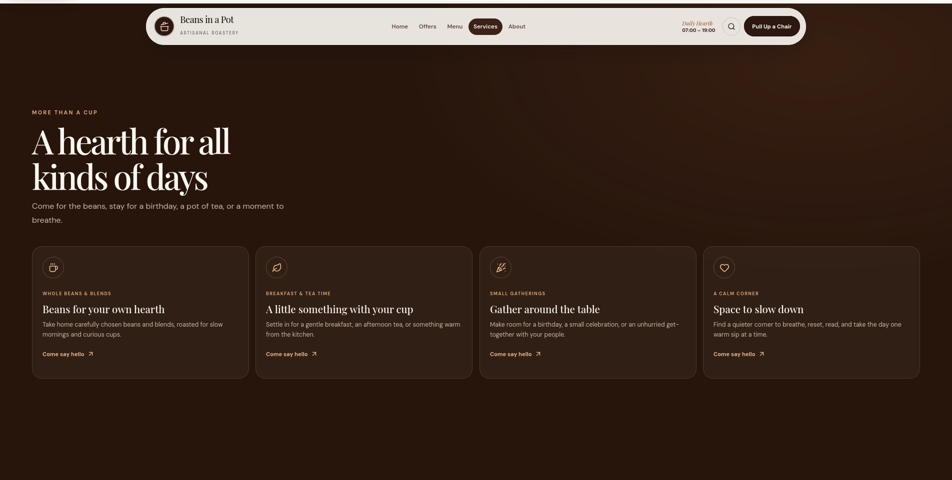
Figure 04 — Homepage — More Than a Cup. Captured at desktop width.

Homepage — Neighborhood Notes
A guest-review carousel adds social proof in the same warm editorial voice.
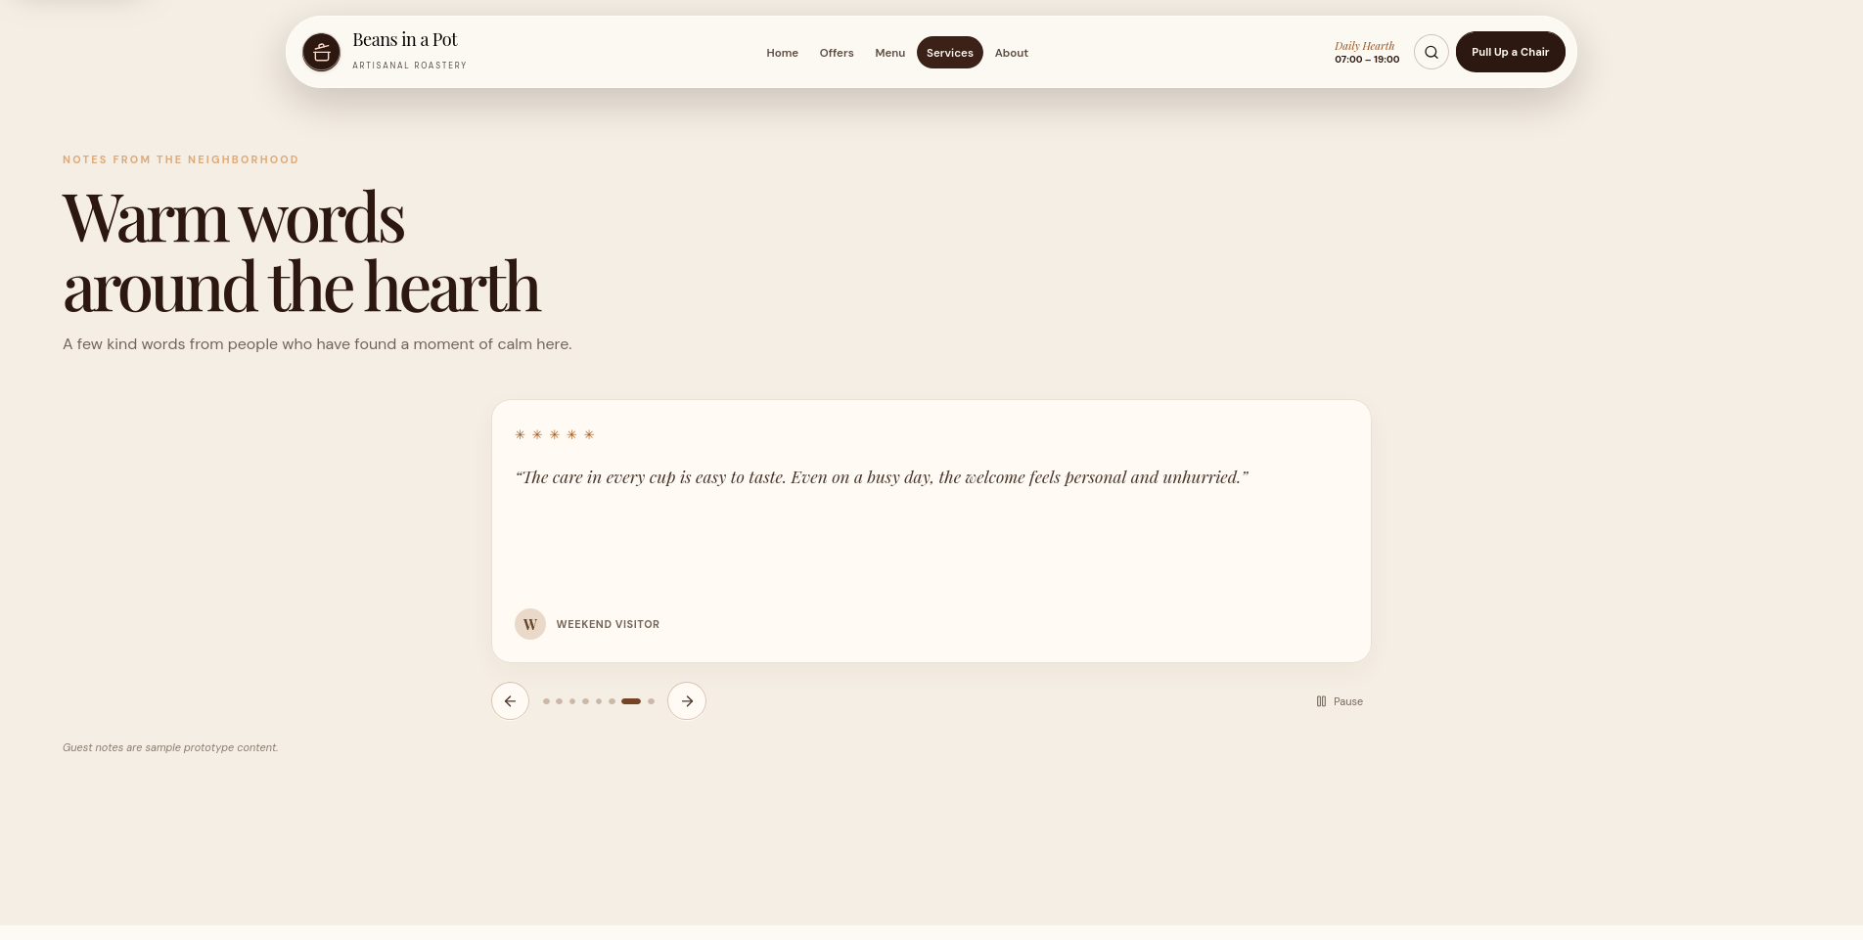
Figure 05 — Homepage — Neighborhood Notes. Captured at desktop width.

Homepage — Visit Us
Location, opening hours and contact details are paired with a clear invitation to step into the hearth.
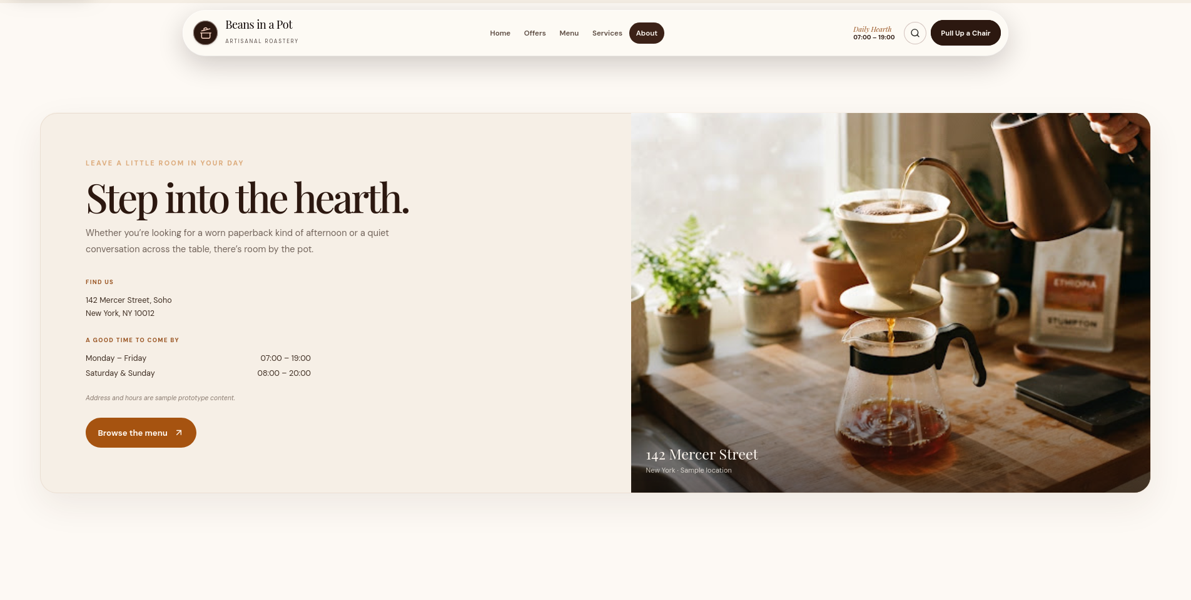
Figure 06 — Homepage — Visit Us. Captured at desktop width.

Homepage — Newsletter & Footer
The Hearth Chronicle signup and footer close the homepage with a low-friction call to stay in touch.
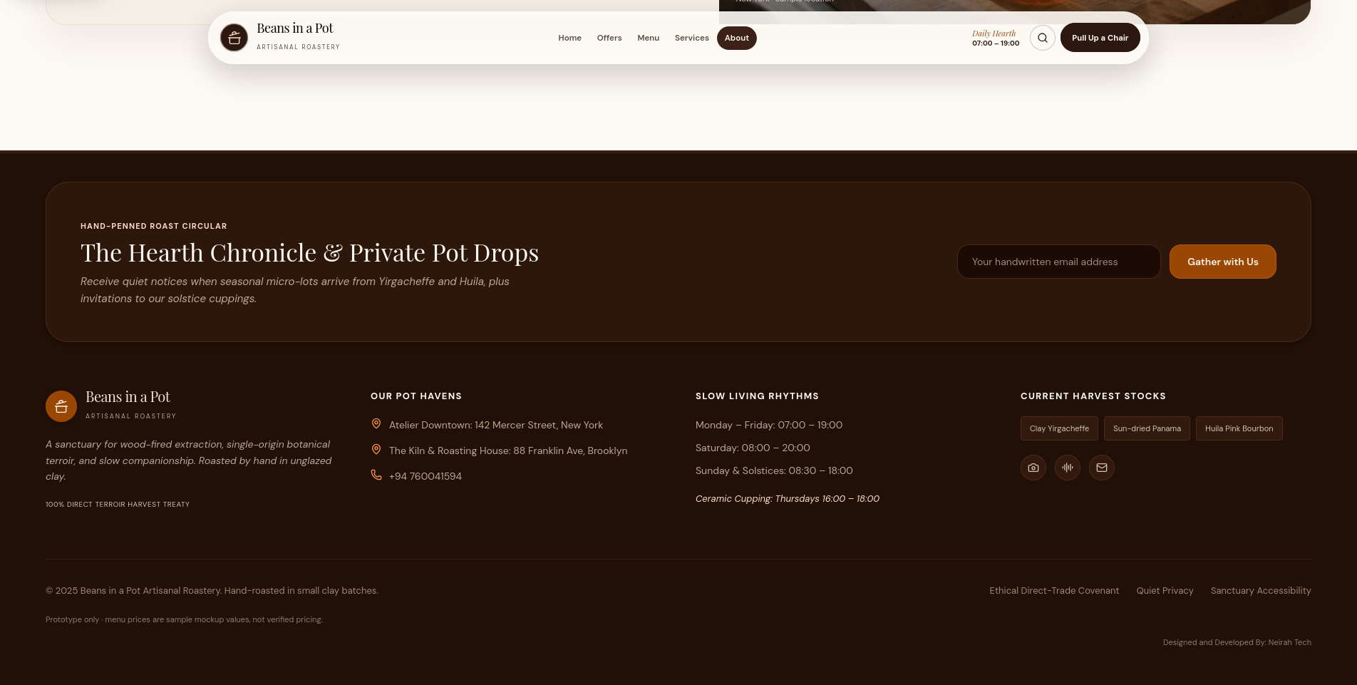
Figure 07 — Homepage — Newsletter & Footer. Captured at desktop width.

Menu — Hero
The full menu opens with an editorial title, a short brewing statement and three production metrics: hearth flame, clay pots and extraction range.
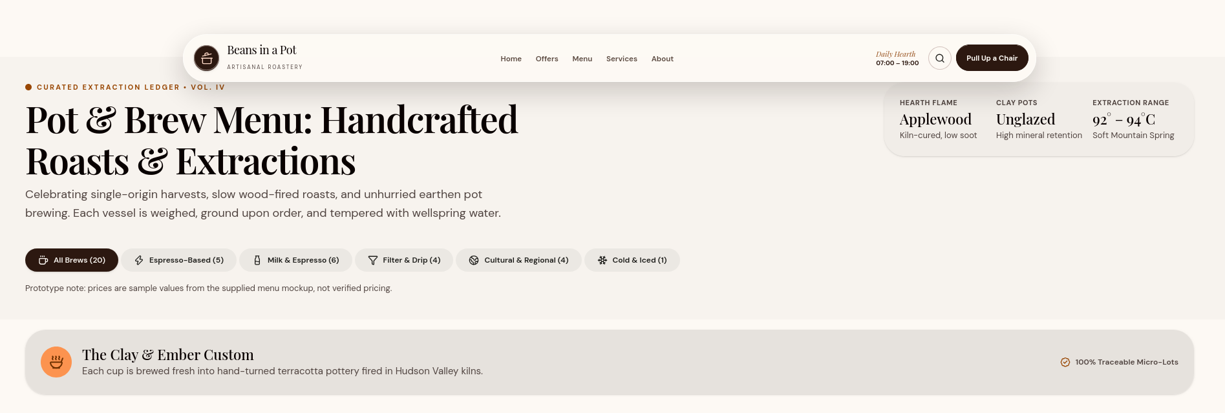
Figure 08 — Menu — Hero. Captured at desktop width.

Menu — Espresso-Based
Short, strong espresso drinks are arranged in a calm card grid with tasting notes, badges and sample prices.
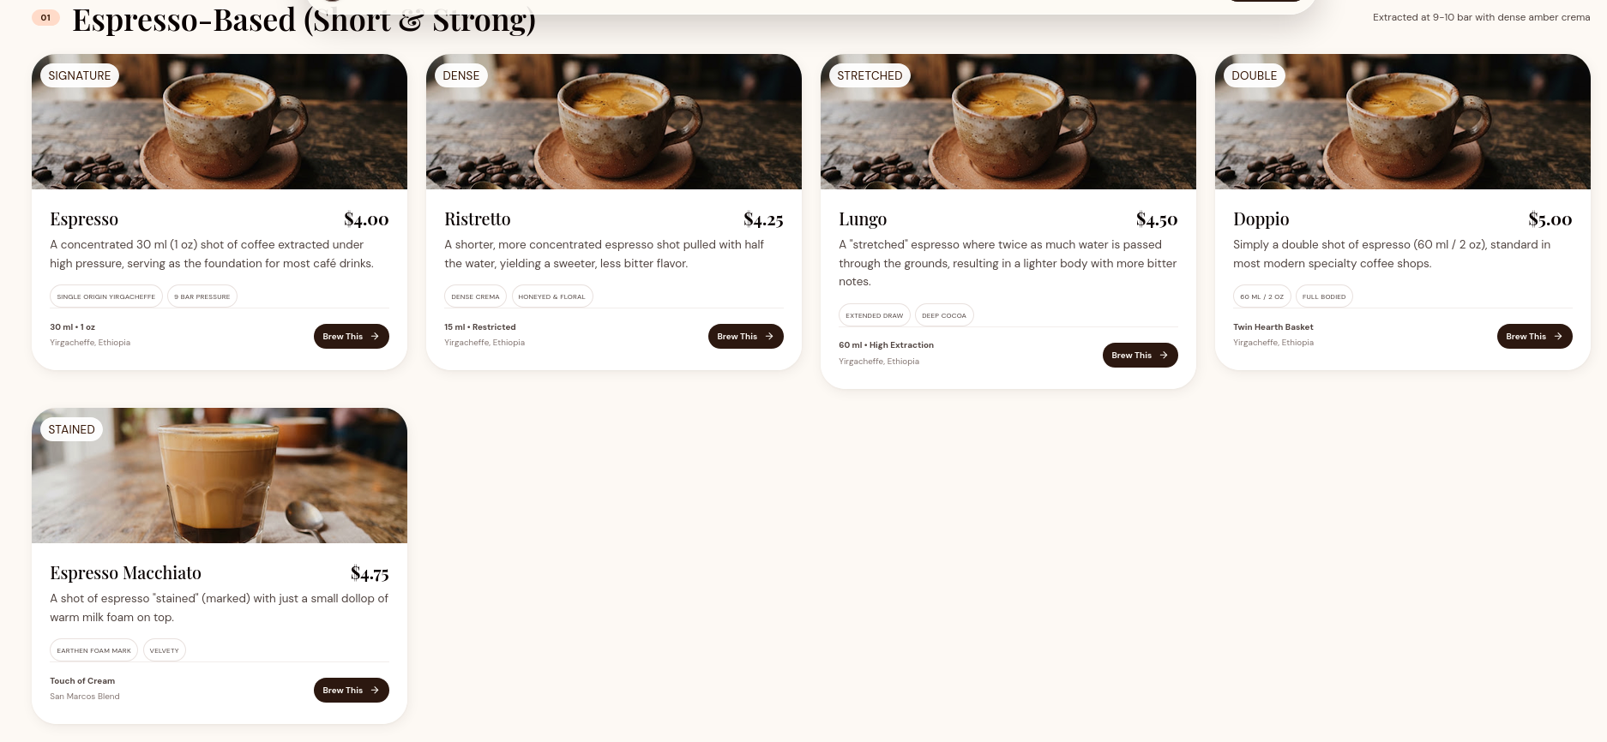
Figure 09 — Menu — Espresso-Based. Captured at desktop width.

Menu — Milk & Espresso
Milk coffee and espresso combinations continue the card rhythm with dairy and oat options.
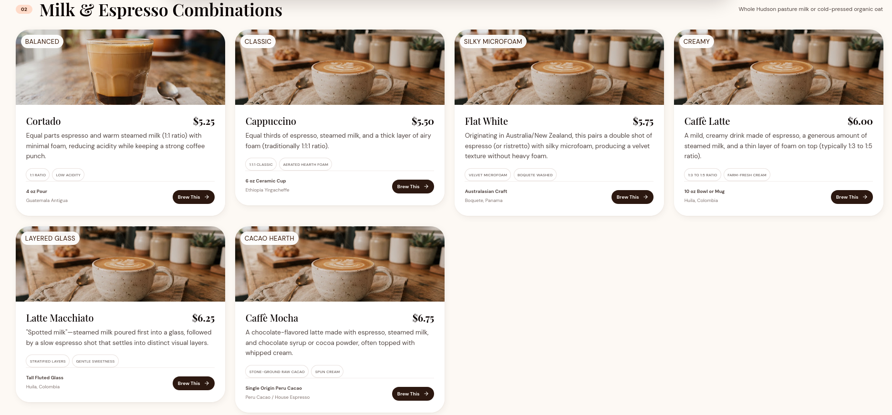
Figure 10 — Menu — Milk & Espresso. Captured at desktop width.

Menu — Filter, Drip & Alternative
Filter and alternative brews show origin, method and slower extraction details.
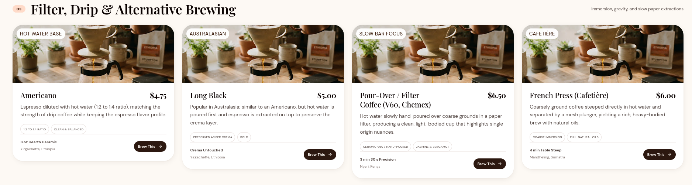
Figure 11 — Menu — Filter, Drip & Alternative. Captured at desktop width.

Menu — Cultural & Regional
Regional preparations from Istanbul, Hanoi, Paris and Rome sit alongside the core menu.
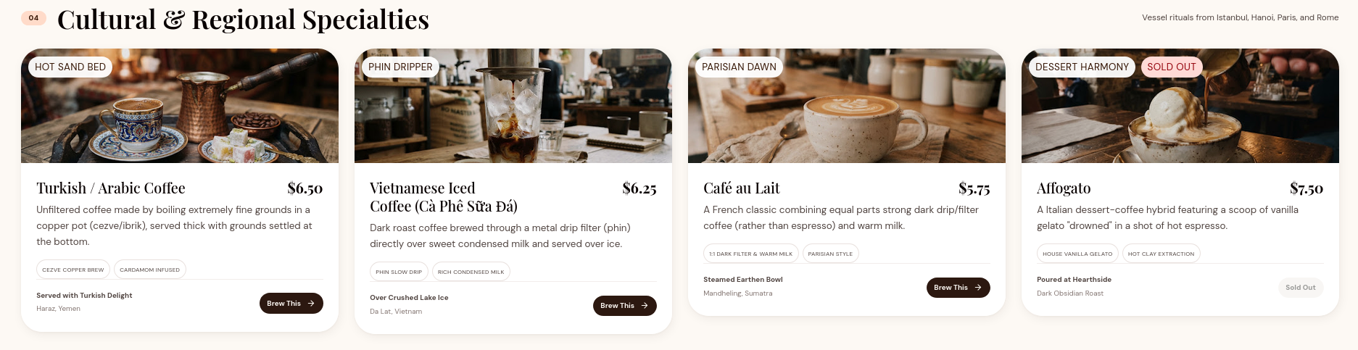
Figure 12 — Menu — Cultural & Regional. Captured at desktop width.

Menu — Cold & Iced
Cold drinks use a cooler image treatment while remaining inside the warm palette.
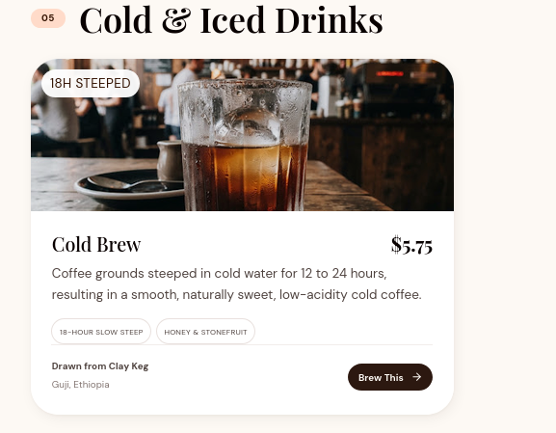
Figure 13 — Menu — Cold & Iced. Captured at desktop width.

Menu — The Custom Cup
Dietary and pot-customization add-ons are presented as clear, priced choices.
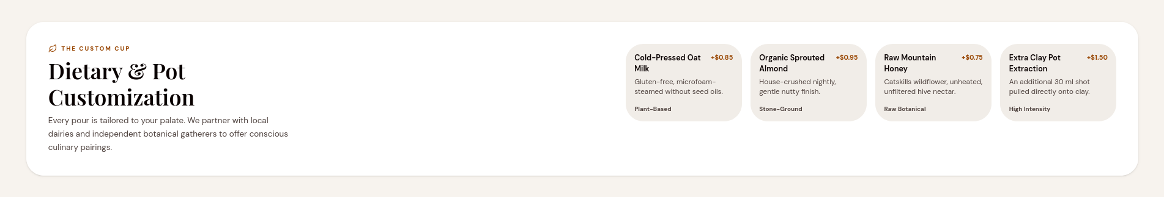
Figure 14 — Menu — The Custom Cup. Captured at desktop width.

Menu — Newsletter & Footer
The Chronicle signup and footer repeat at the end of the menu, keeping the next step consistent.
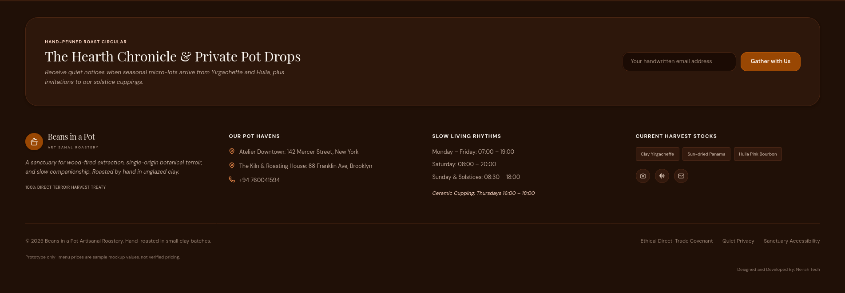
Figure 15 — Menu — Newsletter & Footer. Captured at desktop width.
Public site notes
- The same header, footer and Chronicle signup pattern carries across the Home and Menu routes.
- Category filters and menu cards use the same visual grammar, so the menu preview feels like the full menu.
- Sample prices are labelled as mockup content; no ordering or payment is created in the prototype.

Admin Portal

Admin — Overview & Sales Pulse
A live-feeling operational snapshot combines KPIs, top brews, recent orders and a draft Chronicle prompt.
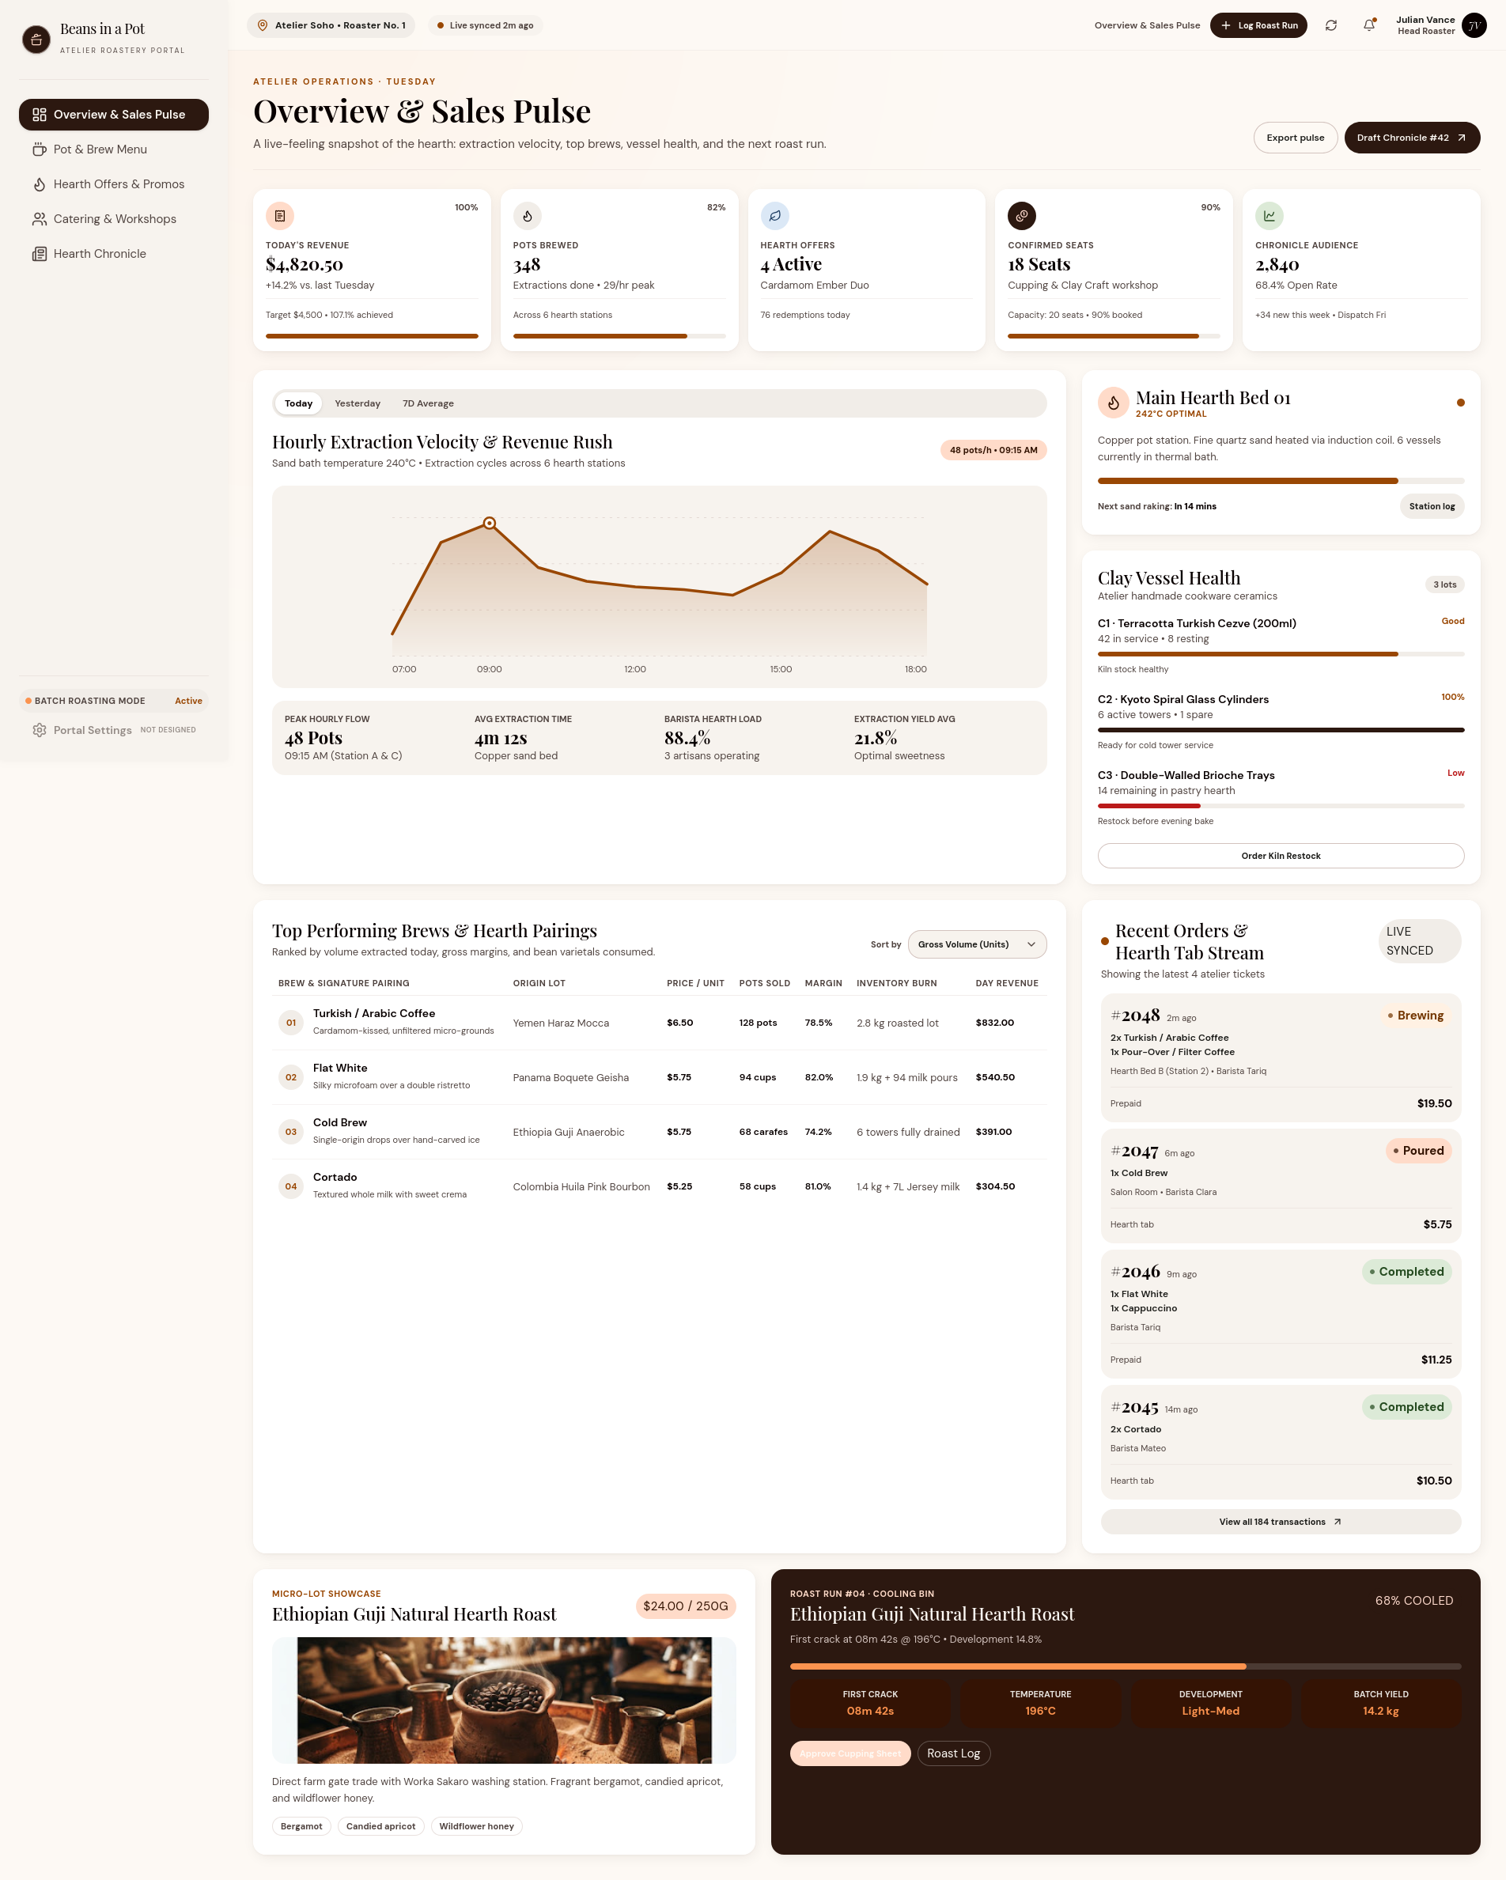
Figure 16 — Admin — Overview & Sales Pulse. Captured at desktop width.

Admin — Pot & Brew Menu Management
The twenty-drink menu is managed through filters, status pills, inline actions and a brew editor.
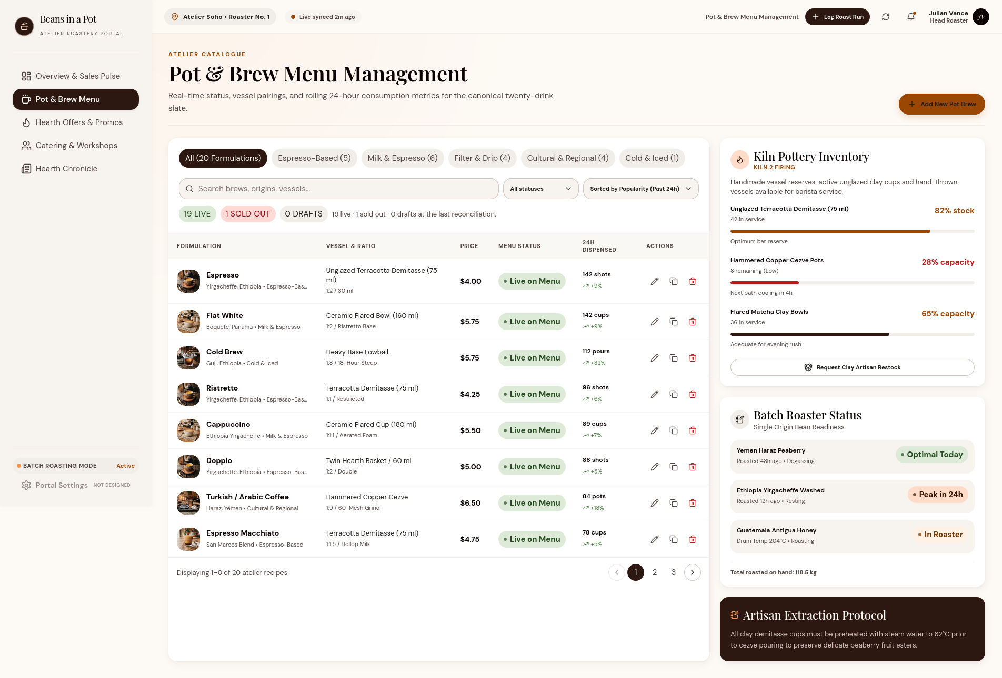
Figure 17 — Admin — Pot & Brew Menu Management. Captured at desktop width.

Admin — Hearth Offers & Promos
Offer cards, scheduling, redemption caps and a seasonal offer builder support campaign management.
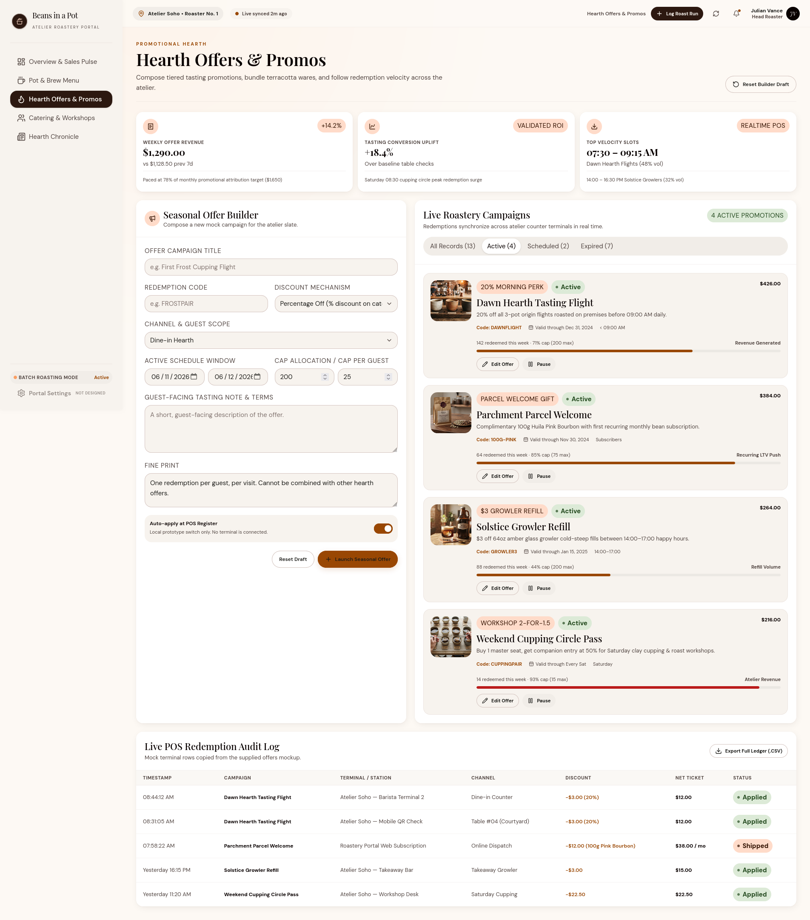
Figure 18 — Admin — Hearth Offers & Promos. Captured at desktop width.

Admin — Catering & Workshops
Bookings, deposits, guest counts, barista leads and equipment readiness are gathered in one ledger.
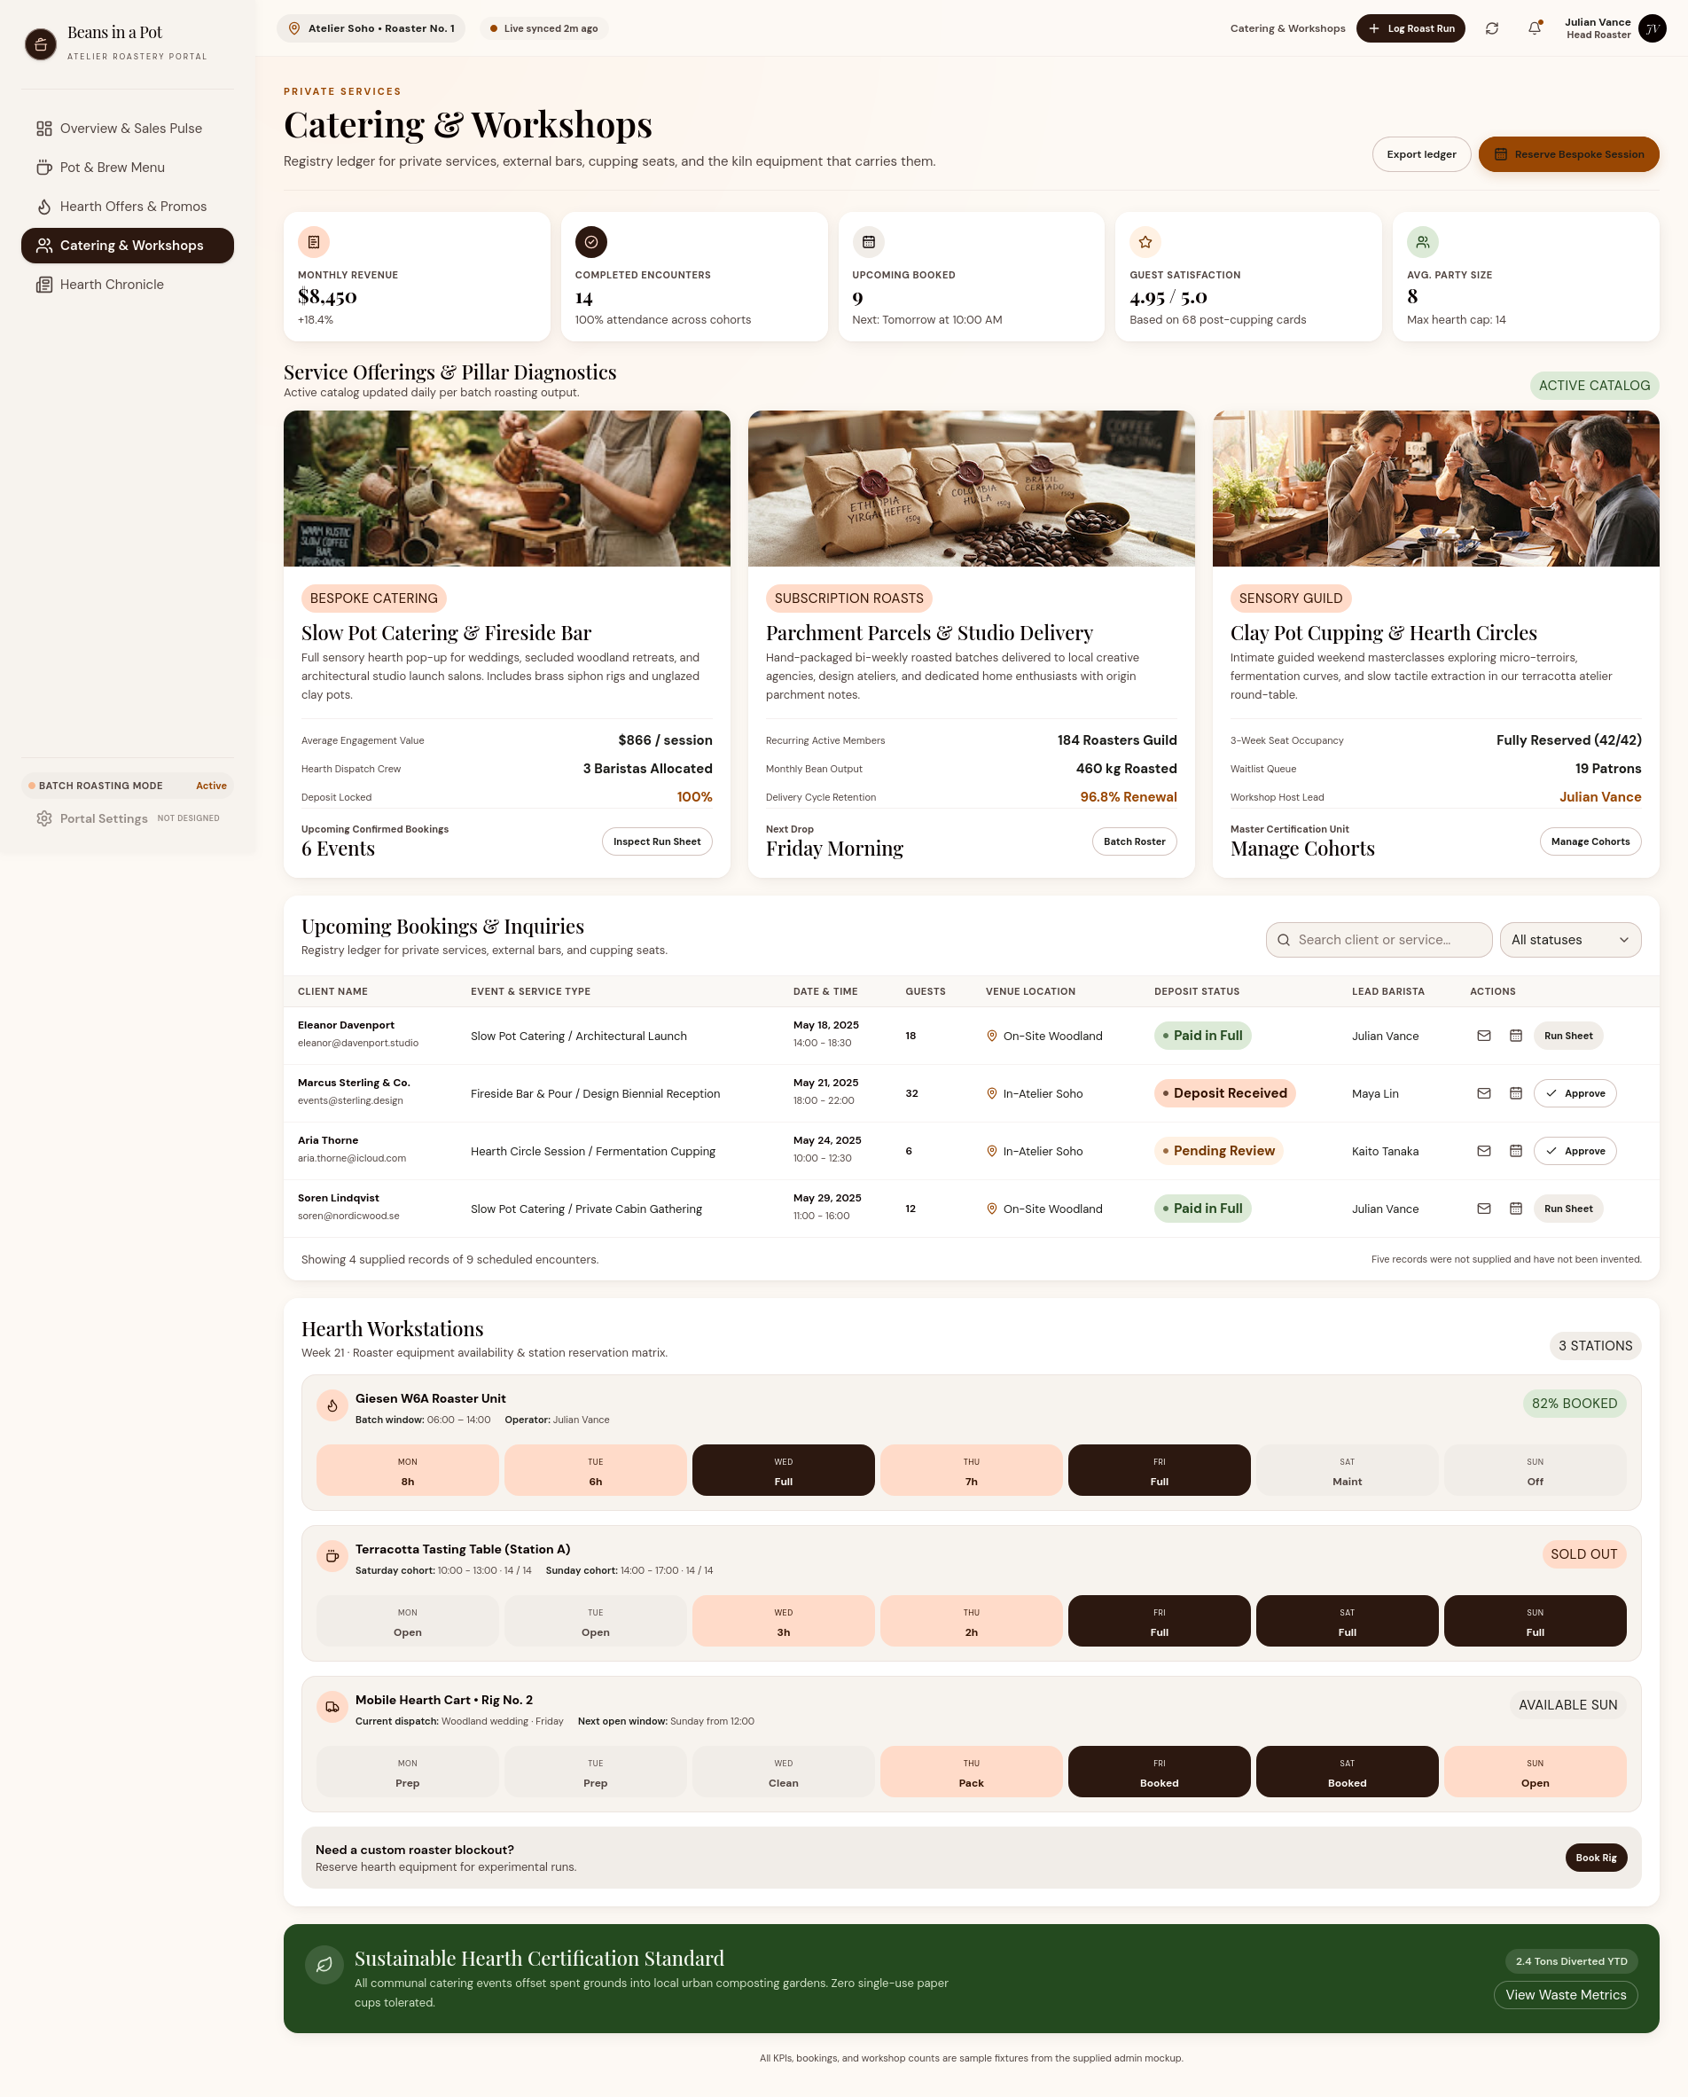
Figure 19 — Admin — Catering & Workshops. Captured at desktop width.

Admin — Hearth Chronicle
The newsletter composer, local preview, subscriber metrics and previous dispatches share one screen.
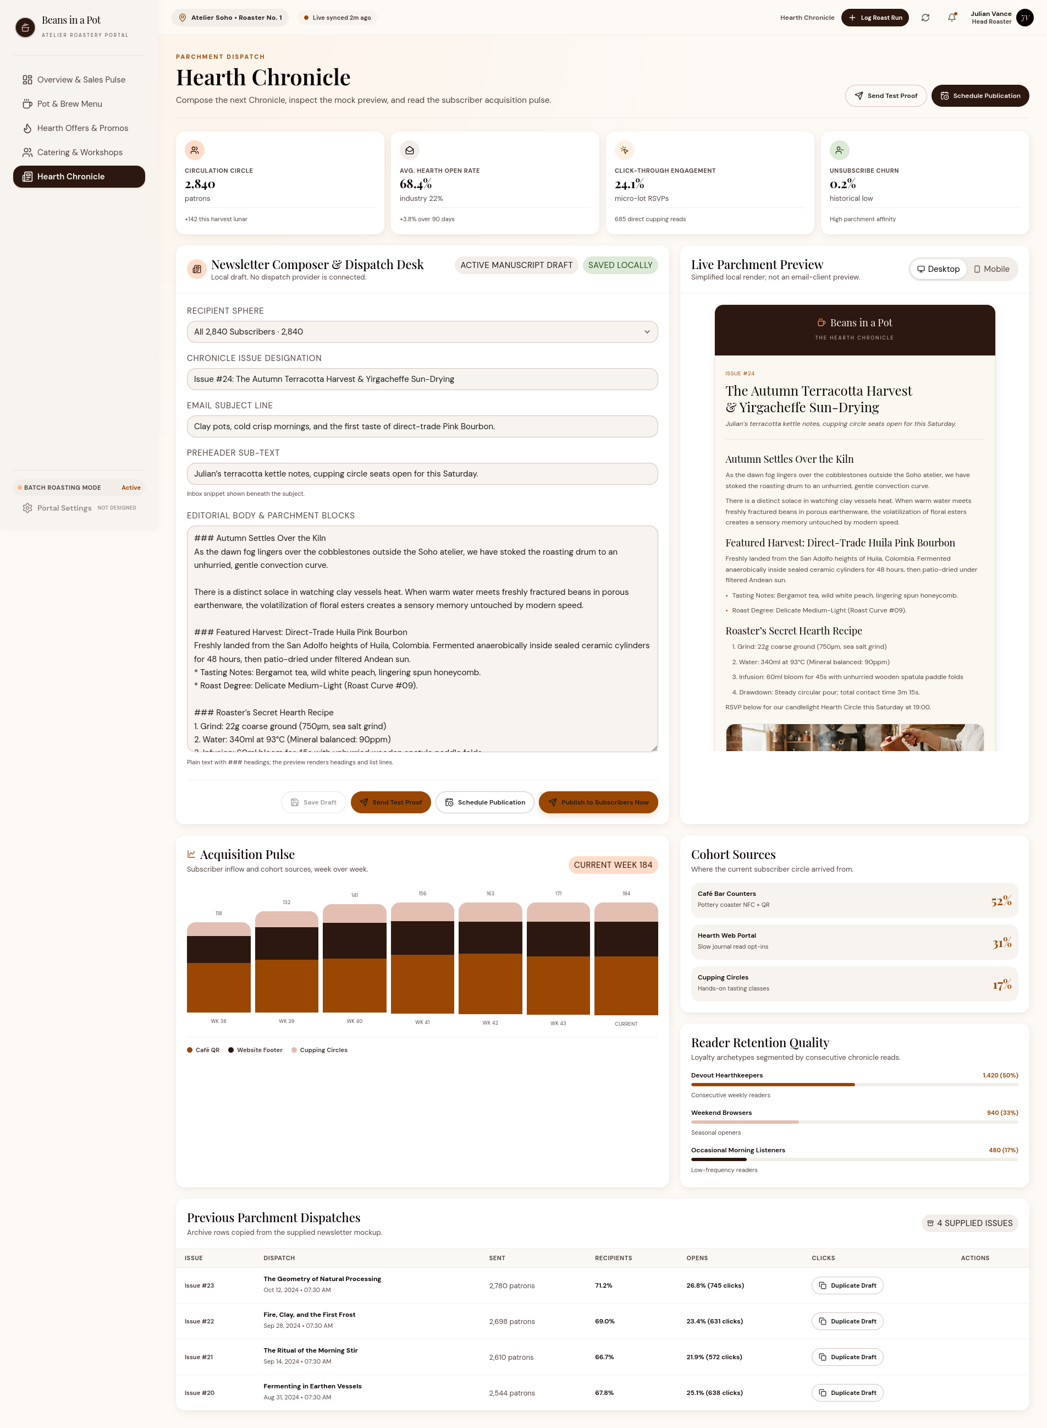
Figure 20 — Admin — Hearth Chronicle. Captured at desktop width.
Beans in a Pot · Design Documentation · November 2026

