hitandfut

# Poster Editing

<https://youtu.be/SV38L4c4JKY>

1. Open Image in Photoshop
2. Select Face area CTRL+C for Copy and paste in untitled new doc of size 400x400 pixels

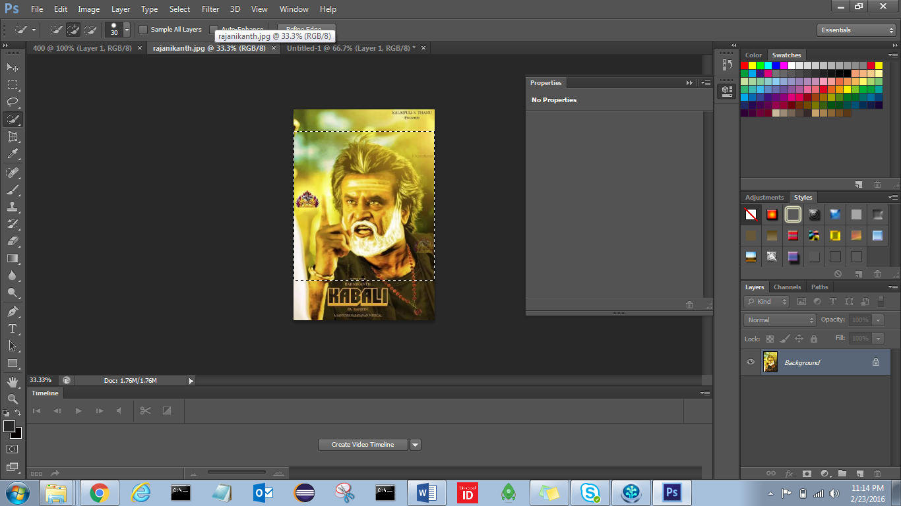

1. Right click on Background 🡪 select Layer from Background

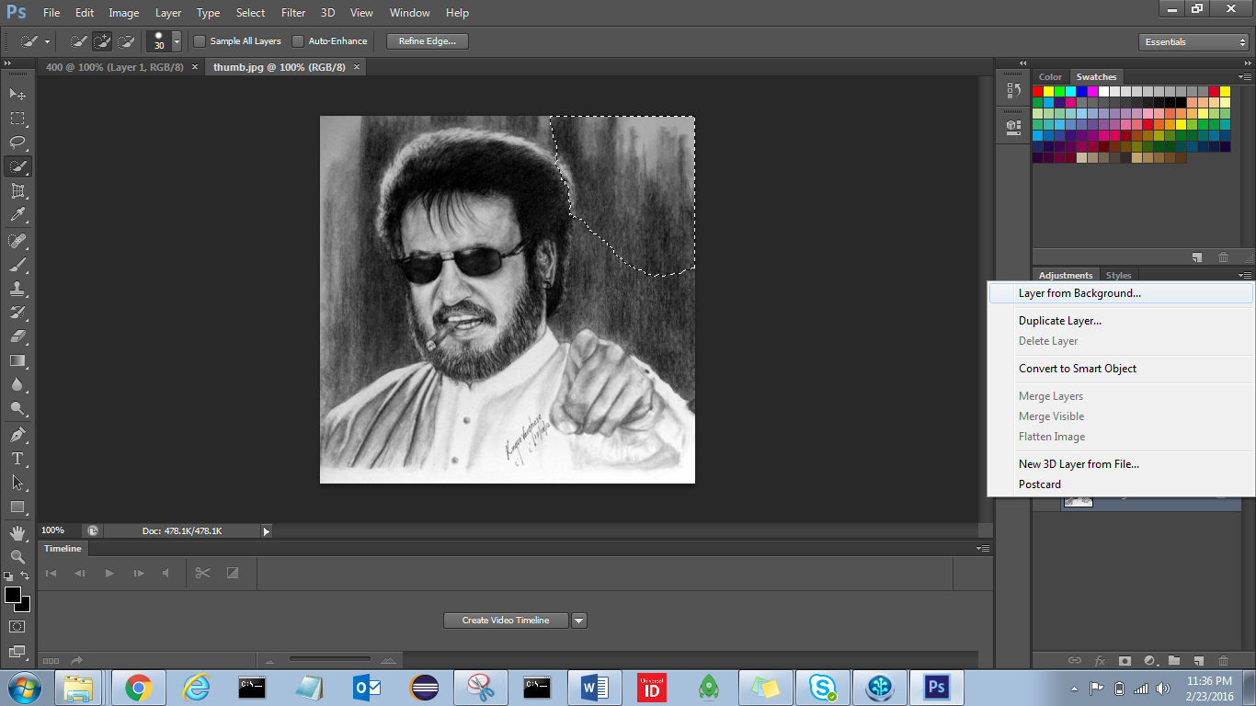

1. Click on Transparency , it will Lock

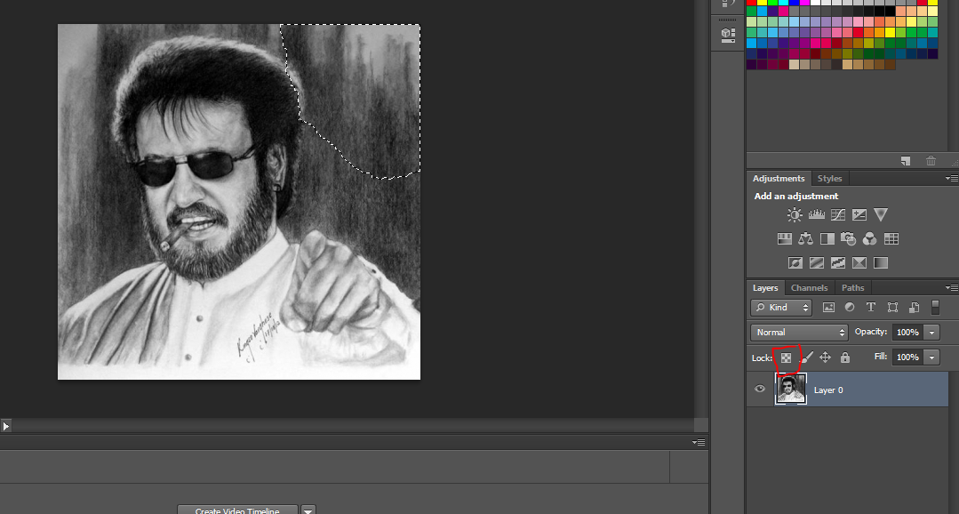

1. Click on Magic tool

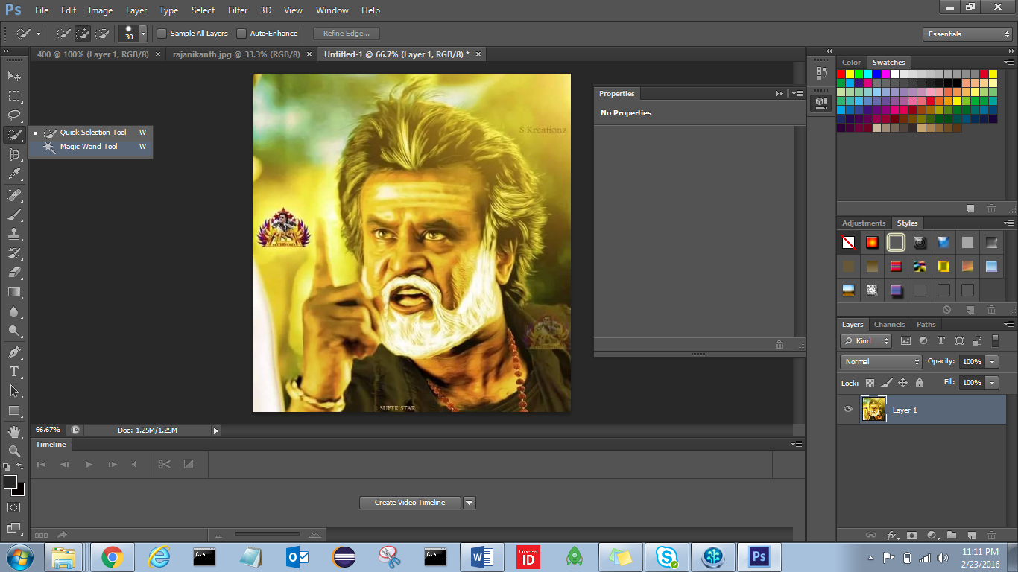

1. Select outside of image and DELETE

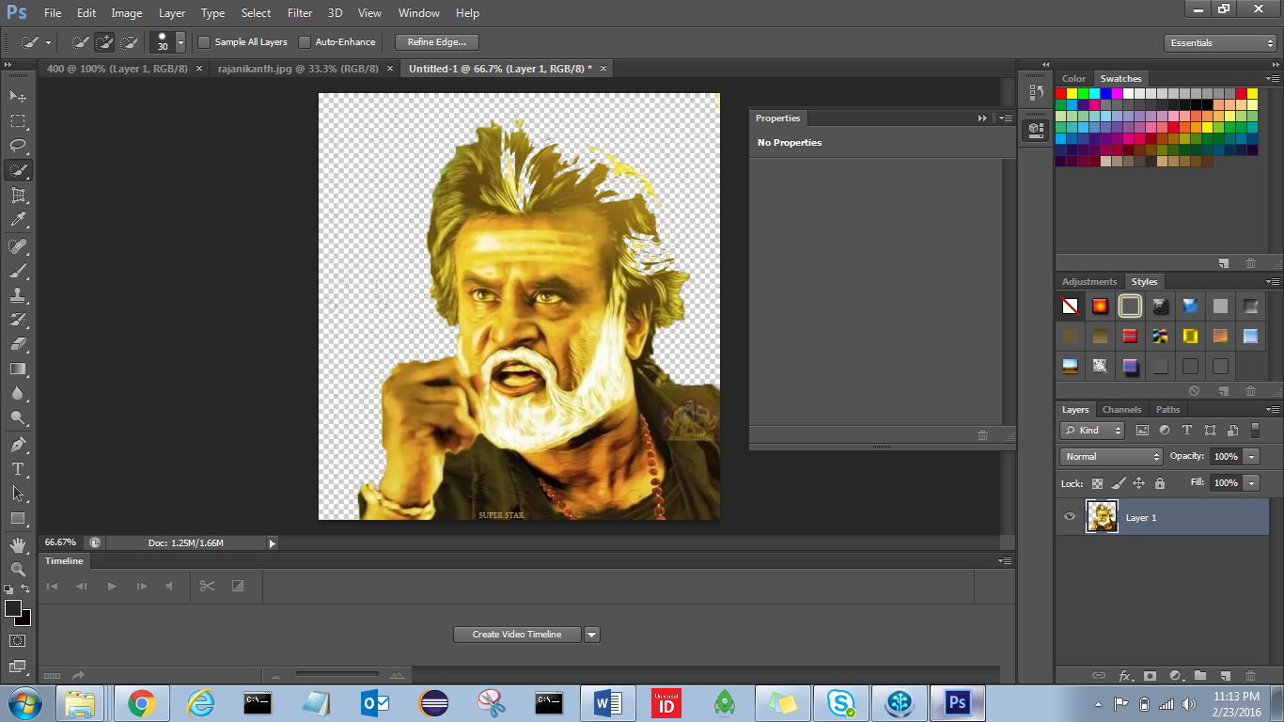

1. Top menu 🡪 Image 🡪 adjustments 🡪 Threshold

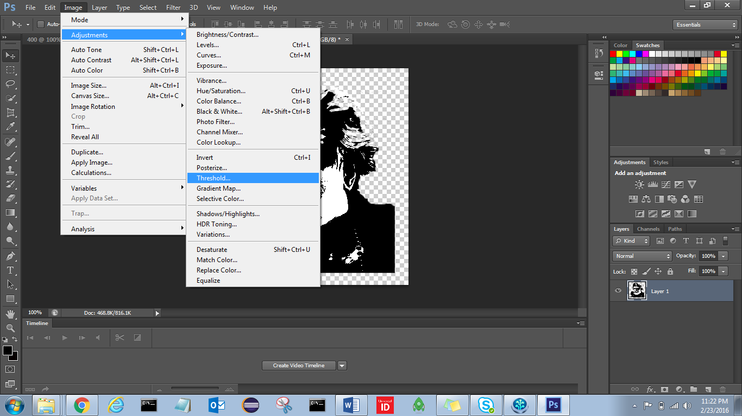

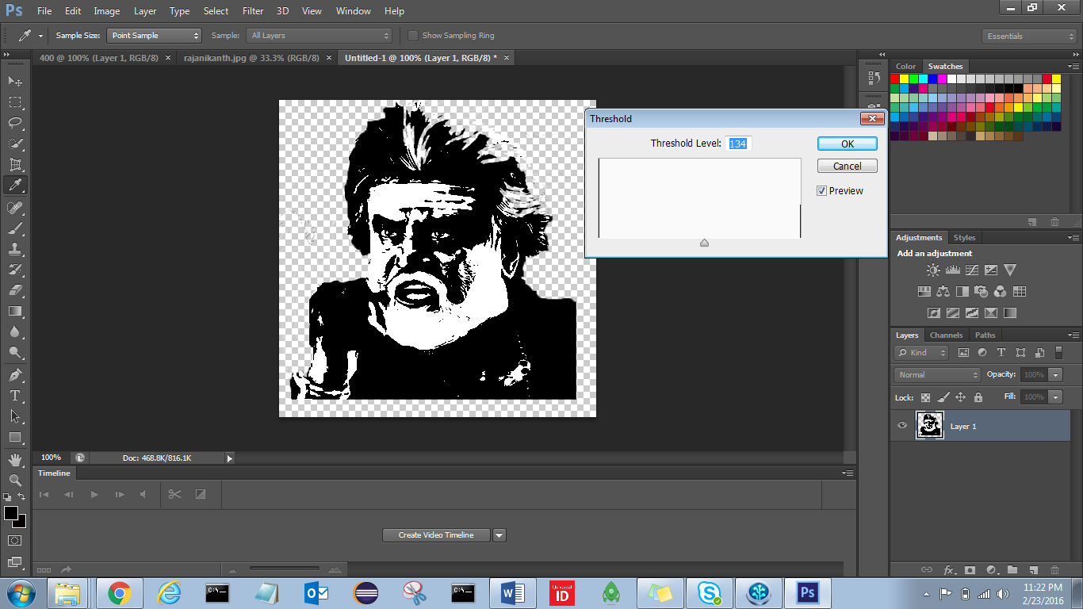

1. Expand image to Complete image area by clicking 
2. If it is not showing check Show transformations 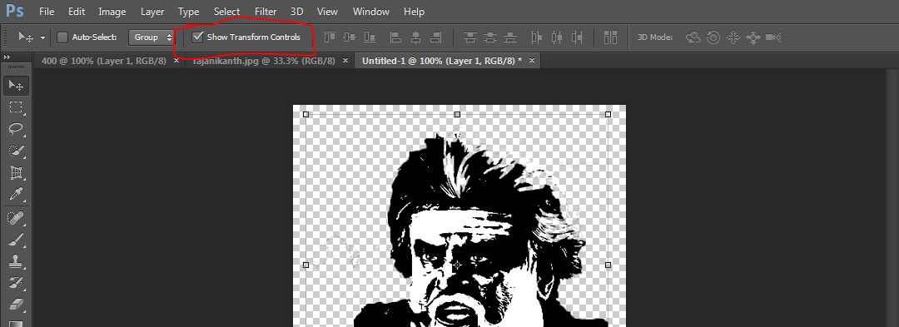
3. Click Save CNTL+S

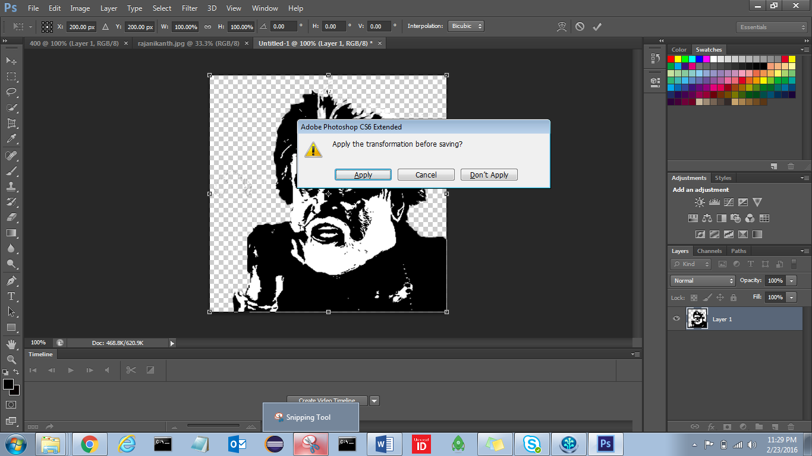

1. Apply, save as PNG

