**Computational Nutrition: A Method of Generating a Diet Plan to Meet Nutritional Requirements**

**Thomas Pikes1, Robert Adams2**

1 Master of Science in Computer Information Systems Student, Padnos School of Computing and Engineering, Grand Valley State University, Allendale, United States of America

2 Associate Professor of Computer Science, Padnos School of Computing and Engineering, Grand Valley State University, Allendale, United States of America

Received **** 2015

Copyright © 2015 by author(s) and Scientific Research Publishing Inc.

This work is licensed under the Creative Commons Attribution International License (CC BY).

<http://creativecommons.org/licenses/by/4.0/>



1-1

**Abstract**

**Many models that are used to generate a meal plan only take proximates into account. The human body requires a mixture of proximates in addition to several macronutrients, micronutrients, and various vitamins and minerals. Furthermore, the models designed to generate these meal plans do not take into account the individual’s specific nutritional needs. These various requirements have some combination of lower bound amount (LBA), ideal amount (IA), and upper bound amount (UBA) necessary for the human body to thrive. The aim of this project was to generate a list of food items using a backtracking algorithm that will meet the specific nutritional requirements as defined by the input. Each nutrient receives a score based on the amount of nutrient contained in the food list in relation to the LBA, IA, and UBA. These scores are aggregated to give the meal plan an overall score.**

**Keywords**

**Computational Nutrition, Diet, Preventative, Nutrition Therapy**

1-1

**1. Introduction**

The United States (US) has the highest health expenditures as a percentage of gross domestic product (GDP) among developed countries. The US also spends the most of any country on healthcare. Of the total cost of US health care, hospital visits are the largest contributor to the total cost. Another significant factor is Obesity. Obesity will contribute to an increase in hospital visits as well as other health services aimed at fixing a symptom. This paper proposes a method that would aid a Dietitian in cultivating a diet plan aimed at increasing the overall health of the patient. The method also allows for personal cultivation of diet plans in the home.

**2. Existing Methods**

There are several websites with the purpose of creating a tailored meal plan. These websites offer a very fast way of creating a meal plan to meet certain types of diets such as paleo, vegetarian, or a ketogenic type diet. Howerver, these websites do not take into account the various macronutrients, micronutrients, vitamins, and minerals that are essiential to the human body’s overall health.

* <https://www.eatthismuch.com/>
* http://custommealplanner.com/

**2.1. EatThisMuch**

First, confirm that you have the correct template for your paper size. This template has been tailored for output on the custom paper size (21 cm * 28.5 cm).

**2.2. CustomMealPlanner**

Custome meal planner desction strengths/weaknesses

**3. Proposed Method**

We propose generating a daily meal plan based on the nutrients referenced in **Table 1****.** All nutrients that are attempted to fit into the meal plan will have a Lower Bound (LB). The LB is the absolute least amount of a nutrient that will be accepted in order for the meal plan to be accepted. The LB provides the user with the ability to account for deficiencies or times when some nutrients will provide better health outcomes. For example, a nursing mother will require a different set of nutrients than a pregnant mother or a person with a cold. All nutrients will also have an Ideal Amount (IA). The IA is the amount of the nutrient that will result in the meal plan receiving a perfect score for the nutrient. It is possible or the LB and IA to be the same. Based on our testing achieving a perfect score is effectively impossible, unless the IA is set based on the available foods. Some nutrients will also have an Upper Bound (UB). The UB is the absolute most that will be accepted after which the meal plan will be deemed unacceptable. The UB provides the user with the ability to limit undesirable qualities of a meal plan. For example, if someone is suffering from high blood pressure the UB of nutrients can be tweaked to levels that will contribute to the blood pressure being lowered. The method does not currently take into account calories but this could be added as one of the “nutrients” that need to be fit into the meal plan using the same technique.

Once an acceptable meal plan has been generated the method will generate a score for each nutrient. The meal plan’s overall score (MSCORE) is a sum of each nutrient’s score (NSCORE). An NSCORE is generated using a set of 3 linear functions. The method selects which of the 3 functions to use based on the

**4. Implementation**

The proposed method uses the United States Department of Agricultures (USDA) National Nutrient Database (NND) for nutrient information of 8,789 foods as of Standard Reference Release 28. We start by selecting a random food from a list of 100 foods that contain the highest amount of the one of the nutrients. The food is added to the list if it does not cause any nutrient to exceed the UB. We then select the next nutrient in the list and repeat the food check process. During this looping process we keep a record of the number of times a nutrient causes a food to be rejected. If a nutrient causes a food to be rejected 3 times we remove the food with the highest amount of that nutrient. See **Figure 1** for graphical representation of the method.

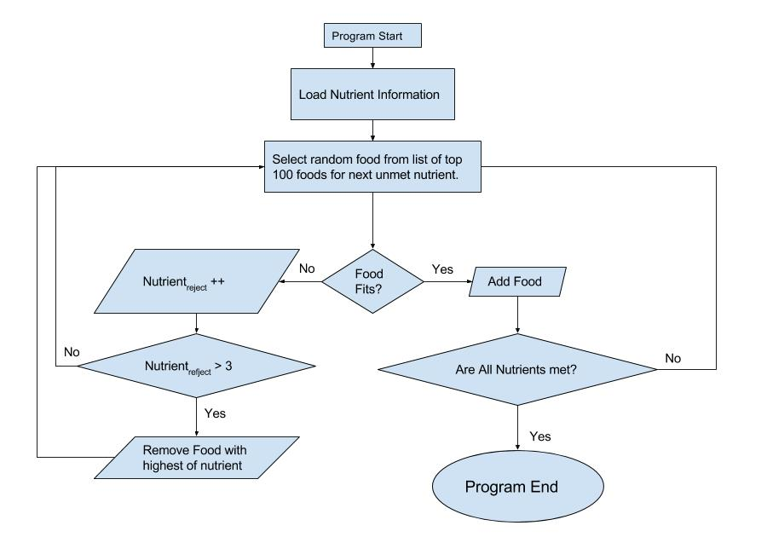

Figure 1.Graphical Representation of method

*Special description of the title. (dispensable)

**2.1. Selecting a Template (Sub-Heading 2.1)**

First, confirm that you have the correct template for your paper size. This template has been tailored for output on the custom paper size (21 cm * 28.5 cm).

**2.2. Maintaining the Integrity of the Specifications**

The template is used to format your paper and style the text. All margins, column widths, line spaces, and text fonts are prescribed; please do not alter them. You may note peculiarities. For example, the head margin in this template measures proportionately more than is customary. This measurement and others are deliberate, using specifications that anticipate your paper as one part of the entire journals, and not as an independent document. Please do not revise any of the current designations.

**3. Prepare Your Paper before Styling (Heading 3)**

Before you begin to format your paper, first write and save the content as a separate text file. Keep your text and graphic files separate until after the text has been formatted and styled. Do not use hard tabs, and limit use of hard returns to only one return at the end of a paragraph. Do not add any kind of pagination anywhere in the paper. Do not number text heads—the template will do that for you.

Finally, complete content and organizational editing before formatting. Please take note of the following items when proofreading spelling and grammar:

**3.1. Abbreviations and Acronyms**

Define abbreviations and acronyms the first time they are used in the text, even after they have been defined in the abstract. Abbreviations such as IEEE, SI, MKS, CGS, sc, dc, and rms do not have to be defined. Do not use abbreviations in the title or heads unless they are unavoidable.

**3.2. Units**

* Use either SI (MKS) or CGS as primary units. (SI units are encouraged.) English units may be used as secondary units (in parentheses). An exception would be the use of English units as identifiers in trade, such as “3.5-inch disk drive”.
* Avoid combining SI and CGS units, such as current in amperes and magnetic field in oersteds. This often leads to confusion because equations do not balance dimensionally. If you must use mixed units, clearly state the units for each quantity that you use in an equation.
* Do not mix complete spellings and abbreviations of units: “Wb/m2” or “webers per square meter”, not “webers/m2”. Spell out units when they appear in text: “... a few henries”, not “... a few H”.
* Use a zero before decimal points: “0.25”, not “.25”. Use “cm3”, not “cc”.

**3.3. Equations**

The equations are an exception to the prescribed specifications of this template. You will need to determine whether or not your equation should be typed using either the Times New Roman or the Symbol font (please no other font). Equations should be edited by Mathtype, not in text or graphic versions. You are suggested to use Mathtype 6.0 (or above version).

Number equations consecutively. Equation numbers, within parentheses, are to position flush right, as in (1), using a right tab stop. To make your equations more compact, you may use the solidus ( / ), the exp function, or appropriate exponents. Italicize Roman symbols for quantities and variables, and Greek symbols. Do not italicize constants as π, etc. Use a long dash rather than a hyphen for a minus sign. Punctuate equations with com- mas or periods when they are part of a sentence, as in

. (1)

Note that the equation is centered. Be sure that the symbols in your equation have been defined before or immediately following the equation. Use “Equation (1)”, not “Eq. (1)”or “(1)”,and at the beginning of a sentence: “Equation (1) is ...”

**4.1. Authors and Affiliations**

The template is designed so that author affiliations are not repeated each time for multiple authors of the same affiliation. Please keep your affiliations as succinct as possible (for example, do NOT post your job titles, positions, academic degrees, zip codes, names of building/street/district/province/state, etc.). This template was designed for two affiliations.

1) For author/s of only one affiliation: To change the default, adjust the template as follows.

a) Selection: Highlight all author and affiliation lines.

b) Change number of columns: Select the Columns icon from the MS Word Standard toolbar and then select “1 Column” from the selection palette.

c) Deletion: Delete the author and affiliation lines for the second affiliation.

2) For author/s of more than two affiliations: To change the default, adjust the template as follows.

a) Selection: Highlight all author and affiliation lines.

b) Change number of columns: Select the “Columns” icon from the MS Word Standard toolbar and then select “1 Column” from the selection palette.

c) Highlight author and affiliation lines of affiliation 1 and copy this selection.

d) Formatting: Insert one hard return immediately after the last character of the last affiliation line. Then paste down the copy of affiliation 1. Repeat as necessary for each additional affiliation.

**4.3. Figures and Tables**

Use “**Figure 1**”and “**Table 1**” in bold fonts, even at the beginning of a sentence.

Table 1.Table type styles (Table caption is indispensable).

| Table Head | Table Column Head | | |
| --- | --- | --- | --- |
| Table column subhead | Subhead | Subhead |
| copy | More table copya |  |  |

a. Sample of a Table footnote (*Table footnote is dispensable*).

**Acknowledgements**

Blank

**References**

1. Aetna (2008) The Facts About Rising Health Case Costs. <http://www.aetna.com/health-reform-connection/aetnas-vision/facts-about-costs.htm>