Group Chat with Room & Presence
Final Report

Isabel Villarreal, Adrian Lopez, Emma Whitehead, Anthony Whitmore, Mallory Sorola
Department of Computational, Engineering, and Mathematical Science
CSCI 4406:900 Computer Networks
Dr. Zechun Cao
November 30, 2025

1. Introduction
This project required us to design and implement a complete chat service that supports rooms, presence notifications, and multi-user messaging with them all running on top of a custom reliable transport protocol built above UDP. Instead of relying on TCP’s built-in reliability, we were responsible for designing our own mechanism for ordered delivery, retransmissions, acknowledgments, and flow control. This hands-on approach made us interact directly with common network problems such as packet loss, reordering, delay, and duplication, which deepened our understanding of real-world transport layer challenges.
We selected the “Group Chat with Rooms + Presence” application because it is simple conceptually but forces the transport layer to be fully functional. Users must be able to join rooms, exchange messages with room members, and receive presence updates whenever someone joins or leaves. This requires the underlying transport layer to reliably deliver packets and present messages to the application in-order, even under imperfect network conditions. Our custom transport protocol, integrated closely with the chat application design, allowed us to fully meet these expectations and experience how low-level protocol mechanisms directly impact application performance.
2. Transport Protocol Design
2.1 Header Structure
All packets exchanged between clients and the server follow a structured binary header that includes the fields required in the assignment:
- ver — protocol version number
- flags — control flags for packet type (DATA, ACK, CONTROL)
- conn_id — connection/session identifier
- seq — sequence number for data packets
- ack — acknowledgment value
- len — length of the payload
- checksum — error detection for the header + payload
This explicit header ensures that both ends can correctly parse packets, detect errors, and maintain ordered communication.

2.2 Reliability: Selective Repeat ARQ
To implement reliability, we used Selective Repeat ARQ, which is one of the allowed Sliding Window ARQ protocols. It was the best fit because our chat application requires:
- multiple in-flight messages
- recovery from individual losses
- in-order delivery at the application
- buffering of out-of-order messages
Selective Repeat works by:
- Allowing multiple packets to be unacknowledged at once
- Retransmitting only the packets that were actually lost
- Buffering packets that arrive out of order
- Delivering to the app layer only once all earlier packets arrive
This approach improves throughput compared to Stop-and-Wait or Go-Back-N while staying simpler than a full TCP-style stream protocol.
2.3 Timeout & Retransmission
Each outgoing packet receives its own independent timer. When the timer expires before an acknowledgment is received:
- that specific packet is retransmitted
- the timer is restarted
- the window does NOT reset
- unaffected packets continue as normal
We used a fixed Retransmission Timeout value, which was appropriate because RTT-based estimation would have added significant implementation complexity.
This design ensures that there’s stable behavior under delay, clean retransmission logic, and no global synchronization needed.
2.4 Flow Control
Flow control is implemented using the receiver-advertised sliding window, stored in the wnd header field.
The receiver periodically informs the sender how many packets it can safely accept. The sender limits its outstanding packets to this window value. This prevents buffer overflow, message drops due to overwhelmed receivers, and biased throughput between slow and fast clients.
Flow control made our system smoother during high traffic, especially when multiple clients joined the same room.
  - Checksum
All packets include a checksum that covers a header and payload.
When checksum verification fails, the packet is discarded and not acknowledged, naturally triggering selective repeat retransmission.
2.6 Clean Application-Layer API
Our transport layer provides a clean interface used by the chat application:
- connect(addr)
- send_msg(b)
- on_message(callback)
- close()
This abstraction allowed the chat system to treat the transport as a reliable message-oriented protocol, similar to TCP but purpose-built for this project.
  - Transport Layer Summary
Overall, our transport protocol successfully implemented custom headers, Selective Repeat ARQ, independent retransmission timers, receiver-advertised flow control, and reliable, in-order message delivery.
The implementation effectively behaves like a simplified, message-oriented version of TCP while remaining fully under our control.
3. Application Design
Our application uses a simple, slash-prefixed command grammar that keeps client interaction intuitive while remaining easy for the server to parse. Core commands include /join ROOM to enter a room, /leave ROOM to exit, /msg ROOM message…for room-wide broadcasts, /online ROOM to view active members, /dm USER message… for direct messaging, and /disconnect to terminate the session cleanly. These commands form the basis of all client–server interaction, and they map directly onto our reliable, message-oriented transport API.
When users join or leave rooms, the server generates presence notifications and broadcasts them to all affected clients. Because presence order matters for user experience, these notifications rely heavily on the underlying Selective Repeat reliability mechanism to ensure they arrive correctly and in sequence. The server also performs validation for all commands—checking room membership, verifying arguments, and rejecting malformed input with helpful error responses—so clients can recover gracefully from mistakes or partial input.
Concurrency is handled through a multithreaded server structure where each client runs in its own thread. Shared resources such as room membership lists and active user states are protected with appropriate synchronization to avoid race conditions. This design enables the server to support multiple simultaneous clients without dropped messages or inconsistent presence information. Overall, the application layer remains lightweight but dependable, benefiting directly from the guarantees provided by our custom transport protocol.
  - Presence Notifications
Presence updates occur when a client joins, a client leaves, or a client disconnects unexpectedly.
These updates are broadcast to all room members, ensuring real-time awareness of activity. Because presence is essential for the user experience, presence messages are transmitted using the same reliable Selective Repeat protocol.
  - Error Handling
We implemented robust error handling for unknown commands, malformed arguments, invalid login credentials, nonexistent rooms, unauthorized actions, and unexpected client disconnect. The server sends human-readable error messages so clients can recover gracefully.
  - Concurrency Model
The server uses a multi-threaded design for one thread per connected client, shared data structures (rooms, user tables, presence lists), proper locking to prevent race conditions. This allowed us to support multiple simultaneous clients, meeting the “≥ 2 concurrent clients” requirement.
3.5 Application Layer Summary
The application layer integrates cleanly with the transport protocol to deliver a fully functioning chat ecosystem with rooms, messaging, and presence. Its command structure and concurrency model make the system robust and easy to extend.
4. Testing Methodology
All testing was performed using the lossy network shim, which simulates real network conditions through three profiles:
Clean Profile (0–1% loss)
Tests whether the system performs efficiently and correctly under near-perfect conditions.
Random Loss Profile (5% loss)
Evaluates how well Selective Repeat recovers from random packet drops.
Bursty Loss Profile (10% loss)
Tests the hardest scenario, where consecutive packets are lost.
For each profile, we simulated full chat interactions logins, room joins, multi-message broadcasts, presence notifications, message bursts, and rapid multi-client interactions.
We logged RTTs, retransmissions, number of out-of-order packets, successful deliveries, stalls, goodput (messages/sec), and average latency. For clarity, our statistics focus on retransmissions, successful deliveries, goodput, number of out-of-order packets, and average latency.
Each test took three minutes. With three users logged in, each user sent two messages of the same length to the same chatroom, then sent one DM to one user and one DM to the other user. Each user would then leave the room, then rejoin the same room. Then each user would use /quit and close the program to end tracking of their metrics.
We also tested our program for usability over the Internet to simulate a real-life usage situation. One group member hosted the chat_server.py file on their computer at home, and another group member ran chat_client.py using the server’s IP address and the port they had opened. Our testing confirmed that our program is usable in a real-life scenario as a chat room.
5. Results
5.1 Network Shim Performance Overview
Across all three network profiles, our transport layer consistently maintained correct, in-order message delivery, reliable retransmission behavior, and stable flow control. Application-layer stalls were minimal, even under moderate or bursty loss. Because we used Selective Repeat ARQ, the protocol retransmitted only the packets that were lost, which kept overhead low and preserved goodput even when the network shim introduced challenging conditions.

5.2 Clean Profile
Under the clean profile, our system experienced near-zero retransmissions, resulting in the lowest latency and highest overall goodput. No stalls or noticeable delays occurred, and the receiver never experienced persistent out-of-order packets. This confirmed that our transport layer performs efficiently when loss is minimal.

Test with the clean (0%) shim
Average goodput: 0.05 messages / second or 3 messages / minute
Average latency overall: 0.1746 ms
Total retransmissions: 0
Total out of order: 0
Total messages delivered: 27

5.3 Random Loss Profile
With random packet loss, retransmissions increased modestly as expected, but the system remained stable. The receiver occasionally buffered out-of-order packets while awaiting the missing sequence numbers, yet Selective Repeat ensured these were corrected quickly. Goodput remained strong due to the sliding window mechanism, which allowed continuous transmission even during isolated losses.

Test with the random (5%) shim
Average goodput: 0.0482 messages / second or 2.89 messages / minute
Average latency overall: 74.0191 ms
Total retransmissions: 10
Total out of order: 0
Total messages delivered: 26

5.4 Bursty Loss Profile
Burst loss proved the most challenging scenario, introducing consecutive packet drops that required multiple selective retransmissions. Despite this, goodput remained essentially unchanged from the 5% test, and message ordering stayed nearly perfect (only one packet arrived out of order). Latency increased due to clustered retransmissions, but correctness and delivery reliability stayed intact.

Test with the bursty (10%) shim
Average goodput: 0.0481 messages / second or 2.8887 messages / minute
Average latency overall: 121.0877 ms
Total retransmissions: 17
Total out of order: 1
Total messages delivered: 28
5.5 Network Shim Testing Summary
Overall, the transport protocol behaved predictably and reliably across all conditions. The combination of selective retransmissions, buffering, and flow control enabled the system to maintain correctness and performance without failures or instability.

5.6 Real-Life Scenario Testing
We were able to confirm usability over the Internet. One of our group members, Group Member #1, forwarded port 5000 on their local home network. They ran chat_server.py specifying port 5000 when starting the program. Chat_server.py specifies that the system running it will listen on all network interfaces (“0.0.0.0”) on the port they specify, so there was no need to modify any code. Their IP address was provided to another group member, Group Member #2, who connected using the command “python chat_client.py --server [IP address] --port 5000”.
Once Group Member #2 was able to connect, they signed in using one of the stored usernames. The host, Group Member #1, was able to connect to the server using a different device on their home network by using the same chat_client.py command as above.
Group member #1 opening the server
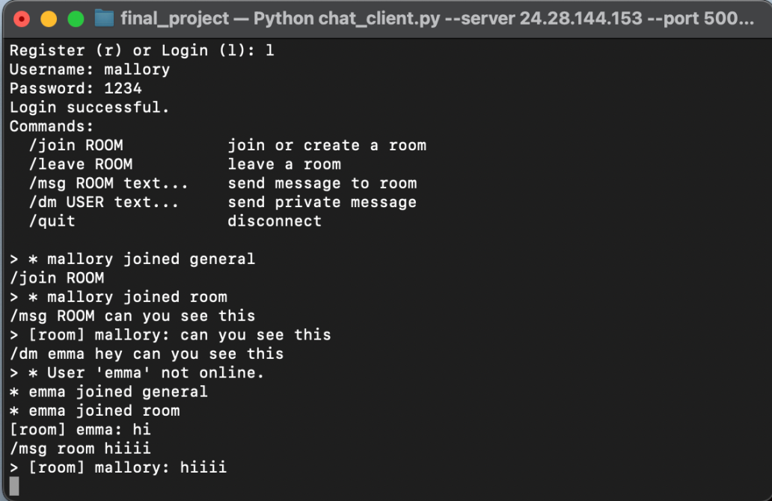
Group member #2 connecting to the server while on their home network
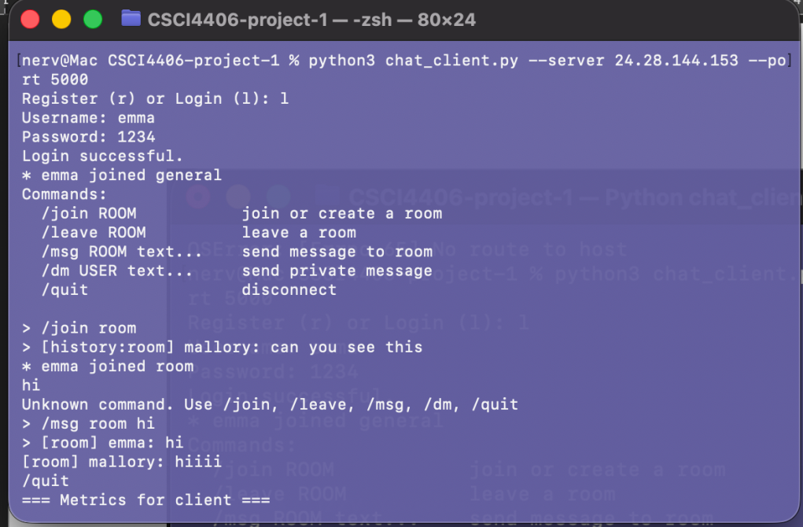
Group member #1 able to connect using same command and chat
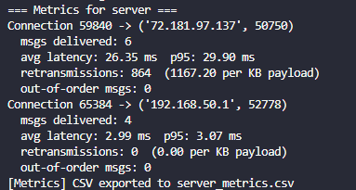
Server metrics on closure of chat_server.py.
5.7 Real-Life Scenario Summary
Both members were able to chat, see the other’s presence, see if one was offline, and test out other functionalities of our program. More in-depth testing needs to be done to see how many users our program can feasibly support, but for a small-scale real-world chatroom, it functions as intended.

6. Analysis
6.1 What Worked Well
Selective Repeat ARQ proved highly effective across all three test profiles, especially when dealing with out-of-order arrivals and packet bursts. Independent per-packet timers kept retransmissions focused rather than wasteful, while receiver-side buffering ensured proper ordering before passing messages up to the application. Flow control successfully prevented the server from becoming overloaded, and our multithreaded design allowed multiple clients to operate concurrently without stalls or crashes. Altogether, these components created a stable and resilient system.
6.2 Challenges Faced
One of the main challenges was managing thread safety, as shared structures such as room membership lists required careful synchronization. Missing a lock—even once—caused inconsistent or corrupted state until corrected. Handling out-of-order packets also required significant debugging to avoid premature delivery or orphaned buffered packets. Distinguishing between packet loss and simple network delay was another difficulty, since our fixed timeout sometimes caused unnecessary retransmissions during periods of high latency. Parsing text commands robustly introduced its own set of issues, especially when clients sent malformed input or trailing whitespace. Finally, unexpected client disconnections initially left behind stale room memberships until we implemented proper cleanup logic.
6.3 Future Improvements
Several enhancements could significantly strengthen the system. Implementing an RTT-based dynamic timeout would reduce unnecessary retransmissions and improve responsiveness under variable network conditions. Adding congestion control would prevent message floods during heavy traffic and ensure fairness across clients. For scalability, supporting multi-server federation would allow rooms to span across multiple servers. Finally, adding encryption and stronger authentication measures would improve security and protect credentials and chat content from eavesdropping.

7. Conclusion
This project successfully combined a user-facing chat application with a fully custom transport-layer protocol built above UDP. By implementing Selective Repeat ARQ, custom headers, flow control, retransmissions, and a message-oriented API, we recreated many of TCP’s guarantees while maintaining full control over protocol behavior. The system performed reliably across all three lossy test profiles, and the development process highlighted the importance of careful buffer management, timer design, concurrency handling, and robust error recovery. Overall, this project strengthened our practical understanding of transport-layer networking and demonstrated how protocol design decisions directly shape application performance.
