TASK-1

AIM
To design a Student Registration Form using HTML5 and CSS3 for collecting student details and storing them in a database. To retrieve the stored data using SQL SELECT queries for display and verification.

ALGORITHM
- Create an HTML form to collect student details like Name, Email, DOB, Department, and Phone.
- Style the form using CSS3 for better user interface and readability.
- Set up a backend server (e.g., using PHP) to handle form submission.
- Create a database and a table to store student information.
- Connect the backend to the database using appropriate credentials.
- Insert the submitted form data into the database using an SQL INSERT query.
- Retrieve stored data using an SQL SELECT query.
- Display the retrieved data on a webpage in a tabular format.

PROGRAM
<!DOCTYPE html>
<html lang="en">
<head>
<meta charset="UTF-8">
<meta name="viewport" content="width=device-width, initial-scale=1.0">
<title>Student Registration</title>
<style>
body {
font-family: Arial, sans-serif;
background: #f4f4f4;
display: flex;
justify-content: center;
align-items: center;
height: 100vh;
}
.container {
background: white;
padding: 20px;
border-radius: 10px;
box-shadow: 0 0 10px rgba(0,0,0,0.2);
width: 350px;
}
h2 { text-align: center; }
input, select {
width: 100%;
padding: 8px;
margin: 8px 0;
}
button {
width: 100%;
padding: 10px;
background: #28a745;
color: white;
border: none;
cursor: pointer;
}
table {
width: 100%;
margin-top: 20px;
border-collapse: collapse;
}
th, td {
border: 1px solid #ddd;
padding: 8px;
text-align: center;
}
</style>
</head>
<body>

<div class="container">
<h2>Student Registration</h2>
<form method="POST" action="">
<input type="text" name="name" placeholder="Name" required>
<input type="email" name="email" placeholder="Email" required>
<input type="date" name="dob" required>
<select name="dept" required>
<option value="">Select Department</option>
<option>CSE</option>
<option>ECE</option>
<option>EEE</option>
<option>MECH</option>
</select>
<input type="text" name="phone" placeholder="Phone" required>
<button type="submit" name="submit">Register</button>
</form>

<?php
$conn = new mysqli("localhost", "root", "", "student_db");

if ($conn->connect_error) {
die("Connection failed: " . $conn->connect_error);
}

// Create table if not exists
$sql = "CREATE TABLE IF NOT EXISTS students (
id INT AUTO_INCREMENT PRIMARY KEY,
name VARCHAR(100),
email VARCHAR(100),
dob DATE,
dept VARCHAR(50),
phone VARCHAR(15)
)";
$conn->query($sql);

// Insert data
if (isset($_POST['submit'])) {
$name = $_POST['name'];
$email = $_POST['email'];
$dob = $_POST['dob'];
$dept = $_POST['dept'];
$phone = $_POST['phone'];

$insert = "INSERT INTO students (name, email, dob, dept, phone)
VALUES ('$name', '$email', '$dob', '$dept', '$phone')";
$conn->query($insert);
}

// Retrieve data
$result = $conn->query("SELECT * FROM students");

if ($result->num_rows > 0) {
echo "<table><tr><th>Name</th><th>Email</th><th>DOB</th><th>Dept</th><th>Phone</th></tr>";
while($row = $result->fetch_assoc()) {
echo "<tr>
<td>{$row['name']}</td>
<td>{$row['email']}</td>
<td>{$row['dob']}</td>
<td>{$row['dept']}</td>
<td>{$row['phone']}</td>
</tr>";
}
echo "</table>";
}

$conn->close();
?>
</div>

</body>
</html>

OUTPUT
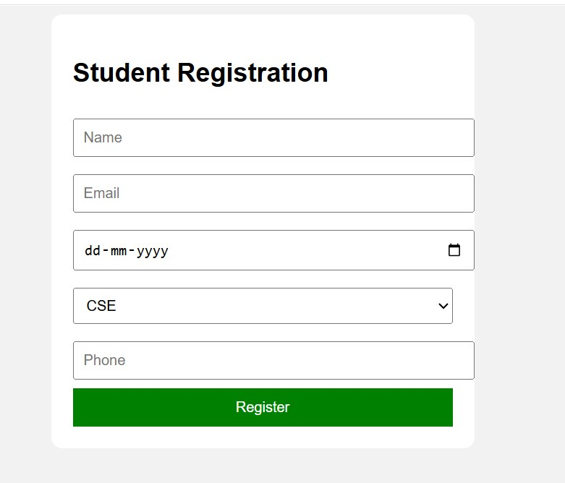

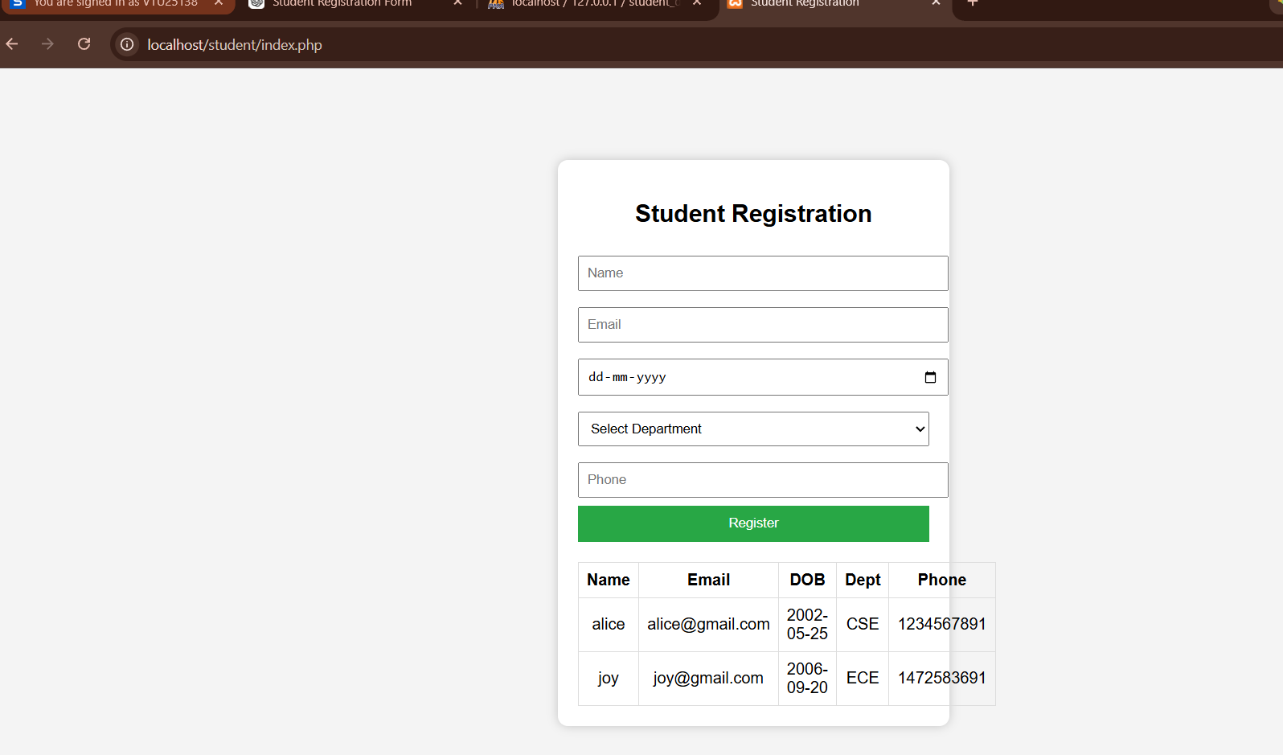

RESULTS
The student registration form was successfully designed using HTML5 and CSS3, allowing users to input their details. The data was stored in the database and retrieved accurately using SQL SELECT queries.

