1. Git-HOL

@sashanknerella MINGW64 ~

$ git --version

git version 2.48.1.windows.1

@sashanknerella MINGW64 ~ $ git config --global --list

user.email=sashanknerella@gmail.com user.name= @sashanknerella core.longpaths=true

@sashanknerella MINGW64 ~

$ notepad++

@sashanknerella MINGW64 ~

$ git config --global core.editor "'C:/Program

Files/Notepad++/notepad++.exe' -multiInst -nosession"

@sashanknerella MINGW64 ~

$ git config --global -e

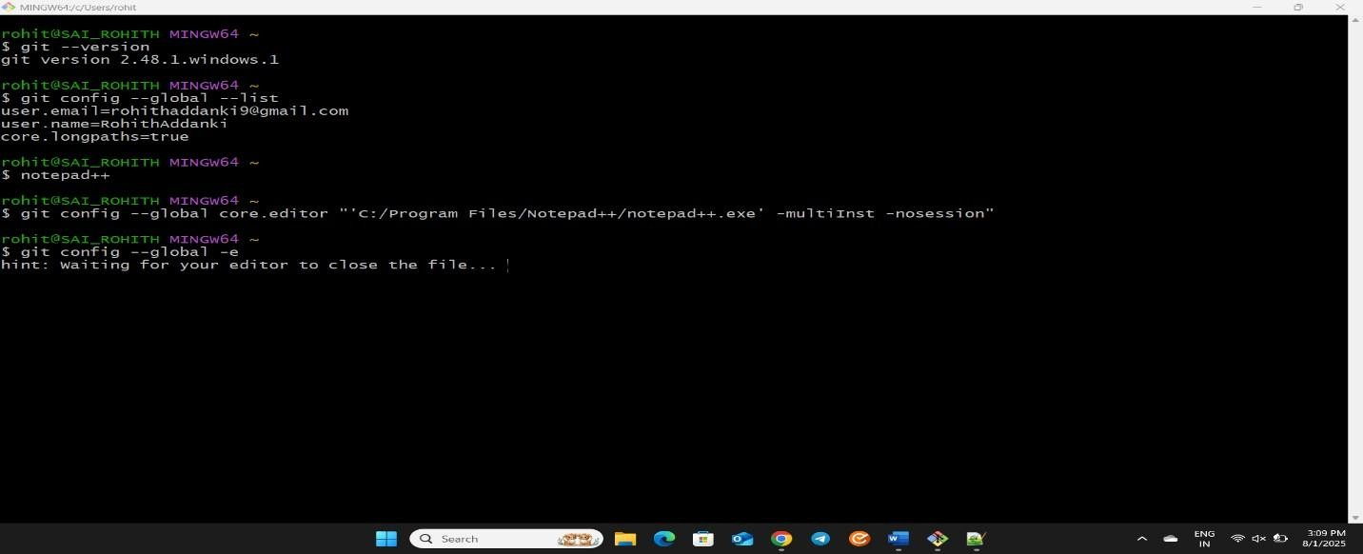

~

$ cd /c/Users/rohit/Desktop/Cognizant/GitWorkspace

@sashanknerella MINGW64 ~/Desktop/Cognizant/GitWorkspace

$ mkdir GitDemo

@sashanknerella MINGW64 ~/Desktop/Cognizant/GitWorkspace

$ cd GitDemo

@sashanknerella MINGW64

~/Desktop/Cognizant/GitWorkspace/GitDemo

$ git init

Initialized empty Git repository in

C:/Users/@sashanknerella /Desktop/Cognizant/GitWorkspace/GitDemo/.git/

@sashanknerella MINGW64

~/Desktop/Cognizant/GitWorkspace/GitDemo (master) $ pwd

/c/Users/@sashanknerella /Desktop/Cognizant/GitWorkspace/GitDemo

@sashanknerella MINGW64

~/Desktop/Cognizant/GitWorkspace/GitDemo (master)

$ ls -a

./ ../ .git/

@sashanknerella MINGW64

~/Desktop/Cognizant/GitWorkspace/GitDemo (master)

$ echo "Welcome to Git Hands-on Lab" > welcome.txt

@sashanknerella MINGW64

~/Desktop/Cognizant/GitWorkspace/GitDemo (master)

$ ls welcome.txt

@sashanknerella MINGW64

~/Desktop/Cognizant/GitWorkspace/GitDemo (master)

$ cat welcome.txt

Welcome to Git Hands-on Lab

@sashanknerella MINGW64

~/Desktop/Cognizant/GitWorkspace/GitDemo (master)

$ git status

On branch master

No commits yet

Untracked files:

(use "git add <file>..." to include in what will be committed) welcome.txt

nothing added to commit but untracked files present (use "git

add" to track)

~/Desktop/Cognizant/GitWorkspace/GitDemo (master)

$ git add welcome.txt

warning: in the working copy of 'welcome.txt', LF will be

replaced by CRLF the next time Git touches it

@sashanknerella MINGW64

~/Desktop/Cognizant/GitWorkspace/GitDemo (master) $ git commit

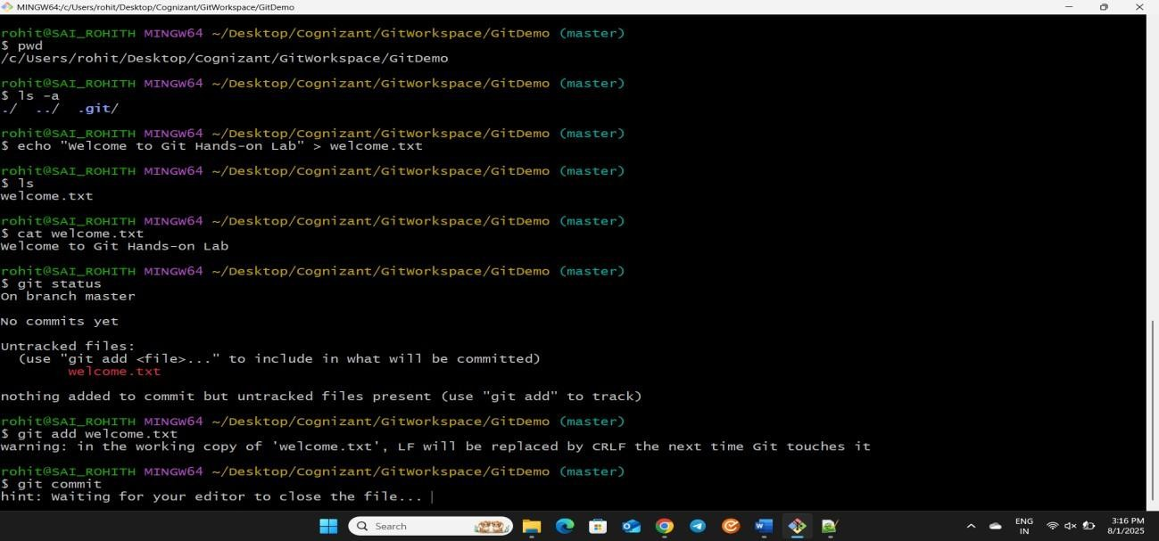

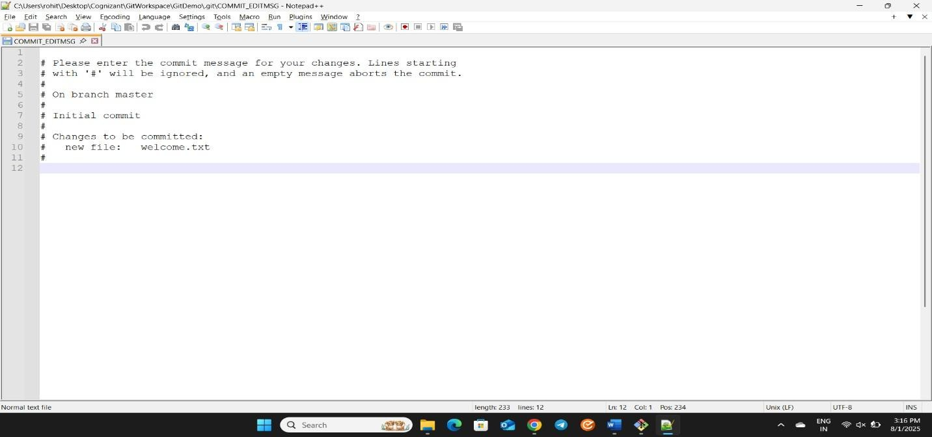

Aborting commit due to empty commit message.

~/Desktop/Cognizant/GitWorkspace/GitDemo (master)

$ git status

On branch master

No commits yet

Changes to be committed:

(use "git rm --cached <file>..." to unstage) new file: welcome.txt

@sashanknerella MINGW64

~/Desktop/Cognizant/GitWorkspace/GitDemo (master)

$ git commit -m "Initial commit: added welcome.txt"

[master (root-commit) f0dbc3c] Initial commit: added welcome.txt

1 file changed, 1 insertion(+) create mode 100644 welcome.txt

@sashanknerella MINGW64

~/Desktop/Cognizant/GitWorkspace/GitDemo (master)

$ git status On branch master

nothing to commit, working tree clean

@sashanknerella MINGW64

~/Desktop/Cognizant/GitWorkspace/GitDemo (master)

$ git add welcome.txt

@sashanknerella MINGW64

~/Desktop/Cognizant/GitWorkspace/GitDemo (master) $ git commit -m "Initial commit: added welcome.txt" On branch master

nothing to commit, working tree clean

@sashanknerella MINGW64

~/Desktop/Cognizant/GitWorkspace/GitDemo (master) $ git push -u origin master info: please complete authentication in your browser... warning: redirecting to

https://gitlab.com/rohithaddanki/gitdemo.git/

Enumerating objects: 3, done.

Counting objects: 100% (3/3), done.

Writing objects: 100% (3/3), 259 bytes | 259.00 KiB/s, done. Total 3 (delta 0), reused 0 (delta 0), pack-reused 0 (from 0) remote: remote: To create a merge request for master, visit:

remote: https://gitlab.com/rohithaddanki/gitdemo//merge_requests/new? merge_request%5Bsource_branch%5D=master remote:

To https://gitlab.com/rohithaddanki/gitdemo *

[new branch] master -> master branch 'master' set up to track 'origin/master'.

