3.Git-HOL

@sashanknerella MINGW64 ~

$ cd ~/Desktop/Cognizant/GitWorkspace/GitDemo

@sashanknerella MINGW64

~/Desktop/Cognizant/GitWorkspace/GitDemo (master)

$ git checkout master

Already on 'master'

Your branch is ahead of 'origin/master' by 1 commit.

(use "git push" to publish your local commits)

@sashanknerella MINGW64

~/Desktop/Cognizant/GitWorkspace/GitDemo (master)

$ git checkout -b GitNewBranch

Switched to a new branch 'GitNewBranch'

@sashanknerella MINGW64

~/Desktop/Cognizant/GitWorkspace/GitDemo (GitNewBranch) $ echo "This file is added in GitNewBranch from master" > branch_change.txt

@sashanknerella MINGW64

~/Desktop/Cognizant/GitWorkspace/GitDemo (GitNewBranch)

$ git add branch_change.txt

warning: in the working copy of 'branch_change.txt', LF will be replaced by CRLF the next time Git touches it

@sashanknerella MINGW64

~/Desktop/Cognizant/GitWorkspace/GitDemo (GitNewBranch)

$ git commit -m "Add branch_change.txt in GitNewBranch" On branch GitNewBranch

nothing to commit, working tree clean

@sashanknerella MINGW64

~/Desktop/Cognizant/GitWorkspace/GitDemo (GitNewBranch)

$ git push origin GitNewBranch warning: redirecting to

https://gitlab.com/rohithaddanki/gitdemo.git/

Enumerating objects: 4, done.

Counting objects: 100% (4/4), done.

Delta compression using up to 16 threads

Compressing objects: 100% (2/2), done.

Writing objects: 100% (3/3), 386 bytes | 193.00 KiB/s, done. Total 3 (delta 0), reused 0 (delta 0), pack-reused 0 (from 0) remote: remote: To create a merge request for GitNewBranch, visit:

remote: https://gitlab.com/rohithaddanki/gitdemo/-

/merge_requests/new?merge_request%5Bsource_branch%5D=GitNewBranc h remote:

To https://gitlab.com/rohithaddanki/gitdemo

* [new branch] GitNewBranch -> GitNewBranch

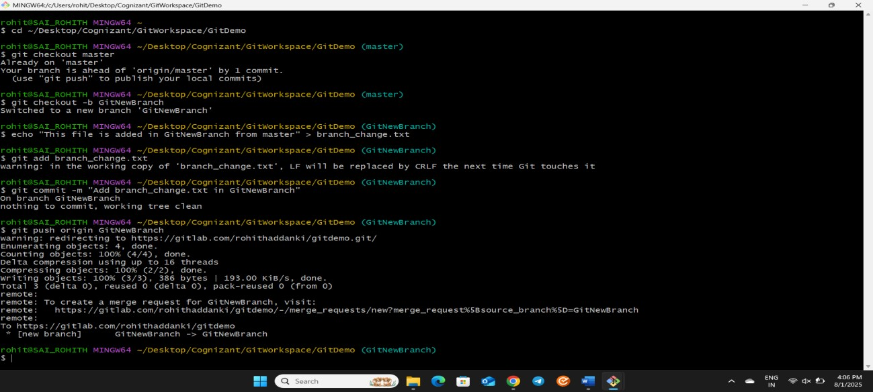

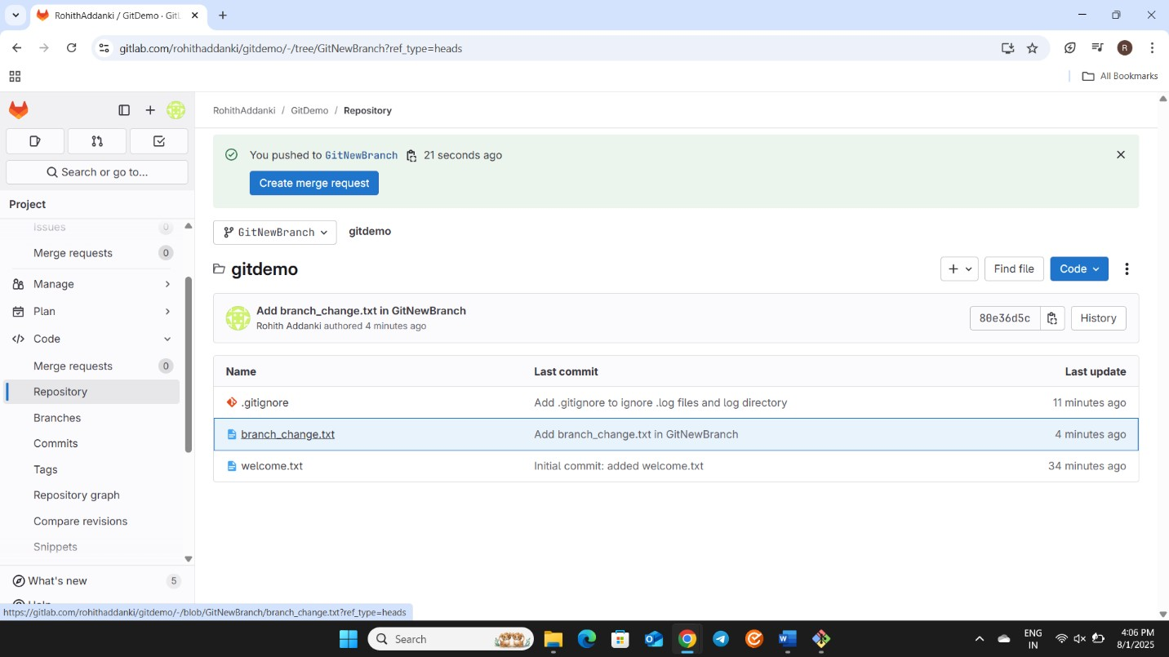

@sashanknerella MINGW64

~/Desktop/Cognizant/GitWorkspace/GitDemo (GitNewBranch)

$ git checkout master

Switched to branch 'master'

Your branch is ahead of 'origin/master' by 1 commit.

(use "git push" to publish your local commits)

@sashanknerella MINGW64

~/Desktop/Cognizant/GitWorkspace/GitDemo (master)

$ git diff GitNewBranch

@sashanknerella MINGW64

~/Desktop/Cognizant/GitWorkspace/GitDemo (master) $ git merge GitNewBranch

Already up to date.

@sashanknerella MINGW64

~/Desktop/Cognizant/GitWorkspace/GitDemo (master)

$ git push origin master warning: redirecting to

https://gitlab.com/rohithaddanki/gitdemo.git/

Total 0 (delta 0), reused 0 (delta 0), pack-reused 0 (from 0) remote: remote: To create a merge request for master, visit: remote: https://gitlab.com/rohithaddanki/gitdemo//merge_requests/new?merge_request%5Bsource_branch%5D=master remote:

To https://gitlab.com/rohithaddanki/gitdemo df9a1f6..80e36d5 master -> master

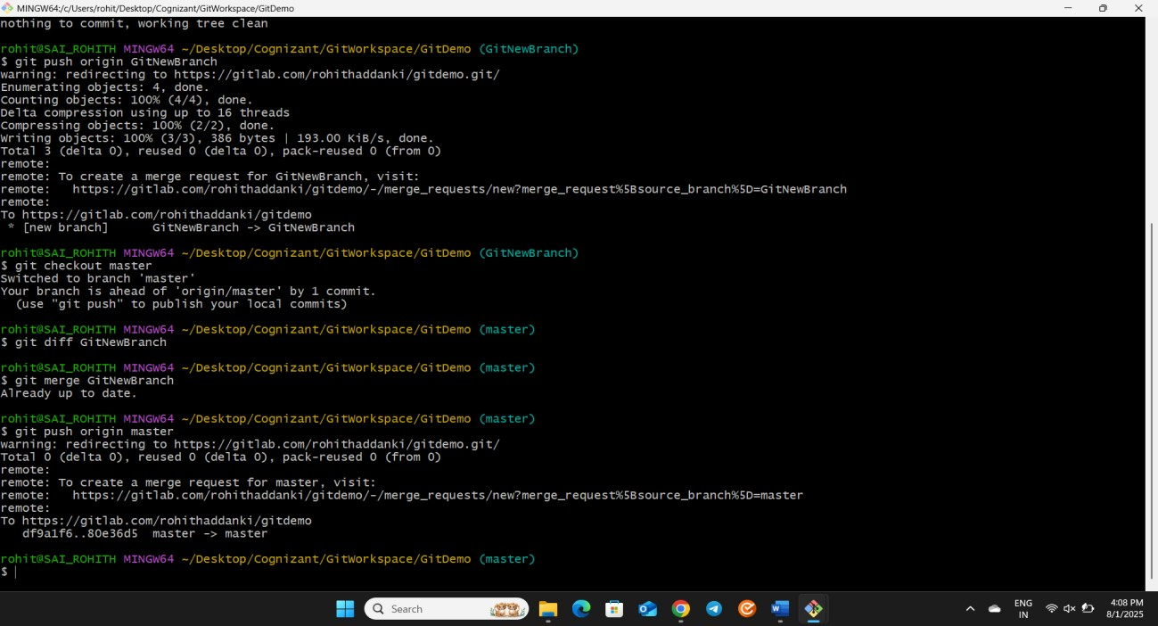

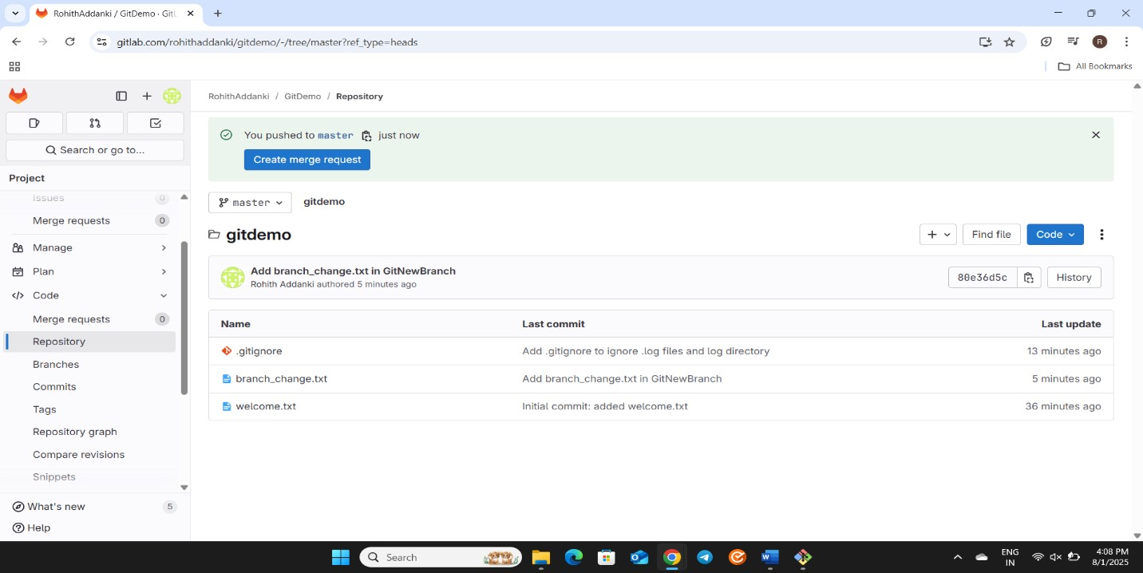

@sashanknerella MINGW64

~/Desktop/Cognizant/GitWorkspace/GitDemo (master)

$ git log --oneline --graph --decorate

* 80e36d5 (HEAD -> master, origin/master, origin/GitNewBranch,

GitNewBranch) Add branch_change.txt in GitNewBranch

* df9a1f6 Add .gitignore to ignore .log files and log directory
* f0dbc3c Initial commit: added welcome.txt

@sashanknerella MINGW64

~/Desktop/Cognizant/GitWorkspace/GitDemo (master)

$ git branch -d GitNewBranch

Deleted branch GitNewBranch (was 80e36d5).

