4.Git-HOL

@sashanknerella MINGW64 ~

$ cd ~/Desktop/Cognizant/GitWorkspace/GitDemo

@sashanknerella MINGW64

# ~/Desktop/Cognizant/GitWorkspace/GitDemo (master)

$ git checkout master

Already on 'master'

Your branch is up to date with 'origin/master'.

@sashanknerella MINGW64

# ~/Desktop/Cognizant/GitWorkspace/GitDemo (master)

$ git status

On branch master

Your branch is up to date with 'origin/master'.

nothing to commit, working tree clean

@sashanknerella MINGW64

# ~/Desktop/Cognizant/GitWorkspace/GitDemo (master)

$ git checkout -b GitWork

Switched to a new branch 'GitWork'

@sashanknerella MINGW64

~/Desktop/Cognizant/GitWorkspace/GitDemo (GitWork) $ echo "<message>Hello from GitWork branch</message>" > hello.xml

@sashanknerella MINGW64

# ~/Desktop/Cognizant/GitWorkspace/GitDemo (GitWork)

$ git status On branch GitWork Untracked files:

(use "git add <file>..." to include in what will be committed) hello.xml

nothing added to commit but untracked files present (use "git add" to track)

@sashanknerella MINGW64

# ~/Desktop/Cognizant/GitWorkspace/GitDemo (GitWork)

$ git add hello.xml

warning: in the working copy of 'hello.xml', LF will be replaced by CRLF the next time Git touches it

@sashanknerella MINGW64

# ~/Desktop/Cognizant/GitWorkspace/GitDemo (GitWork)

$ git commit -m "Add hello.xml in GitWork branch"

[GitWork 0543d22] Add hello.xml in GitWork branch

1 file changed, 1 insertion(+)

create mode 100644 hello.xml

@sashanknerella MINGW64

# ~/Desktop/Cognizant/GitWorkspace/GitDemo (GitWork)

$ git checkout master

Switched to branch 'master'

Your branch is up to date with 'origin/master'.

@sashanknerella MINGW64

# ~/Desktop/Cognizant/GitWorkspace/GitDemo (master)

$ echo "<note>This is a conflicting change in master</note>" > hello.xml

@sashanknerella MINGW64

# ~/Desktop/Cognizant/GitWorkspace/GitDemo (master)

$ git add hello.xml

warning: in the working copy of 'hello.xml', LF will be replaced by CRLF the next time Git touches it

@sashanknerella MINGW64

# ~/Desktop/Cognizant/GitWorkspace/GitDemo (master)

$ git commit -m "Add conflicting hello.xml in master"

[master 553b451] Add conflicting hello.xml in master

1 file changed, 1 insertion(+) create mode 100644 hello.xml

@sashanknerella MINGW64

# ~/Desktop/Cognizant/GitWorkspace/GitDemo (master)

$ git log --oneline --graph --decorate --all

* 553b451 (HEAD -> master) Add conflicting hello.xml in master

| * 0543d22 (GitWork) Add hello.xml in GitWork branch

|/

* 80e36d5 (origin/master) Add branch_change.txt in GitNewBranch * df9a1f6 Add .gitignore to ignore .log files and log directory
* f0dbc3c Initial commit: added welcome.txt

@sashanknerella MINGW64

# ~/Desktop/Cognizant/GitWorkspace/GitDemo (master)

$ git diff GitWork

diff --git a/hello.xml b/hello.xml index 0bf4c19..ccca8b5 100644

--- a/hello.xml

+++ b/hello.xml

@@ -1 +1 @@

-<message>Hello from GitWork branch</message>

+<note>This is a conflicting change in master</note>

@sashanknerella MINGW64

# ~/Desktop/Cognizant/GitWorkspace/GitDemo (master)

$ git merge GitWork

Auto-merging hello.xml

CONFLICT (add/add): Merge conflict in hello.xml

Automatic merge failed; fix conflicts and then commit the result.

@sashanknerella MINGW64

# ~/Desktop/Cognizant/GitWorkspace/GitDemo (master|MERGING)

$ notepad++ hello.xml

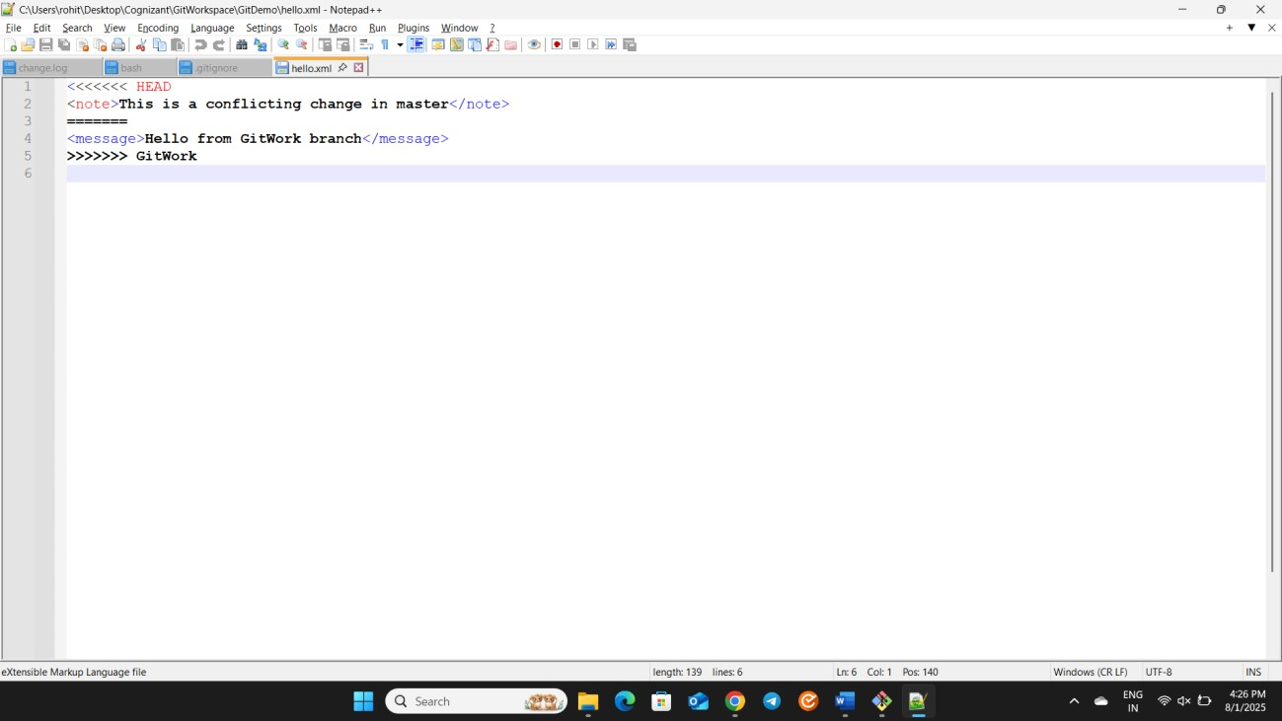

@sashanknerella MINGW64

# ~/Desktop/Cognizant/GitWorkspace/GitDemo (master|MERGING)

$ git add hello.xml

@sashanknerella MINGW64

# ~/Desktop/Cognizant/GitWorkspace/GitDemo (master|MERGING)

$ git commit -m "Resolve merge conflict in hello.xml"

[master be88acf] Resolve merge conflict in hello.xml

@sashanknerella MINGW64

# ~/Desktop/Cognizant/GitWorkspace/GitDemo (master)

$ echo "*.bak" >> .gitignore

@sashanknerella MINGW64

# ~/Desktop/Cognizant/GitWorkspace/GitDemo (master)

$ git add .gitignore

warning: in the working copy of '.gitignore', LF will be replaced by CRLF the next time Git touches it

@sashanknerella MINGW64

# ~/Desktop/Cognizant/GitWorkspace/GitDemo (master)

$ git commit -m "Ignore backup files"

[master 3aedc40] Ignore backup files

1 file changed, 1 insertion(+)

@sashanknerella MINGW64

# ~/Desktop/Cognizant/GitWorkspace/GitDemo (master)

$ git branch

GitWork

* master

@sashanknerella MINGW64

# ~/Desktop/Cognizant/GitWorkspace/GitDemo (master)

$ git branch -d GitWork

Deleted branch GitWork (was 0543d22).

@sashanknerella MINGW64

# ~/Desktop/Cognizant/GitWorkspace/GitDemo (master)

$ git log --oneline --graph --decorate

* 3aedc40 (HEAD -> master) Ignore backup files
* be88acf Resolve merge conflict in hello.xml

|\

| * 0543d22 Add hello.xml in GitWork branch

* | 553b451 Add conflicting hello.xml in master

# |/

* 80e36d5 (origin/master) Add branch_change.txt in GitNewBranch * df9a1f6 Add .gitignore to ignore .log files and log directory
* f0dbc3c Initial commit: added welcome.txt

@sashanknerella MINGW64

# ~/Desktop/Cognizant/GitWorkspace/GitDemo (master)

$ git push -u origin master warning: redirecting to

