**FFOM**

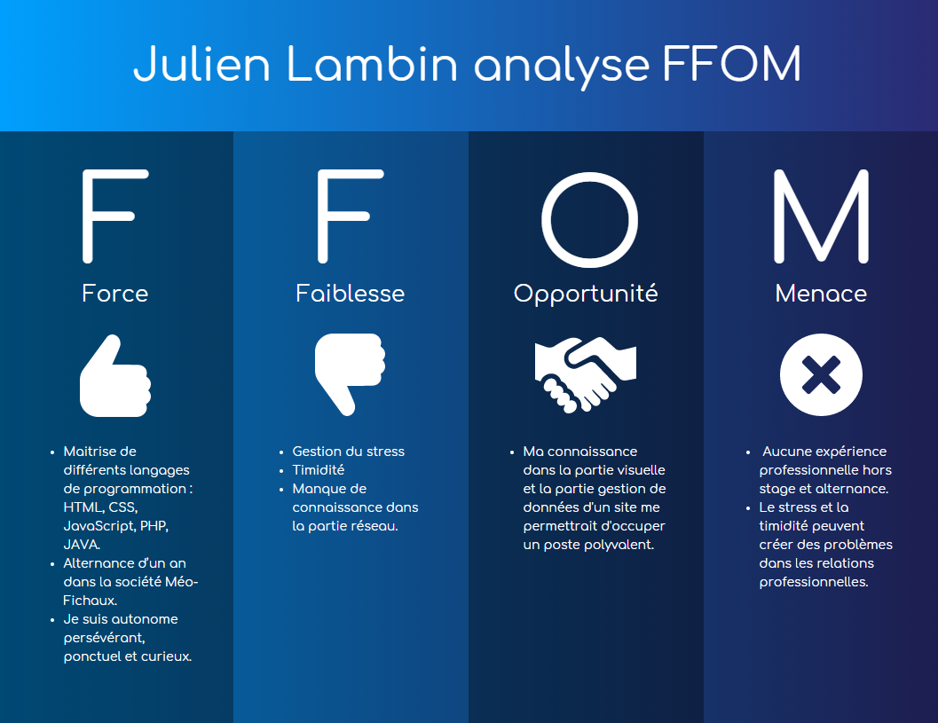

**Logo**



**Couleur**

#243686

#ee8133

**Police**

Poppins Light | **Poppins Light** | *Poppins Light* | Poppins Light

Comfortaa | **Comfortaa** | *Comfortaa* | Comfortaa