Spotify Data Analysis
Project Documentation & Analytical Summary | Data Analyst Program
Institution: Atlas College in collaboration with Tel Aviv University
Dataset: Spotify Sequential Listening History
Core Focus: User Skip Behavior, Session Dynamics & Catalog Concentration

Part 1: Business Problem Understanding
Core Business Question
“What drives a user to continue listening without skipping, and how can we diversify the listening experience without disrupting streaming continuity?”
In other words, the goal is to strike an optimal balance between user preferences and strategic exposure to new content.
Expected Business Impact
Based on the subsequent analysis, the organization will gain actionable insights into track skip drivers. This allows data-driven optimizations to enhance continuous play and determine the precise timing and context for serving unfamiliar tracks aligned with user preferences.
Key Business Questions & Framework
- 1. Primary KPI Question: What is the proportion of tracks in a playlist that are not skipped versus those skipped by users?
- 2. Group Comparison & Segmentation: Is there a significant difference in the types of playlists used by Premium users compared to Free users?
- 3. Variable Relationship Analysis: Is there a relationship between the listening context type and the likelihood of a user skipping a track?
- 4. Long-Tail, Concentration & Diversity: What is the stream distribution across unique tracks, with a focus on consistency and relevance?
Part 2: Data Overview & Variable Selection
- Not_skipped (Categorical / Target Variable: Indicates whether the user skipped the track (1 = Not Skipped, 0 = Skipped).)
- hist_user_behavior_reason_start / end (Categorical / Explanatory: Trigger events starting/ending playback. Rare categories (<1%) are grouped into 'Other'.)
- context_type (Categorical / Segmentation: The playlist or recommendations context chosen for the track.)
- Premium (Categorical / Binary: Subscription tier (1 = Premium paid, 0 = Free standard).)
- session_position (Discrete Numerical: Sequential track order position within the session.)
- Duration (Continuous Numerical: Track duration in seconds.)
Primary KPI Definition
Non-Skip Rate (%) = (Total Not Skipped Streams / Total Streams) × 100
• Business Justification: Directly measures user engagement and stream continuity per track.
• Limitation: Does not measure genuine emotional satisfaction or passive listening (e.g., user leaving device unattended).
Overall Skip Distribution in Dataset
- Skipped: 66.77%
Not Skipped: 33.23%
Key Takeaway: Approximately two-thirds of all streams in the dataset ended in a user skip.
Part 3: Data Quality & Anomalies
1. Time Window Constraint: Over 99% of data points span across only 2 days. This prevents multi-temporal trend analysis, restricting Question 4 strictly to quantitative volume.
2. Logical Contradictions: Minor instances (<1%) where skip flags contradict end reasons were removed. However, discrepancy between explicit skip flags and forward/backward end reasons occurred in over 10% of cases. These were retained to preserve volume, but flagged as operational noise.

Part 4: Summary Statistics
Session Length & Track Duration Metrics
Metric | Session Length (Max Position) | Track Duration (Seconds)
Mean | 16.79 | 215.89 (~3.6 min)
Standard Error | 0.038 | 0.15
Median | 20.00 | 212.03
Mode | 20.00 | 217.93
Standard Deviation | 3.81 | 60.22
Sample Variance | 14.50 | 3,626.89
Kurtosis | -1.28 | 23.89
Skewness | -0.62 | 2.22
Range | 10 | 1,757.75
Min / Max | 10 / 20 | 30.01 / 1,787.76
Total Count (N) | 10,001 sessions | 167,880 streams

Descriptive Analysis & Findings
A basic descriptive analysis of quantitative variables reveals clear structural patterns in streaming sessions: More than half of all sessions reach the maximum track length of 20 (as confirmed by a median of 20). Additionally, sorting session lengths from largest to smallest shows that the shortest recorded session contains exactly 10 tracks.
Session Length Frequency Distribution
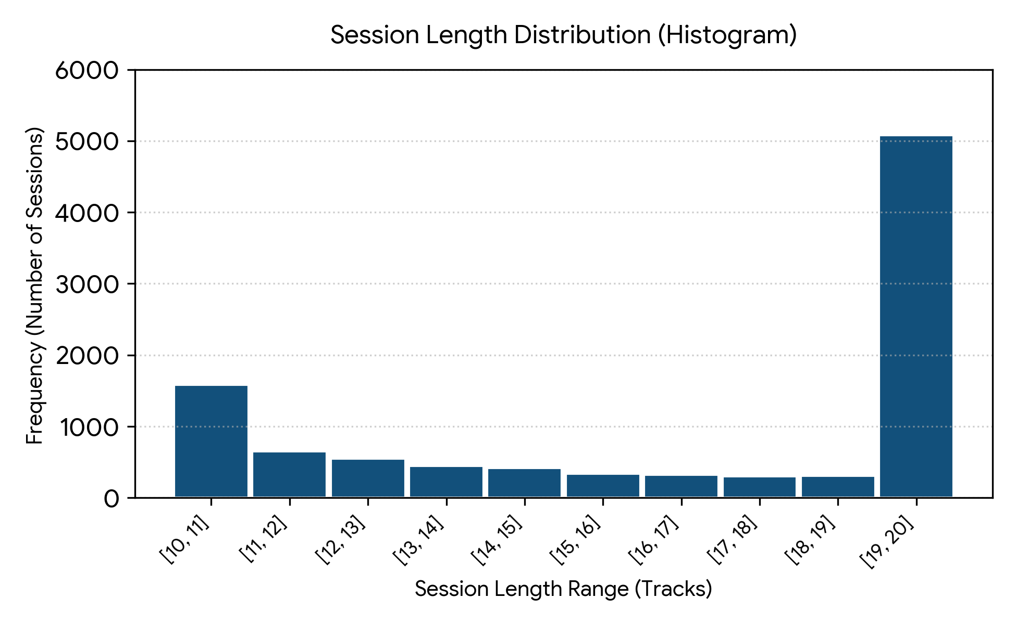

Part 5: Hypotheses & Behavioral Insights
Initial Hypotheses Evaluation
We initially evaluated three primary drivers suspected of influencing skips: context_type, session_position, and Premium subscription status. Findings revealed that none of these three variables independently impacted skip rates. Premium vs. Free tiers and distinct contexts maintained the exact baseline 1:2 non-skip ratio (~33% vs. ~67%).

Deeper Sequential Insights
- Trigger Memory: A track's start reason heavily dictates its outcome.
- Skip Cascades: Tracks initiated via a forward skip (fwdbtn) have a dramatically higher probability of being skipped again.
- Passive Play Continuity: Tracks started automatically via natural transition (trackdone) are significantly more likely to finish without skipping.

Part 6: Long-Tail & Concentration Analysis
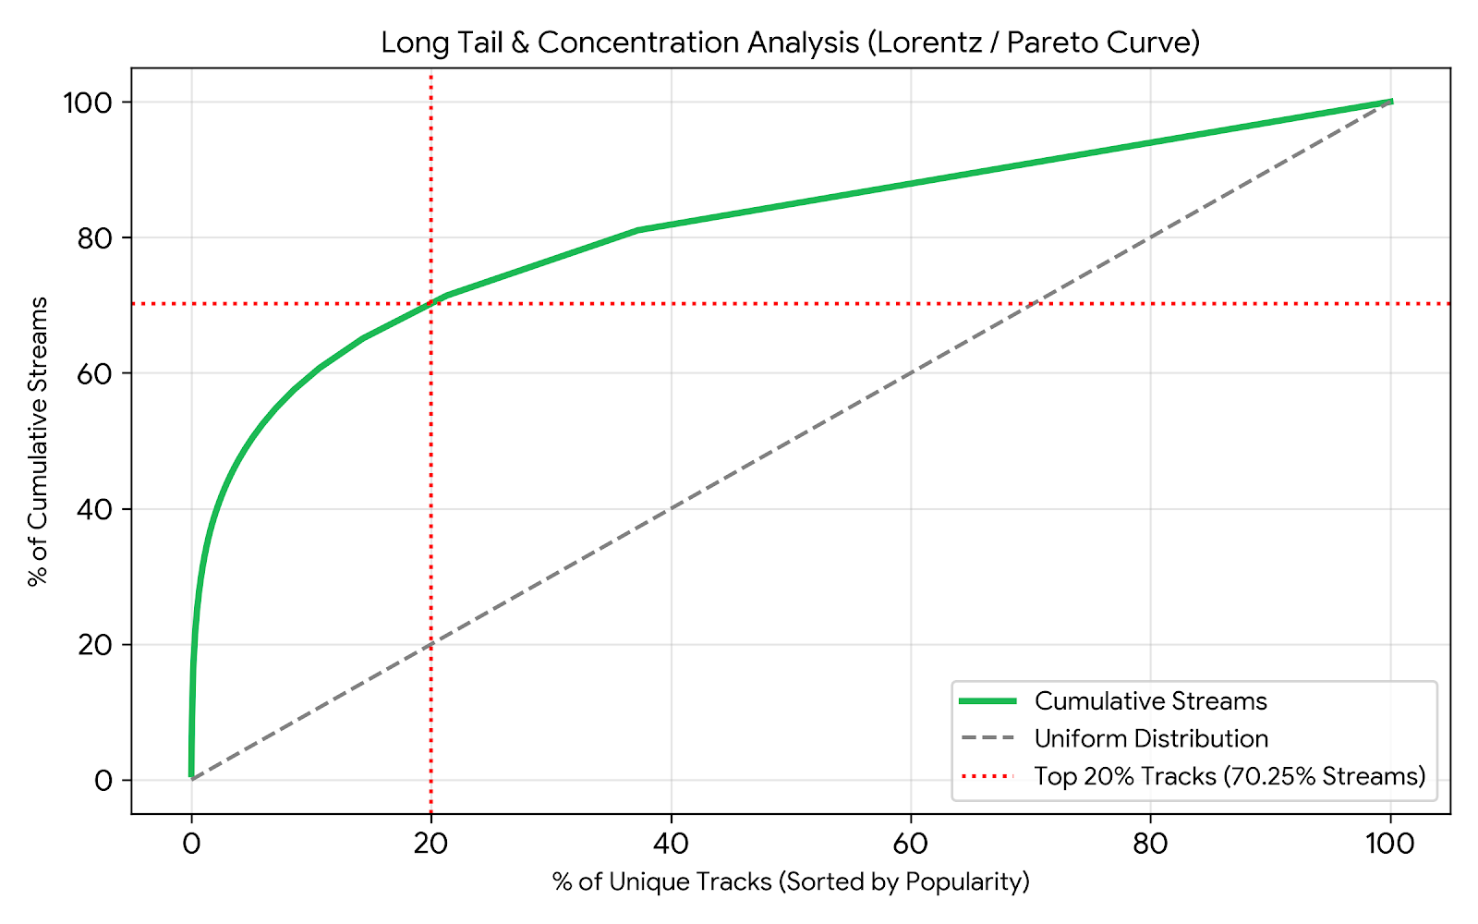

Track Catalog Tier | Unique Tracks | Total Streams | Skip Rate (%) | Completion Rate (%)
Head (Top 20%) | 10,140 (20%) | 117,938 (~70%) | 51.69% | 33.44%
Tail (Bottom 80%) | 40,556 (80%) | 49,942 (~30%) | 51.79% | 32.92%

Key Observation: High concentration exists (Pareto 70/20 rule). However, skip rate is remarkably invariant between Head and Tail tracks (~51.7%). Data quality in Head tracks is higher due to larger sample density, whereas Tail tracks suffer high sparsity (Median = 1 stream per track).
Part 7: Data Limitations & Recommendations
- • Device State & Multitasking Data: To differentiate active interaction from passive background playback.
- • Multi-Session Continuity: Indicators on session restarts to measure actual user churn.
- • Demographics: Age and gender attributes, which strongly influence skip propensity.
- • Extended Timeframe: Multi-month historical scope for seasonal trends.
Part 8: Strategic Recommendations
- Capitalize on Natural Transitions: When a track transitions naturally (trackdone), introduce Long-Tail or discovery tracks, as user tolerance for new music is highest.
- Interrupt Skip Loops: During active skip cascades, rather than serving popular Head tracks (which retain identical skip probability), dynamically alter the recommendation context or playlist genre.

