

**Kauno technologijos universitetas**

INFORMATIKOS FAKULTETAS

**T120B162 Programų sistemų testavimas**

IFF-6/11 Nerijus Dulkė

Data: 2019.12.16

KAUNAS

2019

# Contents

Contents 2

Initial setup 3

Bug registration and adding to backlog 3

Creating a sprint 3

Assigning users to issues 4

Bug descriptions 5

Sprint progress 6

Sprint report 7

# Initial setup

* Created JIRA cloud project
* Registered all bugs from previous Lab works
* Created a sprint for bug fixing
* Assigned tasks

# Bug registration and adding to backlog

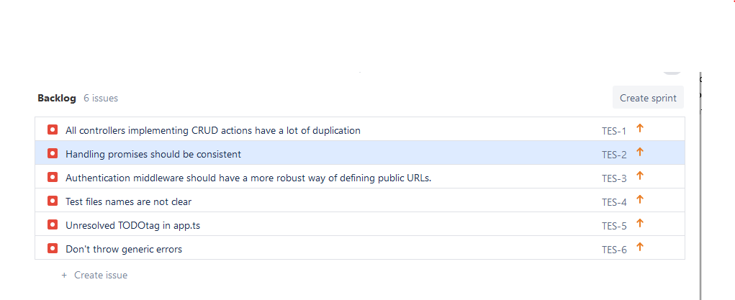

# Creating a sprint

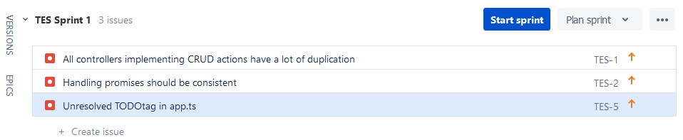

# Assigning users to issues

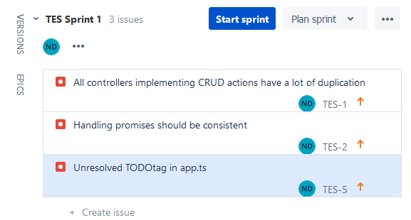

# Bug descriptions

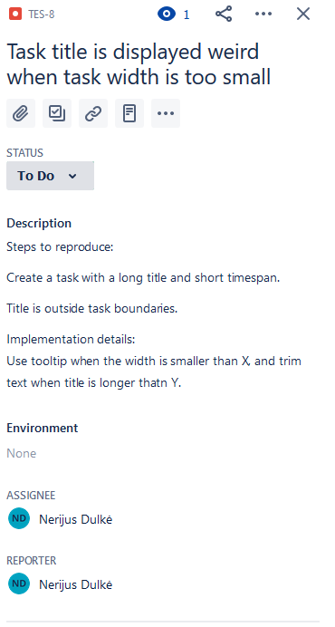

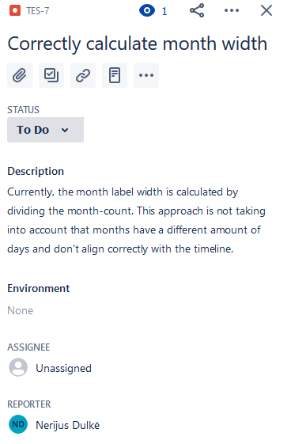

# Sprint progress

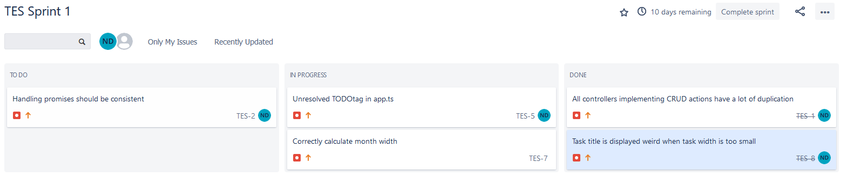

# Sprint report

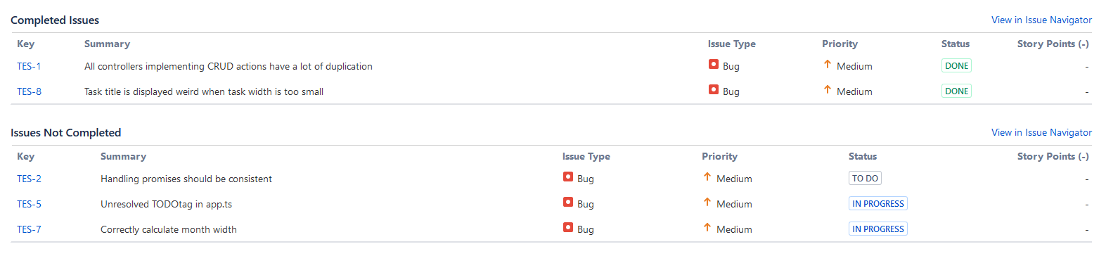

# Conclusion

Learned to work with project management tools with a team. Also worked on creating sprint reports and analyzing sprint progress.