

**All India Index 2013-2022**

**For SSCE – 2023 Examination**

**Name Board Roll No.**

1. **AKSHAT MEHTA ________________**
2. **ANSH SONI ________________**

**Submitted to:**

**RITU SAREEN**

**INDEX**

1. **Acknowledgement**
2. **Certificate**
3. **About Project**
4. **Libraries imported with their description**
5. **Menu options with their description**
6. **Coding**
7. **Output**
8. **Bibliography**

**Acknowledgement**

**I would like to express my special thanks of gratitude to my teacher Ritu Sareen who gave me golden opportunity to do this project of INFORMATICS PRACTICES, which also helped me in doing a lot of research and I came to know new things about it. Without their help, guidance and support it would be impossible to complete this project.**

**Secondly, I would also like to thank my parents and friends who helped me a lot in finishing this project within limited time. I am making this project not only for marks but also to increase my knowledge.**

**Once again thanks to all who helped me in doing this project.**

**Name of student:________________________**

**Signature: ______________________________**

**CERTIFICATE**

**This is to certify that Mr./Ms Akshat Mehta has completed his/her project on “All India Index 2013 -2022” for SSCE-2023 Examination in partial fulfilment of the requirement of CBSE, New Delhi for the award of Senior School Certificate in Informatics Practices (065). The original research work was carried out by him/her under my guidance for the session 2022-2023. On the basis of the declaration made by him/her I recommend this project report for evaluation.**

**Certified by:**

**Internal External Signature: _______________ _________________ Ritu Sareen**

**INTRODUCTION**

**The purpose of this project was to develop the Management Information System (MIS) and to automate the record keeping me medals. It mainly consists of computerized database, a collection of inter related tables/CSV files, capable to produce different reports according to the user. Using Application program (Python) or frontend, we can store, manage, retrieve all information in proper way. The software being simple in design and working, does not require any prerequisite training to users, and can be used as a powerful tool for automating our " All India Index 2013 -2022". To make analysis much easier a user-friendly interface was used to keep records in most detailed and coordinated manner.**

**PURPOSE**

**This Analysis system is capable of analysing Data of all Indian Index of 2013-2022 and can be seen visually as well as in tabular form.**



**(PANDAS)**



**Pandas is a high-level data manipulation tool developed by Wes McKinney. It is built on the Numpy package and its key data structure is called the Data Frame. Data Frames allow you to store and manipulate tabular data in rows of observations and columns of variables.**

**The Pandas Library can be installed by typing Pip install pandas in command prompt Pandas Library can be imported as Import pandas as pd**

**(MATPLOTLIB)**



**The Matplotlib Python library, developed by John Humer and many other contributors is used to create high quality graphs, charts, and figures. The library extensive and capable of changing very minute**

**details of a figure.**

**The matplotlib Library can be installed by typing Pip install matplotlib in command prompt Matplotlib Library can be imported as Import matplotlib.pyplot as plt**

## **(Date Time)**



**The Datetime module supplies classes for manipulating dates and times. While date and time arithmetic is supported, the focus of the implementation is on efficient attribute extraction for output formatting and manipulation.**

**To import datetime just type – import datetime**

**Note – Python datetime module comes built into python , so there’s no need to install it externally**

**WORK FLOW OF A PROJECT**

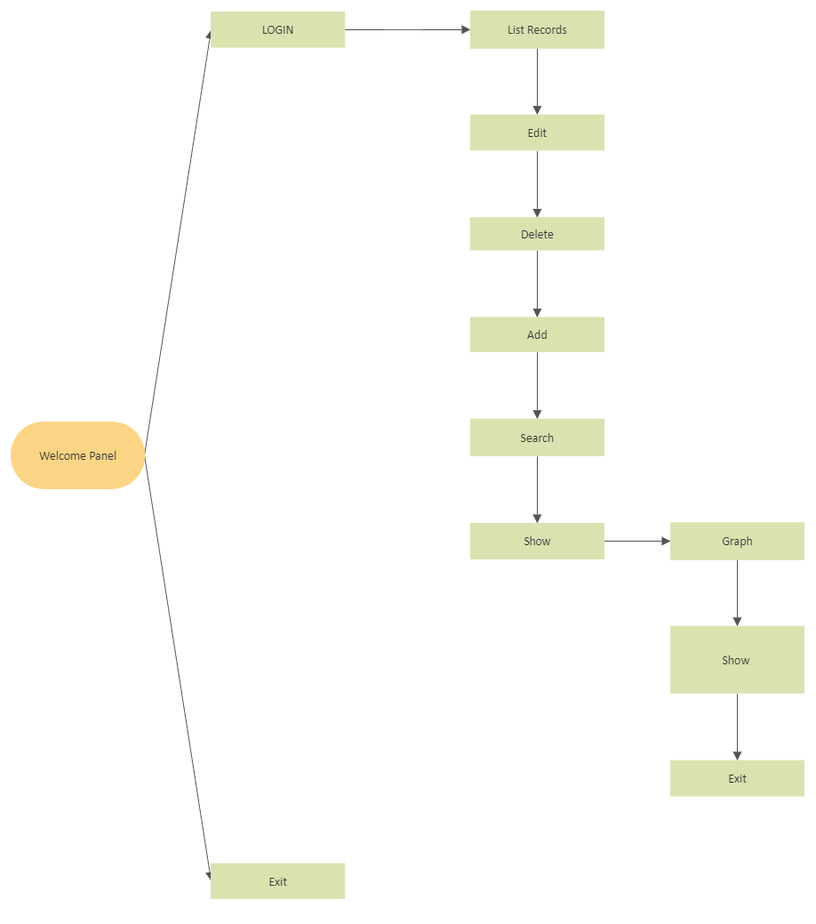

**Menu Functions**

1. Show User Details:

This menu option will show the User Name, Program Running and the login time in the output window.

1. Add Record in CSV File:

This menu is use to add values in a row in the CSV file by specifying the value for each column.

3.Delete Record in CSV File:

This menu option is use to delete record in CSV file which is used to delete a certain row of records by searching the name of the player in the row you want to be deleted.

4.Search a Record in CSV File:

This Menu option is use to search record in csv file by Entering the name of the player which belongs to the row you want the data to be seen .

5.Update Record in CSV File:

This menu option is use to update the record in the row by Entering the name of player whose Record needs to be Updated.

6.Show Records:

This menu option is use to show all the records in the CSV File.

7.Show Graphs:

This menu option is use to Show Graphs for better understanding of data through data visualisation in form of various graphs.

8.Remove CSV File:

This menu option is use to Remove CSV File.

9.Exit:

This menu option is use to Exit the main program.

**CODING**

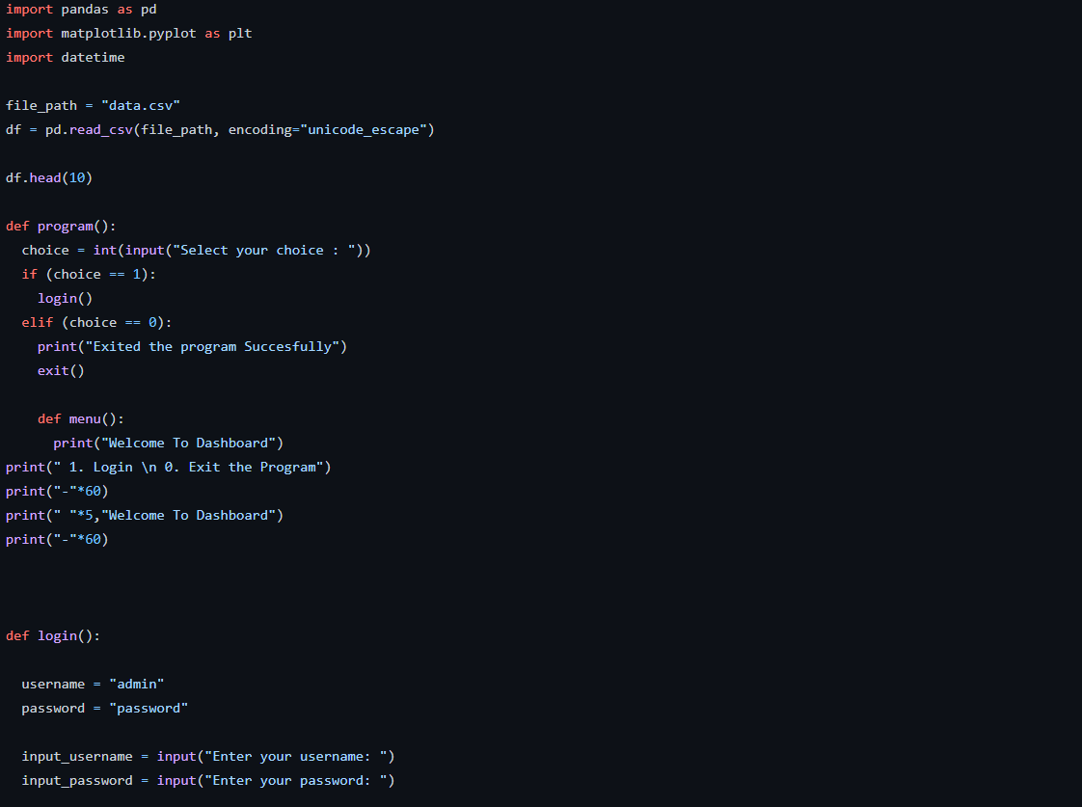

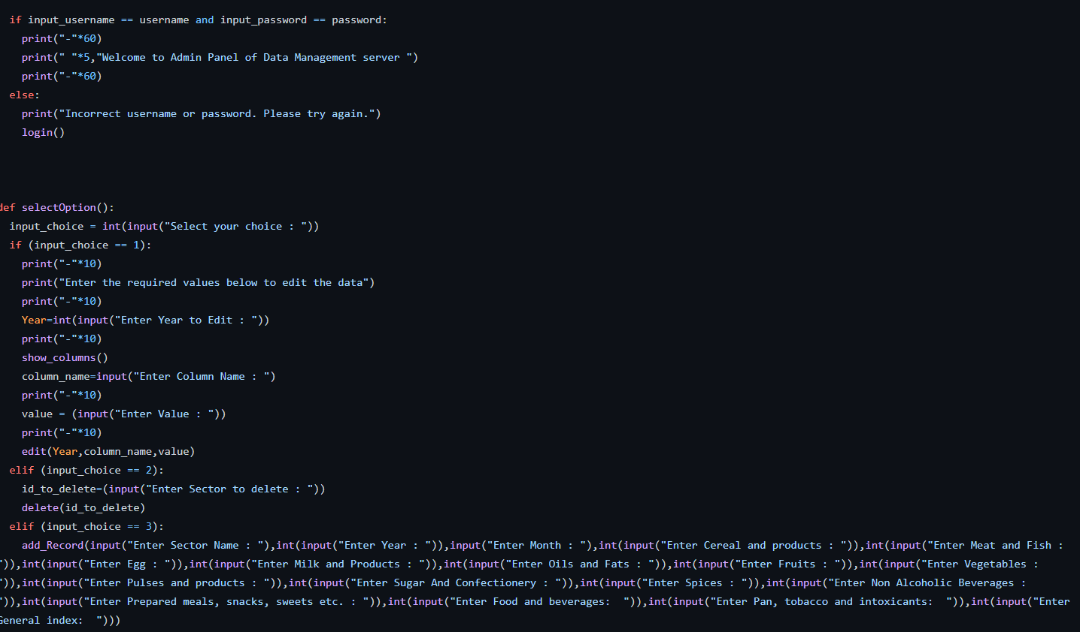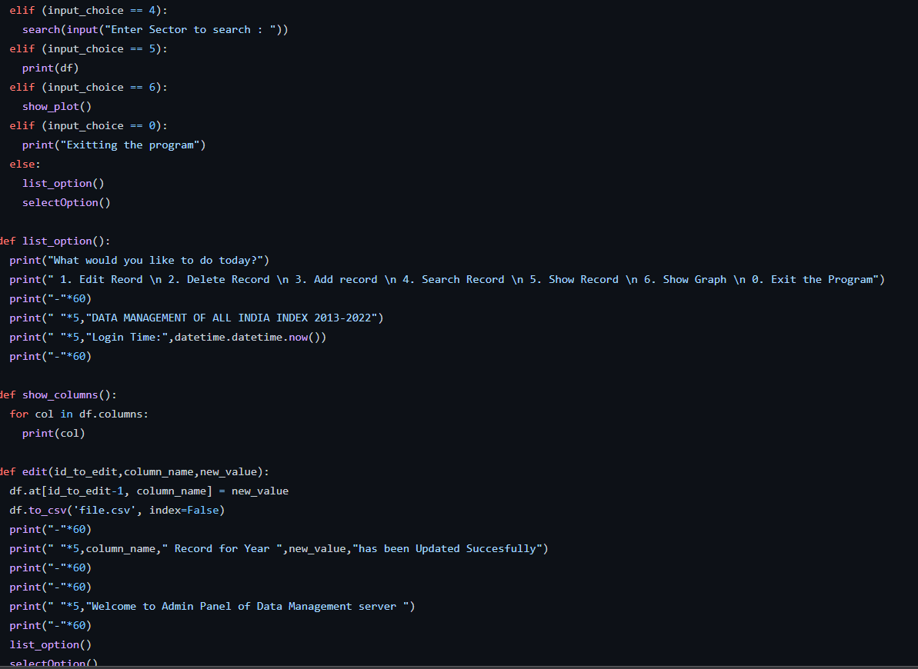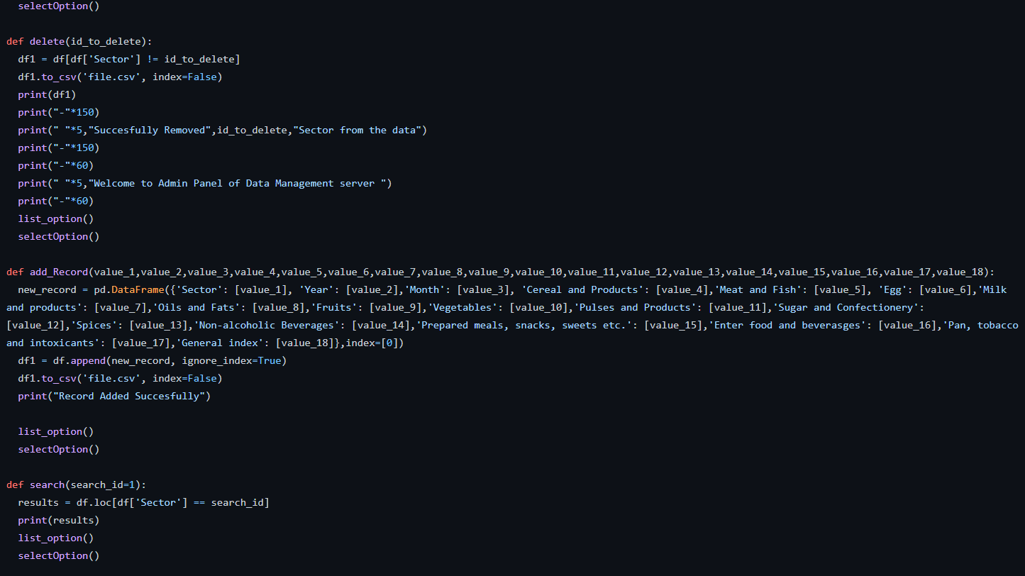

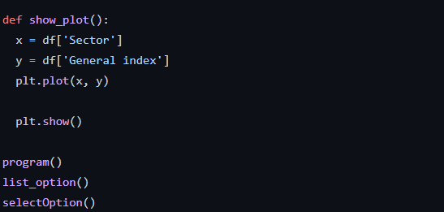

**OUTPUT**

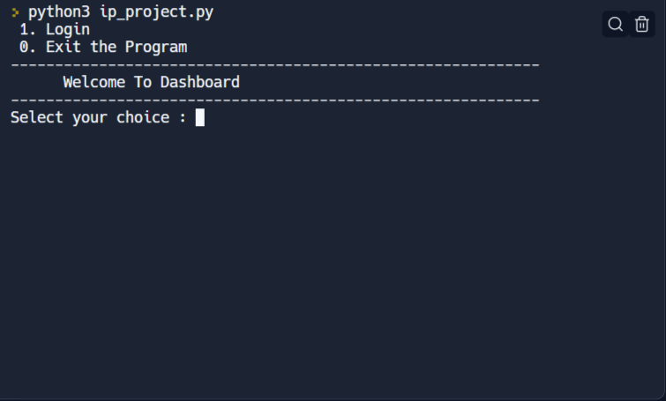

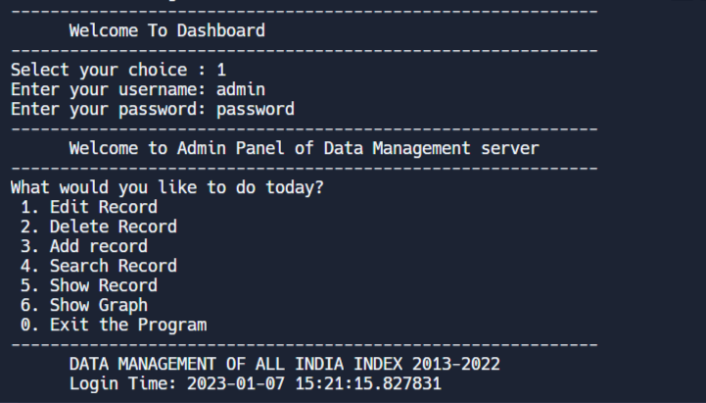

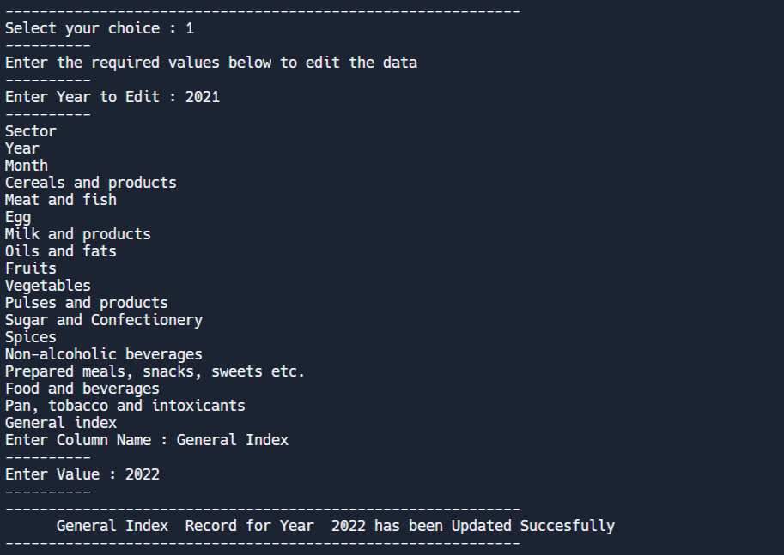

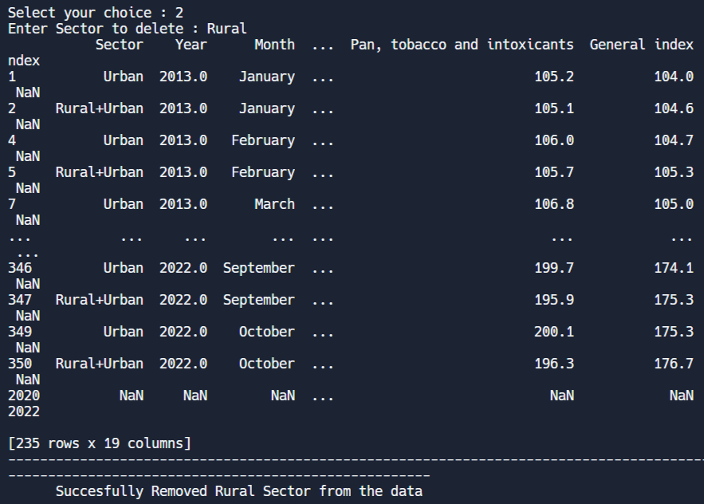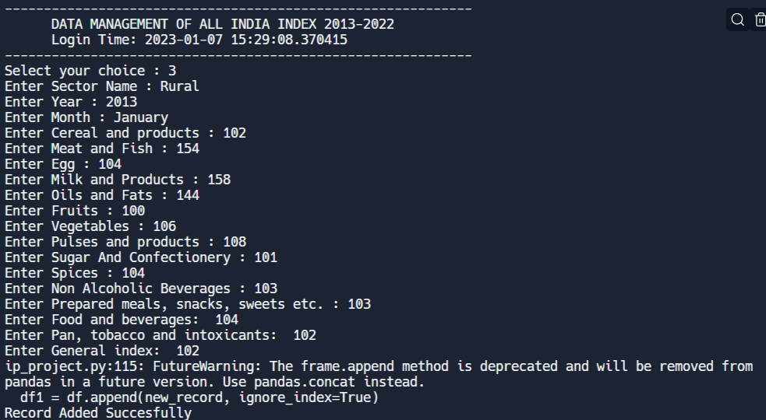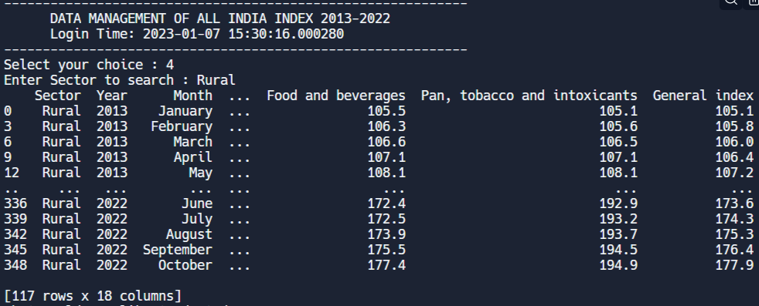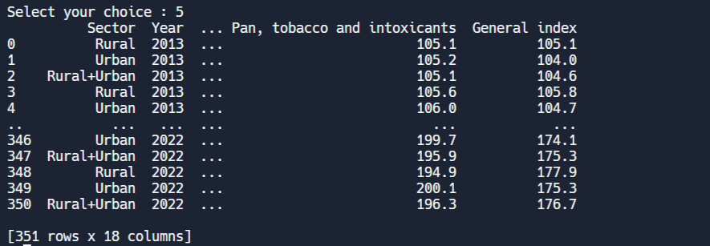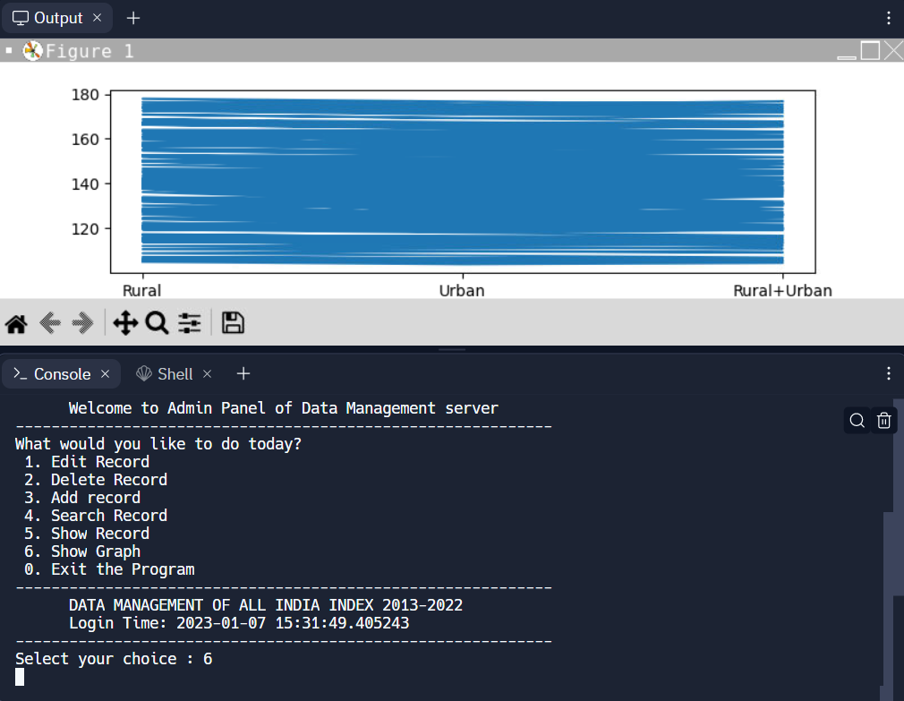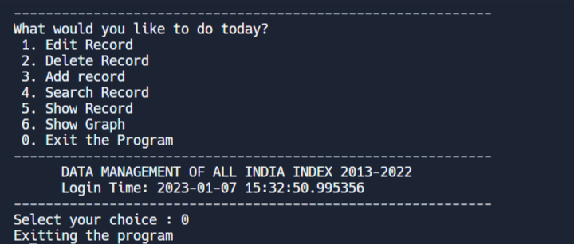

**BIBLIOGRAPHY**

For creating the project following sources have been used:

1. Text Book: Informatics Practices by Sumita Arora

2. InterneT