

**Faculty of engineering - Shoubra**

**Benha University**

**Research project**

in fulfillment of the requirements of

|  |  |
| --- | --- |
| **Department** | **Engineering Mathematics and Physics** |
| **Division** | **-----------------** |
| **Academic Year** | **2019-2020 Preparatory** |
| **Course name** | **Computer** |
| **Course code** | **ECE001** |

**Title: -**

**…… …programming languages…………..**

By:

|  |  |  |  |
| --- | --- | --- | --- |
|  | Name | Edu mail | B.N |
| 1 | نرمين ناجي ايراهيم عبدالنبي | Nermine196117@feng.bu.edu.eg | 991 |

**Approved by:**

|  |  |
| --- | --- |
| Examiners committee | Signature |
| Dr. Ahmed Bayoumi | 1 |
| Dr. Shady Elmashad | 2 |
| Dr. abdelhamid Attaby | 3 |
|  |  |

**Definition and types of programming language**

A programming language is a vocabulary and set of grammatical rules for instructing a computer or computing device to perform specific tasks. The term programming language usually refers to high-level languages. The programming process uses special languages called programming languages, which contain vocabulary to guide the system for carrying out specific tasks, in addition to specific rules. A number of special words are in every programming language, some of them (JAVA, Java script, C#, SQL, PHP, and C++)

**Uses programming language**

There are several areas in which programming languages are involved, and each field has its uses and goals

• The field of applications and software: one of the programming languages used in developing programs, including web browsers, such as its language C#

• Artificial intelligence comes in many areas, such as: Video games, one of the programming languages that enter this field (AIML)

• Database field: Programming languages are used in this field to create and modify databases, from these languages SQL language

**GitHub link:**

**GitHub Page:**

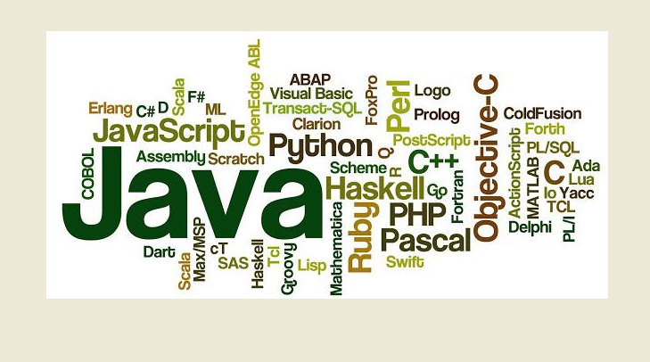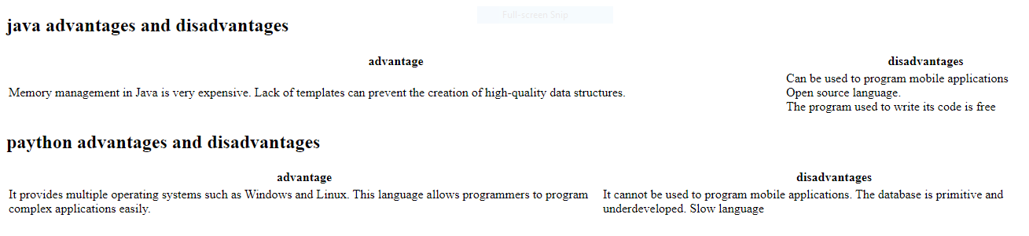**Screenshots:**

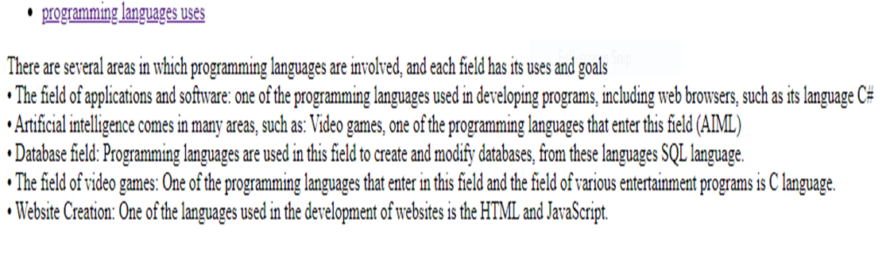

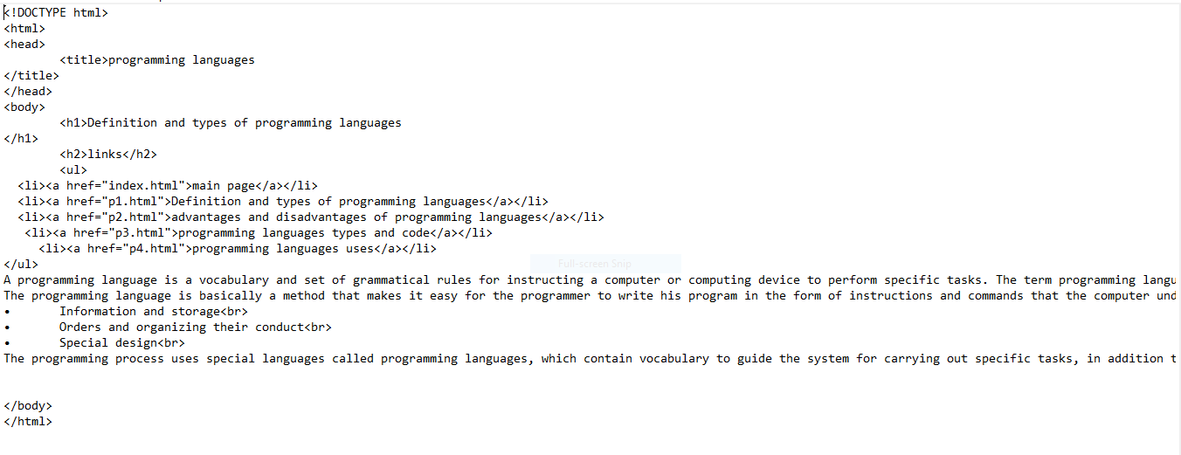**Source code:**