DataLex4AI Crowdsourcing Platform
Engineering Reference Analysis (v1.4) & Product Backlog Specification
Prepared for Engineering & Product Alignment | Version: 1.0 | Date: October 2026
Target Repository: crowdsourcing (Django Backend & Streamlit Frontend)

Executive Summary
This engineering report provides an exhaustive benchmark of the DataLex4AI Crowdsourcing Platform Technical Reference (v1.4) against the current codebase in repository 'crowdsourcing'. The analysis synthesizes both the normative textual specification and all 13 system architecture diagrams and UI mockups extracted directly from the reference document. Its primary objective is to equip the backend and frontend engineering teams with a clear roadmap of already implemented MVP capabilities, critical gaps in linguistic governance and quality control, and a fully decomposed, estimated Product Backlog ready for sprint planning.
[CORE ARCHITECTURAL MANDATE] The DataLex4AI standard differentiates itself through Arabic dialect governance, 3-tier holistic quality measurement, calibration batch gating, and strict separation between automated AI assistance and human ground truth. These mechanisms prevent synthetic model bias and dialectal homogenization from corrupting Arabic speech and text datasets.

1. Visual & Architectural Breakdown of Reference Figures
The reference document includes 13 figures: Figures 1 through 4 define the operational lifecycle, quality policy, multi-tier measurement, and AI assistance routing; Figures 5 through 13 detail the user interface paradigms for the core task execution tools (Tools 5 through 14). Below is the comprehensive technical breakdown of each visual.

Figure 1: 4-Stage Operating Lifecycle & Stage Deliverables (الشكل 1)
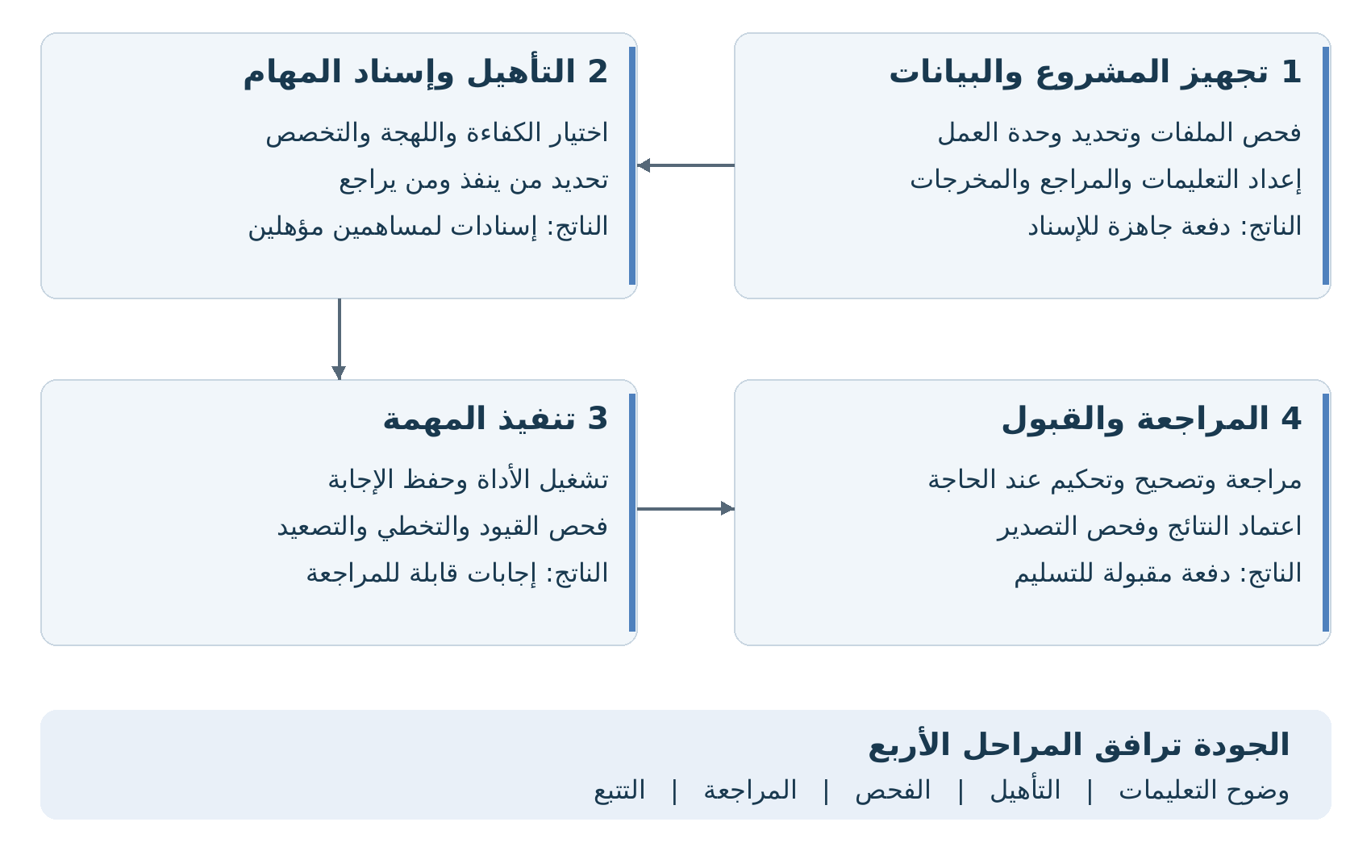
Reference Mockup: Figure 1 - 4-Stage Operating Lifecycle & Stage Deliverables (الشكل 1)
Illustrates the sequential state transitions governing crowdsourcing projects from ingestion to export:
• Stage 1 (Preparation & Data Ingestion): Input validation, atomic work unit definition, instruction and guideline authoring -> Output: Batch ready for assignment.
• Stage 2 (Qualification & Worker Assignment): Screening by task competency, accredited dialect, and domain specialization -> Output: Certified worker assignment queues.
• Stage 3 (Task Execution): Tool execution, automatic draft persistence, constraints enforcement, skip/escalation logic -> Output: Reviewable candidate answers.
• Stage 4 (Review, Adjudication & Acceptance): Independent review, corrective feedback, multi-party adjudication -> Output: Validated delivery-ready batch.
• Transversal Quality Pillar: Quality accompanies all 4 stages: guideline clarity -> qualification -> automated verification -> independent review -> immutable traceability.

Figure 2: Project Quality Policy Configuration Matrix (الشكل 2)
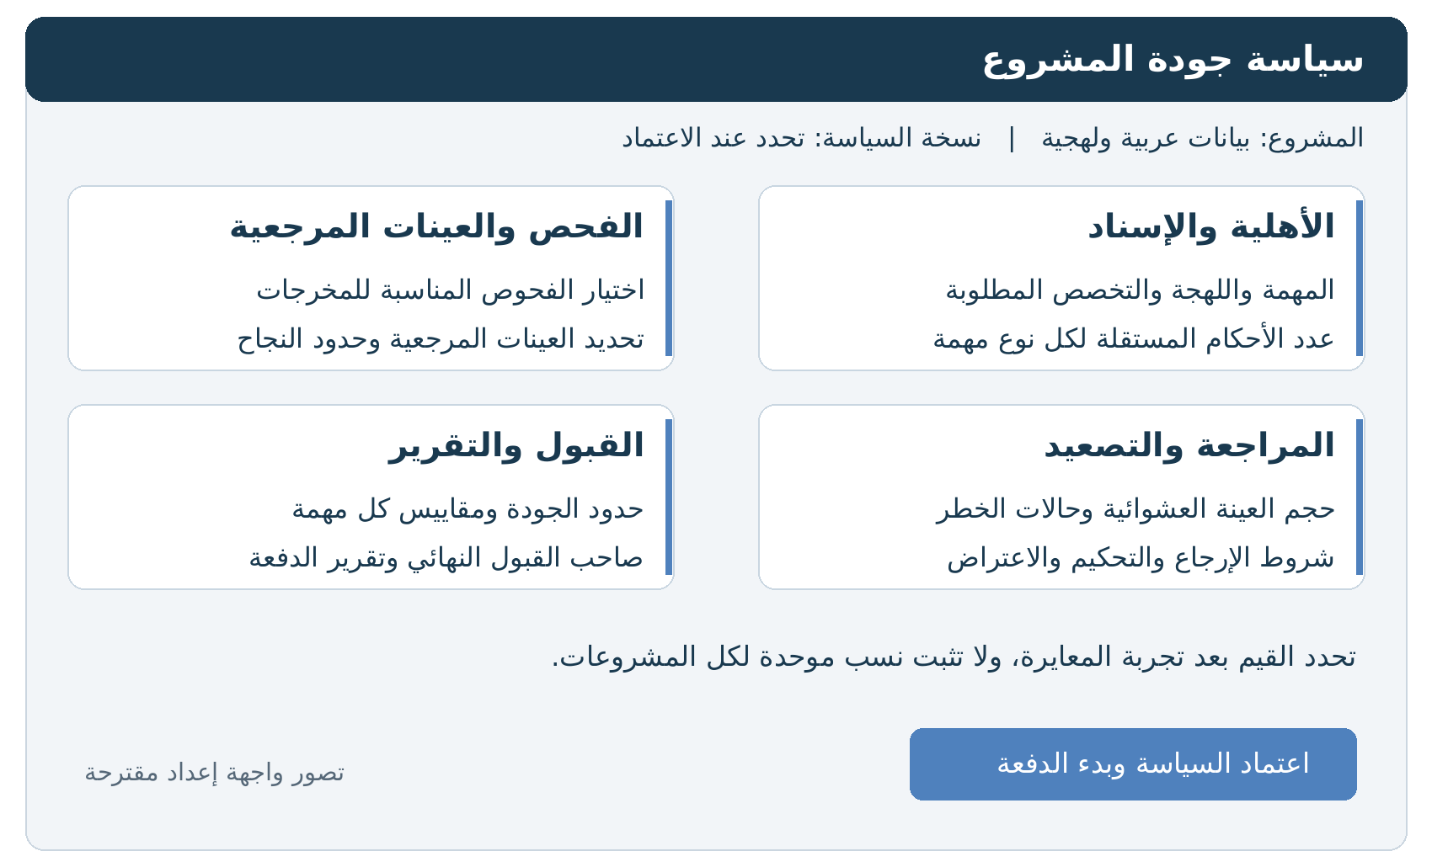
Reference Mockup: Figure 2 - Project Quality Policy Configuration Matrix (الشكل 2)
Defines the pre-production gatekeeping screen configured by the Quality Manager before batch opening:
• Eligibility & Assignment: Required dialect, domain specialization, number of independent annotator judgements (N) per task.
• Inspection & Benchmarks: Selection of output format constraints, hidden golden benchmark frequency and accuracy thresholds.
• Review & Escalation: Baseline random sample percentage, risk-based escalation triggers (speed outliers, high variance), and re-work conditions.
• Acceptance & Reporting: Per-task error tolerance thresholds, batch sign-off authority, and QC audit report generation.
• Calibration Rule: Values are strictly locked and tuned after the Calibration Batch trial; uniform fixed percentages are never imposed across disparate projects.

Figure 3: Three-Tier Quality Measurement Framework (الشكل 3)
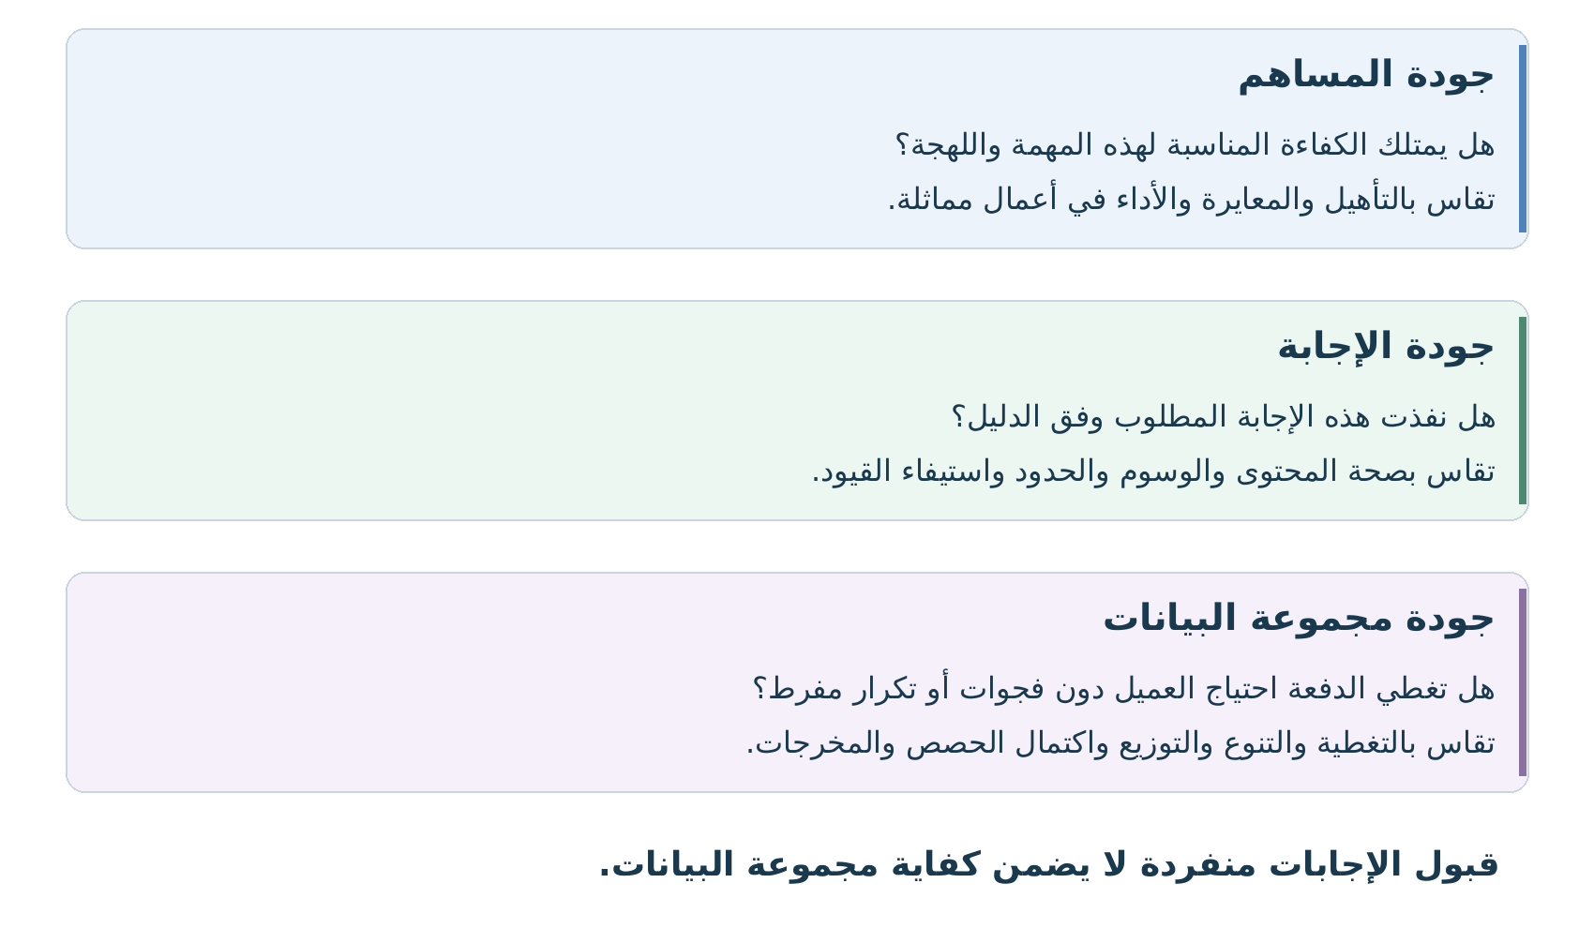
Reference Mockup: Figure 3 - Three-Tier Quality Measurement Framework (الشكل 3)
Establishes a three-dimensional quality hierarchy to ensure dataset fitness:
1. Contributor Quality (جودة المساهم): Does the worker possess verified competence for this dialect and task? Evaluated via qualification exams, calibration performance, and rolling accuracy.
2. Answer Quality (جودة الإجابة): Did this specific answer satisfy guidelines? Measured via span boundaries, label accuracy, and structural constraints.
3. Dataset / Batch Quality (جودة مجموعة البيانات): Does the aggregate batch meet client quota and diversity goals? Measured via regional dialect coverage, speaker demographics, and deduplication.
• Core Principle: 'Accepting individual answers in isolation does not guarantee dataset adequacy.'

Figure 4: AI-Assisted vs. Independent Human Routing (الشكل 4)
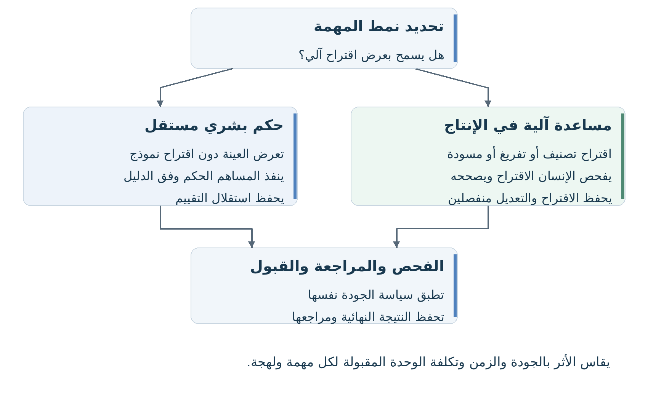
Reference Mockup: Figure 4 - AI-Assisted vs. Independent Human Routing (الشكل 4)
A bifurcated decision tree governing model assistance:
• Independent Human Judgment: Input sample presented without AI suggestions to preserve uninfluenced ground truth (essential for model benchmarking and preference evaluations).
• AI-Assisted Production: AI draft (ASR transcript, MT translation, NER spans) presented for human post-editing and verification to optimize throughput.
• Database Schema Rule: Both tracks converge into identical quality inspection, but the system must store AI suggestion, model version, raw human edit, and final accepted answer in separate, unmerged database fields.

Figure 5: Tool 5: Choice & Attribute Assignment UI Mockup
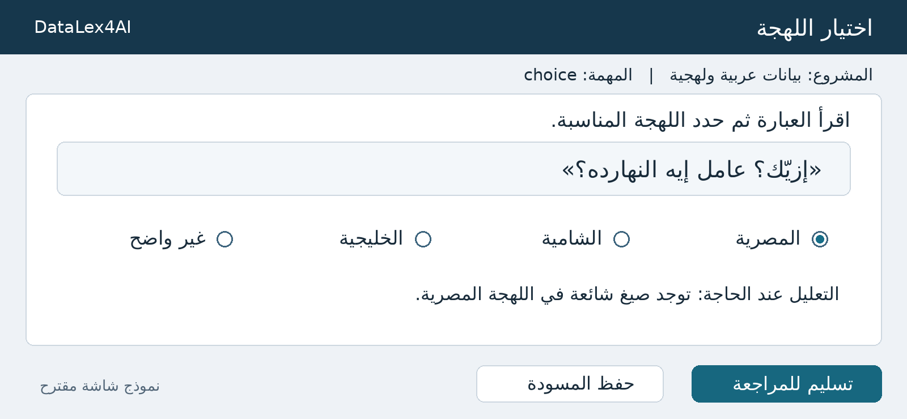
Reference Mockup: Figure 5 - Tool 5: Choice & Attribute Assignment UI Mockup
The launch tool for categorical labeling, content validation, and dialect identification:
• Contributor Interface: Displays input prompt box with Arabic sentence ('إزيّك؟ عامل إيه النهارده؟'), followed by dialect radio options (المصرية [selected], الشامية, الخليجية, غير واضح), an optional reasoning field, [Save Draft], and [Submit for Review].
• Engineering Mandate: Choice IDs must remain immutable even if labels are renamed. Conflict detection prevents contradictory attribute selections.

Figure 6: Tool 6: Text Authoring & Post-Editing UI Mockup
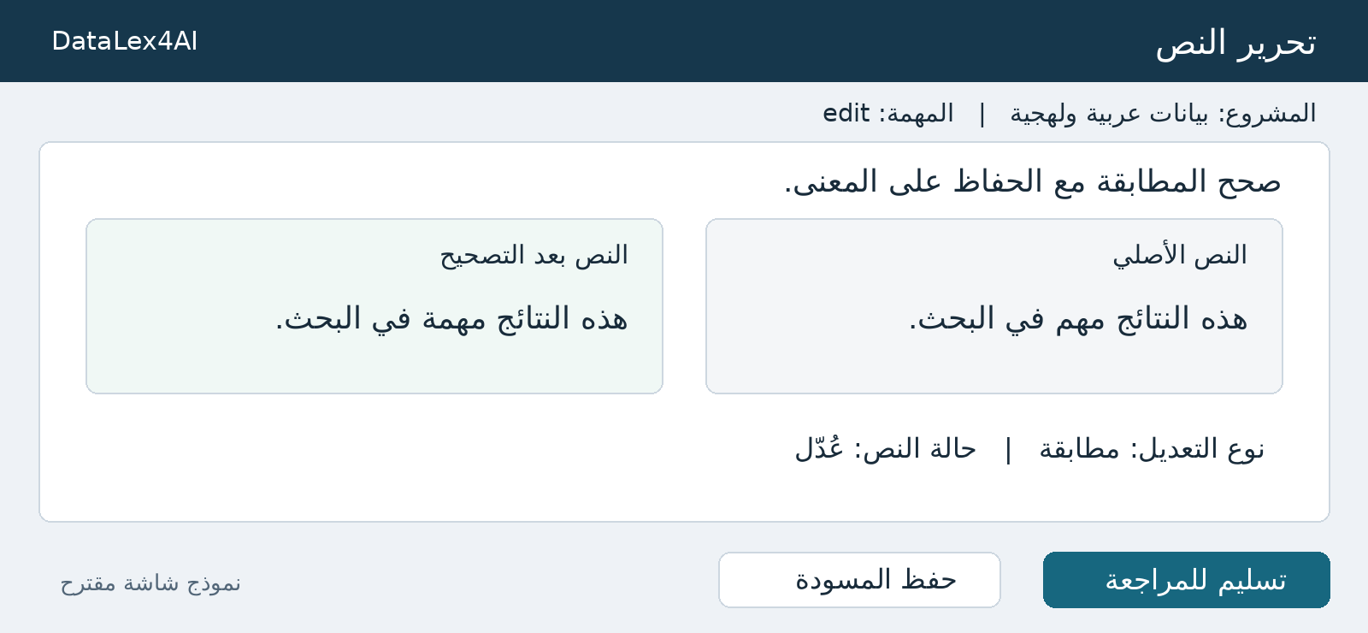
Reference Mockup: Figure 6 - Tool 6: Text Authoring & Post-Editing UI Mockup
Supports text generation, summarization, proofreading, and MT post-editing:
• Contributor Interface: Side-by-side layout displaying Source Text ('هذه النتائج مهم في البحث.') vs. Edited Output ('هذه النتائج مهمة في البحث.'), edit type indicator ('مطابقة'), text status ('عُدّل'), [Save Draft], and [Submit for Review].
• Engineering Mandate: Automated character- and word-level diff tracking. Dialectal deviations from standard Arabic must not be flagged as errors in dialectal tasks.

Figure 7: Tool 8: Rubric-Based Criteria Rating UI Mockup
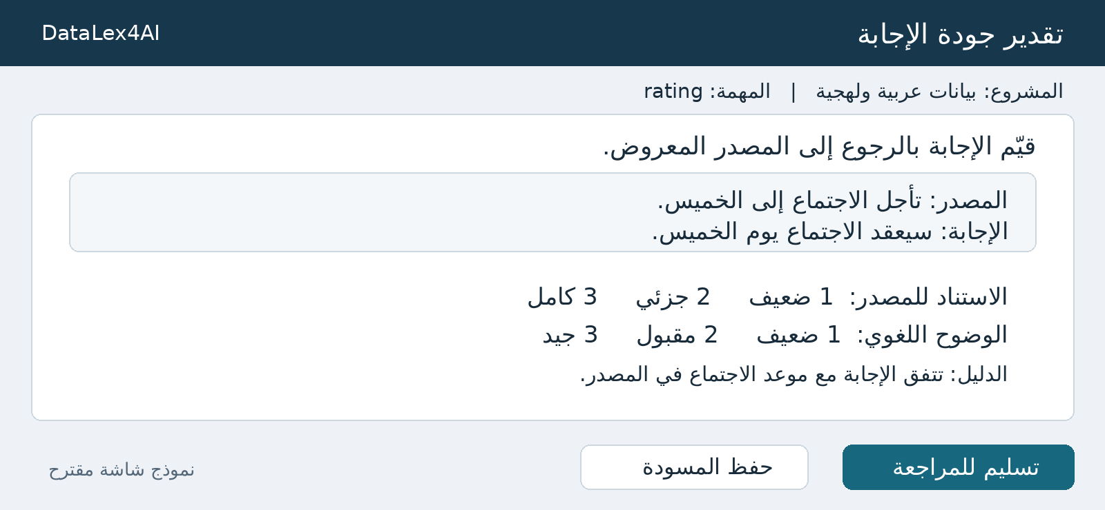
Reference Mockup: Figure 7 - Tool 8: Rubric-Based Criteria Rating UI Mockup
Enables multi-dimensional scoring of LLM responses against structured rubric axes:
• Contributor Interface: Source box ('تأجل الاجتماع إلى الخميس.') vs. Response box ('سيعقد الاجتماع يوم الخميس.'), multi-criteria Likert scales (Source Grounding: 1 Weak, 2 Partial, 3 Complete; Linguistic Clarity: 1 Weak, 2 Acceptable, 3 Good), mandatory Evidence field ('تتفق الإجابة مع موعد الاجتماع في المصدر.').
• Engineering Mandate: Support 'Unable to Judge' without zero-penalty distortion. Low ratings require mandatory textual justifications.

Figure 8: Tool 9: Comparison & Ranking (RLHF) UI Mockup
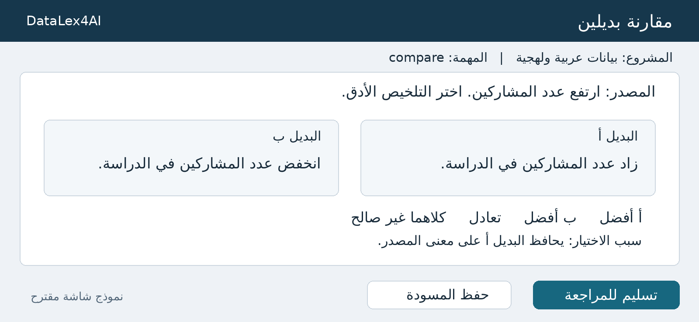
Reference Mockup: Figure 8 - Tool 9: Comparison & Ranking (RLHF) UI Mockup
Gathers preference data for RLHF reward modeling:
• Contributor Interface: Source prompt ('ارتفع عدد المشاركين. اختر التلخيص الأدق.'), side-by-side Candidate A vs. Candidate B cards, decision buttons (A is better [selected], B is better, Tie, Both invalid), and Rationale textbox.
• Engineering Mandate: Automated randomization of visual placement (A/B) to eliminate position bias. The contributor's judgment binds to immutable model IDs, not visual screen coordinates.

Figure 9: Tool 10: Span Annotation (NER) UI Mockup
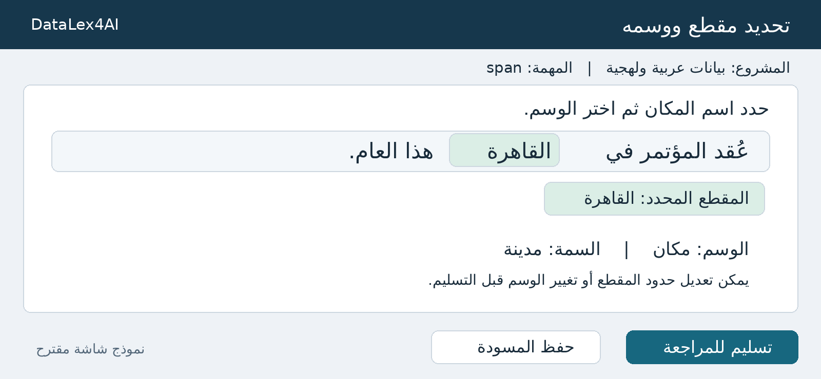
Reference Mockup: Figure 9 - Tool 10: Span Annotation (NER) UI Mockup
High-precision token and phrase labeling for Named Entity Recognition and PII extraction:
• Contributor Interface: In-text token highlighter container ('عُقد المؤتمر في [القاهرة] هذا العام.'), selected span badge ('المقطع المحدد: القاهرة'), Tag dropdown ('مكان'), Attribute ('مدينة'), and boundary adjusters.
• Engineering Mandate: Character offsets (start_offset, end_offset) must remain immune to offset drift caused by Arabic diacritics, tatweel, or directional formatting.

Figure 10: Tool 11: Text Unit & Morphological Segmentation UI Mockup
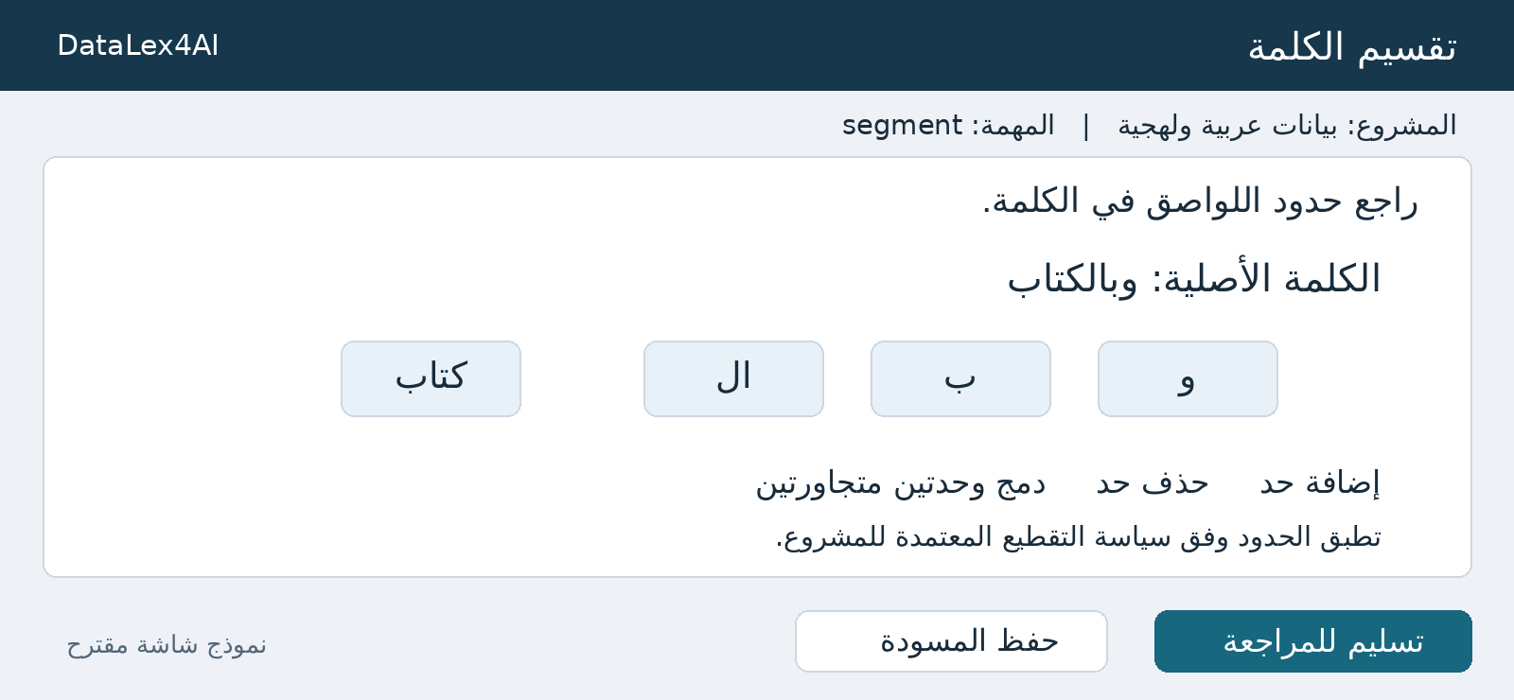
Reference Mockup: Figure 10 - Tool 11: Text Unit & Morphological Segmentation UI Mockup
Supports clitic detachment, sub-word tokenization, and morphological decomposition:
• Contributor Interface: Original word display ('الكلمة الأصلية: وبالكتاب'), segmented token chips (['و'] ['بـ'] ['الـ'] ['كتاب']), action buttons (إضافة حد, حذف حد, دمج وحدتين متجاورتين).
• Engineering Mandate: Supports complex Arabic clitic detachment while keeping the original string intact and fully recoverable.

Figure 11: Tool 12: Audio Sample Recording & Upload UI Mockup
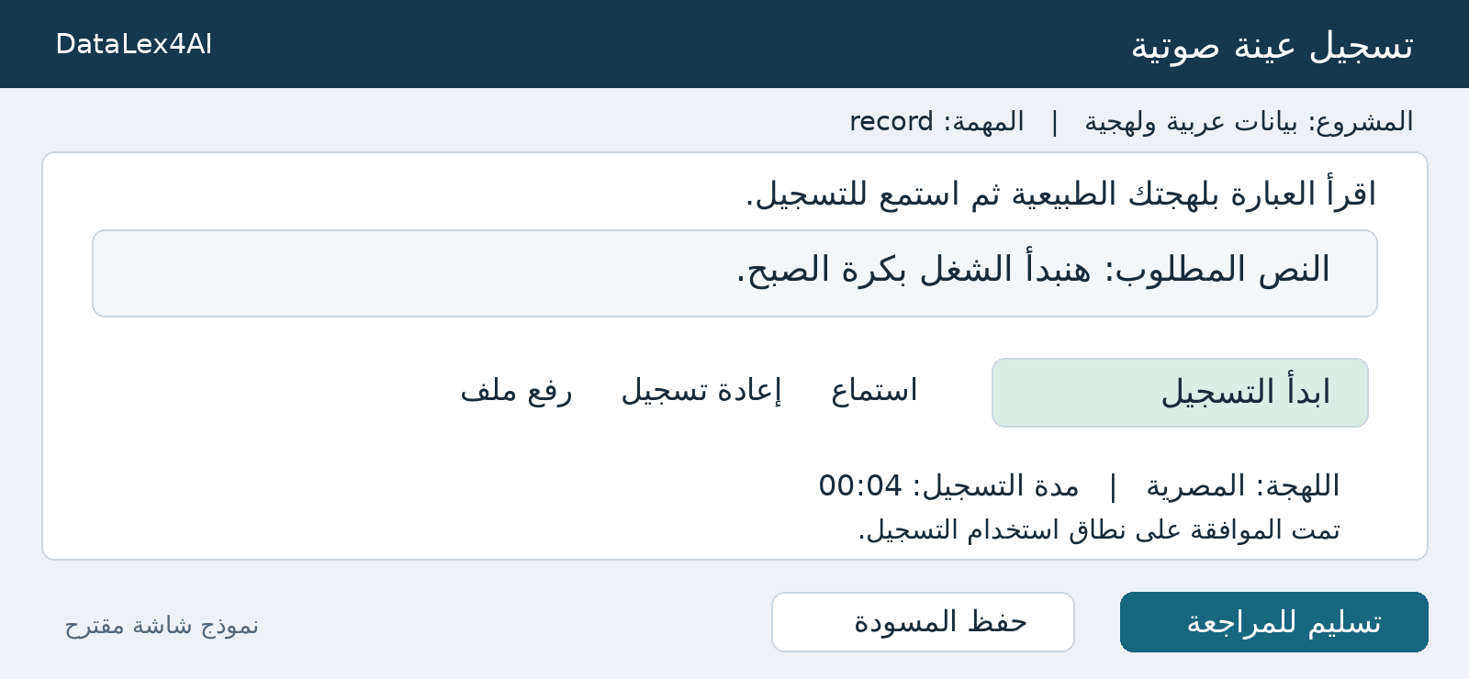
Reference Mockup: Figure 11 - Tool 12: Audio Sample Recording & Upload UI Mockup
In-browser voice data collection for prompted speech corpora:
• Contributor Interface: Script display ('النص المطلوب: هنبدأ الشغل بكرة الصبح.'), action buttons ([ابدأ التسجيل], [استماع], [إعادة تسجيل], [رفع ملف]), Dialect badge ('المصرية'), Duration counter ('00:04'), and explicit Consent confirmation.
• Engineering Mandate: Automated client-side audio checks (silence detection, clipping/saturation, minimum duration). Secure upload and contributor identity de-identification.

Figure 12: Tool 13: Temporal Audio Segmentation & Diarization UI Mockup
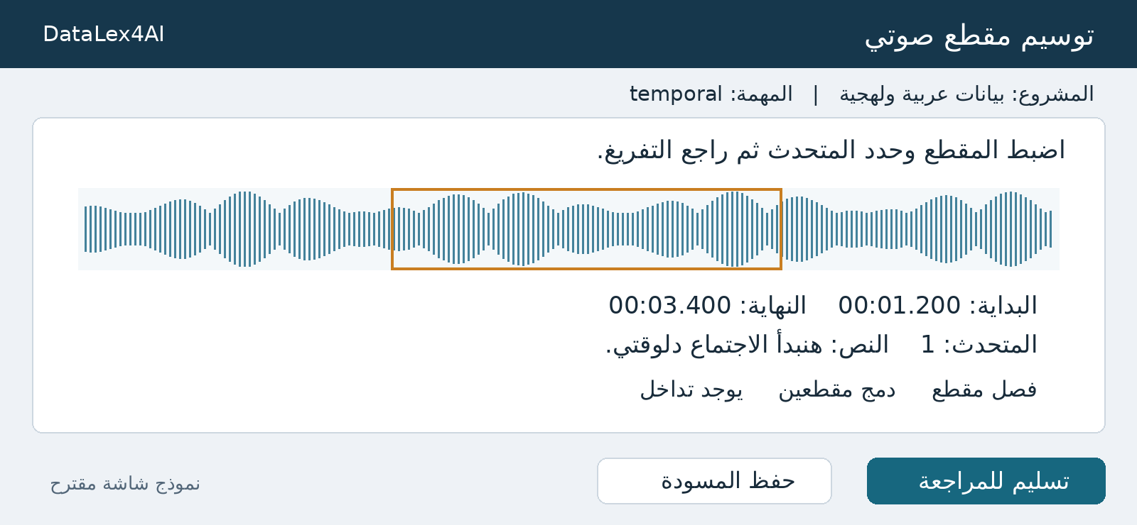
Reference Mockup: Figure 12 - Tool 13: Temporal Audio Segmentation & Diarization UI Mockup
Interactive audio waveform segmentation and conversational diarization:
• Contributor Interface: Audio waveform canvas with draggable time bounding box, start/end timestamps ('00:01.200 - 00:03.400'), Speaker ID selector ('1'), transcript editor ('هنبدأ الاجتماع دلوقتي'), and Overlap toggle ('يوجد تداخل').
• Engineering Mandate: Millisecond-level boundary precision, multi-speaker turn overlapping support, and synced audio playback loop.

Figure 13: Tool 14: Claim-to-Evidence Linking & Alignment UI Mockup
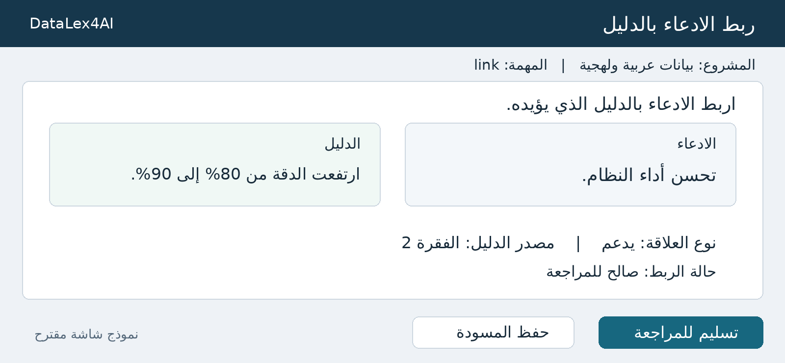
Reference Mockup: Figure 13 - Tool 14: Claim-to-Evidence Linking & Alignment UI Mockup
Relational mapping between text units, claims, and supporting evidence:
• Contributor Interface: Side-by-side cards: Claim ('تحسن أداء النظام.') vs. Evidence ('ارتفعت الدقة من 80% إلى 90%.'), Relationship type dropdown ('يدعم'), Source paragraph reference ('الفقرة 2'), and validation status ('صالح للمراجعة').
• Engineering Mandate: Persists source/target entity IDs with relationship type; supports multi-to-one claim mapping.

2. Comprehensive Gap Analysis (DataLex4AI v1.4 vs Codebase)
The crowdsourcing repository (Django backend on branch 'feature/task_assignment' and Streamlit frontend) was rigorously compared against the DataLex4AI standard. The table below details the current implementation status across all architectural and tool domains.
Domain / Feature Area | DataLex4AI v1.4 Standard | Current Codebase State | Status | Action Required
Project Management | Organization -> Project -> Batch -> Plan hierarchy. | Fully implemented in apps/project_management. | Ready | Maintain and add dialect fields.
Planning & Estimation | Batch cost, man-days, team sizing, rate freezing. | Fully implemented in apps/planning. | Ready | Integrate calibration unit cost metrics.
Worker Qualification | Exam question banks, BaseExam, grading workflows. | Implemented in apps/qualification_test. | Ready | Add dialect accreditation tags.
Arabic Dialect Policy | Dialect metadata, orthography rules, tashkeel retention. | Missing. Text stored as generic unconstrained strings. | Missing | Add dialect fields & serializer validation.
Calibration Batch | Mandatory small trial batch (5-10%) to test IAA. | Missing. Batches launch directly to mass production. | Missing | Add CALIBRATION status & sign-off gating.
Hidden Golden Tasks | Injecting blind benchmarks to track worker accuracy. | Missing. Only initial entrance exam exists. | Missing | Implement real-time benchmark injection.
Risk-Based Review | Random 10% sampling + risk escalation (speed/variance). | Partial. Basic image IAA counter; no risk routing. | Partial | Add duration tracking & self-review block.
AI vs Human Schema | Separate DB fields for AI suggestion, raw edit, final. | Missing. Only final result stored without provenance. | Missing | Add 4-way JSON schema separation.
Tool 5: Choice/Attrs | Single/multi categorical choice & dialect selection. | Fully implemented as TextLabellingTask. | Ready | Add optional rationale textbox.
Tool 6: Text Editing | Authoring, summarization, automated diff tracking. | Summarization/validation exist; no diff engine. | Partial | Implement character/word diff service.
Tool 8: Rubric Rating | Multi-criteria Likert scoring with evidence capture. | Missing from backend models and frontend. | Missing | Create TextRubricRatingTask and views.
Tool 9: RLHF Ranking | Blinded pairwise comparison, randomized positioning. | Missing from backend models and frontend. | Missing | Create TextComparisonTask and views.
Tool 10: Span NER | Character offset span labeling, nested attributes. | Missing. Only Image Bounding Box/Polygon exist. | Missing | Create TextSpanAnnotationTask and UI.
Tool 11: Segmentation | Sub-word morphological tokenization and boundary edit. | Basic sentence splitting exists; no sub-word tool. | Partial | Add token boundary edit controls.
Tool 12: Audio Record | In-browser WebRTC recording, noise checks, consent. | Missing from backend models and frontend. | Missing | Create AudioCollectionTask & WebRTC UI.
Tool 13: Audio Temporal | Waveform segmentation, diarization, transcription. | Missing. transcription.py & diarization.py are 0-byte stubs. | Missing | Implement models & waveform editor UI.
Tool 14: Linking/Align | Relational mapping between units, claim-evidence. | Not implemented (specified as advanced post-MVP). | Missing | Deferred to Post-MVP.

3. Product & Engineering Backlog
To transition the current platform into market-readiness matching DataLex4AI v1.4, the missing capabilities have been organized into 7 Epics with detailed User Stories, Acceptance Criteria, impacted architectural modules, and implementation priorities (P0, P1, P2).

Epic 1: Arabic Language & Dialect Governance (P0)

STORY-1.1: Batch Dialect & Orthography Configuration
User Story: As a PM, I want to configure the dialect and orthography policy for each batch, so contributors adhere to standard linguistic rules without backend diacritic stripping.
Acceptance Criteria:
1. Add language_variant, dialect_code, and orthography_policy to Batch model.
2. Serializers must not strip tashkeel or tatweel unless explicitly configured.
3. Export pipelines retain exact UTF-8 dialectal encoding.
Impacted Modules: apps/project_management, serializers.py | Priority: P0 | Estimation: FE: 3d | BE: 4d | Total: 7d

STORY-1.2: Dialect-Gated Task Assignment Engine
User Story: As an Operations Lead, I want tasks to be assigned only to workers accredited in the required dialect, ensuring native linguistic accuracy.
Acceptance Criteria:
1. Record accredited dialects and exam scores in WorkerProfile.
2. TaskAssignmentService filters available tasks by worker's accredited dialects.
3. Prevent unaccredited workers from pulling dialectal tasks.
Impacted Modules: apps/profile, apps/project_management/services/assignment.py | Priority: P0 | Estimation: FE: 2d | BE: 4d | Total: 6d

Epic 2: Quality Control, Calibration & Verification (P0)

STORY-2.1: Calibration Batch Workflow & Gating
User Story: As a QA Lead, I want to execute a small calibration batch (5-10%) with multi-annotator overlap, verifying agreement before opening mass production.
Acceptance Criteria:
1. Introduce CALIBRATION status to BatchStatusEnum.
2. Route calibration items to N>=3 workers independently.
3. Compute IAA metrics and render calibration dashboard.
4. Sign-off action freezes guidelines and unlocks production.
Impacted Modules: apps/project_management, apps/IAA | Priority: P0 | Estimation: FE: 4d | BE: 6d | Total: 10d

STORY-2.2: Hidden Golden Benchmarks Injection
User Story: As a QA Manager, I want to inject blind benchmark tasks into active queues, continuously tracking worker accuracy in real time.
Acceptance Criteria:
1. Add is_benchmark and ground_truth_payload fields to task models.
2. Contributor API strips benchmark flags so tasks appear identical to normal items.
3. Real-time grading updates rolling_accuracy_score upon submission.
4. Automatic worker suspension if rolling accuracy drops below threshold.
Impacted Modules: apps/quality_control, apps/text_annotation, apps/audio_annotation | Priority: P0 | Estimation: FE: 3d | BE: 5d | Total: 8d

STORY-2.3: Risk-Based Sampling & Review Escalation
User Story: As a Quality Auditor, I want random sampling combined with risk escalation for rapid completions and high-variance items, preventing self-review.
Acceptance Criteria:
1. Track duration_seconds per task and flag speed anomalies.
2. Enforce self-review blocking (reviewer_id != annotator_id).
3. Route split decisions to Adjudicator queue with dispute resolution log.
Impacted Modules: apps/IAA, apps/project_management/views/review.py | Priority: P0 | Estimation: FE: 4d | BE: 5d | Total: 9d

Epic 3: AI-Assisted Architecture & Provenance (P0)

STORY-3.1: Four-Way Provenance Schema Separation
User Story: As an ML Engineer, I want separate fields for AI suggestion, model version, raw human answer, and final accepted result, preserving uncorrupted training data.
Acceptance Criteria:
1. Add ai_suggestion (JSON), model_version (Char), human_raw_answer (JSON), and final_accepted_result (JSON) to all task models.
2. Feature flag to suppress AI suggestions for control group A/B benchmarking.
3. Export service outputs all 4 fields cleanly.
Impacted Modules: All annotation models, serializers, export services | Priority: P0 | Estimation: FE: 2d | BE: 4d | Total: 6d

Epic 4: Core NLP & Text Annotation Tools (P1)

STORY-4.1: Rubric-Based Criteria Rating (Tool 8)
User Story: As an Evaluator, I want to score model outputs across multiple rubric dimensions with rationale and 'unable to judge' option, so model safety and alignment are graded.
Acceptance Criteria:
1. Create TextRubricRatingTask and Result models.
2. Dynamic rubric configuration (Likert 1-5 with text labels per level).
3. Mandatory rationale/evidence for low ratings.
4. Support 'Unable to Judge' without zero-penalty corruption.
Impacted Modules: apps/text_annotation/models/rubric.py, Frontend Rating UI | Priority: P1 | Estimation: FE: 5d | BE: 4d | Total: 9d

STORY-4.2: RLHF Pairwise Comparison & Ranking (Tool 9)
User Story: As an RLHF Annotator, I want side-by-side blinded comparison with randomized positioning, so I can rank outputs without position bias.
Acceptance Criteria:
1. Create TextComparisonTask and Result models.
2. Randomize visual placement of Alternative A vs B.
3. Support choices: A is better, B is better, Tie, Both invalid.
4. Map contributor decision to immutable candidate IDs.
Impacted Modules: apps/text_annotation/models/comparison.py, Frontend Comparison UI | Priority: P1 | Estimation: FE: 4d | BE: 4d | Total: 8d

STORY-4.3: Span Annotation / NER Tool (Tool 10)
User Story: As an NLP Annotator, I want to highlight text segments and assign entity labels without character offset drift, so NER datasets are accurately generated.
Acceptance Criteria:
1. Create TextSpanAnnotationTask and Result models.
2. Store spans as [start_offset, end_offset, text_snippet, label, attributes].
3. Offset integrity preserved with Arabic diacritics and tatweel.
4. Frontend interactive text token selection widget.
Impacted Modules: apps/text_annotation/models/span.py, Frontend Span Highlighting UI | Priority: P1 | Estimation: FE: 8d | BE: 5d | Total: 13d

STORY-4.4: Text Post-Editing & Automated Diff Tracking (Tool 6)
User Story: As a Linguistic Editor, I want character and word-level diff tracking when post-editing AI drafts, so edit effort and error categories are quantified.
Acceptance Criteria:
1. Backend diff service computing insertions, deletions, substitutions.
2. Store original text, edited text, and structured diff JSON.
3. Classify edit types (Grammar, Spelling, Dialectal Adaptation, Style).
Impacted Modules: apps/text_annotation/services/diff_engine.py, Frontend Editor UI | Priority: P1 | Estimation: FE: 5d | BE: 4d | Total: 9d

Epic 5: Speech & Audio Collection & Annotation (P1)

STORY-5.1: Temporal Audio Segmentation & Diarization (Tool 13)
User Story: As an Audio Annotator, I want an interactive waveform editor to tag speaker turns and time-aligned transcripts, producing rich speech corpora.
Acceptance Criteria:
1. Implement AudioTranscriptionTask and AudioDiarizationTask models.
2. Store segments: start_time_ms, end_time_ms, speaker_id, transcript, overlap.
3. Frontend interactive waveform with zoom, draggable boundaries, and audio playback loop.
Impacted Modules: apps/audio_annotation/models/transcription.py, diarization.py, Waveform UI | Priority: P1 | Estimation: FE: 10d | BE: 6d | Total: 16d

STORY-5.2: In-Browser Audio Recording & Upload (Tool 12)
User Story: As a Voice Contributor, I want to record voice samples from prompt scripts directly in browser, with instant playback and quality checks.
Acceptance Criteria:
1. WebRTC browser audio recorder exporting WAV/MP3.
2. Technical validation: silence check, clipping/saturation check, minimum duration.
3. Contributor demographic metadata and explicit consent logging.
Impacted Modules: apps/audio_annotation/models/collection.py, Frontend Audio Recorder UI | Priority: P1 | Estimation: FE: 6d | BE: 4d | Total: 10d

Epic 6: Production Acceptance & Quality Reporting (P2)

STORY-6.1: Template Technical & Linguistic Acceptance Checklist
User Story: As an Operations Lead, I want a formal template sign-off checklist before launching batches, ensuring guidelines and inputs are verified.
Acceptance Criteria:
1. Model TemplateAcceptanceSignoff with checks for Arabic rendering, edge case examples, and guideline versioning.
2. Prevent batch activation until signoff is recorded by authorized lead.
Impacted Modules: apps/project_management/models/template.py | Priority: P1 | Estimation: FE: 3d | BE: 3d | Total: 6d

STORY-6.2: Batch Delivery Sign-off & Three-Tier Quality Report
User Story: As a Delivery Manager, I want a comprehensive QC report covering Contributor, Answer, and Quota metrics, validating dataset completeness for export.
Acceptance Criteria:
1. Aggregate Layer 1 (Contributor), Layer 2 (Answer), and Layer 3 (Quota/Diversity) metrics.
2. Separate random audit error rate from risk-escalated error rate.
3. Generate downloadable QA Audit Report and export validated JSONL archive.
Impacted Modules: apps/dashboard, apps/project_management/services/export_service.py | Priority: P2 | Estimation: FE: 5d | BE: 5d | Total: 10d

4. Implementation Phasing & Frontend Estimation Guide
To support engineering capacity planning and frontend-backend time assessment, the work packages are divided into four chronological phases, prioritizing core quality governance before expanding specialized tool suites.
Phase | Sprint | Focus Area | Key Deliverables | Dependencies | Duration
Phase 1: Foundation (P0) | Sprint 1 | Linguistic & AI Schema | Dialect metadata, UTF-8 retention, 4-way AI DB schema. | Core backend models | 2 Weeks
Phase 1: Foundation (P0) | Sprint 2 | Calibration & Golden Tasks | Calibration workflow, IAA calculator, benchmark injector. | Sprint 1 models | 2.5 Weeks
Phase 2: NLP Suite (P1) | Sprint 3 | Rubric & RLHF Tooling | Rubric rating UI (Tool 8), RLHF pairwise ranking (Tool 9). | Sprint 1 schema | 2 Weeks
Phase 2: NLP Suite (P1) | Sprint 4 | NER & Diff Tracking | Interactive Span highlighter (Tool 10), Diff engine (Tool 6). | Sprint 1 UTF-8 | 2.5 Weeks
Phase 3: Speech Suite (P1) | Sprint 5 | Voice Collection | Browser WebRTC audio recorder (Tool 12), silence/clipping check. | Dialect tagging | 2 Weeks
Phase 3: Speech Suite (P1) | Sprint 6 | Temporal Diarization | Interactive waveform canvas, diarization editor (Tool 13). | Audio storage infra | 3 Weeks
Phase 4: Gatekeeping (P2) | Sprint 7 | 3-Tier Reporting | Template checklist, 3-tier QC analytics, export packaging. | Sprints 2, 3, 4 | 2.5 Weeks

Frontend Time Assessment Complexity Summary
For the upcoming frontend estimation session, interface components are categorized by implementation complexity:
• Low Complexity (3 to 5 Days): Choice & Attribute Assignment (Figure 5), Rubric Rating (Figure 7), RLHF Comparison (Figure 8).
• Medium Complexity (6 to 8 Days): Text Authoring with Diff Highlighting (Figure 6), In-Browser Audio Recorder (Figure 11), Quality Policy Matrix (Figure 2).
• High Complexity (10 to 14 Days): Interactive Span / NER Highlighting (Figure 9), Audio Waveform Diarization & Segmentation Canvas (Figure 12).

