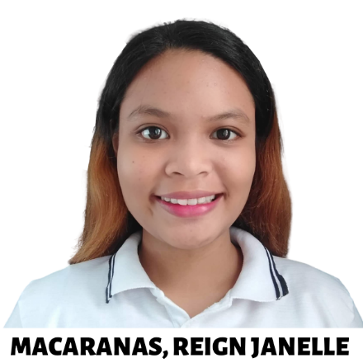
Reign Janelle Macaranas
Phone: 0916 597 0912
Email: macaranasjanelle1@gmail.com
Address: 32B Brgy. Butao, Malasiqui, Pangasinan
SUMMARY
Dedicated and driven Computer Science student with a passion for problem-solving, continuous learning, and collaboration. Proficient in mathematics, Microsoft Office, and research, with foundational knowledge in programming and web development. Highly adaptable, analytical, and proactive in delivering results.EDUCATION
Bachelor of Science in Computer Science
Virgen Milagrosa University Foundation | 2022 - Present
Senior High School – STEM Strand
Perpetual Help College of Pangasinan | 2019 - 2021
Junior High School – Business High School
Perpetual Help College of Pangasinan | 2016 - 2019
Junior High School (Grade 7)
Baesa Adventist Academy | 2015 - 2016
Elementary School
Lucas R. Pascual Memorial Elementary School | 2009 - 2015SKILLS
- Programming Languages – Python, C  - Web Development – HTML, CSS  - Research & Data Analysis  - Microsoft Word, Excel, PowerPoint | - Problem-Solving & Critical Thinking  - Leadership & Teamwork  - Fast Learner & Adaptability  - Time Management
ACHIEVEMENT
- Academic Scholar – 2023 - Present  - Valedictorian – STEM Strand – 2021  - Academic Excellence Award – 2021  - Outstanding Performance in Mathematics – 2021  - Research & Innovation Award – 2021  - Math Festival Quiz (Division Level Qualifier) – 2021 | - With High Honors – 2021, 2018  - With Honors – 2020, 2019, 2017  - Metrobank-MTAP-DepEd (Division Level Qualifier) – 2017 - 2019  - Math Festival Relay – 3rd Place (Municipal Level) – 2018  - Gold Medalist Award – 2016
LEADERSHIP AND VOLUNTEER EXPERIENCE
- Assistant Head – Multimedia Team | Malasiqui Baptist Church | 2023 - Present

