EASY ROUND
- How should a loss on sale of machinery be presented in a statement of cash flows using an indirect method?
- A deduction from net income
- An addition to net income
- An inflow and outflow of cash
- An outflow of cash

ANSWER: B. An addition to net income

- The two primary account classifications within shareholders’ equity are
- Preference shares and retained earnings
- Par value of ordinary shares and retained earnings
- Contributed capital and retained earnings
- Preference shares and ordinary shares

ANSWER: C. Contributed capital and retained earnings

- X, a minor, through negligence, inflicted damage upon another child. X’s father was made liable by court to pay civil damages to the other child. The liability of X’s father arises from:
- Quasi-delict
- Quasi-contract
- Contract
- Delict

ANSWER: B. Quasi-contract

- One of the following is not a real contract
- Commodatum
- Pledge
- Sale
- Deposit

ANSWER: C. Sale

- In a process costing system using the weighted average method, cost per equivalent unit for a given cost component is found by dividing which of the following by EUP?
- Only current period cost
- Current period cost plus the cost of beginning inventory
- Current period cost less the cost of beginning inventory
- Current period cost plus the cost of ending inventory

ANSWER: B. Current period cost plus the cost of beginning inventory

- The actual effort exerted by the government to effect the exaction of what is due from the taxpayers is known as
- Collection
- Payment
- Enforced contribution
- Levy

ANSWER: A. Collection

- Accounting for the interest in a noninterest bearing note receivable is an example of what aspect of accounting theory?
- Matching
- Substance over form
- Verifiability
- Form over substance

ANSWER: B. Substance over form

- All of the following are characteristics of property, plant and equipment except:
- The property, plant and equipment are tangible assets
- The property, plant and equipment are used in business
- The property, plant and equipment are expected to be used over a period or more than a year.
- The property, plant and equipment are subject to depreciation.

ANSWER: D. The property, plant and equipment are subject to depreciation.

- Which method of recording bad debt lss is consistent with accrual accounting?
- Allowance method
- Direct writeoff method
- Percent of sales method
- Percent of accounts receivable method

ANSWER: A. Allowance method

- Ann Company incurred the following costs:
Materials 700,000
Storage costs of finished goods 180,000
Delivery to customers 40,000
Irrecoverable purchase taxes 60,000
At what amount should the inventory be measured?
- 880,000
- 760,000
- 700,000
- 940,000

ANSWER: B.
Solution: 700,000 + 60,000 = 760,000

MODERATE ROUND

- The interest method of amortizing premium provides for
- Increasing amortization and increasing interest income
- Increasing amortization and decreasing interest income
- Decreasing amortization and decreasing interest income
- Decreasing amortization and increasing interest income

ANSWER: B. Increasing amortization and decreasing interest income

- Who among the following is a non-resident alien?
- An alien who comes to the Philippines for a definite purpose which in its nature may be promptly accomplished.
- An alien who comes to the Philippines for a definite purpose which in its nature would require an extended stay.
- An alien who has acquired residence in the Philippines.
- An alien who lives in the Philippines with no definite intention as to his stay.

ANSWER: A. An alien who comes to the Philippines for a definite purpose which in its nature may be promptly accomplished.

- At the beginning of current year, Sophia Company had a credit balance of 260,000 in the allowance for uncollectible accounts. Based on past experience, 2% of credit sales would be uncollectible. During the current year, the entity wrote off 325,000 of uncollectible accounts. Credit sales for the year totaled 9,000,000. What amount should be reported as allowance for uncollectible accounts at year-end?
- 115,000
- 180,000
- 245,000
- 65,000

ANSWER: A
Solution: 260,000 + 180,000(9,000,000 x 2%) - 325,000 = 115,000
- Who among the following is a non-resident alien?
- An alien who comes to the Philippines for a definite purpose which in its nature may be promptly accomplished.
- An alien who comes to the Philippines for a definite purpose which in its nature would require an extended stay.
- An alien who has acquired residence in the Philippines.
- An alien who lives in the Philippines with no definite intention as to his stay.

ANSWER: A. An alien who comes to the Philippines for a definite purpose which in its nature may be promptly accomplished.

- Kobe Company purchased an asset with a useful life of 10 years at the beginning of the current year for 6,500,000. At year-end, the amount the entity would receive from the disposal of the asset if it was already of the age and in the condition expected at the end of the useful life was estimated at 700,000. Inclusive of inflation, the actual amount expected to be received on disposal was estimated at 900,000. What amount should be recorded as depreciation for the current year?
- 580,000
- 650,000
- 560,000
- 0

ANSWER: A
Solution: 6,500,000 - 700,000 = 5,800,000
5,800,000/10 = 580,000

- The following costs relate to Rumi Industries for the last quarter:
Conversion cost 435,000
Direct materials 215,600
Factory overhead is applied at 60% of direct labor cost
Selling and administrative expense 185,000
What is Rumi’s prime cost for last quarter?
- 486,000
- 435,000
- 486,475
- 487,475

ANSWER: D.
Solution: 435,000/1.60 = 271,875
271,875 + 215,600 = 487,475

- Based on a physical inventory taken at year-end, Karina Company determined the chocolate inventory on a FIFO basis at 5,200,000 with a replacement cost of 4,000,000. The entity estimated that after further processing costs of 2,400,000, the chocolate could be sold as finished candy bars for 8,000,000. The normal profit margin is 10% of sales. Using the measurement at the lower cost and net realizable value, what amount should be reported as chocolate inventory at year-end?
- 5,600,000
- 4,000,000
- 5,200,000
- 4,800,000

ANSWER: A.
Solution: 8,000,000 - 2,400,000 = 5,600,000
5,600,000 vs. 5,200,000 = 5,200,000

- A, B and C are joint debtors of joint creditors, W, X, Y and Z, in the amount of P300,000. How much can W and X collect from B?
- 75,000
- 150,000
- 100,000
- 50,000

ANSWER: D.
Solution: 300,000/3 = 100,000
300,000/4 = 75,000
75,000/300,000 = 0.25
Creditor W 100,000 x 0.25 = 25,000
Creditor X 100,000 × 0.25 = 25,000
25,000 + 25,000 = 50,000

DIFFICULT ROUND
- Jake, a resident citizen, received the following interest income:
- 80,000 from short-term Peso time deposit
- 16,000 from a five year bonds issued by a commercial bank
- 24,000 from ⅚ lending to market vendor
How much final tax must have been withheld from Jake’s interest income?
- 0
- 16,000
- 20,000
- 24,000

ANSWER: C.
Solution: 80,000/(100% - 20%) = 100,000 - 80,000 = 20,000

- On January 1, 2025, Kathryn Company purchased equity securities to be held at fair value through comprehensive income. On December 31, 2021, the cost and market value were:
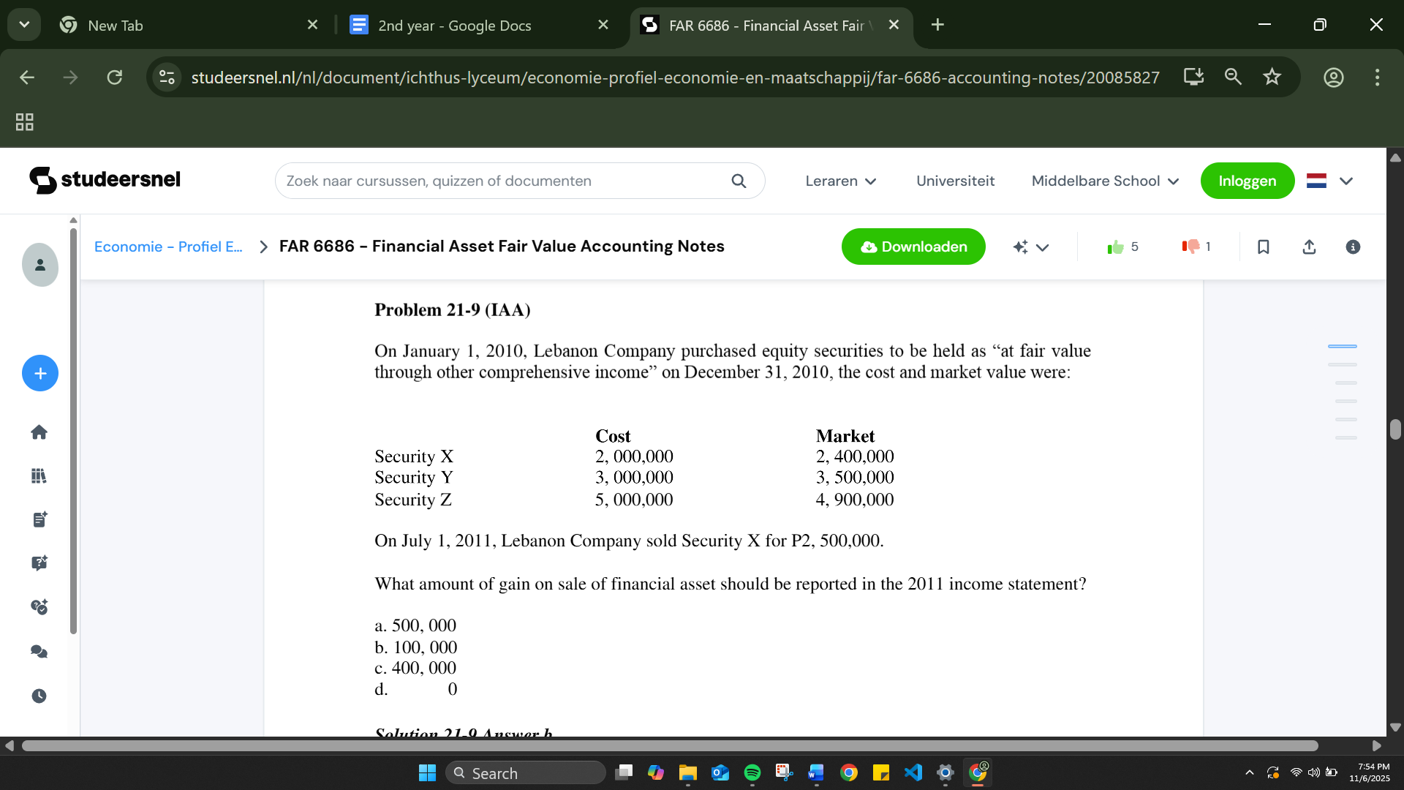
On July 1, 2026, the entity sold Security X for 2,500,000. What amount should be recognized directly in retained earnings as a result of the sale of financial assets in 2026?

- 500,000
- 100,000
- 400,000
- 0

ANSWER: A.
Solution: 2,500,000 - 2,000,000 = 500,000

- Girly Company showed a cash account balance of 4,500,000 at the month-end. The bank statement did not include a deposit of 230,000 made on the last day of the month. The bank statement showed a collection of a note receivable by the bank of 94,000 for the depositor and a customer check for 32,000 returned because it was NSF. A customer check for 45,000 was recorded by the depositor as 54,000 and a check written 79,000 was recorded as 97,000. What amount should be reported as cash in bank?
- 4,765,000
- 4,517,000
- 4,819,000
- 4,801,000

ANSWER: B.
Solution: 4,500,000 + 94,000 - 32,000 - 9,000(45,000 - 54,000) + 18,000(79,000 + 97,000) = 4,517,000

- Gomez earned the following items of income for the calendar year ending 2025:
Interest income, debtor resides in Hong Kong, 420,000
payment made in the Philippines.
Interest income, debtor resides in the Philippines, 330,000
payment made in China.
Gain from sale of real property, real property situated in America. 440,000
Gain from sale of personal property, sale made in UK, 290,000
property is in the Philippines.
Gain from sale of shares of stock of a domestic corporation, 225,000
residence of buyer is Taiwan, sale made in Argentina
If Gomez is a non-resident citizen, how much of his income is subject to Philippine income tax?
- 330,000
- 555,000
- 845,000
- 1,705,000

ANSWER: B.
Solution: 330,000 + 225,000 = 555,000

- On January 1, 2025, Megan Company purchased 9% bonds with a face amount of 4,000,000 for 3,756,000 to yield 10%. The bonds are dated January 1, 2025, mature on December 31, 2035 and pay interest annually on December 31. The interest method of amortizing bond discount is used. What amount should be reported as interest revenue for 2026?
- 400,000
- 375,000
- 360,000
- 377,160
ANSWER: D.
Solution: 375,600(10% x 3,756,000) - 360,000(9% x 4,000,000) = 15,600
3,756,000 - 15,600 = 3,771,600 x 10% = 377,160

