

KoBi – Komuniti Bijak
A smarter way to care for our neighbourhood
Team Name : Alchemist: Project KoBi
Team Members : Laila Karmila
Putri Qhailisa
Nazreen Sofea
Muaz
Hafiz
Institution : Universiti Tenaga Nasional (UNITEN)
Submission Date : 23 October 2026

2. Executive Summary
Identifying the right place
KoBi – Komuniti Bijak is a neighbourhood application with an interactive 2D map that helps residents report facility issues, track repair progress and discover community and recycling process. The app connects residents with Sime Darby Property (SDP) to ensure that facilities are well maintained and that community engagement is made easier.
Our target users are residents living in the township and SDP staff responsible for facility management and community programmes. KoBi addresses three key problems: difficulty in identifying the exact facility to report, lack of clear updates on repair progress and challenges in finding community and recycling activities. By providing a simple, visual and centralized platform, KoBi makes neighbourhood care more transparent, convenient and engaging for everyone.

3. Problem Statement

Identifying the right place
Residents may find it difficult to explain exactly which facility is faulty, especially when several look alike. On the map, they select the specific object before submitting a report.
Objective :
Make reporting easier with a clear facility location, a short description and an optional photo.
Research on citizen participation applications identifies reporting problems with urban infrastructure maintenance as a common use of these tools (Bastos et al., 2022).

Knowing what happens next
After submitting a report, residents want to know whether it has been received, is being addressed or has been resolved. SDP staff also need organized information to act on.
Objective :
Keep progress updates, staff notes and evidence of completed repairs in one place.

Missing local activities
Community and recycling announcements may be scattered across different channels. Residents need an easy way to find out what is happening, where it takes place and how to join.
Objective :
Bring announcements and the option to join or cancel participation into the same app.
Dursun et al. (2024) explain that recycling apps can address knowledge barriers by helping users recognise recyclable materials and understand appropriate recycling methods. This supports KoBi’s provision of accepted-material and collection information.

4. Proposed Solution and Key Features

Key Features
KoBi provides and easy-to-use platform with the following key features:
Feature | Description
Interactive 2D map | Explore the neighbourhood and locate facilities such as streetlights, parks and community halls.
Facility issue reporting | Report issues with a description, optional photo and exact location.
Repair status tracking | View status : Received In progress Resolved, with staff notes and photos.
Pixel worker animation | A visual worker appears near the facility during repairs to make the process clear and friendly.
Community activities | Browse announcements and view details (date, time, location, instructions).
Recycling events | Get information on accepted materials, collection points and event timing.
Join / cancel participation | Register or withdraw from activities directly in the app.

5. User Workflow and System Design

Resident Workflow
- Open the neighbourhood map and tap a facility (e.g: streetlight)
- Submit a report with description and optional photo.
- View the report in the resident’s own list.
- Track the status as SDP updates the progress.
- Discover and join community or recycling activities.

5.2 SDP Staff Workflow
- View new reports in the staff dashboard.
- Update the status: Received In progress Resolved.
- Add staff notes and photos as evidence.
- The update is visible to the resident on the map in their list.

6. Technical Implementation

Technologies Used
The project uses the following technologies:
Component | Technology
1.
2.
3.
4.
5.

7. Expected Impact and Evaluation

7.1 Expected Benefits
Stakeholder | Benefits
Residents | Easier reporting, clearer progress updates and simpler activity discovery.
SDP | More organized reports and efficient facility management.
Community | Stronger engagement and a cleaner, safer neighbourhood.
Environment | More recycling participation and reduced waste.

7.2 Evaluation Metrics (proposed)
Time taken to submit a report
Completeness of submitted reports
Time taken to handle issues
Number of activity registrations

8. References
Bastos, D., Fernández-Caballero, A., Pereira, A., & Rocha, N. P. (2022). Smart city applications to promote citizen participation in city management and governance: A systematic review. Informatics, 9(4), Article 89. https://doi.org/10.3390/informatics9040089
Dursun, İ., Tümer, E., & Yürüyen Kılıç, H. (2024). Roles of mobile applications in removing barriers to individual recycling: Case of Türkiye. Environmental Research and Technology, 7(1), 97–107. https://doi.org/10.35208/ert.1317616

Appendix A — Citation evidence
Bastos et al. (2022), article page 1 (PDF page 2). The highlighted abstract passage supports the infrastructure-reporting statement in Section 3.
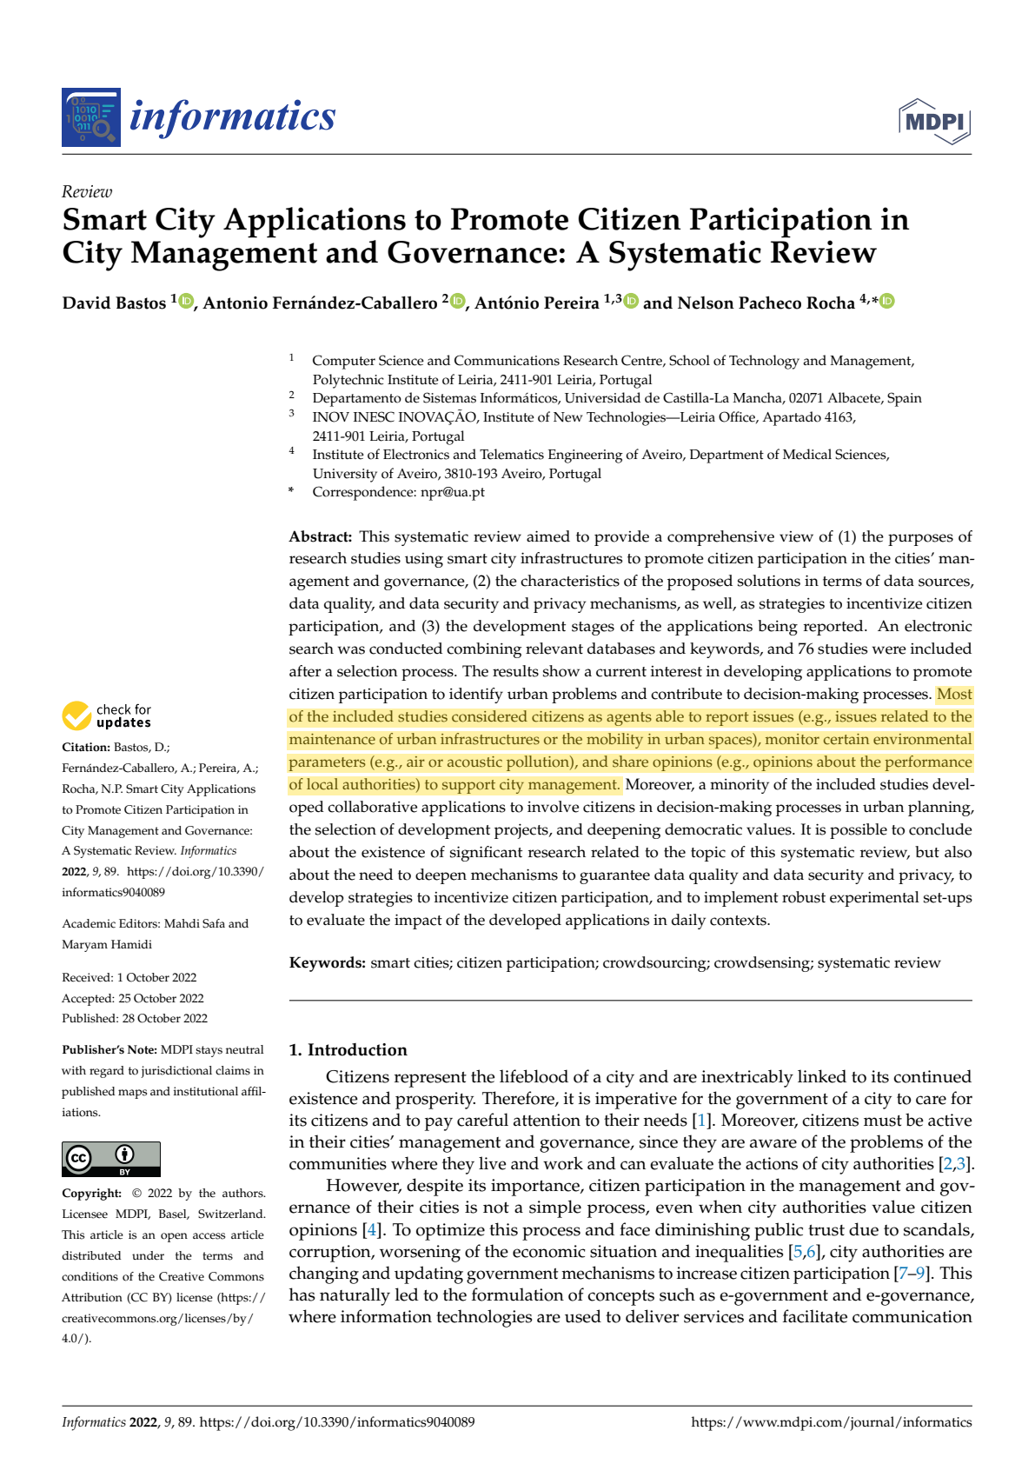

Appendix B — Citation evidence
Dursun et al. (2024), article page 102 (PDF page 6). The highlighted passage supports the recycling-information statement in Section 3.
