

分页查询学习乐园信息

shanguoyinyi/event/onlineStudy/mobile/findAllForMobile.do

参数

page(page:start,limit)、conditionStr(conditionStr:{“title”:标题,”studyType”:一级分类ID,”studyChildType”:二级分类ID,”createTime”:1 or 0,”readNum”:1 or 0}) 1降序 0升序

参数模式

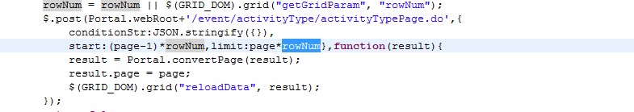

返回结果集

{

"totalPages": 1,

"totalRecords": 2,

"resultList": [

{

"id": "234389858471858176",

"title": "123123123",

"studyType": "233943622294749184",

"studyTypeName": "1-1",

"studyChildType": "233943661001003008",

"studyChildTypeName": "1-1-2",

"type": "2",

"readNum": "0",

"author": "213213123",

"videoUrl": "3123123",

"covePic": "234662506945761280",

"covePicUrl": "http://7xk1l7.dl1.z0.glb.clouddn.com/14606894255257e10a0b.jpg-img",

"createTime": "2016-04-14 17:00:23",

"createBy": "1",

"updateTime": "2016-04-15 11:03:47",

"updateBy": "1",

"content": "<p>123123123213<img src=\"http://7xk1l7.dl1.z0.glb.clouddn.com/@/ueditor/jsp/upload/image/20160415/1460689258139050229.png\" title=\"1460689258139050229.png\" alt=\"QQ截图20160324113709.png\"/></p>"

},

{

"id": "234662728770457600",

"title": "123213213",

"studyType": "233943622294749184",

"studyTypeName": "1-1",

"studyChildType": "233943661001003008",

"studyChildTypeName": "1-1-2",

"type": "1",

"readNum": "0",

"author": "213123",

"videoUrl": "",

"covePic": "",

"covePicUrl": null,

"createTime": "2016-04-15 11:04:40",

"createBy": "1",

"updateTime": null,

"updateBy": null,

"content": "<p>12312321</p>"

}

],

"conditons": {}

}

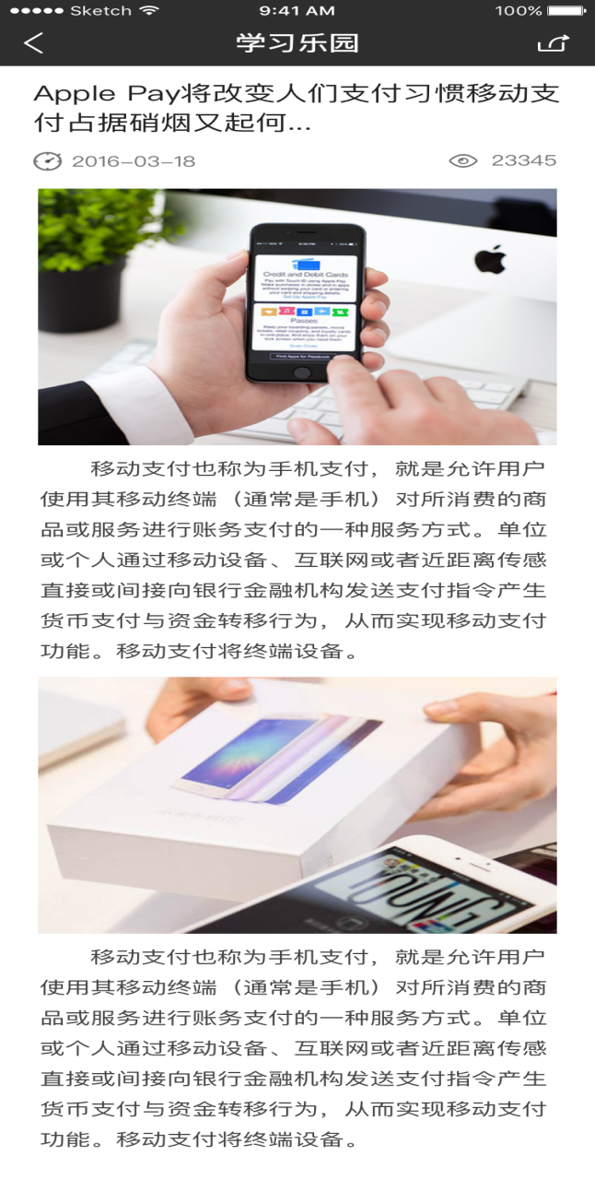

学习乐园详情

shanguoyinyi/event/onlineStudy/mobile/findOneById.do

参数

Id=xxxxx

结果：

{

"msg": {

"id": "234389858471858176",

"title": "123123123",

"studyType": "233943622294749184",

"studyTypeName": "1-1",

"studyChildType": "233943661001003008",

"studyChildTypeName": "1-1-2",

"type": 2,

"readNum": 0,

"author": "213213123",

"videoUrl": "3123123",

"covePic": "234662506945761280",

"covePicUrl": "http://7xk1l7.dl1.z0.glb.clouddn.com/14606894255257e10a0b.jpg-img",

"createTime": "2016-04-14 17:00:23",

"createBy": 1,

"updateTime": "2016-04-15 11:03:47",

"updateBy": 1,

"content": "<p>123123123213<img src=\"http://7xk1l7.dl1.z0.glb.clouddn.com/@/ueditor/jsp/upload/image/20160415/1460689258139050229.png\" title=\"1460689258139050229.png\" alt=\"QQ截图20160324113709.png\"/></p>"

},

"success": true

}