1. 缺失切图：我的订单－空页面提示.png

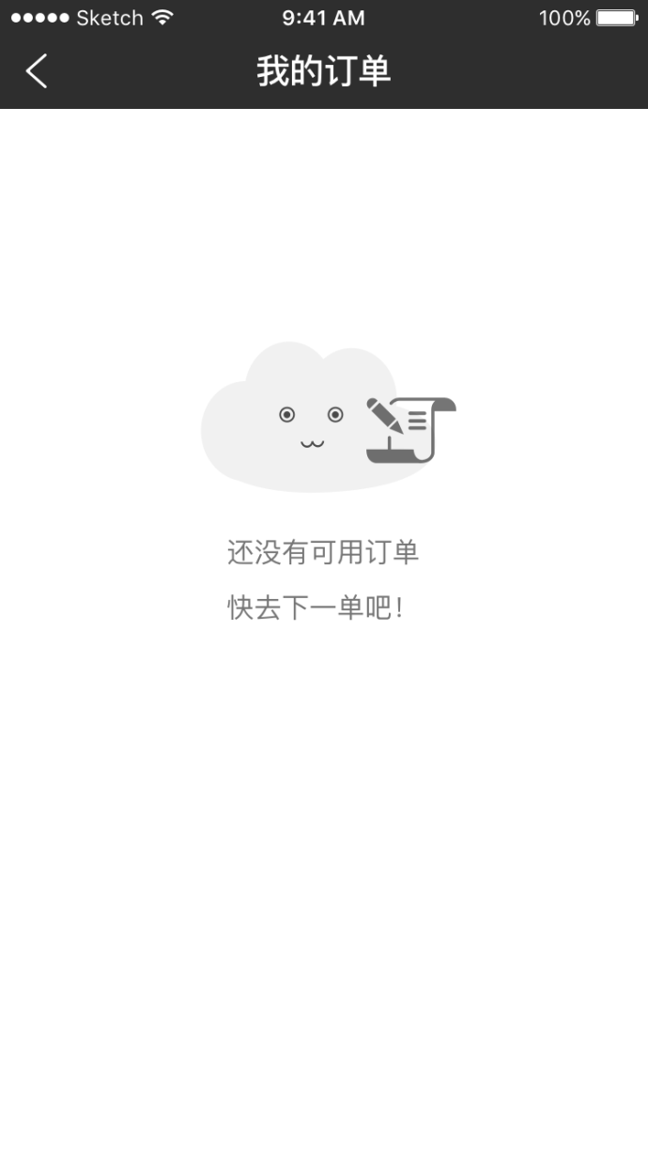

2.查询订单详情，没有退货说明

|  |  |
| --- | --- |
| **接口名称** | 查询订单详情 |
| **接口描述** | 查询订单详情 |
| **接口路径** | /deal/indent/mobile/getOrderDetail.do |
| **方法名称** | getOrderDetail |
| **输入输出参数数据类型定义** | |
| **输入参数**  **（json格式）** | |  |  |  |  |  | | --- | --- | --- | --- | --- | | **参数代码** | **参数名称** | **数据类型** | **非空** | **参数说明** | | id | 主键 | string | Y |  | |
| **返回参数**  **（json格式）** | |  |  |  |  |  | | --- | --- | --- | --- | --- | | **参数代码** | **参数名称** | **数据类型** | **非空** | **参数说明** | | name | 订单号 |  |  |  | | status | 订单状态 |  |  | 待付款-1,待发货（已付款）-2,退款申请-3,待收货-5,退货申请-6,  退货中-7,已退款-8,已退货-9,已收货-10,已取消-11 | | receiver | 收货人 |  |  |  | | receiverPhone | 手机号码 |  |  |  | | fullAddress | 收货地址 |  |  |  | | createTime | 下单时间 |  |  |  | | totalAmount | 商品总额 |  |  |  | | payType | 支付方式 |  |  | 1:微信支付,2:支付宝支付 | | number | 商品数量 |  |  |  | | paymentAmount | 实付款 |  |  |  | | carriage | 运费 |  |  |  | | buyer_remark | 备注 |  |  |  | | indentList | |  |  |  |  |  | | --- | --- | --- | --- | --- | | **参数代码** | **参数名称** | **数据类型** | **参数说明** | **参数说明** | | tradeGoodSkuId | 商品SKU Id |  |  | | tradeGoodName | 商品名称 |  |  | | tradeGoodImgUrl | 商品图片 |  |  | | number | 商品数量 |  |  | | tradeGoodAmount | 原价 |  |  | | finalAmount | 成交价 |  |  | | tradeGoodType | 商品规格 |  |  | | | | | |
| **例子** | [**http://localhost:8089/shanguoyinyi/deal/indent/mobile/getOrderDetail.do?id=237068918100140032**](http://localhost:8089/shanguoyinyi/deal/indent/mobile/getOrderDetail.do?id=237068918100140032)  {"id":"237068918100140032","name":"zte20160422022600660","tradeHeadStoreId":null,"subbranchId":"233210451701841920","storeName":"全聚德","buyerId":"241570554461483008","referrerId":"null","referrer":null,"totalAmount":"56.23","paymentAmount":"0.01","createTime":"2016-04-20 16:25:43","payTime":"2016-04-22 16:26:17","number":2,"type":1,"province":"福建省","city":"厦门市","town":"思明区","address":"何愁134号","receiverPhone":"18950475586","buyerRemark":null,"expressNumber":null,"expressCompany":null,"weight":null,"carriage":null,"shipper":null,"shipTime":null,"receiver":"demo","status":10,"payType":2,"payAccount":"2088802344495810","needInvoice":true,"invoiceName":null,"invoiceContent":null,"remark":"游客 于 2016-04-22 02:27:04 将订单状态置为 '待发货'<br/>","finishTime":"2016-04-02 16:28:41","indentList":[{"id":"238373809515216877","indentId":"237068918100140032","tradeGoodSkuId":"244158364955500544","number":1,"finalAmount":"109.00","tradeGoodName":"衣服","tradeGoodImgUrl":"http://7xk1l7.dl1.z0.glb.clouddn.com/1461721204604b2bc14f.png","tradeGoodAmount":"199.00","tradeGoodType":"2-3,550ML-600ML"}],"typeName":"正常交易","buyerName":"柳伟军","payTypeName":"支付宝支付","fullAddress":"福建省厦门市思明区何愁134号","needInvoiceText":"是","statusName":"已收货"} |

