The pain-related targets collected in PAIN-CKB
Gene name | Protein name | Uniport ID | 3D structure
5HT1B | 5-hydroxytryptamine receptor 1B | P28222 | 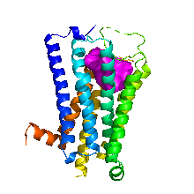
5HT2A | 5-hydroxytryptamine receptor 2A | P28223 | 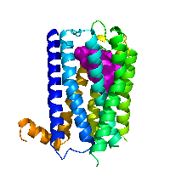
5HT2B | 5-hydroxytryptamine receptor 2B | P41595 | 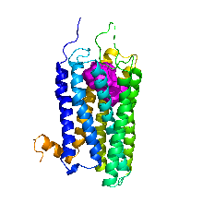
5HT2C | 5-hydroxytryptamine receptor 2C | P28335 | 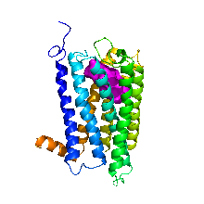
AA1R | Adenosine receptor A1 | P30542 | 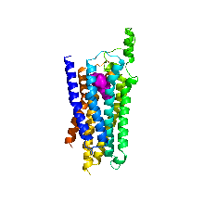
AA2AR | Adenosine receptor A2a | P29274 | 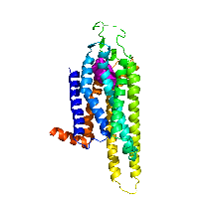
ACE | Angiotensin-converting enzyme | P12821 | 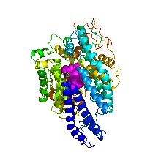
ACES | Acetylcholinesterase | P22303 | 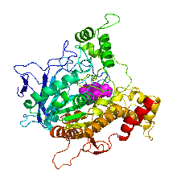
ACHA9 | Neuronal acetylcholine receptor subunit alpha-9 | Q9UGM1 | 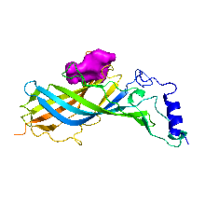
ACHB2 | Neuronal acetylcholine receptor subunit beta-2 | P17787 | 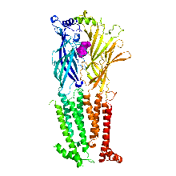
ACM1 | Muscarinic acetylcholine receptor M1 | P11229 | 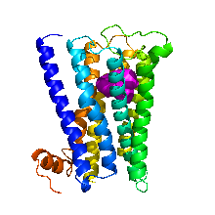
ACM4 | Muscarinic acetylcholine receptor M4 | P08173 | 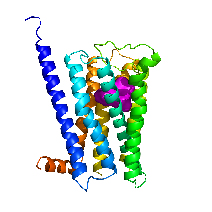
ADRB2 | Beta-2 adrenergic receptor | P07550 | 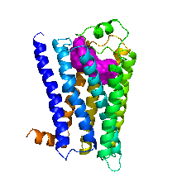
AGTR2 | Type-2 angiotensin II receptor | P50052 | 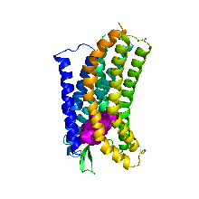
ALDR | Aldo-keto reductase family 1 member B1 | P15121 | 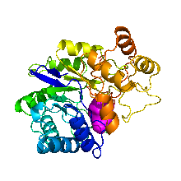
AMPN | Aminopeptidase N | P15144 | 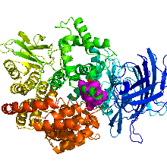
AOFA | Amine oxidase [flavin-containing] A | P21397 | 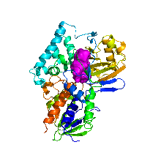
AOFB | Amine oxidase [flavin-containing] B | P27338 | 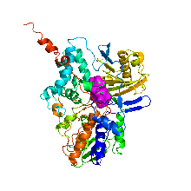
BACE1 | Beta-secretase 1 | P56817 | 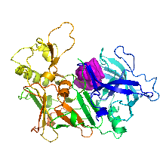
CAH2 | Carbonic anhydrase 2 | P00918 | 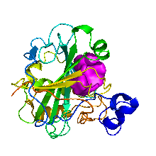
CASP1 | Caspase-1 | P29466 | 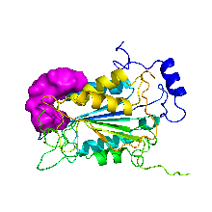
CDK5 | Cyclin-dependent-like kinase 5 | Q00535 | 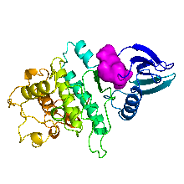
CHLE | Cholinesterase | P06276 | 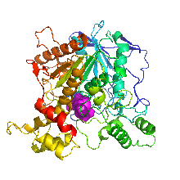
CNR1 | Cannabinoid receptor 1 | P21554 | 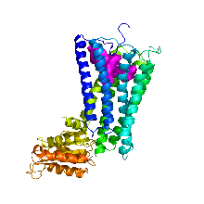
CNR2 | Cannabinoid receptor 2 | P34972 | 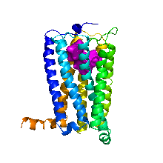
COLI | Pro-opiomelanocortin | P01189 | 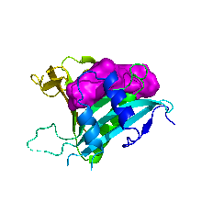
COMT | Catechol O-methyltransferase | P21964 | 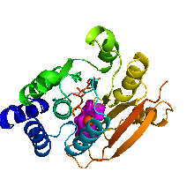
CRP | C-reactive protein | P02741 | 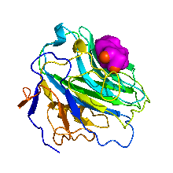
CXCR1 | C-X-C chemokine receptor type 1 | P25024 | 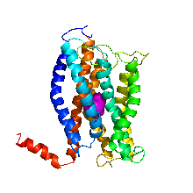
CXCR4 | C-X-C chemokine receptor type 4 | P61073 | 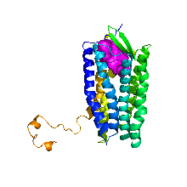
DRD2 | D (2) dopamine receptor | P14416 | 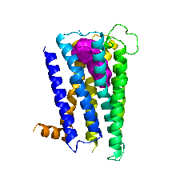
DRD3 | D (3) dopamine receptor | P35462 | 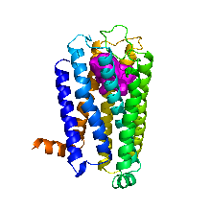
DRD4 | D (4) dopamine receptor | P21917 | 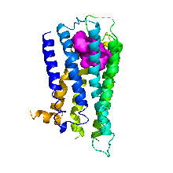
EDN1 | Endothelin-1 | P05305 | 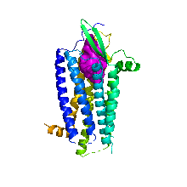
ESR1 | Estrogen receptor | P03372 | 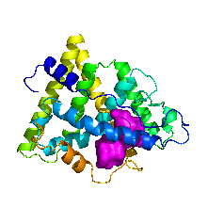
FABP5 | Fatty acid-binding protein 5 | Q01469 | 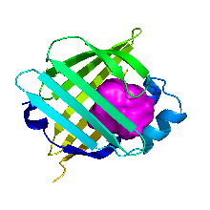
FYN | Tyrosine-protein kinase Fyn | P06241 | 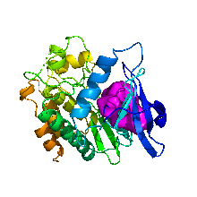
GLRA3 | Glycine receptor subunit alpha-3 | O75311 | 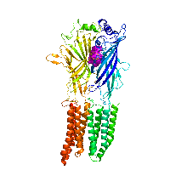
GLRA3 modulator | Glycine receptor subunit alpha-3 | O75311 | 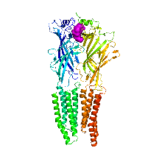
GRM5 | Metabotropic glutamate receptor 5 | P41594 | 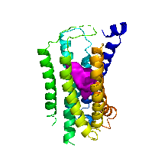
HPGDS | Hematopoietic prostaglandin D synthase | O60760 | 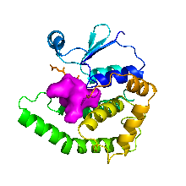
HRH1 | Histamine H1 receptor | P35367 | 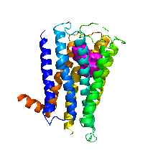
HYES | Bifunctional epoxide hydrolase 2 | P34913 | 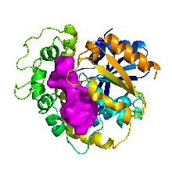
IKKB | Inhibitor of nuclear factor kappa-B kinase subunit beta | O14920 | 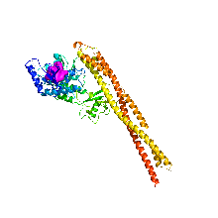
MDR1 | ATP-dependent translocase ABCB1 | P08183 | 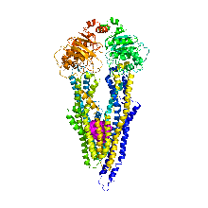
MIF | Macrophage migration inhibitory factor | P14174 | 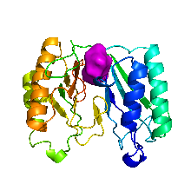
MK01 | Mitogen-activated protein kinase 1 | P28482 | 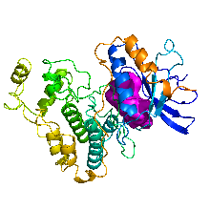
MK03 | Mitogen-activated protein kinase 3 | P27361 | 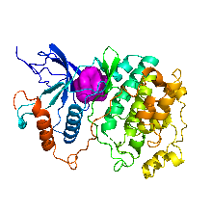
MTOR | Serine/threonine-protein kinase mTOR | P42345 | 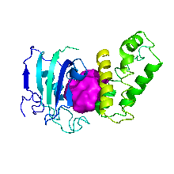
NEP | Neprilysin | P08473 | 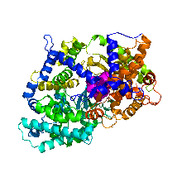
NK1R | Substance-P receptor | P25103 | 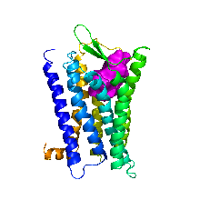
NMDE1 | Glutamate receptor ionotropic epsilon-1 | Q12879 | 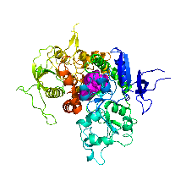
NMDE2 | Glutamate receptor ionotropic epsilon-2 | Q13224 | 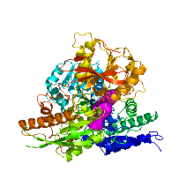
NMDZ1 | Glutamate receptor ionotropic zeta-1 | Q05586 | 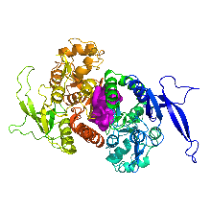
NOS1 | Nitric oxide synthase 1 | P29475 | 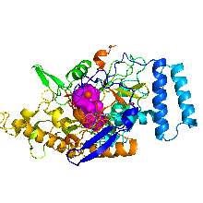
NOS2 | Nitric oxide synthase 2 | P35228 | 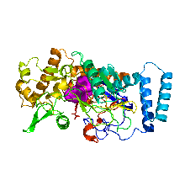
NTRK1 | High affinity nerve growth factor receptor | P04629 | 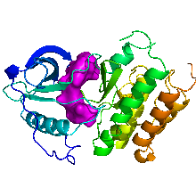
OPRD | Delta-type opioid receptor | P41143 | 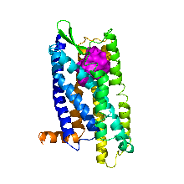
OPRK | Kappa-type opioid receptor | P41145 | 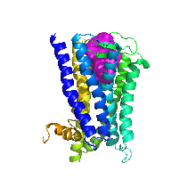
OPRM | Mu-type opioid receptor | P35372 | 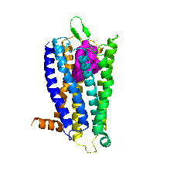
OPRX | Nociceptin receptor | P41146 | 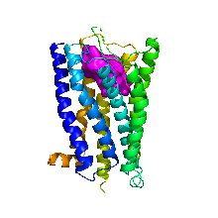
P2RX3 | P2X purinoceptor 3 | P56373 | 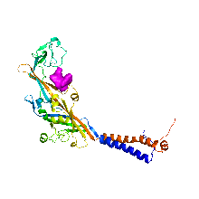
P2Y12 | P2Y purinoceptor 12 | Q9H244 | 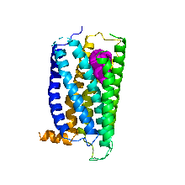
PAR1 | Proteinase-activated receptor 1 | P25116 | 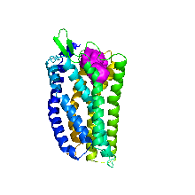
PDE4B | cAMP-specific 3',5'-cyclic phosphodiesterase 4B | Q07343 | 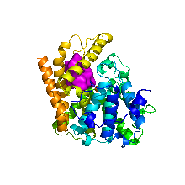
PDE5A | cGMP-specific 3',5'-cyclic phosphodiesterase 5A | O76074 | 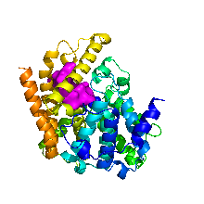
PERM | Myeloperoxidase | P05164 | 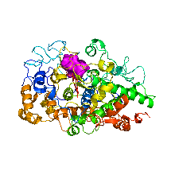
PGH1 | Prostaglandin G/H synthase 1 | P23219 | 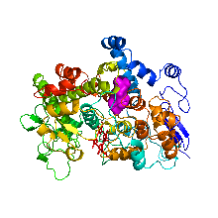
PGH2 | Prostaglandin G/H synthase 2 | P35354 | 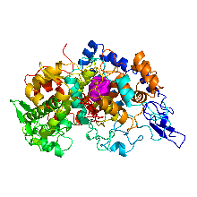
PPAP | Prostatic acid phosphatase | P15309 | 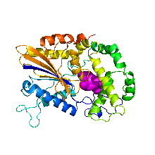
PPARG | Peroxisome proliferator-activated receptor gamma | P37231 | 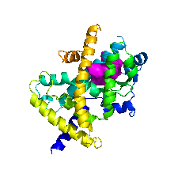
PRGR | Progesterone receptor | P06401 | 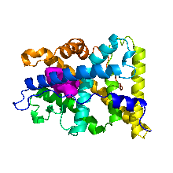
PTGES | Prostaglandin E synthase | O14684 | 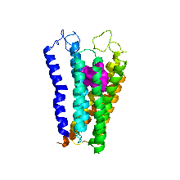
SC6A4 | Solute carrier family 6 member 4 | P31645 | 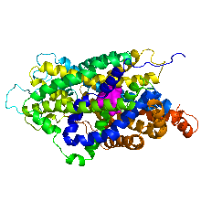
SCN9A | Sodium channel protein type 9 subunit alpha | Q15858 | 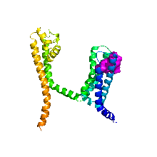
TLR4 | Toll-like receptor 4 | O00206 | 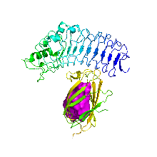
TNFA | Tumor necrosis factor | P01375 | 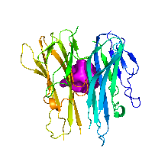
TRBM | Thrombomodulin | P07204 | 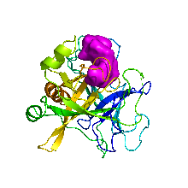
TRPM4 | Transient receptor potential cation channel subfamily M member 4 | Q8TD43 | 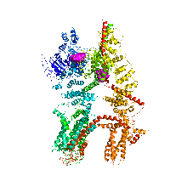
TRPM8 | Transient receptor potential cation channel subfamily M member 8 | Q7Z2W7 | 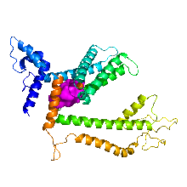
TRPV1 | Transient receptor potential cation channel subfamily V member 1 | Q8NER1 | 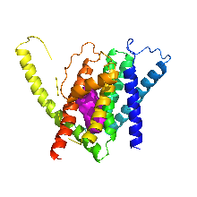
TRPV2 | Transient receptor potential cation channel subfamily V member 2 | Q9Y5S1 | 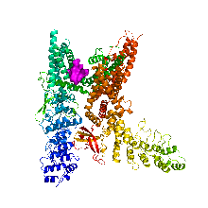
TRPV3 | Transient receptor potential cation channel subfamily V member 3 | Q8NET8 | 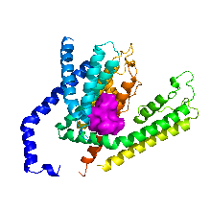
TRY1 | Trypsin-1 | P07477 | 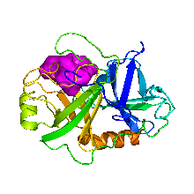

The approved anti-pain drugs in PAIN-CKB
Drug name | Target | Structure | URL
Acetaminophen | PTGES, TRPV1, PGH2, PGH1 | 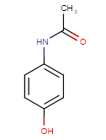 | https://www.drugbank.ca/drugs/DB00316
Tramadol | OPRM, OPRK, OPRD, TRPV1, 5HT2C, ACM1, SLC6A4, NK1R | 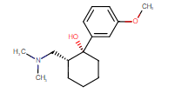 | https://www.drugbank.ca/drugs/DB00193
Morphine | OPRM, OPRK, OPRD | 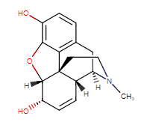 | https://www.drugbank.ca/drugs/DB00295
Dihydroergotamine | 5HT1B, 5HT2B | 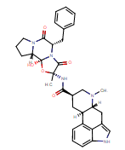 | https://www.drugbank.ca/drugs/DB00320
Hydromorphone | OPRM, OPRD, OPRK, | 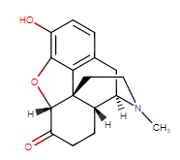 | https://www.drugbank.ca/drugs/DB00327
Methadone | OPRM, OPRD, ACHB2 | 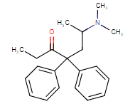 | https://www.drugbank.ca/drugs/DB00333
Meperidine | OPRK, OPRM, SC6A4 | 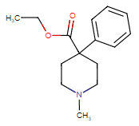 | https://www.drugbank.ca/drugs/DB00454
Oxycodone | OPRM, OPRK, OPRD | 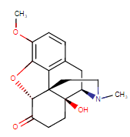 | https://www.drugbank.ca/drugs/DB00497
Butorphanol | OPRK, OPRD, OPRM | 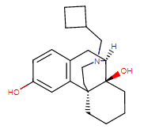 | https://www.drugbank.ca/drugs/DB00611
Dextropropoxyphene (withdraw) | OPRM, OPRD, OPRK | 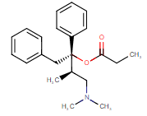 | https://www.drugbank.ca/drugs/DB00647
Pentazocine | OPRM, OPRK, | 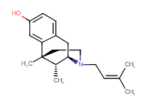 | https://www.drugbank.ca/drugs/DB00652
Ergotamine | 5HT1B, 5HT2A, DRD2 | 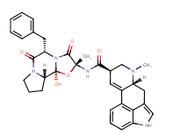 | https://www.drugbank.ca/drugs/DB00696
Fentanyl | OPRM, OPRD, OPRK, | 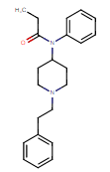 | https://www.drugbank.ca/drugs/DB00813
Nalbuphine | OPRK, OPRM, OPRD | 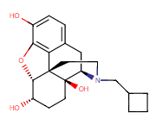 | https://www.drugbank.ca/drugs/DB00844
Diflunisal | PGH2, PGH1 | 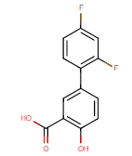 | https://www.drugbank.ca/drugs/DB00861
Salicylic acid | PGH1, PGH2 | 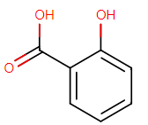 | https://www.drugbank.ca/drugs/DB00936
Dezocine | OPRM, OPRK | 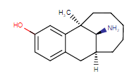 | https://www.drugbank.ca/drugs/DB01209
Salsalate | PGH2, PGH1 | 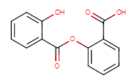 | https://www.drugbank.ca/drugs/DB01399
Metamizole | PGH1 | 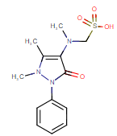 | https://www.drugbank.ca/drugs/DB04817
Pizotifen | ACM1, 5HT2A, 5HT2B, 5HT2C, 5HT1B, HRH1 | 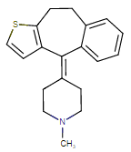 | https://www.drugbank.ca/drugs/DB06153
Choline | ACES, CHLE | 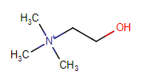 | https://www.drugbank.ca/drugs/DB00122
Mesalazine | PGH2, PGH1, PPARG, IKKB, PERM | 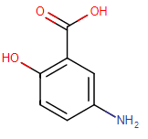 | https://www.drugbank.ca/drugs/DB00244
Codeine | OPRM, OPRK, OPRD | 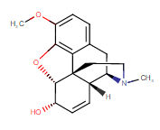 | https://www.drugbank.ca/drugs/DB00318
Amitriptyline | 5HT2A, OPRD, OPRK, NTRK1, HRH1, 5HT2C, OPRM, 5HT1B, 5HT2C, SC6A4 | 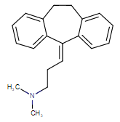 | https://www.drugbank.ca/drugs/DB00321
Indometacin | PGH1, PGH2, PPARG | 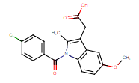 | https://www.drugbank.ca/drugs/DB00328
Pimecrolimus | MTOR | 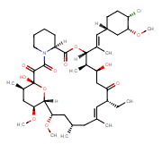 | https://www.drugbank.ca/drugs/DB00337
Carbachol | ACM1, ACES, ACM4 | 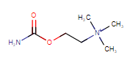 | https://www.drugbank.ca/drugs/DB00411
Nabumetone | PGH2, PGH1 | 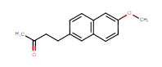 | https://www.drugbank.ca/drugs/DB00461
Ketorolac | PGH2, PGH1 | 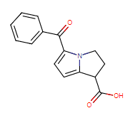 | https://www.drugbank.ca/drugs/DB00465
Tenoxicam | PGH2, PGH1 | 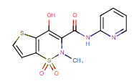 | https://www.drugbank.ca/drugs/DB00469
Dronabinol | CNR1, CNR2 | 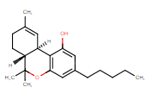 | https://www.drugbank.ca/drugs/DB00470
Celecoxib | PGH2, CAH2 | 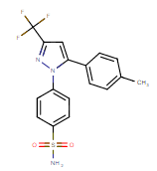 | https://www.drugbank.ca/drugs/DB00482
Tolmetin | PGH2, PGH1 | 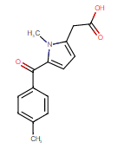 | https://www.drugbank.ca/drugs/DB00500
Rofecoxib | PGH2 | 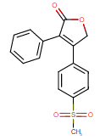 | https://www.drugbank.ca/drugs/DB00533
Piroxicam | PGH2, PGH1 | 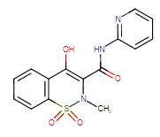 | https://www.drugbank.ca/drugs/DB00554
Fenoprofen | PGH2, PGH1, PPARG | 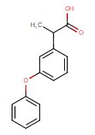 | https://www.drugbank.ca/drugs/DB00573
Valdecoxib | PGH2, CAH2 | 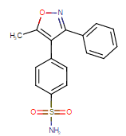 | https://www.drugbank.ca/drugs/DB00580
Diclofenac | PGH2, PGH1 | 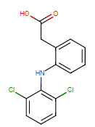 | https://www.drugbank.ca/drugs/DB00586
Sulindac | PGH2, PGH1, MK03 | 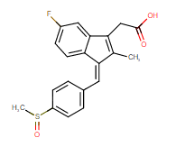 | https://www.drugbank.ca/drugs/DB00605
Sufentanil | OPRM, OPRD, OPRK | 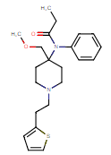 | https://www.drugbank.ca/drugs/DB00708
Flurbiprofen | PGH1, PGH2 | 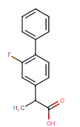 | https://www.drugbank.ca/drugs/DB00712
Etodolac | PGH2, PGH1 | 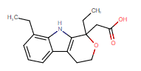 | https://www.drugbank.ca/drugs/DB00749
Mefenamic acid | PGH2, PGH1 | 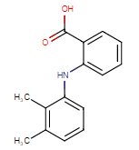 | https://www.drugbank.ca/drugs/DB00784
Naproxen | PGH1, PGH2 | 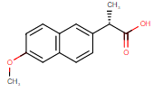 | https://www.drugbank.ca/drugs/DB00788
Sulfasalazine | PGH2, PGH1, PPARG, IKKB | 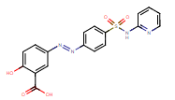 | https://www.drugbank.ca/drugs/DB00795
Alfentanil | OPRM | 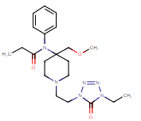 | https://www.drugbank.ca/drugs/DB00802
Phenylbutazone | PGH2, PGH1 | 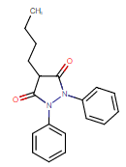 | https://www.drugbank.ca/drugs/DB00812
Meloxicam | PGH2, PGH1 | 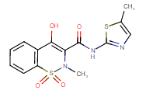 | https://www.drugbank.ca/drugs/DB00814
Carprofen (withdraw) | PGH2, PGH1 | 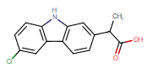 | https://www.drugbank.ca/drugs/DB00821
Levorphanol | OPRM, OPRD, OPRK | 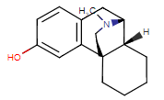 | https://www.drugbank.ca/drugs/DB00854
Suprofen (withdraw) | PGH1, PGH2 | 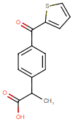 | https://www.drugbank.ca/drugs/DB00870
Remifentanil | OPRM, OPRD, OPRK | 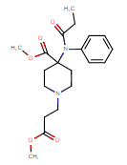 | https://www.drugbank.ca/drugs/DB00899
Amantadine | DRD2 | 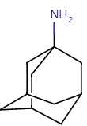 | https://www.drugbank.ca/drugs/DB00915
Buprenorphine | OPRM, OPRK, OPRD | 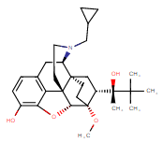 | https://www.drugbank.ca/drugs/DB00921
Meclofenamic acid | PGH1, PGH2 | 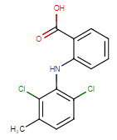 | https://www.drugbank.ca/drugs/DB00939
Aspirin | PGH1, PGH2, CASP1, IKKB | 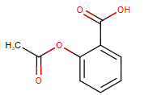 | https://www.drugbank.ca/drugs/DB00945
Hydrocodone | OPRM, OPRD | 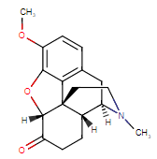 | https://www.drugbank.ca/drugs/DB00956
Bromfenac | PGH2, PGH1 | 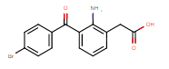 | https://www.drugbank.ca/drugs/DB00963
Oxaprozin | PGH1, PGH2 | 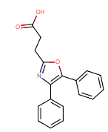 | https://www.drugbank.ca/drugs/DB00991
Ketoprofen | PGH1, PGH2, CXCR1 | 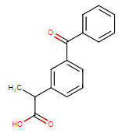 | https://www.drugbank.ca/drugs/DB01009
Balsalazide | PPARG, PGH2, PGH1 | 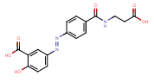 | https://www.drugbank.ca/drugs/DB01014
Ibuprofen | PGH2, PGH1, PPARG | 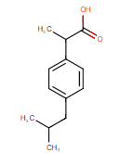 | https://www.drugbank.ca/drugs/DB01050
Diphenoxylate | OPRM, OPRD | 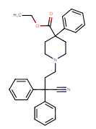 | https://www.drugbank.ca/drugs/DB01081
Nefazodone (withdraw) | 5HT2A, 5HT2C, SC6A4 | 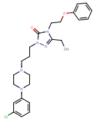 | https://www.drugbank.ca/drugs/DB01149
Oxymorphone | OPRM, OPRD | 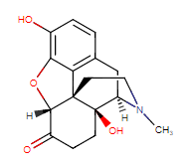 | https://www.drugbank.ca/drugs/DB01192
Ketamine | DRD2, OPRD, OPRK, OPRM | 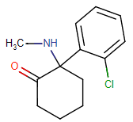 | https://www.drugbank.ca/drugs/DB01221
Levacetylmethadol | OPRM | 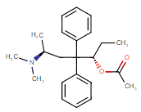 | https://www.drugbank.ca/drugs/DB01227
Lumiracoxib | PGH2, PGH1 | 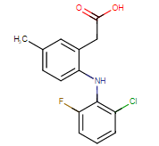 | https://www.drugbank.ca/drugs/DB01283
Choline magnesium trisalicylate | PGH1, PGH2 | 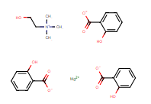 | https://www.drugbank.ca/drugs/DB01401
Methotrimeprazine | DRD2, DRD4, 5HT2A, 5HT2C, HRH1 | 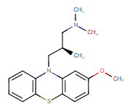 | https://www.drugbank.ca/drugs/DB01403
Antipyrine | PGH2, PGH1 | 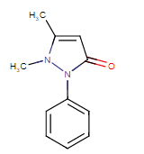 | https://www.drugbank.ca/drugs/DB01435
Diamorphine | OPRM, OPRK, OPRD | 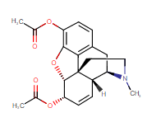 | https://www.drugbank.ca/drugs/DB01452
Etorphine | OPRM, OPRD, OPRK, COLI | 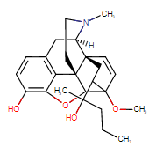 | https://www.drugbank.ca/drugs/DB01497
Carfentanil | OPRM, OPRD, OPRK | 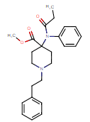 | https://www.drugbank.ca/drugs/DB01535
Tiaprofenic acid | PGH2, PGH1 | 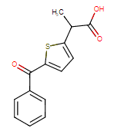 | https://www.drugbank.ca/drugs/DB01600
Etoricoxib | PGH2 | 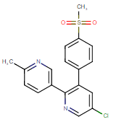 | https://www.drugbank.ca/drugs/DB01628
Nimesulide (withdraw) | PGH2 | 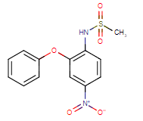 | https://www.drugbank.ca/drugs/DB04743
Apremilast | PDE4B | 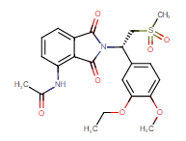 | https://www.drugbank.ca/drugs/DB05676
Icatibant | AMPN | 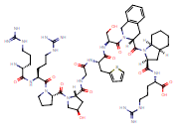 | https://www.drugbank.ca/drugs/DB06196
Lornoxicam | PGH2, PGH1 | 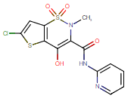 | https://www.drugbank.ca/drugs/DB06725
Aceclofenac | PGH2, PGH1 | 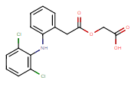 | https://www.drugbank.ca/drugs/DB06736
Nepafenac | PGH1, PGH2 | 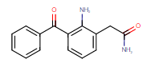 | https://www.drugbank.ca/drugs/DB06802
Parecoxib | PGH2 | 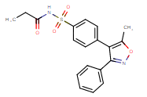 | https://www.drugbank.ca/drugs/DB08439
Pholcodine | OPRM, OPRK, OPRD | 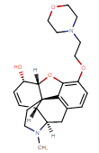 | https://www.drugbank.ca/drugs/DB09209
Loxoprofen | PGH2, PGH1 | 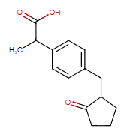 | https://www.drugbank.ca/drugs/DB09212
Tolfenamic Acid | PGH1, PGH2 | 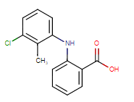 | https://www.drugbank.ca/drugs/DB09216
Opium | OPRD, OPRK, OPRM |  | https://www.drugbank.ca/drugs/DB11130
Curcumin | PPARG | 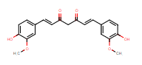 | https://www.drugbank.ca/drugs/DB11672
Alclofenac (withdraw) | PGH2 | 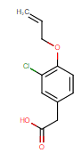 | https://www.drugbank.ca/drugs/DB13167
Bufexamac (withdraw) | PGH1, PGH2 | 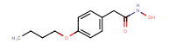 | https://www.drugbank.ca/drugs/DB13346
Bendazac (withdraw) | PGH1, PGH2 | 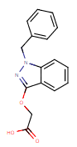 | https://www.drugbank.ca/drugs/DB13501
Acemetacin | PGH1, PGH2 | 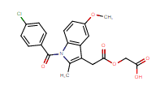 | https://www.drugbank.ca/drugs/DB13783
Eletriptan | 5HT1B | 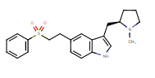 | https://www.drugbank.ca/drugs/DB00216
Methysergide | 5HT2B, 5HT2C, 5HT2A, 5HT1B | 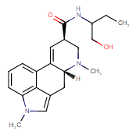 | https://www.drugbank.ca/drugs/DB00247
Zolmitriptan | 5HT1B, 5HT2A, 5HT2B | 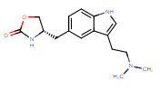 | https://www.drugbank.ca/drugs/DB00315
Lisuride | DRD2, DRD3, DRD4, 5HT2B, 5HT2A, 5HT2C, 5HT1B, | 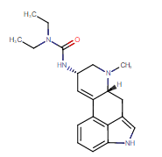 | https://www.drugbank.ca/drugs/DB00589
Almotriptan | 5HT1B | 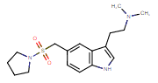 | https://www.drugbank.ca/drugs/DB00918
Naratriptan | 5HT1B | 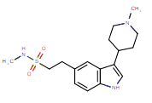 | https://www.drugbank.ca/drugs/DB00952
Rizatriptan | 5HT1B | 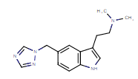 | https://www.drugbank.ca/drugs/DB00953
Frovatriptan | 5HT1B | 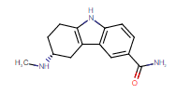 | https://www.drugbank.ca/drugs/DB00998
Tapentadol | OPRM, OPRK, OPRD, 5HT3A, SC6A4 | 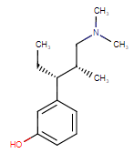 | https://www.drugbank.ca/drugs/DB06204
Choline salicylate | ACES, CHLE | 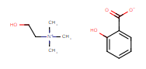 | https://www.drugbank.ca/drugs/DB14006
Sumatriptan | 5HT1B | 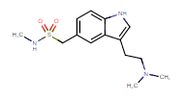 | https://www.drugbank.ca/drugs/DB00669
Naltrexone | OPRD, OPRM, OPRK | 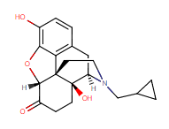 | https://www.drugbank.ca/drugs/DB00704
Naloxone | OPRM, OPRD, OPRK, ESR1 | 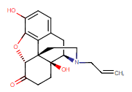 | https://www.drugbank.ca/drugs/DB01183
Dexketoprofen | PGH1, PGH2 | 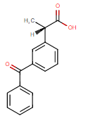 | https://www.drugbank.ca/drugs/DB09214

