Getting Started

Lab 00

# Objectives:

The purpose of the first lab of DBS211 is to familiarize yourself with the User Interface, SQL Developer that we will be using throughout the course to communicate with the Oracle server. By the end of this lab you should be able to:

* Successfully establish a connection with and login to the Oracle database server using SQL Developer
* Run the sample database creation script
* Navigate SQL Developer to view the tables created, their structure and the data contained within them.

# Preface:

If you have not already done so, you will need to download the sample database creation script from blackboard and run it. These instructions are included in the W01 - Getting Started with SQL Developer document.

# Lab Mark

This lab does not have any weight but has to be completed in the first week.

# LAB 00 - SUBMISSION

## Explore the Database

Answer the following questions in the provided space. Save you file as a PDF file and name it as following:

**DBS211_L00_LastName.sql**

**Oracle SQL Developer Setup**

Your Oracle account information is available in My Grades from the course page on Blackboard.

Use the following link to download Oracle Developer:

<https://www.oracle.com/tools/downloads/sqldev-downloads.html>

Choose the proper download compatible to your OS.

For instance, if your OS is Windows_X64 choose the first option to download.

Windows 64-bit with JDK 8 included

If you have MAC, download the MAC version, you also need to download the JDK and install it. You can find the link to JDK on the Notes column.

Decompress the file and execute the sqldeveloper.exe

…\sqldeveloper

If you have any problems with the font size of the SQL DEVELOPER program (menu bar and navigation panel, and …) go to the following link for the instruction to fix the problem:

<https://christian-gohmann.de/2018/10/25/running-sql-developer-on-high-dpi-screens/>

When you have SQL Developer running, you need to create a new connection to connect to Seneca Oracle.

To create a new connection:

* Choose a name for your connection.
* Connection Name: DBS311 (or any name you want)
* Host name: **myoracle12c.senecacollege.ca**
* Service name: **oracle12c**
* Your Oracle username and password

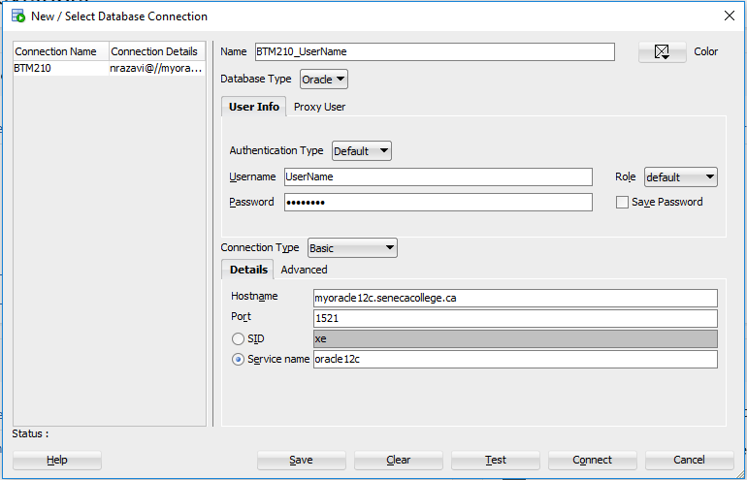

Figure 1

**You have already created the schema but you have different tables**

If you have created the schema you should see the following table under “Tables” in your DBS311 connection:

DBS211_CUSTOMERS

DBS211_EMPLOYEES

DBS211_OFFICES

DBS211_ORDERDETAILS

DBS211_ORDERS

DBS211_PAYMENTS

DBS211_PRODUCTLINES

DBS211_PRODUCTS

If you see different tables from the above tables, you need to remove them and do the following instruction to create correct tables in your database.

To remove tables:

1. Right click on the table name in the navigation panel and select “Table” and the select “Drop”.

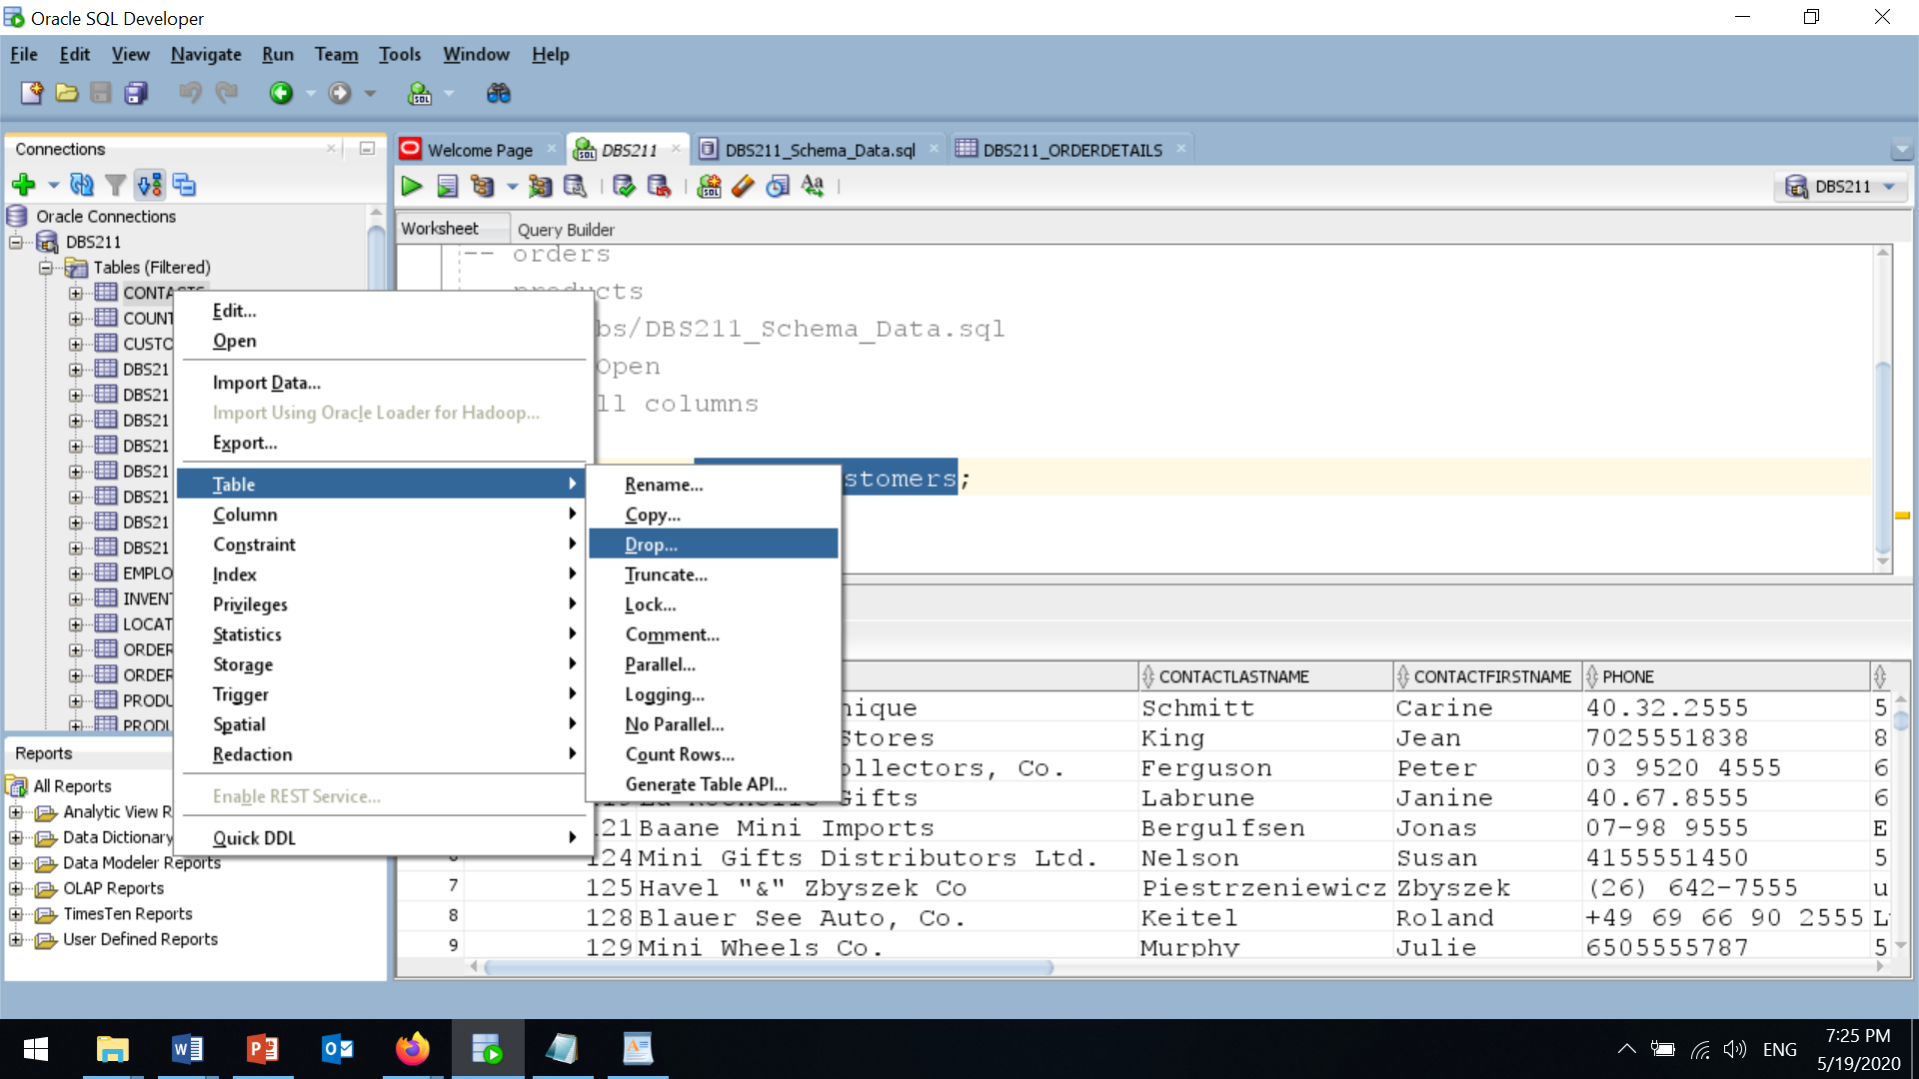

Figure 2

1. In the “Drop” page, check “Cascade Constraints” and click on the “apply” Button.

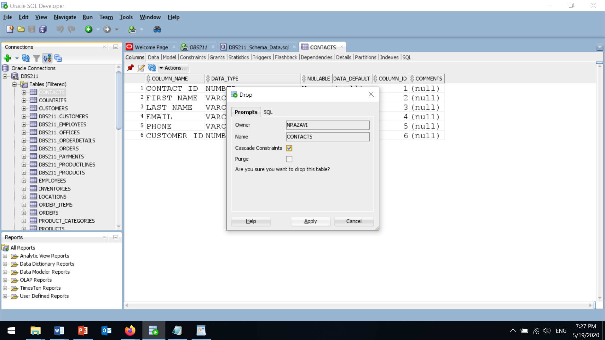

Figure 3

Repeat this to drop (remove) all tables and create the correct tables following the instruction below:

**Schema (Create Tables and Insert Data)**

To create the schema, download and execute the file from

Schema Creation and Data Insertion

You can find all the files you need in this Lab 00 folder.

Right click on “Schema Creation Script” and select the “Save link as” to save the file on your computer.

schema.sql

Open this file in SQL Developer.

1. From the file menu, select **Open**.
2. Select the downloaded script and hit the open button.

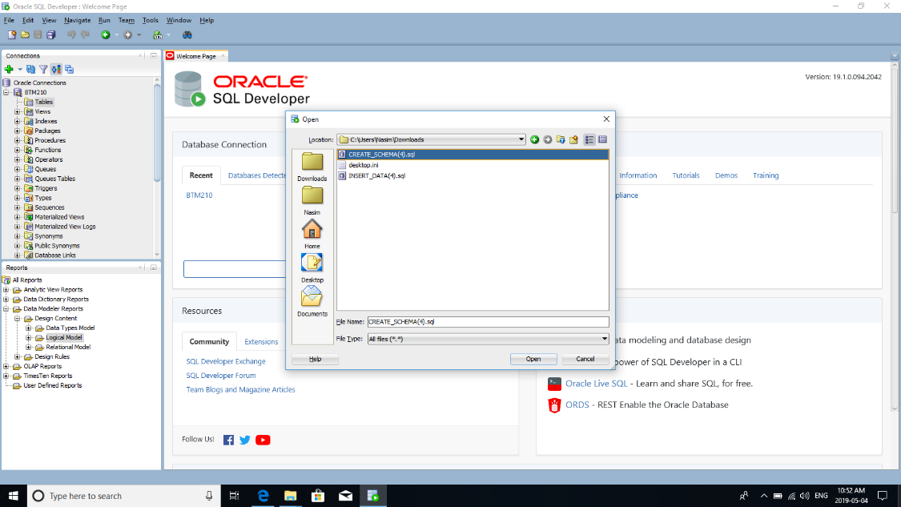

Figure 4

1. To execute the script, hit “**Run Script (F5)**” icon (the icon next the green triangle).

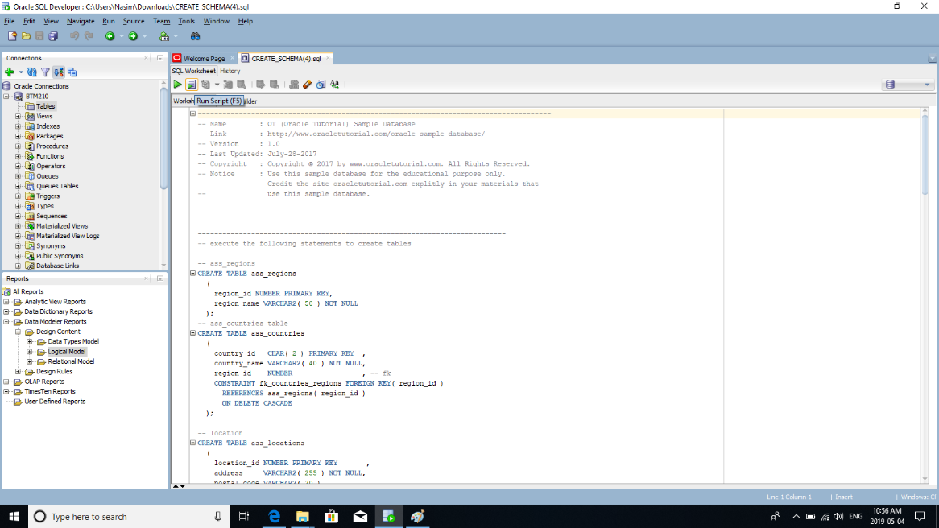

Figure 5

1. From the drop-down list, select the connection that you have created at the beginning of this lab and hit **OK**.

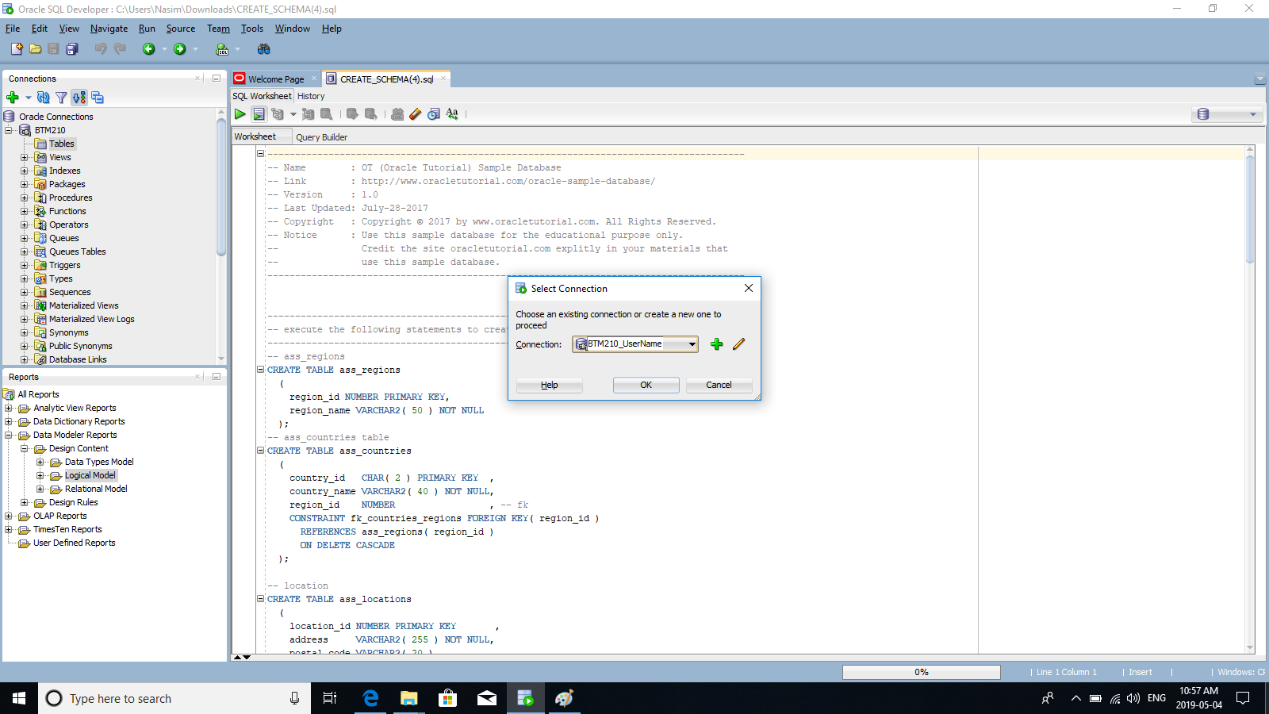

Figure 6

After all tables are created, you may not see the tables under “Tables” in the navigation panel. Right click on “Tables” and select “Refresh”. Now, expand “Tables”. You should see the following tables:

DBS211_CUSTOMERS

DBS211_EMPLOYEES

DBS211_OFFICES

DBS211_ORDERDETAILS

DBS211_ORDERS

DBS211_PAYMENTS

DBS211_PRODUCTLINES

DBS211_PRODUCTS

**Tasks:**

To answer the questions in this lab you need the Oracle SQL developer running and the sample database with

In the connections window, expand **Tables.**

1. How many tables have been created? List the names of the created tables.

|  |
| --- |
| There are 8 number of the tables created they are DBS211_PRODUCTS, DBS211_PRODUCTLINES, DBS211_PAYMENTS, DBS211_ORDERS, DBS211_ORDERDETAILS, DBS211_OFFICES, DBS211_EMPLOYEES, DBS211_CUSTOMERS. |

1. Click on table **DBS211_customers**. Click on the Data tab near the top of the worksheet. How many rows are there in the table **customers**?

|  |
| --- |
| There are rows in the table of the customers. |

1. What SQL statement would return the same results? Write the statement in the box below.   
     
   You will learn how to select rows and columns from a table by writing SQL select statements later in this course.

|  |
| --- |
|  |

1. How many columns does the **DBS211_customers** table have? List the column names.

|  |
| --- |
| There are 13 columns created in the customers list and the name of the columns are CUSTOMERNUMBER, CUSTOMERNUMBER, CONTACTLASTNAME, CONTACTFIRSTNAME, PHONE, ADDRESSLINE1, ADDRESSLINE2, CITY, STATE, POSTALCODE, COUNTRY, SALESREPEMPLOYEENUMBER, CREDITLIMIT. |

1. What is the value of each column in the first row in table **DBS211_customers**? Write the column name and the column data type in addition to the value.

|  |
| --- |
| The value of the each column in the first row in the table DBS211_customers are 5. The column name and its data type are as follows CUSTOMERNUMBER with data type NUMBER(38,0) , CUSTOMERNAME with data type VARCHAR2(50 BYTE), CUSTOMERLASTNAME with data type VARCHAR2(50 BYTE), CUSTOMERFIRSTNAME with data type VARCHAR2(50 BYTE), PHONE with data type VARCHAR2(50 BYTE), ADDRESSLINE1 with data type VARCHAR2(50 BYTE), ADDRESSLINE2 with data type VARCHAR2(50 BYTE), CITY with data type VARCHAR2(50 BYTE), STATE with data type VARCHAR2(50 BYTE), POSTALCODE with data type VARCHAR2(15 BYTE), COUNTRY with data type VARCHAR2(50 BYTE), SALESREPEMPLOYEENUMBER with data type NUMBER(38,0), CREDITLIMIT with data type NUMBER(10,2), |

1. Write the number of rows and columns for the rest of the tables in your schema. Format it something like the following.

Table Name Rows Columns

_ DBS211_PRODUCTS __ __9___ __6_____  
_ DBS211_PRODUCTLINES __4___ ___6____

DBS211_PAYMENTS 4 ___6____

DBS211_ORDERS 7 ___6____

DBS211_ORDERDETAILS 5 ___6____

DBS211_OFFICES 9 ___6____

DBS211_EMPLOYEES 8 ___6____

1. Right Click on the **DBS211_orderdetails** table and choose tables/count rows. How many rows does the order details table include?

|  |
| --- |
| The order details given in the table about the row count is 2996 rows. |

1. Write the following SQL statement in the new tab.

desc DBS211_offices;

You can also write

describe DBS211_offices;

What is the result of the statement execution?

|  |
| --- |
| After running the statement the result we get is;  Name Null? Type  ------------ -------- ------------  OFFICECODE NOT NULL VARCHAR2(10)  CITY NOT NULL VARCHAR2(50)  PHONE NOT NULL VARCHAR2(50)  ADDRESSLINE1 NOT NULL VARCHAR2(50)  ADDRESSLINE2 VARCHAR2(50)  STATE VARCHAR2(50)  COUNTRY NOT NULL VARCHAR2(50)  POSTALCODE NOT NULL VARCHAR2(15)  TERRITORY NOT NULL VARCHAR2(10) |

1. Type the following statements in, execute them, then briefly describe what the statement is doing!

SELECT * FROM DBS211_employees;

After running this statement it gives us the precise information of the employee list and the name and contact details and every other minor details of each and every employee like employee number, Name, last name, email, office code, their position etc.

SELECT * FROM DBS211_customers ORDER BY ContactLastName;

This statement helps in the arranging of the list by the A-Z list in the order and this list get all the names of the customers in the sequence of their first alphabetical name.

1. How many constraints does the **DBS211_products** table have?

|  |
| --- |
| There are total 11 constraints in the DBS211_products table. |

1. Find a way to turn on line numbers in the gutter.

|  |
| --- |
|  |

1. Set the font size in the worksheet editor to a size that is best for you. (Hint: Tools/Preferences)

|  |
| --- |
| Tools 🡪 preferences 🡪 code editor 🡪 fonts 🡪 font size 🡪 12  At first select the tool tile and clicking on the preferences it will pop up the menu of the preferences and in that menu selecting the code editor file it will drop the menu of the code editor and this will give the font tile and by clicking this tile we can change our fonts of the worksheet editor. |