**NAAN MUDHALVAN**

– IBM CLOUD BASED PROJECT

**TITLE**

MEDIA STREAMING WITH IBM CLOUD VIDEO STREAMING

INTRODUCTION:-

Media streaming with IBM Cloud Video Streaming is a powerful and versatile solution for delivering live and on-demand video content to audiences across the globe. Whether you are a content creator, business, or organization looking to distribute video content online, IBM Cloud Video Streaming provides a comprehensive platform to make it happen. In this introduction, we'll explore the key features, benefits, and components of IBM Cloud Video Streaming.

Key Features:

|  |  |
| --- | --- |
| Live and On-Demand Streaming | IBM Cloud Video Streaming supports both live and on-demand video streaming. Whether you're broadcasting a live event or sharing pre-recorded content, this platform can handle your needs. |
| Video Monetization | You can monetize your video content through various methods such as pay-per-view, subscription models, or advertising, helping you generate revenue from your video assets. |
| High-Quality Streaming | IBM Cloud Video Streaming ensures high-quality video delivery with adaptive streaming technology, which automatically adjusts the video quality based on the viewer's internet connection, ensuring a seamless viewing experience. |
| Content Security | Protect your content with features like encryption, password protection, and domain restriction. This helps safeguard your video assets from unauthorized access. |
| Analytics and Insights | Gain valuable insights into viewer behaviour and engagement with analytics tools. This data can help you refine your content and marketing strategies. |
| Customization and Branding | Customize the video player and viewer experience to match your brand's identity, giving your audience a consistent and immersive experience. |
| Global Content Delivery | IBM Cloud Video Streaming leverages a global content delivery network (CDN) to ensure low-latency, high-performance streaming to viewers worldwide |

BENEFITS:

|  |  |
| --- | --- |
| Scalability | Whether you have a small audience or a global following, the platform can scale to accommodate your needs, ensuring that your content reaches your audience reliably. |
| Cost-Effective | IBM Cloud Video Streaming offers flexible pricing models, allowing you to choose the plan that aligns with your budget and usage requirements. |
| Reliability | With IBM's cloud infrastructure and robust content delivery network, you can trust that your video content will be available to viewers when they need it. |
| User Engagement | Engage your audience with interactive features like chat, polls, and Q&A, enhancing the viewer experience and fostering community engagement. |
| Support and Integration | IBM provides comprehensive support and integration options, making it easier for you to implement the platform into your existing workflows and applications. |

COMPONENTS:

IBM Cloud Video Streaming comprises several key components:

|  |  |
| --- | --- |
| Streaming Manager | This is the central platform for managing your video content. It allows you to upload, organize, and schedule your live and on-demand videos. |
| Video Delivery Network | IBM's global CDN ensures fast and reliable delivery of your content to viewers worldwide. |
| Video Player | A customizable video player that can be embedded on your website or app, providing a seamless viewing experience for your audience. |
| Analytics and Monetization Tools | Access analytics data to gain insights into viewer behaviour and monetize your content effectively. |

PLATFORM DEFINITION:

Features: -

* User registration
* Video upload
* On-demand streaming
* Social sharing

USER INTERFACE DESIGN: -

Goals: -

* Seamless viewing experience
* User-friendly design
* Intuitive navigation

VIDEO UPLOAD: -

Requirements: -

* Supported formats
* Metadata management
* Secure upload process

STREAMING INTEGRATION: -

Components: -

* Security measures
* Content delivery
* IBM Cloud Video Streaming

USER EXPERIENCE: -

Priorities: -

* Social interaction
* Device compatibility

WORKFLOW: -

1. Users register and log in to the platform.

2. Users can upload videos with metadata.

3. Uploaded videos are stored securely.

4. Content is indexed in the content database.

5. Users can search and discover content.

6. Streaming servers utilize IBM Cloud Video Streaming services for adaptive video playback.

7. Users can interact with content through comments and sharing.

8. Payment gateways are used for monetization if applicable.

9. CDNs assist in efficient content delivery to users worldwide.

USER INTERFACE DESIGN: -

User interface (UI) design in media streaming platforms is crucial for creating a user-friendly, engaging, and intuitive experience for viewers. A well-designed UI can significantly impact user satisfaction and the success of your media streaming service.

KEY CONSIDERATIONS OF UI:

|  |  |
| --- | --- |
| CONTENT DISCOVERY | 1. **Search and Filters** 2. **Recommendations** 3. **Categories and Genres** |
| HOME PAGE LAYOUT | 1. **Featured Content** 2. **Personalization** |
| VIDEO PLAYER INTERFACE | 1. **Quality Settings** 2. **Playback Controls** 3. **Clean Design** |
| USER PROFILES | 1. **User Accounts** 2. **Switching Profiles** |
| NAVIGATION AND MENUS | 1. **Eye-Catching Thumbnails** 2. **Title and Description** |
| PROGRESS TRACKING | 1. **Viewing Progress** 2. **Watchlist** |
| INTERACTIVE FEATURES | 1. **Chat and Comments** 2. **Ratings and Reviews** |
| ACCESSIBILITY | 1. **Keyboard Shortcuts** 2. **Captioning and Subtitles** |

There also some other important design features are there:

1. **Responsive Design**
2. **Branding and Customization**
3. **Performance Optimization**
4. **Security and User Privacy**
5. **User Feedback**

ARCHITECTURE FOR VIDEO STREAMING: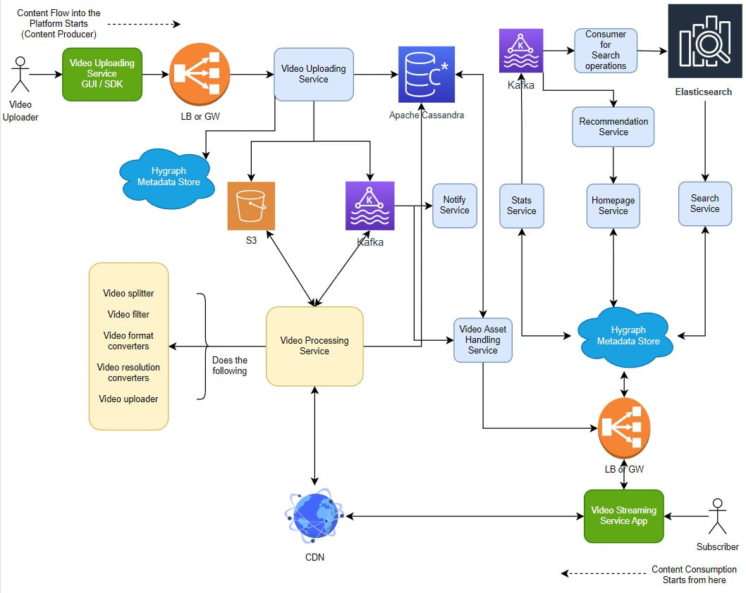

In this architecture, the subscriber wants to make a connection with the video streaming application.

The components involve are:

1.video uploading services like GUI/SDK.

2.Video processing services like S3/Kafka

3.In video processing services there are

* Video splitter,
* Video splitter
* Video format convertors
* Video resolution Convertors
* Video uploaders

VIDEO STREAMING APP ARCHITECTURE: -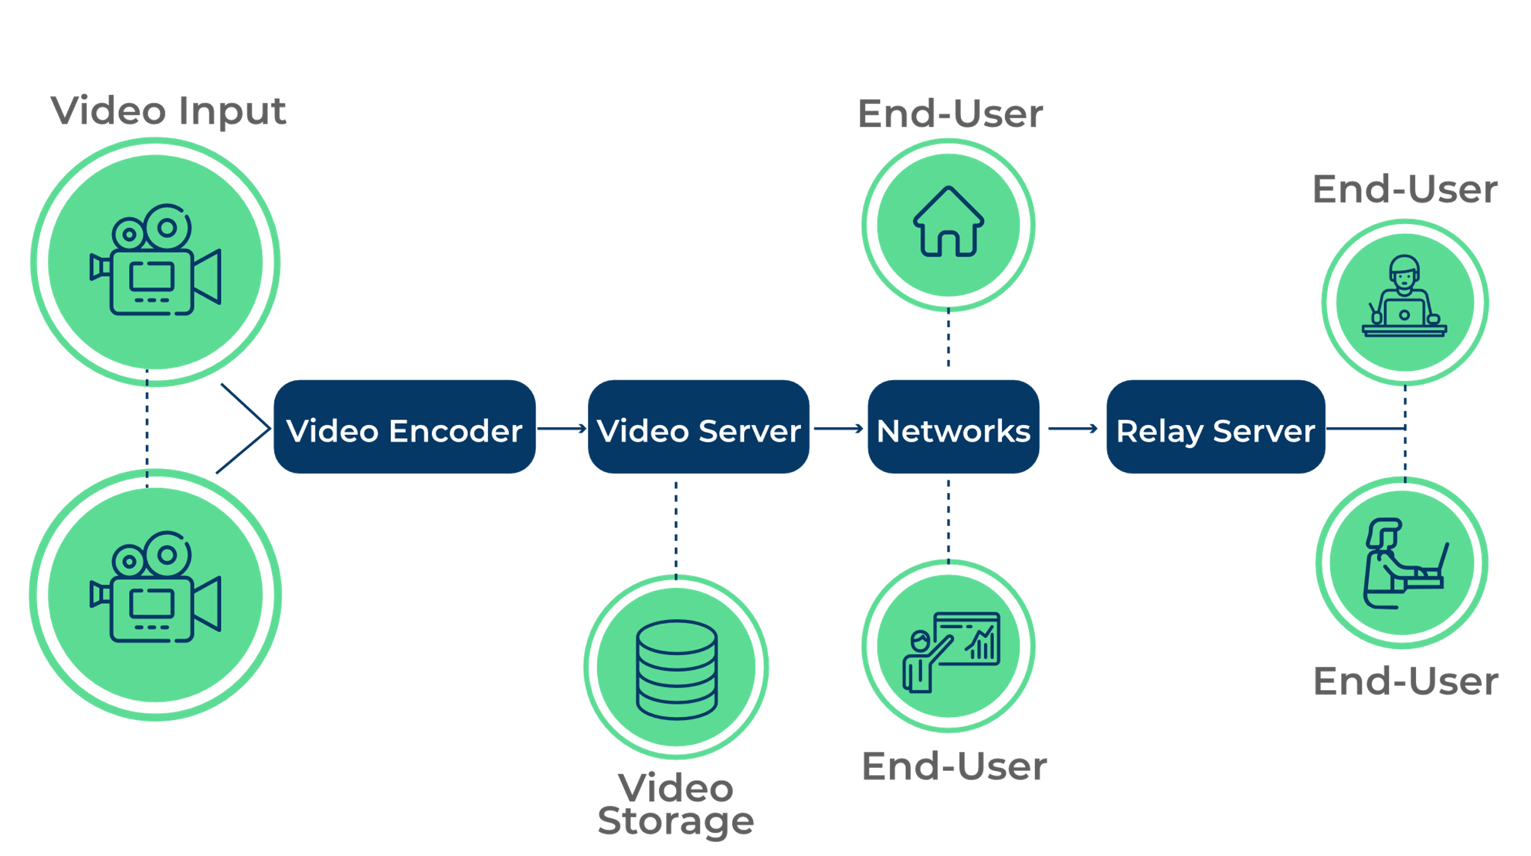

VIDEO ENCODING ARCHITECTURE: -

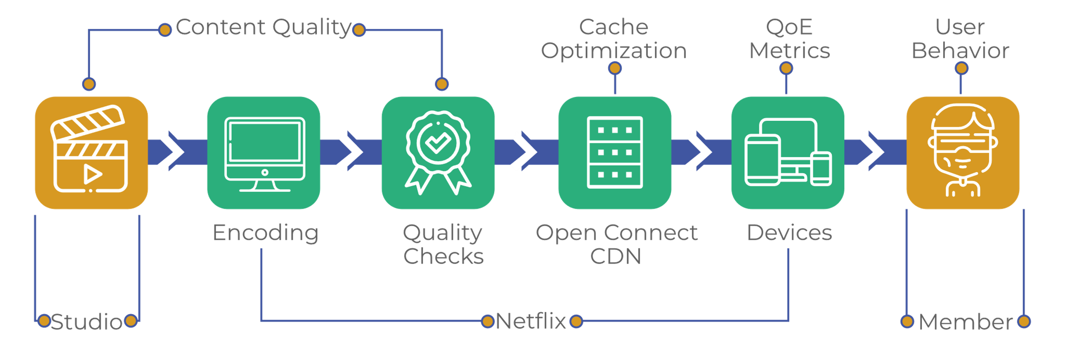

This is the media streaming with IBM cloud video streaming.

It describes the process of Platform Definition, User Interface Design, Video Upload, Streaming Integration and User Experience.

**THANK YOU!!!**