**Innovation In Media Streaming with IBM Cloud Video Streaming**

it's possible that there have been significant innovations and developments in this field with IBM Cloud Video Streaming or similar services. Here are some potential innovations and trends that could have occurred in media streaming with IBM Cloud Video Streaming or similar platforms:

1. **Improved Video Quality**: One of the key areas of innovation in media streaming is continually improving video quality. This could include support for higher resolutions (such as 4K and 8K), better compression algorithms for reduced bandwidth consumption, and enhanced support for high dynamic range (HDR) content.



1. **Low Latency Streaming**: Reducing latency is crucial for real-time applications like live sports streaming and online gaming. Innovations in low-latency streaming technologies can offer viewers a more immersive and interactive experience.
2. **AI-Enhanced Content Delivery**: IBM Cloud Video Streaming may have integrated AI and machine learning technologies to optimize content delivery. This could involve predictive analytics for content popularity, personalized content recommendations, and content delivery network (CDN) optimizations.



1. **Multi-Platform Streaming**: Innovation in media streaming often involves supporting a wide range of devices and platforms. IBM Cloud Video Streaming may have expanded its compatibility with smart TVs, gaming consoles, mobile devices, and other emerging platforms.



1. **Security Enhancements**: Given the importance of content security, innovations in encryption, digital rights management (DRM), and content watermarking may have been implemented to protect media content from piracy and unauthorized access.



1. **Interactivity and Engagement**: Streaming services are increasingly focused on enhancing viewer engagement. This could include interactive features like live chatpolls, and viewer participation in live events, all integrated into the streming. 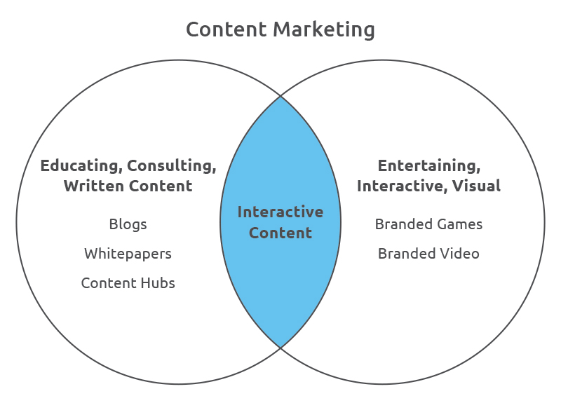
2. **Global Reach**: Expanding the reach of media streaming to a global audience often requires innovations in content delivery and localization. IBM Cloud Video Streaming may have developed more efficient ways to deliver content to viewers worldwide.



1. **Content Monetization**: Innovations in advertising technology and subscription management may have been integrated to help content providers effectively monetize their content.



1. **Analytics and Insights**: Advanced analytics tools might have been developed to provide content creators and businesses with valuable insights into viewer behavior, helping them make data-driven decisions.
2. **Accessibility Features**: Innovations in media streaming often include improved accessibility features, such as closed captioning, audio descriptions, and support for multiple languages, to make content more inclusive.

**Detailed comprehension on problem statement**

IBM Cloud Video Streaming is a comprehensive platform that provides a range of services and tools for media streaming. It's designed to help businesses and content creators deliver high-quality video content to their audiences, whether for live streaming events, on-demand video, or other media streaming needs. Here are some key features and components of IBM Cloud Video Streaming:

1. **Content Delivery Network (CDN)**: IBM Cloud Video Streaming utilizes a global CDN to ensure efficient and reliable content delivery. This means that your videos are distributed across multiple servers worldwide, reducing latency and ensuring smooth playback for viewers across different regions.
2. **Live Streaming**: The platform supports live streaming for a wide range of use cases, including webinars, conferences, sports events, and more. You can broadcast live video to a global audience with low-latency streaming options.
3. **Video-on-Demand (VOD)**: IBM Cloud Video Streaming allows you to upload and manage on-demand video content. This is ideal for creating libraries of pre-recorded videos, such as training materials, educational content, or entertainment.
4. **Monetization**: You can monetize your video content through various means, including pay-per-view, subscription models, and advertising. The platform offers tools to help you manage and track revenue generated from your videos.
5. **Security**: IBM Cloud Video Streaming provides robust security features to protect your content. This includes access controls, digital rights management (DRM), and encryption to prevent unauthorized access and piracy.
6. **Analytics and Insights**: The platform offers analytics tools to help you understand viewer behavior. You can track metrics such as viewer engagement, geographic data, and video performance, enabling data-driven decisions and content optimization.
7. **Customization**: You can customize the player and the viewing experience to match your brand. This includes features like custom logos, color schemes, and player behavior.
8. **Interactive Features**: IBM Cloud Video Streaming supports interactive features like live chat, polls, and Q&A sessions, enhancing viewer engagement during live events.
9. **Multi-Platform Support**: Your content can be streamed across a variety of devices, including desktop computers, smartphones, tablets, smart TVs, and gaming consoles. This ensures your audience can access your content on their preferred platform.
10. **APIs and Integration**: The platform offers APIs and integration options, allowing you to integrate IBM Cloud Video Streaming with other tools and platforms to streamline your workflows.
11. **Content Management**: You can organize and manage your video content within the platform, making it easy to upload, categorize, and distribute your videos.
12. **Accessibility Features**: IBM Cloud Video Streaming supports accessibility features like closed captioning and audio descriptions to make your content inclusive to a broader audience.